Índice de Documentación Técnica
Documentación

Índice completo de documentación técnica y de negocio
Generado el 24 de November de 2025

📑 Índice de Contenidos
• 📚 Neural Marketing Consciousness Platform - Documentation Index
- • 🎯 Overview
- • 📋 Core Documentation
- • 🏗️ Technical Architecture
- • 💼 Business Documentation
- • 🚀 Implementation Guides
- • 🧠 AI & Consciousness Documentation
- • Core AI Systems
- • AI Marketing Systems
- • 📊 Business & Strategy Documentation
- • Market Analysis
- • Financial Planning
- • 🛠️ Technical Implementation
- • Development Guides
- • Code Examples
- • 📈 Analytics & Reporting
- • Analytics Systems
- • Reporting
- • 🎓 Educational Content
- • Courses & Training
- • Learning Materials
- • 🔒 Security & Compliance
- • Security Documentation
- • Compliance
- • 📝 Quick Reference
- • Getting Started
- • Key Files by Role

📊 Análisis Visual
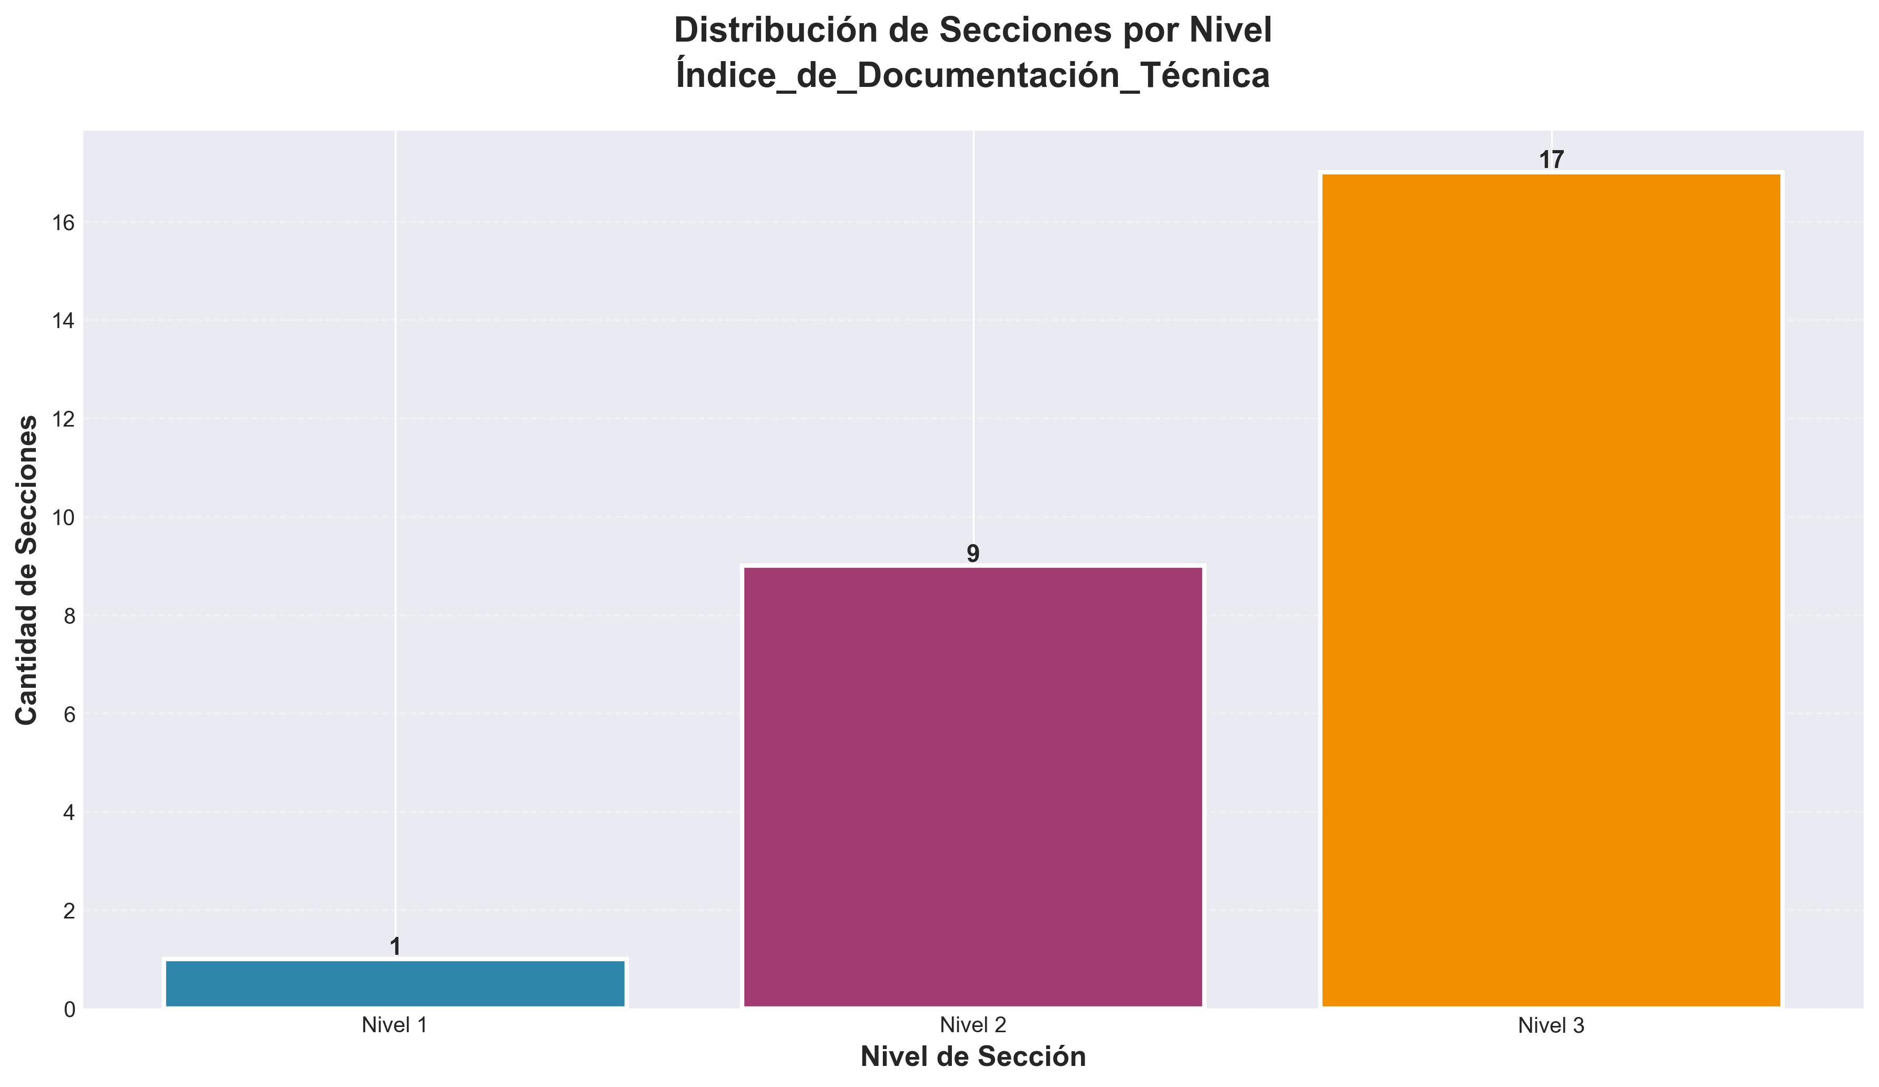

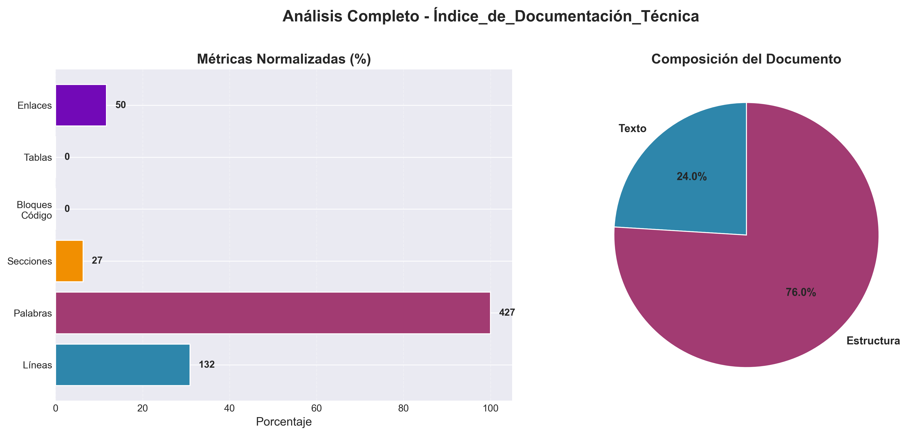

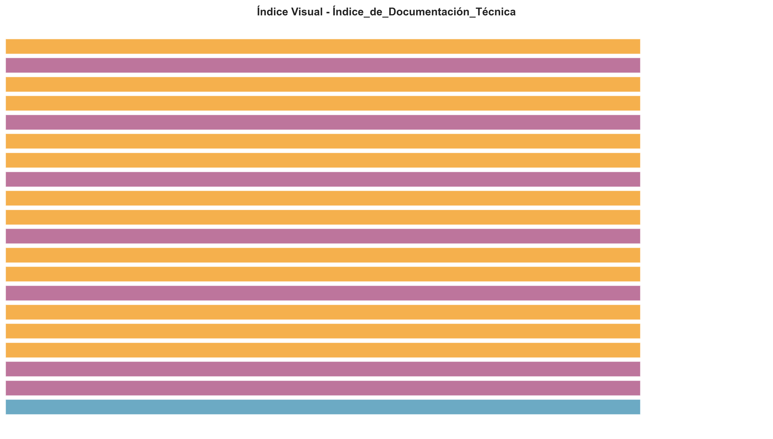

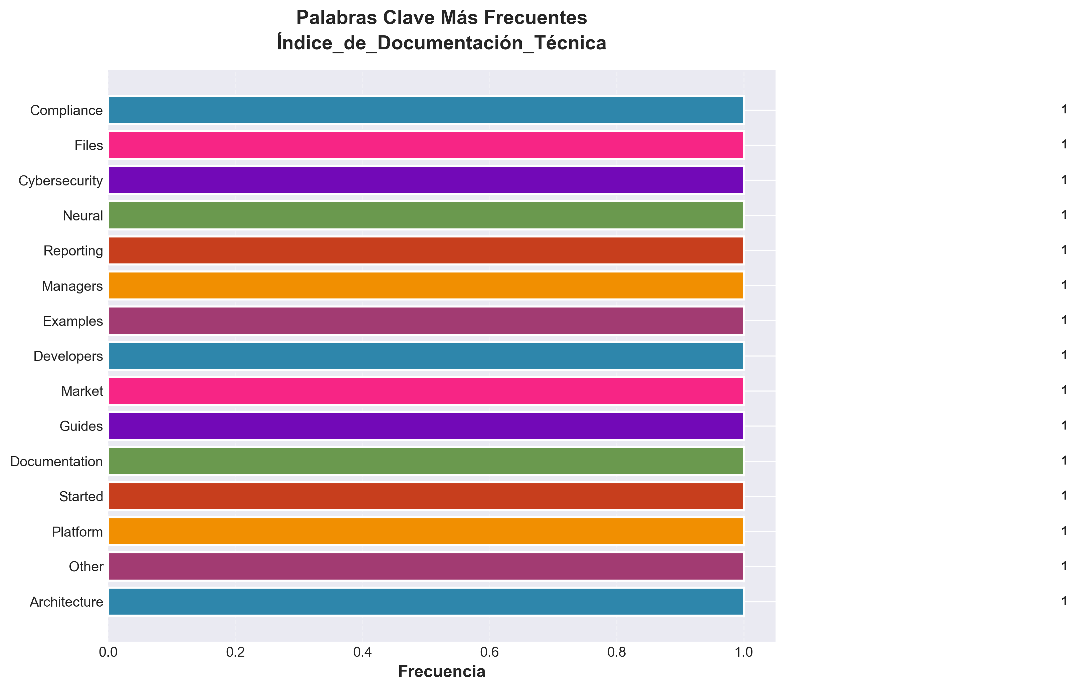

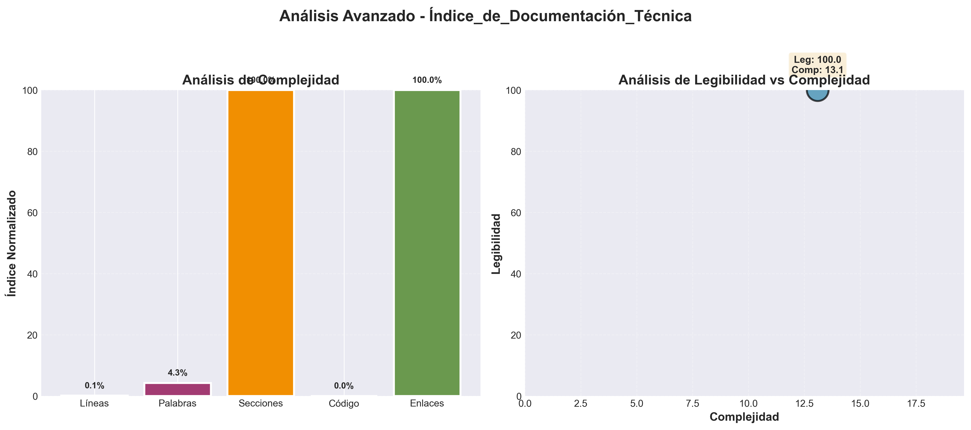

📄 Contenido
---
title: "Docs Index"
category: "06_documentation"
tags: []
created: "2025-10-29"
path: "06_documentation/Index_files/docs_index.md"
---

📚 Neural Marketing Consciousness Platform - Documentation Index

🎯 Overview
This comprehensive documentation index provides organized access to all technical, business, and implementation documentation for the Neural Marketing Consciousness Platform.
---

📋 Core Documentation

🏗️ Technical Architecture
- **[ARCHITECTURE.md](06_documentation/Other/architecture.md)** - Complete system architecture documentation
- **[Advanced_AI_Integration_Guide.md](./Advanced_AI_Integration_Guide.md)** - AI integration patterns and best practices
- **[advanced_ai_system.py](./advanced_ai_system.py)** - Python AI system implementation

💼 Business Documentation
- **[BUSINESS_PLAN.md](./BUSINESS_PLAN.md)** - Comprehensive business plan with financial projections
- **[IMPLEMENTATION_ROADMAP.md](./IMPLEMENTATION_ROADMAP.md)** - 36-month implementation roadmap
- **[COMPETITIVE_ANALYSIS.md](./COMPETITIVE_ANALYSIS.md)** - Market analysis and competitive positioning

🚀 Implementation Guides
- **[Neural_Commission_AI_Integration.md](./Neural_Commission_AI_Integration.md)** - Commission system with AI
- **[TECHNICAL_SPECIFICATIONS.md](./TECHNICAL_SPECIFICATIONS.md)** - Detailed technical specifications
---

🧠 AI & Consciousness Documentation

Core AI Systems
- **[CONSCIOUSNESS_AI_ALGORITHMS.md](./CONSCIOUSNESS_AI_ALGORITHMS.md)** - Consciousness assessment algorithms
- **[CONSCIOUSNESS_DATA_SCIENCE.md](./CONSCIOUSNESS_DATA_SCIENCE.md)** - Data science for consciousness
- **[CONSCIOUSNESS_NEUROSCIENCE_INTEGRATION.md](./CONSCIOUSNESS_NEUROSCIENCE_INTEGRATION.md)** - Neuroscience integration

AI Marketing Systems
- **[AI_Marketing_Course_Complete.md](./AI_Marketing_Course_Complete.md)** - Complete AI marketing course
- **[AI_Marketing_SaaS_CRM_Course.md](./AI_Marketing_SaaS_CRM_Course.md)** - SaaS CRM integration
- **[Advanced_AI_Marketing_Psychology.md](./Advanced_AI_Marketing_Psychology.md)** - Marketing psychology
---

📊 Business & Strategy Documentation

Market Analysis
- **[Market_Analysis_Document.md](./Market_Analysis_Document.md)** - Comprehensive market analysis
- **[Competitive_Positioning_Matrix.md](./Competitive_Positioning_Matrix.md)** - Competitive positioning
- **[Business_Strategy_ROI_Guide.md](./Business_Strategy_ROI_Guide.md)** - ROI strategy guide

Financial Planning
- **[calculadora-roi-ultra-revolucionaria.md](./calculadora-roi-ultra-revolucionaria.md)** - ROI calculator
- **[Commission_Calculator_Tool.md](./Commission_Calculator_Tool.md)** - Commission calculator
---

🛠️ Technical Implementation

Development Guides
- **[DEVELOPER_RESOURCES.md](./DEVELOPER_RESOURCES.md)** - Developer resources
- **[API_DOCUMENTATION.md](06_documentation/Other/Api_docs/api_documentation.md)** - API documentation
- **[Technical_Implementation_Guide.md](./Technical_Implementation_Guide.md)** - Technical implementation

Code Examples
- **[advanced_ai_system.py](./advanced_ai_system.py)** - Python AI system
- **[advanced_analytics_engine.py](./advanced_analytics_engine.py)** - Analytics engine
- **[autonomous_ai_system.py](./autonomous_ai_system.py)** - Autonomous AI system
---

📈 Analytics & Reporting

Analytics Systems
- **[ADVANCED_ANALYTICS_DASHBOARD.md](06_documentation/Other/Analytics/advanced_analytics_dashboard.md)** - Analytics dashboard
- **[DASHBOARD.md](./DASHBOARD.md)** - Dashboard documentation

Reporting
- **[Reporting_Framework.md](./Reporting_Framework.md)** - Reporting framework
- **[Performance_Metrics_Guide.md](./Performance_Metrics_Guide.md)** - Performance metrics
---

🎓 Educational Content

Courses & Training
- **[Complete_Course_Overview.md](./Complete_Course_Overview.md)** - Course overview
- **[Course_Summary_Resources.md](./Course_Summary_Resources.md)** - Course resources
- **[Assessment_Certification_Framework.md](./Assessment_Certification_Framework.md)** - Certification framework

Learning Materials
- **[Advanced_Prompt_Engineering_Mastery.md](./Advanced_Prompt_Engineering_Mastery.md)** - Prompt engineering
- **[AI_Marketing_Tools_Platforms_Guide.md](./AI_Marketing_Tools_Platforms_Guide.md)** - AI marketing tools
---

🔒 Security & Compliance

Security Documentation
- **[CONSCIOUSNESS_SECURITY_AND_PRIVACY.md](./CONSCIOUSNESS_SECURITY_AND_PRIVACY.md)** - Security and privacy
- **[cybersecurity_system.py](./cybersecurity_system.py)** - Cybersecurity system

Compliance
- **[CONSCIOUSNESS_ETHICS_AND_GOVERNANCE.md](./CONSCIOUSNESS_ETHICS_AND_GOVERNANCE.md)** - Ethics and governance
- **[Compliance_Framework.md](./Compliance_Framework.md)** - Compliance framework
---

📝 Quick Reference

Getting Started
1. New to the project? Start with [BUSINESS_PLAN.md](./BUSINESS_PLAN.md)
2. Technical implementation? Read [ARCHITECTURE.md](06_documentation/Other/architecture.md)
3. AI integration? Check [Advanced_AI_Integration_Guide.md](./Advanced_AI_Integration_Guide.md)
4. Implementation timeline? See [IMPLEMENTATION_ROADMAP.md](./IMPLEMENTATION_ROADMAP.md)

Key Files by Role
- **Developers:** [ARCHITECTURE.md](06_documentation/Other/architecture.md), [API_DOCUMENTATION.md](06_documentation/Other/Api_docs/api_documentation.md)
- **Business:** [BUSINESS_PLAN.md](./BUSINESS_PLAN.md), [COMPETITIVE_ANALYSIS.md](./COMPETITIVE_ANALYSIS.md)
- **AI Engineers:** [CONSCIOUSNESS_AI_ALGORITHMS.md](./CONSCIOUSNESS_AI_ALGORITHMS.md), [advanced_ai_system.py](./advanced_ai_system.py)
- **Product Managers:** [IMPLEMENTATION_ROADMAP.md](./IMPLEMENTATION_ROADMAP.md), [TECHNICAL_SPECIFICATIONS.md](./TECHNICAL_SPECIFICATIONS.md)
---
This documentation index is maintained as part of the Neural Marketing Consciousness Platform project. 📚✨

