Refactoring Plan - Production Code
Generado el 24 de November de 2025

Gráficas y Análisis
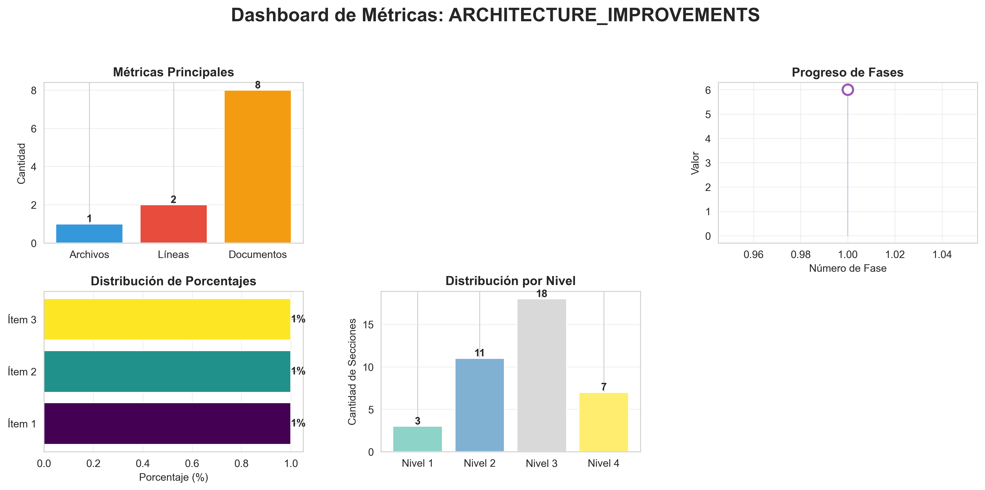

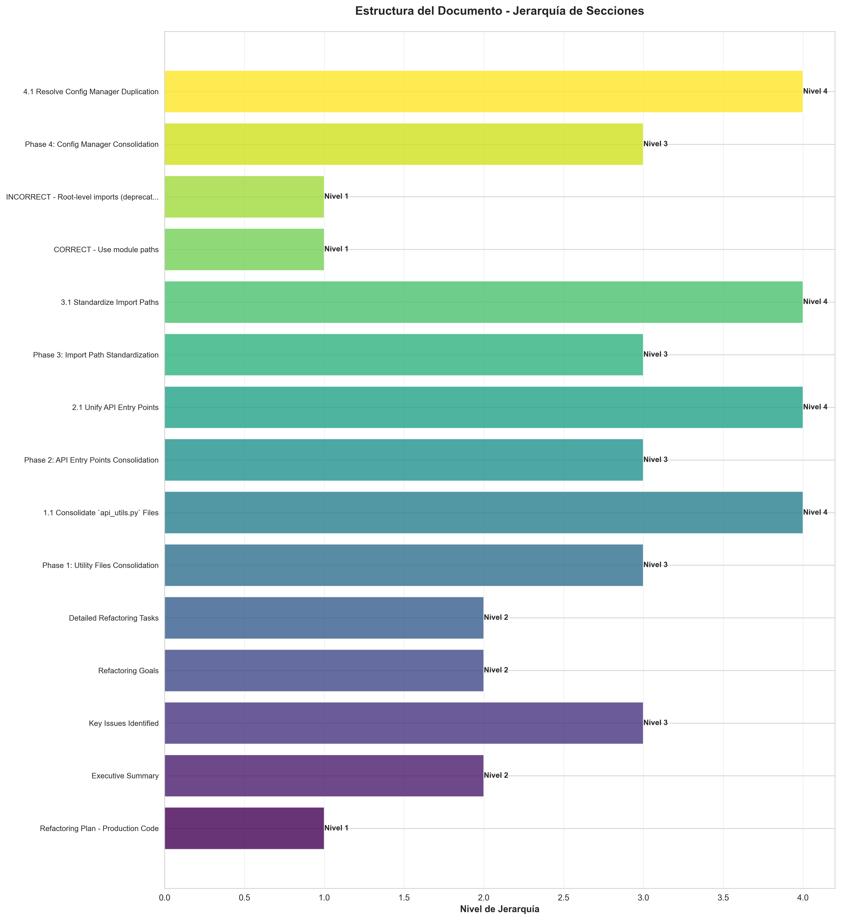

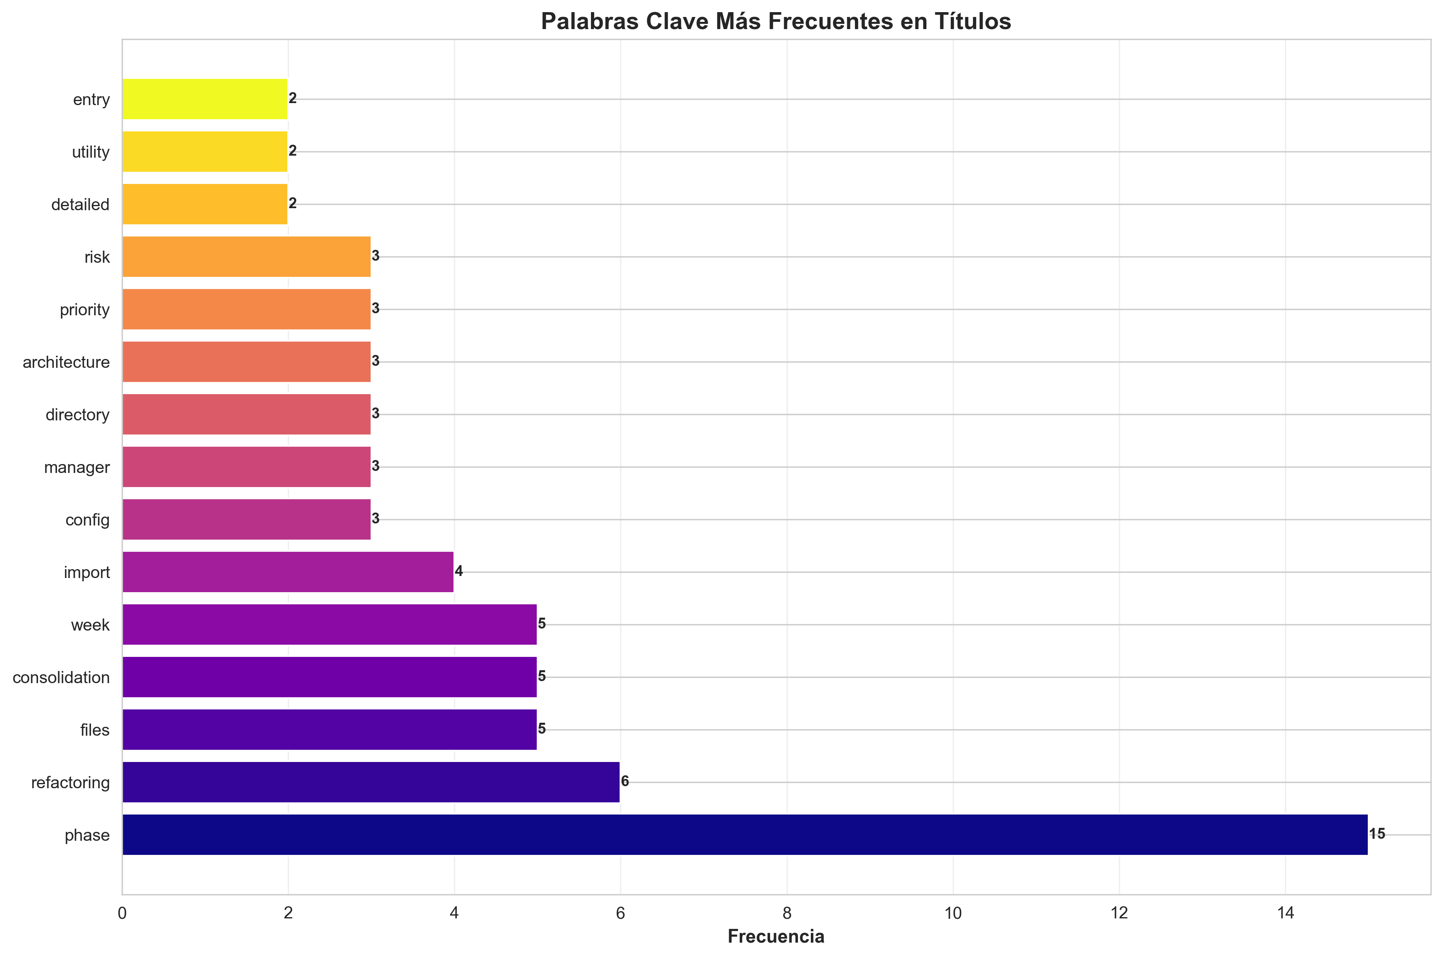

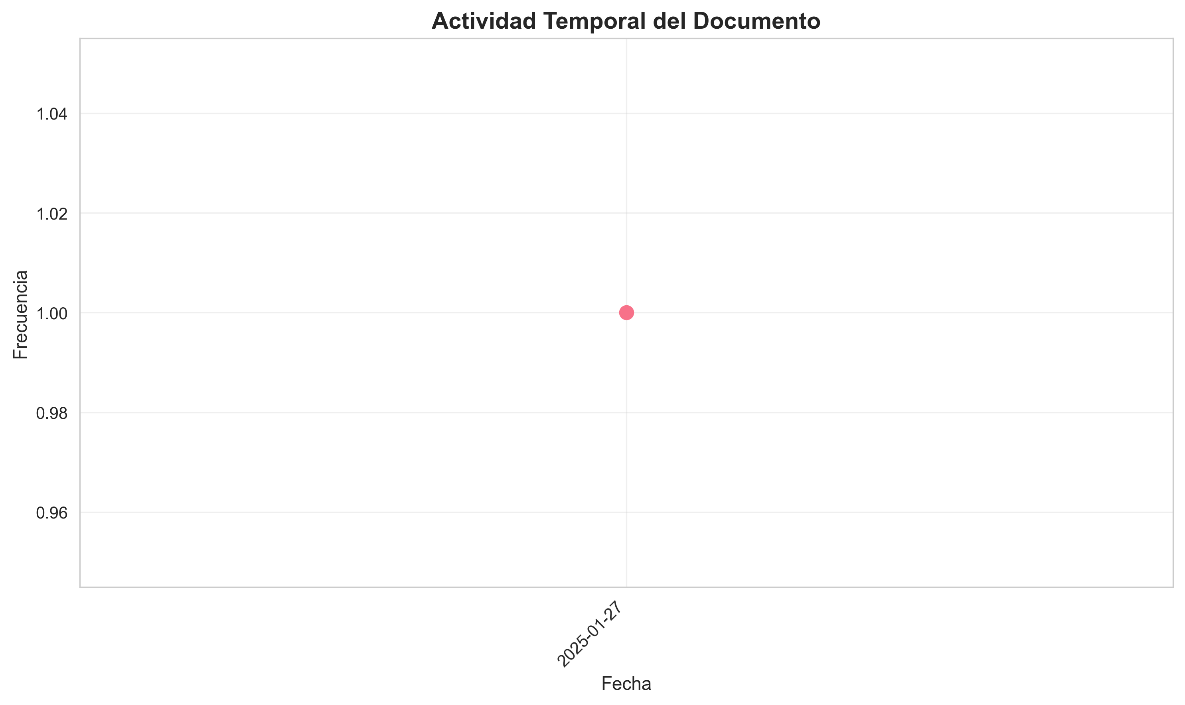

Índice de Contenido
- 1. Refactoring Plan - Production Code
- 2. Executive Summary
- 3. Key Issues Identified
- 4. Refactoring Goals
- 5. Detailed Refactoring Tasks
- 6. Phase 1: Utility Files Consolidation
- 7. 1.1 Consolidate `api_utils.py` Files
- 8. Phase 2: API Entry Points Consolidation
- 9. 2.1 Unify API Entry Points
- 10. Phase 3: Import Path Standardization
- 11. 3.1 Standardize Import Paths
- 12. CORRECT - Use module paths
- 13. INCORRECT - Root-level imports (deprecated)
- 14. Phase 4: Config Manager Consolidation
- 15. 4.1 Resolve Config Manager Duplication
- 16. Phase 5: Directory Structure Alignment
- 17. 5.1 Resolve `code/` Directory Naming Conflict
- 18. 5.2 Move Root-Level Files to Appropriate Layers
- 19. Phase 6: Architecture Alignment
- 20. 6.1 Ensure Layered Architecture Compliance
- 21. Detailed File Analysis
- 22. Files Requiring Immediate Attention
- 23. High Priority
- 24. Medium Priority
- 25. Low Priority
- 26. Implementation Checklist
- 27. Phase 1: Utility Consolidation
- 28. Phase 2: API Consolidation
- 29. Phase 3: Import Standardization
- 30. Phase 4: Config Manager

Refactoring Plan - Production Code
- **Date**: 2025-01-27
- **Status**: Analysis Complete - Ready for Implementation
- ---

Executive Summary
This document outlines a comprehensive refactoring plan for the `production_code` directory to improve code organization, eliminate duplication, resolve import inconsistencies, and align with the documented layered architecture.

Key Issues Identified
1. **Duplicate Utility Files** (3 instances of `api_utils.py`)
2. **Import Inconsistencies** (mixed import paths)
3. **Multiple API Entry Points** (3 different files)
4. **Architecture Misalignment** (old structure vs. new layered architecture)
5. **Directory Naming Conflict** (`code/` conflicts with Python built-in)
6. **Config Manager Duplication** (root vs. core)
- ---

Refactoring Goals
1. **Eliminate Code Duplication**: Consolidate duplicate utility files
2. **Standardize Imports**: Use consistent import paths throughout
3. **Align with Architecture**: Follow the documented layered architecture
4. **Improve Maintainability**: Clear separation of concerns
5. **Resolve Naming Conflicts**: Fix Python built-in module conflicts
6. **Enhance Testability**: Better structure for unit testing
- ---

Detailed Refactoring Tasks

Phase 1: Utility Files Consolidation

1.1 Consolidate `api_utils.py` Files
- **Current State:**
- - `api_utils.py` (root, 268 lines) - Tensor validation functions
- - `core/api_utils.py` (231 lines) - FastAPI/Flask helpers, HTTP clients
- - `api/api_utils.py` (180 lines) - API route validation functions
- **Problem:**
- - Overlapping functionality
- - Inconsistent import paths
- - Confusion about which file to use
- **Solution:**
- **Option A (Recommended):** Keep separate but clarify purposes
- - `api/api_utils.py` → Keep for API route validation (domain-specific)
- - `core/api_utils.py` → Keep for general HTTP/web utilities (reusable)
- - `api_utils.py` (root) → **DEPRECATE** and migrate to `api/api_utils.py`
- **Migration Steps:**
1. Move tensor validation functions from root `api_utils.py` to `api/api_utils.py`
2. Update all imports in `api_unified.py` and other files
3. Add deprecation warnings to root `api_utils.py`
4. Remove root `api_utils.py` after migration period
- **Files to Update:**
- - `api_unified.py` (line 38: `from api_utils import ...`)
- - `tests/test_api_utils.py` (line 13: `from api_utils import ...`)
- **Option B:** Merge all into `core/api_utils.py`
- - More consolidation but larger file
- - Less domain-specific organization
- ---

Phase 2: API Entry Points Consolidation

2.1 Unify API Entry Points
- **Current State:**
- - `api_unified.py` (1237 lines) - Full API implementation (old structure)
- - `application.py` (122 lines) - Application factory (new layered architecture)
- - `api_server.py` (53 lines) - Simple wrapper using `application.py`
- **Problem:**
- - `api_unified.py` doesn't use the new `api/routes/` structure
- - Duplicate API implementations
- - Confusion about which entry point to use
- **Solution:**
- **Recommended Approach:**
1. **Keep `application.py`** as the primary application factory (already follows layered architecture)
2. **Keep `api_server.py`** as the entry point script (uses `application.py`)
3. **Migrate `api_unified.py`** functionality to `api/routes/` structure
4. **Deprecate `api_unified.py`** after migration
- **Migration Steps:**
1. Review endpoints in `api_unified.py` that aren't in `api/routes/`
2. Create missing route files in `api/routes/` if needed
3. Update `application.py` to include all routes
4. Add compatibility shim in `api_unified.py` that imports from `application.py`
5. Update documentation to use `api_server.py` or `application.py`
6. Remove `api_unified.py` after migration period
- **Files to Review:**
- - Compare endpoints in `api_unified.py` vs. `api/routes/*.py`
- - Ensure all functionality is covered in new structure
- ---

Phase 3: Import Path Standardization

3.1 Standardize Import Paths
- **Current Issues:**
- - Mixed imports: `from api_utils import ...` vs `from core.api_utils import ...`
- - Inconsistent use of root-level imports vs. module imports
- **Solution:**
- **Import Standards:**

CORRECT - Use module paths
from api.api_utils import validate_episode_data
from core.api_utils import create_fastapi_app
from core.config_manager import ConfigManager
from services.memory_service import MemoryService

INCORRECT - Root-level imports (deprecated)
from api_utils import validate_episode_data
from config_manager import ConfigManager
- **Files to Update:**
1. `api_unified.py` - Update all root-level imports
2. `tests/test_api_utils.py` - Update imports
3. `infrastructure/providers/pipeline_provider.py` - Update `config_manager` import
4. `application/service_container.py` - Update `config_manager` import
5. `cli_unified.py` - Update `config_manager` import
6. `examples/example_config.py` - Update imports
7. Any other files with root-level imports
- **Search Pattern:**
grep -r "from (api_utils|config_manager|api_auth|api_middleware) import" --include="*.py"
- ---

Phase 4: Config Manager Consolidation

4.1 Resolve Config Manager Duplication
- **Current State:**
- - `config_manager.py` (root, 521 lines)
- - `core/config_manager.py` (mentioned in README but may not exist)
- **Problem:**
- - Unclear which config manager to use
- - Potential duplication
- **Solution:**
1. Check if `core/config_manager.py` exists
2. If it exists, compare functionality
3. Consolidate into single location: `core/config_manager.py`
4. Update all imports to use `core.config_manager`
5. Remove root `config_manager.py` after migration
- **Files to Update:**
- - All files importing from root `config_manager`
- - Update to `from core.config_manager import ...`
- ---

Phase 5: Directory Structure Alignment

5.1 Resolve `code/` Directory Naming Conflict
- **Current Issue:**
- - `code/` directory conflicts with Python's built-in `code` module
- - Causes import issues when torch tries to import built-in `code`
- **Solution:**
1. Rename `code/` → `code_modules/` or `code_models/`
2. Update all imports referencing `code.`
3. Update documentation
- **Files to Update:**
- - All files with `from code import ...` or `import code.`
- - Update to `from code_modules import ...`
- ---

5.2 Move Root-Level Files to Appropriate Layers
- **Files to Consider Moving:**
- **To `api/` (Presentation Layer):**
- - `api_auth.py` → `api/auth.py` (already exists, check for duplication)
- - `api_middleware.py` → `api/middleware.py` (already exists, check for duplication)
- **To `services/` (Application Layer):**
- - `monitoring_system.py` → `services/monitoring_service.py` (if not already in services/)
- - `integration_pipeline.py` → Keep at root (or move to `services/` if it's a service)
- **To `core/` (Domain Layer):**
- - Utility functions that are domain-agnostic
- **Keep at Root:**
- - `api_server.py` - Entry point script
- - `application.py` - Application factory
- - `cli.py`, `cli_unified.py` - CLI entry points
- - `chat_server.py` - Chat server entry point
- - `README.md`, `ARCHITECTURE.md` - Documentation
- ---

Phase 6: Architecture Alignment

6.1 Ensure Layered Architecture Compliance
- **Current Architecture (from ARCHITECTURE.md):**
Presentation (api/, api_*.py, cli*.py, dashboard.html)
↓
Application (services/, integration_pipeline.py, monitoring_system.py)
↓
Domain (core/, memory/, research/, inference/, etc.)
↓
Infrastructure (infrastructure/, providers/)
- **Verification Checklist:**
- - [ ] Presentation layer doesn't import directly from Domain
- - [ ] Application layer uses ServiceContainer for dependencies
- - [ ] Domain layer has no framework dependencies
- - [ ] Infrastructure implements domain contracts
- **Files to Review:**
- - Check imports in `api/routes/*.py` - should only import from `services/` and `api/`
- - Check imports in `services/*.py` - should only import from `core/` and domain modules
- - Check imports in `core/*.py` - should not import FastAPI, Flask, etc.
- ---

Detailed File Analysis

Files Requiring Immediate Attention

High Priority
1. **`api_unified.py`** (1237 lines)
- - **Issue**: Doesn't use new `api/routes/` structure
- - **Action**: Migrate endpoints to `api/routes/` or deprecate
- - **Dependencies**: Used by some tests/examples
2. **`api_utils.py`** (root, 268 lines)
- - **Issue**: Duplicate functionality
- - **Action**: Migrate to `api/api_utils.py` and remove
- - **Dependencies**: Used by `api_unified.py`, `tests/test_api_utils.py`
3. **`config_manager.py`** (root, 521 lines)
- - **Issue**: Potential duplication with `core/config_manager.py`
- - **Action**: Consolidate and standardize imports
- - **Dependencies**: Used by many files

Medium Priority
4. **`api_auth.py`** (root, 313 lines)
- - **Issue**: May duplicate `api/auth.py`
- - **Action**: Check for duplication, consolidate if needed
5. **`api_middleware.py`** (root, 158 lines)
- - **Issue**: May duplicate `api/middleware.py`
- - **Action**: Check for duplication, consolidate if needed
6. **`code/` directory**
- - **Issue**: Naming conflict with Python built-in
- - **Action**: Rename to `code_modules/`

Low Priority
7. **Documentation files**
- - **Action**: Update references to moved/renamed files
- - **Files**: `README.md`, `ARCHITECTURE.md`, `docs/*.md`
- ---

Implementation Checklist

Phase 1: Utility Consolidation
- - [ ] Analyze differences between three `api_utils.py` files
- - [ ] Migrate root `api_utils.py` functions to `api/api_utils.py`
- - [ ] Update all imports from root `api_utils`
- - [ ] Add deprecation warnings
- - [ ] Remove root `api_utils.py`
- - [ ] Update tests

Phase 2: API Consolidation
- - [ ] Compare endpoints in `api_unified.py` vs. `api/routes/`
- - [ ] Migrate missing endpoints to `api/routes/`
- - [ ] Update `application.py` to include all routes
- - [ ] Create compatibility shim in `api_unified.py`
- - [ ] Update documentation
- - [ ] Remove `api_unified.py` after migration period

Phase 3: Import Standardization
- - [ ] Create import standards document
- - [ ] Update all root-level imports to module paths
- - [ ] Run linter to verify no root-level imports remain
- - [ ] Update documentation with import examples

Phase 4: Config Manager
- - [ ] Check if `core/config_manager.py` exists
- - [ ] Compare functionality if both exist
- - [ ] Consolidate into `core/config_manager.py`
- - [ ] Update all imports
- - [ ] Remove root `config_manager.py`

Phase 5: Directory Structure
- - [ ] Rename `code/` to `code_modules/`
- - [ ] Update all imports
- - [ ] Move `api_auth.py` to `api/auth.py` (if not duplicate)
- - [ ] Move `api_middleware.py` to `api/middleware.py` (if not duplicate)
- - [ ] Update documentation

Phase 6: Architecture Verification
- - [ ] Verify presentation layer imports
- - [ ] Verify application layer imports
- - [ ] Verify domain layer imports
- - [ ] Verify infrastructure layer imports
- - [ ] Fix any violations
- - [ ] Update architecture documentation
- ---

🧪 Testing Strategy

Before Refactoring
1. Run full test suite to establish baseline
2. Document current behavior
3. Create integration tests for critical paths

During Refactoring
1. Run tests after each phase
2. Fix any broken imports immediately
3. Verify functionality hasn't changed

After Refactoring
1. Run full test suite
2. Run linter (ruff, mypy)
3. Check for circular imports
4. Verify all imports resolve correctly
5. Integration testing
- ---

Documentation Updates

Files to Update
1. **`README.md`**
- - Update import examples
- - Update entry point instructions
- - Remove references to deprecated files
2. **`ARCHITECTURE.md`**
- - Update file locations
- - Update import examples
- - Clarify entry points
3. **`docs/API_README.md`**
- - Update API usage examples
- - Update import paths
4. **`docs/architecture/layers.md`**
- - Update file mappings
- - Update import rules
- ---

Risks and Mitigation

Risk 1: Breaking Changes
- - **Risk**: Changing imports may break existing code
- - **Mitigation**:
- - Use compatibility shims during transition
- - Deprecation warnings before removal
- - Gradual migration

Risk 2: Lost Functionality
- - **Risk**: Consolidation may lose some functionality
- - **Mitigation**:
- - Comprehensive comparison before consolidation
- - Test coverage
- - Code review

Risk 3: Import Cycles
- - **Risk**: Reorganization may create circular imports
- - **Mitigation**:
- - Follow layered architecture strictly
- - Use dependency injection
- - Test imports after changes
- ---

Migration Timeline

Week 1: Analysis & Planning
- - Complete file comparison
- - Create detailed migration scripts
- - Set up test baseline

Week 2: Phase 1 & 2
- - Consolidate utilities
- - Migrate API endpoints
- - Update imports

Week 3: Phase 3 & 4
- - Standardize imports
- - Consolidate config manager
- - Update tests

Week 4: Phase 5 & 6
- - Directory reorganization
- - Architecture verification
- - Documentation updates

Week 5: Testing & Cleanup
- - Full test suite
- - Remove deprecated files
- - Final documentation
- ---

Success Metrics
1. **Code Duplication**: Reduce duplicate files to 0
2. **Import Consistency**: 100% of imports use module paths
3. **Architecture Compliance**: All layers follow dependency rules
4. **Test Coverage**: Maintain or improve test coverage
5. **Documentation**: All docs updated with new structure
- ---

Related Documents
- - `ARCHITECTURE.md` - Layered architecture documentation
- - `docs/architecture/layers.md` - Detailed layer rules
- - `CLEANUP_SUMMARY.md` - Previous cleanup efforts
- - `CODE_CLEANUP_SUMMARY.md` - Code quality improvements
- - `MEJORAS_MODULOS_V2.md` - Module improvements
- ---

Notes
- - This refactoring should be done incrementally
- - Maintain backward compatibility during transition
- - Use feature flags if needed for gradual rollout
- - Communicate changes to all team members
- - Update CI/CD pipelines if import paths change
- ---
- **Status**: Analysis Complete
- **Next Step**: Begin Phase 1 - Utility Files Consolidation

