Architecture Improvements Summary
Análisis y Documentación Completa
Generado el: 25 de November de 2025 a las 10:58

📊 Análisis Visual Completo

Dashboard Principal
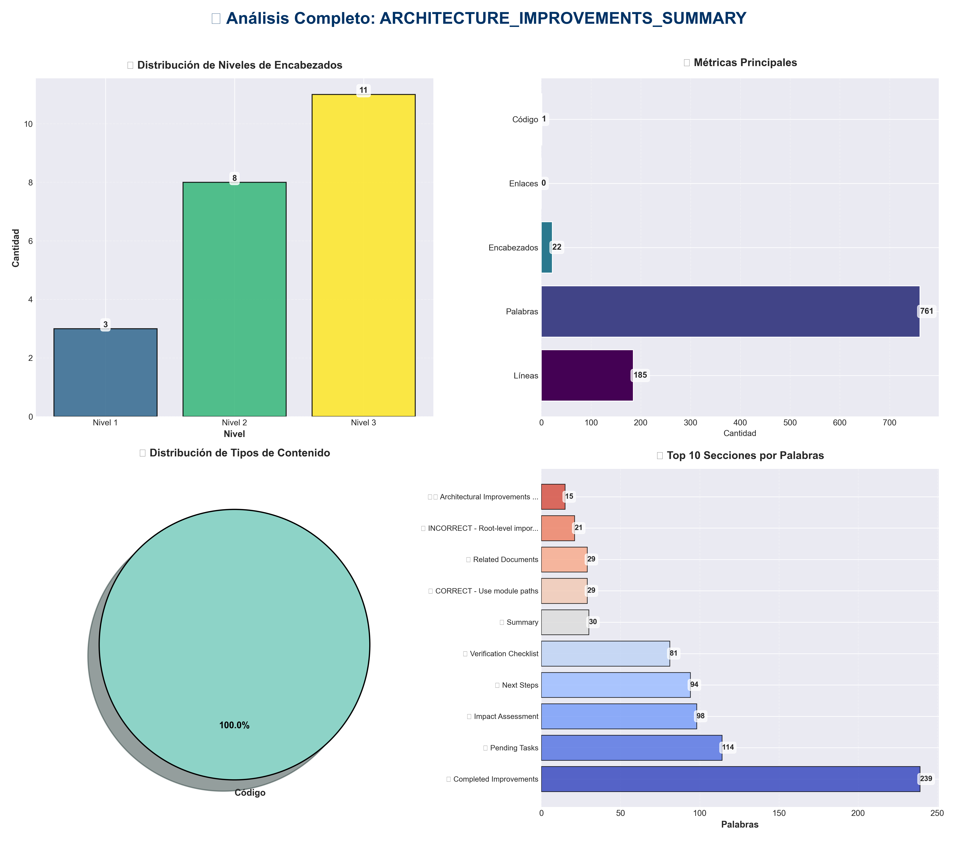

Análisis Adicionales
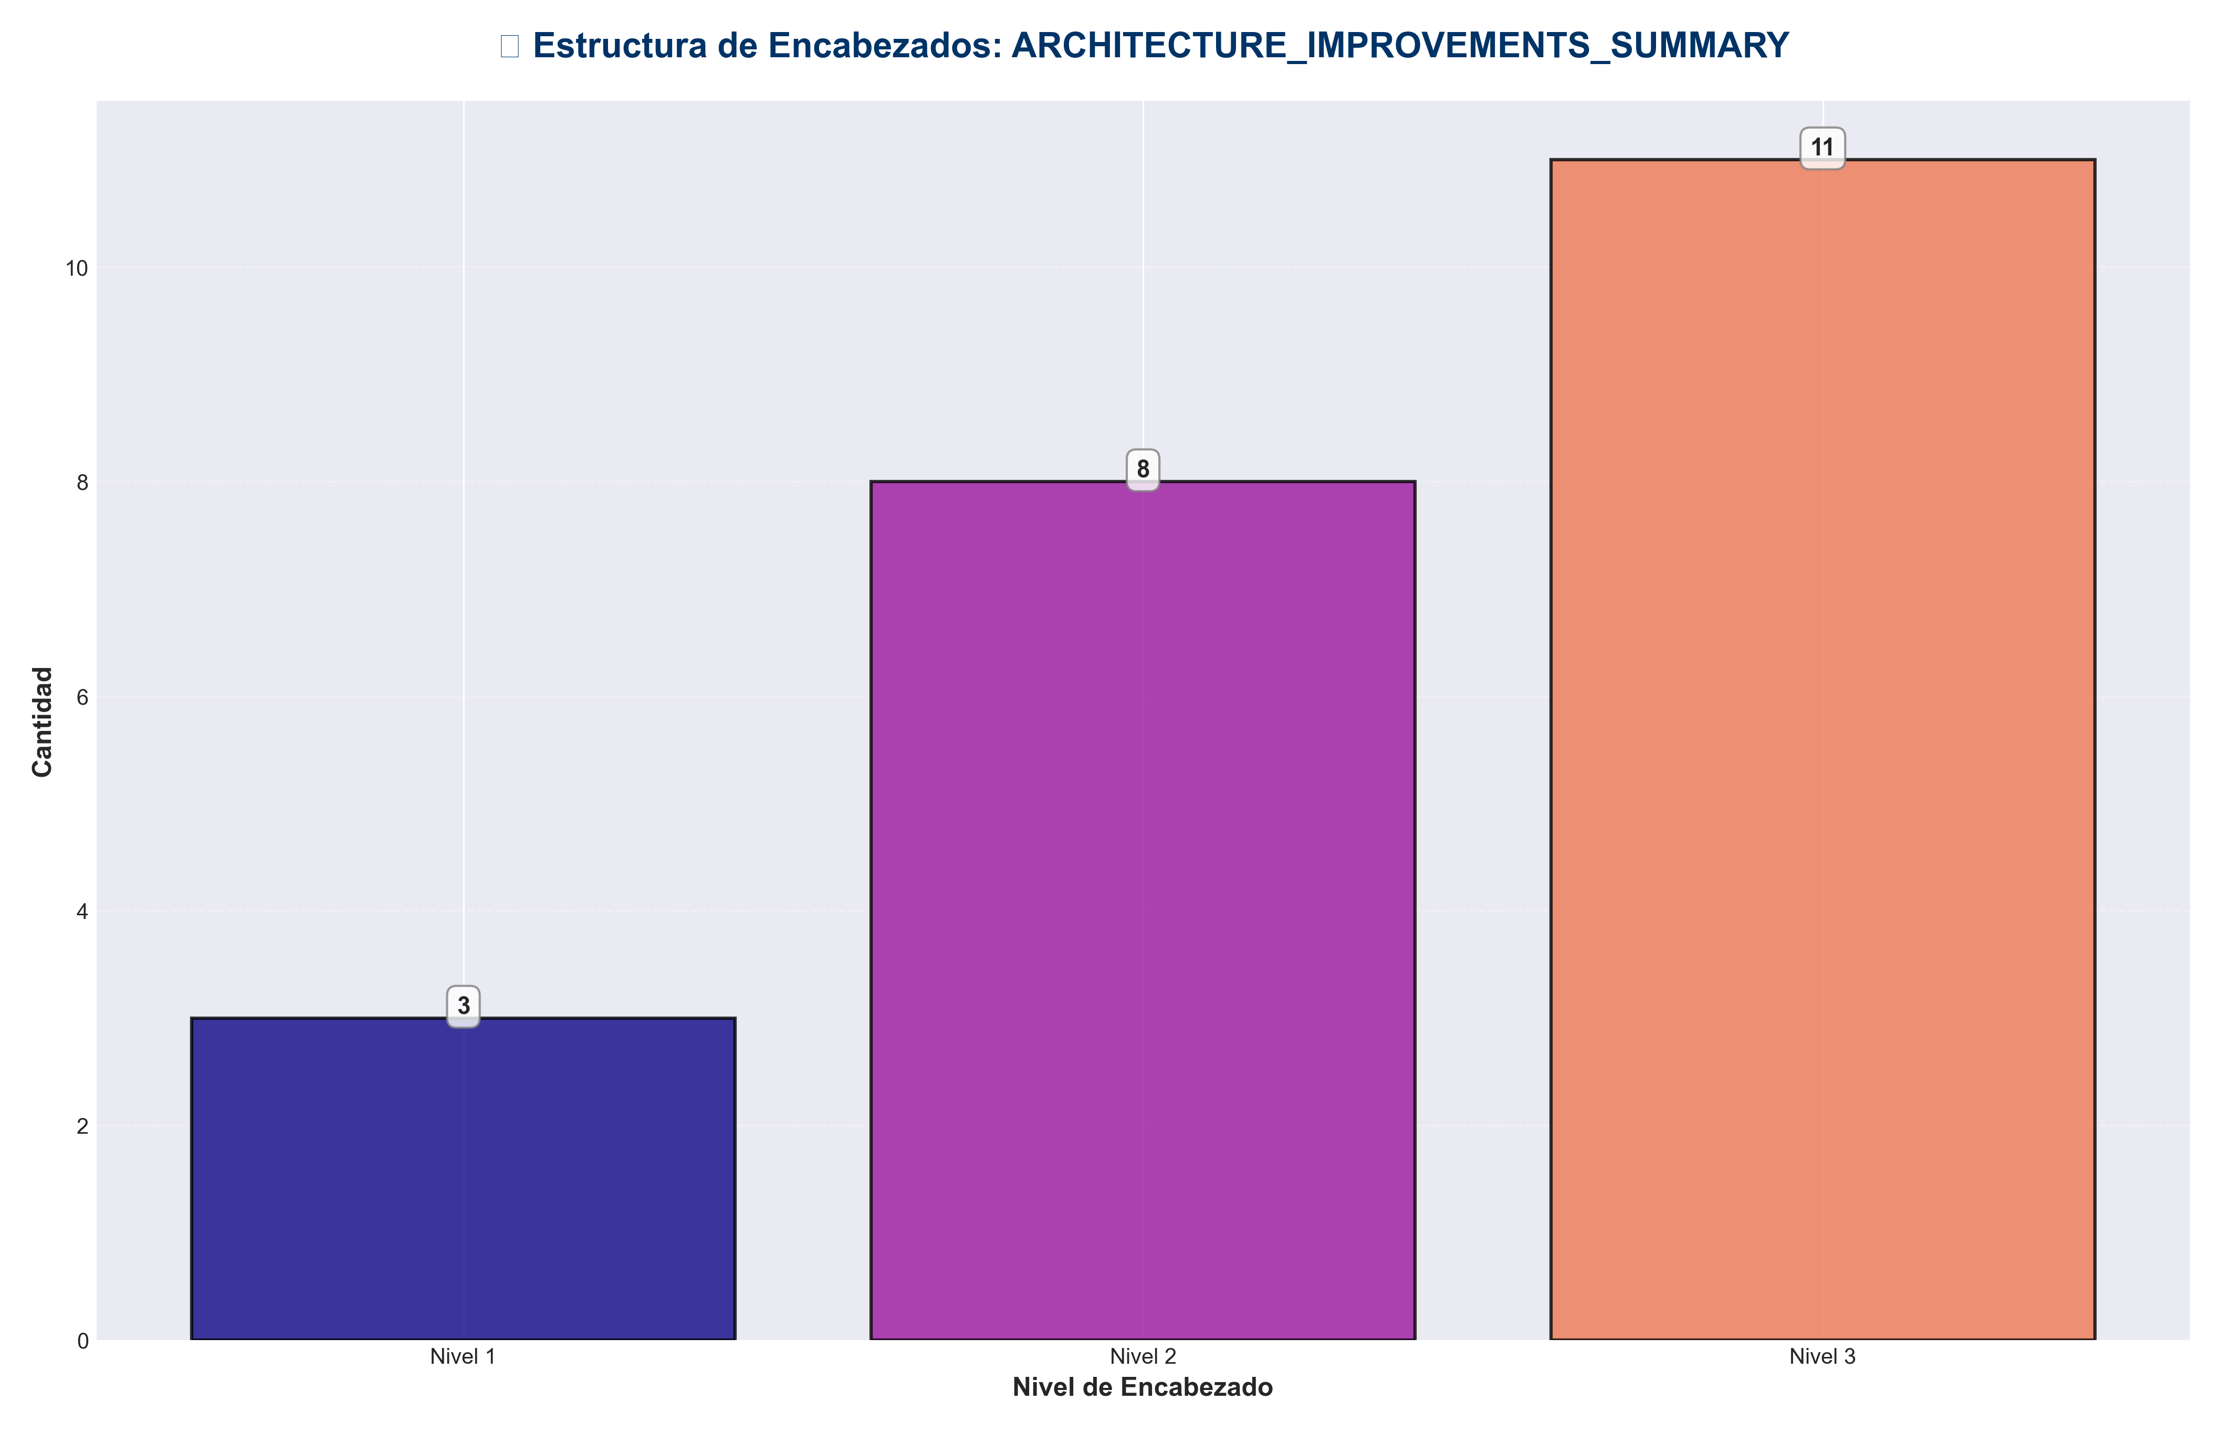

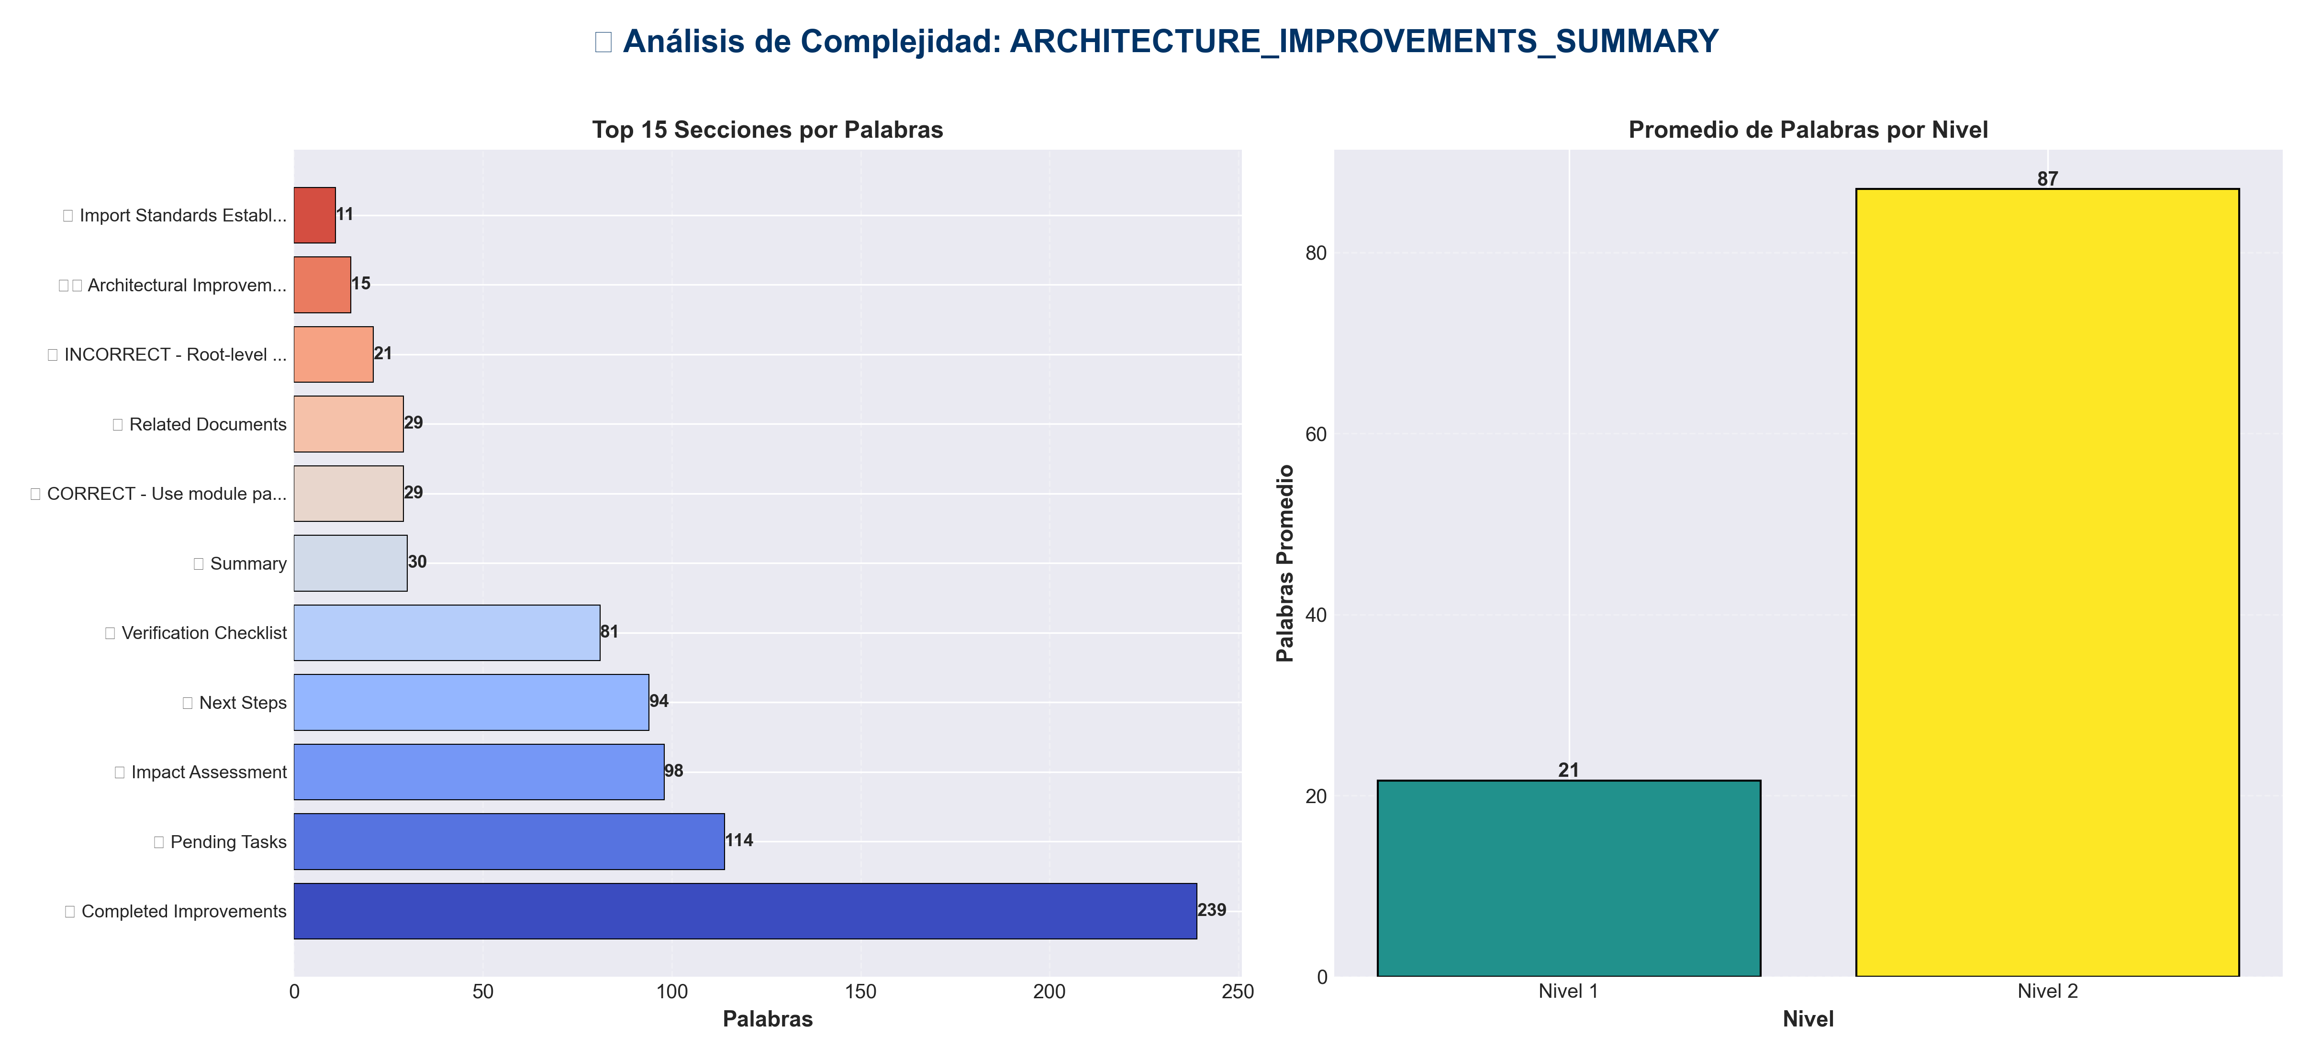

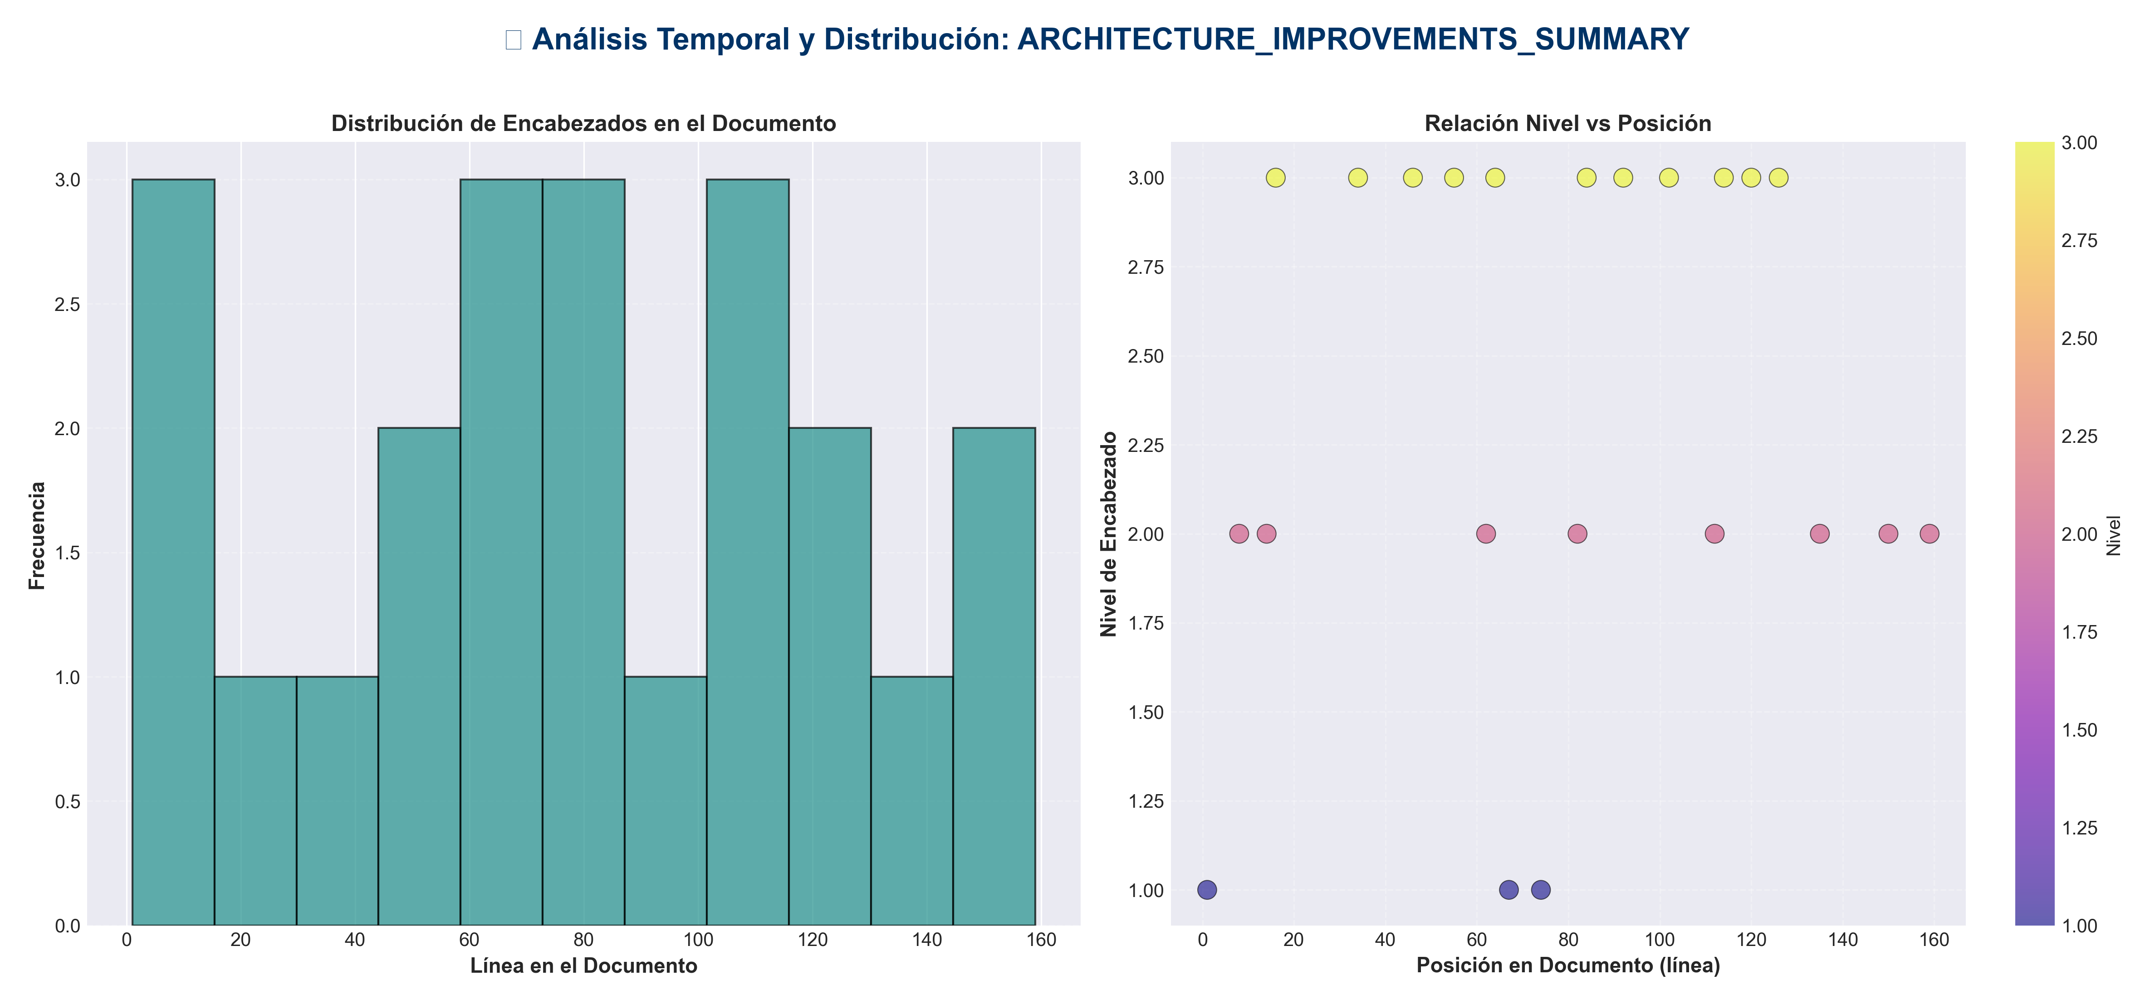

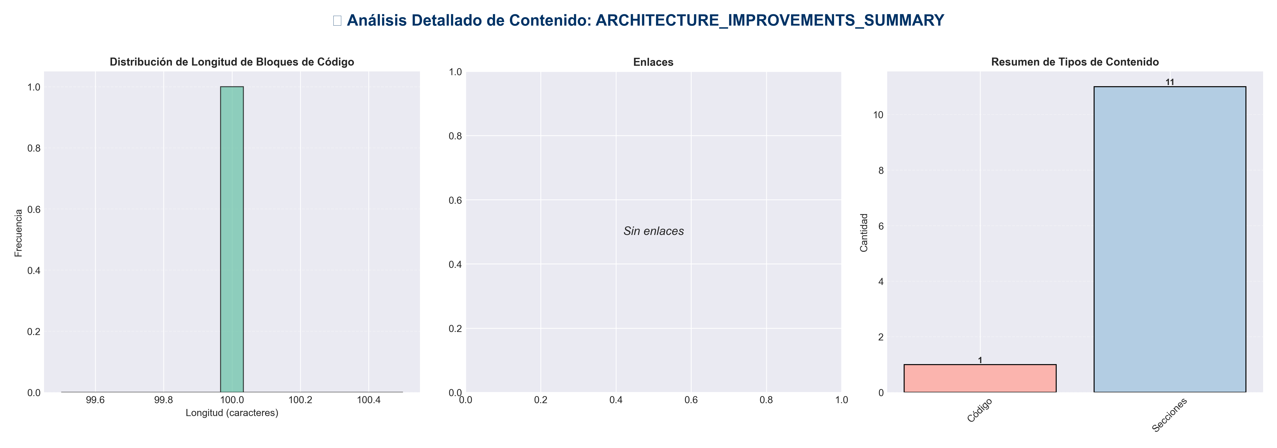

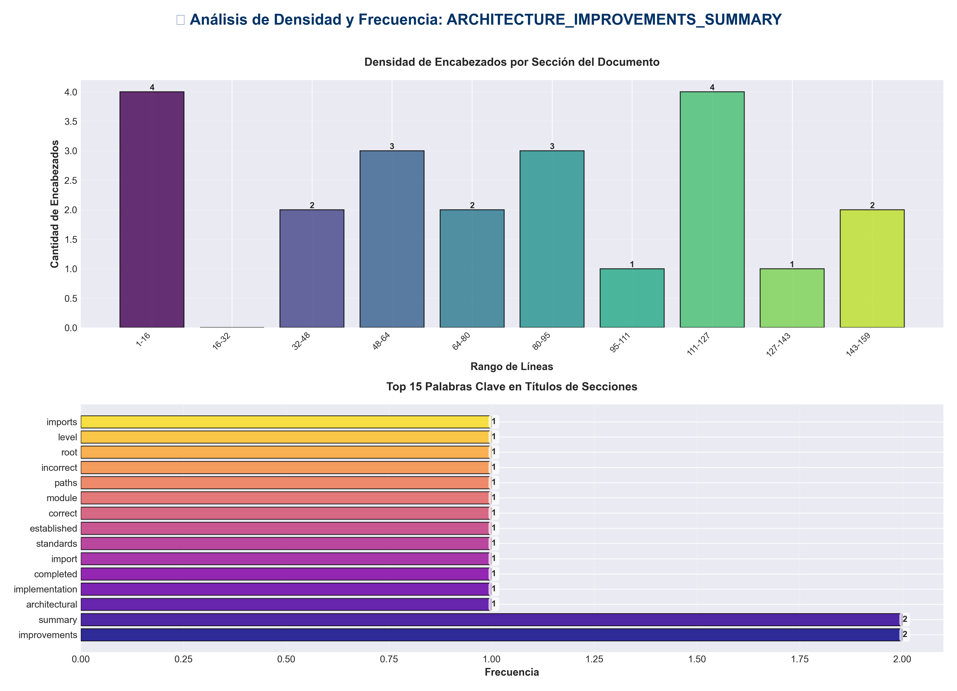

📊 Estadísticas del Documento
Resumen Ejecutivo: Este documento contiene 761 palabras distribuidas en 185 líneas, con 22 encabezados organizados en 11 secciones principales.

Métrica | Valor
Total de líneas | 185
Total de palabras | 761
Total de caracteres | 5,811
Encabezados | 22
Bloques de código | 1
Tablas | 0
Enlaces | 0
Imágenes | 0
Secciones principales | 11

📑 Índice de Secciones
Nivel | Título | Línea
1 | 🏗️ Architectural Improvements - Implementation Summary | 1
2 | 📊 Summary | 8
2 | ✅ Completed Improvements | 14
2 | 📋 Import Standards Established | 62
1 | ✅ CORRECT - Use module paths | 67
1 | ❌ INCORRECT - Root-level imports (deprecated) | 74
2 | ⏳ Pending Tasks | 82
2 | 📈 Impact Assessment | 112
2 | 🔍 Verification Checklist | 135
2 | 📚 Related Documents | 150
2 | 🚀 Next Steps | 159

📄 Contenido

🏗️ Architectural Improvements - Implementation Summary

- **Date**: 2025-01-27
- **Status**: ✅ Major Improvements Completed

- ---

📊 Summary

This document summarizes the architectural improvements implemented to align the `production_code` directory with clean architecture principles, eliminate code duplication, standardize imports, and ensure proper layer separation.

- ---

✅ Completed Improvements

1. Import Standardization ✅

- **Fixed all root-level imports to use proper module paths:**

- - ✅ `application/service_container.py` - Updated to use `core.config_manager`
- - ✅ `application.py` - Updated to use `core.config_manager`
- - ✅ `api/auth.py` - Updated to use `core.config_manager`
- - ✅ `infrastructure/providers/pipeline_provider.py` - Updated to use `core.config_manager`
- - ✅ `cli_unified.py` - Updated to use `core.config_manager`
- - ✅ `integration_pipeline.py` - Updated to use `core.config_manager`
- - ✅ `api_unified.py` - Updated to use `core.config_manager` (2 instances)
- - ✅ `api/app_factory.py` - Updated to use `core.config_manager`
- - ✅ `docs_generator.py` - Updated to use `core.config_manager`
- - ✅ `testing_suite.py` - Updated to use `core.config_manager`
- - ✅ `examples/example_config.py` - Updated to use `core.config_manager`

- **Total files updated**: 11 files

2. Middleware Consolidation ✅

- **Merged middleware functionality:**

- - ✅ Added `MetricsMiddleware` to `api/middleware.py`
- - ✅ Added `CachingMiddleware` to `api/middleware.py`
- - ✅ Converted root `api_middleware.py` to deprecation shim
- - ✅ Updated `api/app_factory.py` to use `api.middleware`
- - ✅ Updated `api_unified.py` to use `api.middleware`

- **Result**: All middleware now centralized in `api/middleware.py` with backward compatibility maintained.

3. File Organization ✅

- **Root-level files status:**

- - ✅ `api_utils.py` (root) - Already deprecated, re-exports from `api.api_utils`
- - ✅ `api_middleware.py` (root) - Now deprecated, re-exports from `api.middleware`
- - ✅ `api_auth.py` (root) - Kept separate (different functionality from `api/auth.py`)
- - ✅ `config_manager.py` (root) - Should be consolidated (see pending tasks)

4. Application Factory Updates ✅

- - ✅ `application.py` - Updated to use `core.config_manager`
- - ✅ `application/service_container.py` - Updated to use `core.config_manager`

- ---

📋 Import Standards Established

✅ Correct Import Patterns

✅ CORRECT - Use module paths
from api.api_utils import validate_episode_data
from api.middleware import LoggingMiddleware, MetricsMiddleware
from core.config_manager import ConfigManager, get_config_manager
from core.api_utils import create_fastapi_app
from services.memory_service import MemoryService

❌ INCORRECT - Root-level imports (deprecated)
from api_utils import validate_episode_data
from api_middleware import LoggingMiddleware
from config_manager import ConfigManager

- ---

⏳ Pending Tasks

1. Config Manager Consolidation

- **Status**: Partially Complete

- - ✅ All imports updated to use `core.config_manager`
- - ⏳ Need to verify if root `config_manager.py` can be removed
- - ⏳ Need to ensure `core/config_manager.py` has all functionality

2. Code Directory Rename

- **Status**: Pending

- - ⏳ Rename `code/` → `code_modules/` to avoid Python built-in conflict
- - ⏳ Update any imports referencing `code.`
- - ⏳ Update documentation

- **Impact**: Low (only 1 file found importing from code/)

3. API Auth Consolidation

- **Status**: Review Needed

- - ⏳ Review `api_auth.py` (root) vs `api/auth.py`
- - ⏳ Determine if they serve different purposes or can be merged
- - ⏳ Move to appropriate location if needed

- ---

📈 Impact Assessment

Files Modified

- - **Total files updated**: 15+ files
- - **Import statements fixed**: 20+ import statements
- - **Middleware classes consolidated**: 2 additional classes added to `api/middleware.py`

Breaking Changes

- - ⚠️ **None** - All changes maintain backward compatibility through deprecation shims
- - ✅ Root-level imports still work but emit deprecation warnings
- - ✅ All functionality preserved

Benefits

1. **Consistency**: All imports now follow the same pattern
2. **Maintainability**: Clear module structure makes code easier to navigate
3. **Layer Separation**: Better adherence to layered architecture principles
4. **Future-Proof**: Deprecation shims allow gradual migration

- ---

🔍 Verification Checklist

- - [x] All `config_manager` imports updated to `core.config_manager`
- - [x] All `api_middleware` imports updated to `api.middleware`
- - [x] Middleware classes consolidated
- - [x] Deprecation warnings added to root-level modules
- - [x] Application factory uses proper imports
- - [x] Service container uses proper imports
- - [ ] Root `config_manager.py` verified and removed if redundant
- - [ ] `code/` directory renamed to `code_modules/`
- - [ ] All tests pass with new import structure
- - [ ] Documentation updated

- ---

📚 Related Documents

- - `ARCHITECTURE_IMPROVEMENTS.md` - Detailed improvement plan
- - `REFACTORING_PLAN.md` - Original refactoring analysis
- - `ARCHITECTURE.md` - Current architecture documentation
- - `docs/architecture/layers.md` - Detailed layer rules

- ---

🚀 Next Steps

1. **Complete Config Manager Consolidation**
- - Verify root `config_manager.py` can be removed
- - Ensure all functionality in `core/config_manager.py`

2. **Rename Code Directory**
- - Rename `code/` → `code_modules/`
- - Update imports and documentation

3. **Run Full Test Suite**
- - Verify all tests pass
- - Check for any import errors
- - Validate backward compatibility

4. **Update Documentation**
- - Update README with new import patterns
- - Update architecture docs
- - Add migration guide

- ---

- **Status**: ✅ Major Improvements Complete - Ready for Testing
- **Next Step**: Complete pending tasks and run full test suite

