Import Standards
Análisis y Documentación Completa
Generado el: 25 de November de 2025 a las 10:58

📊 Análisis Visual Completo

Dashboard Principal
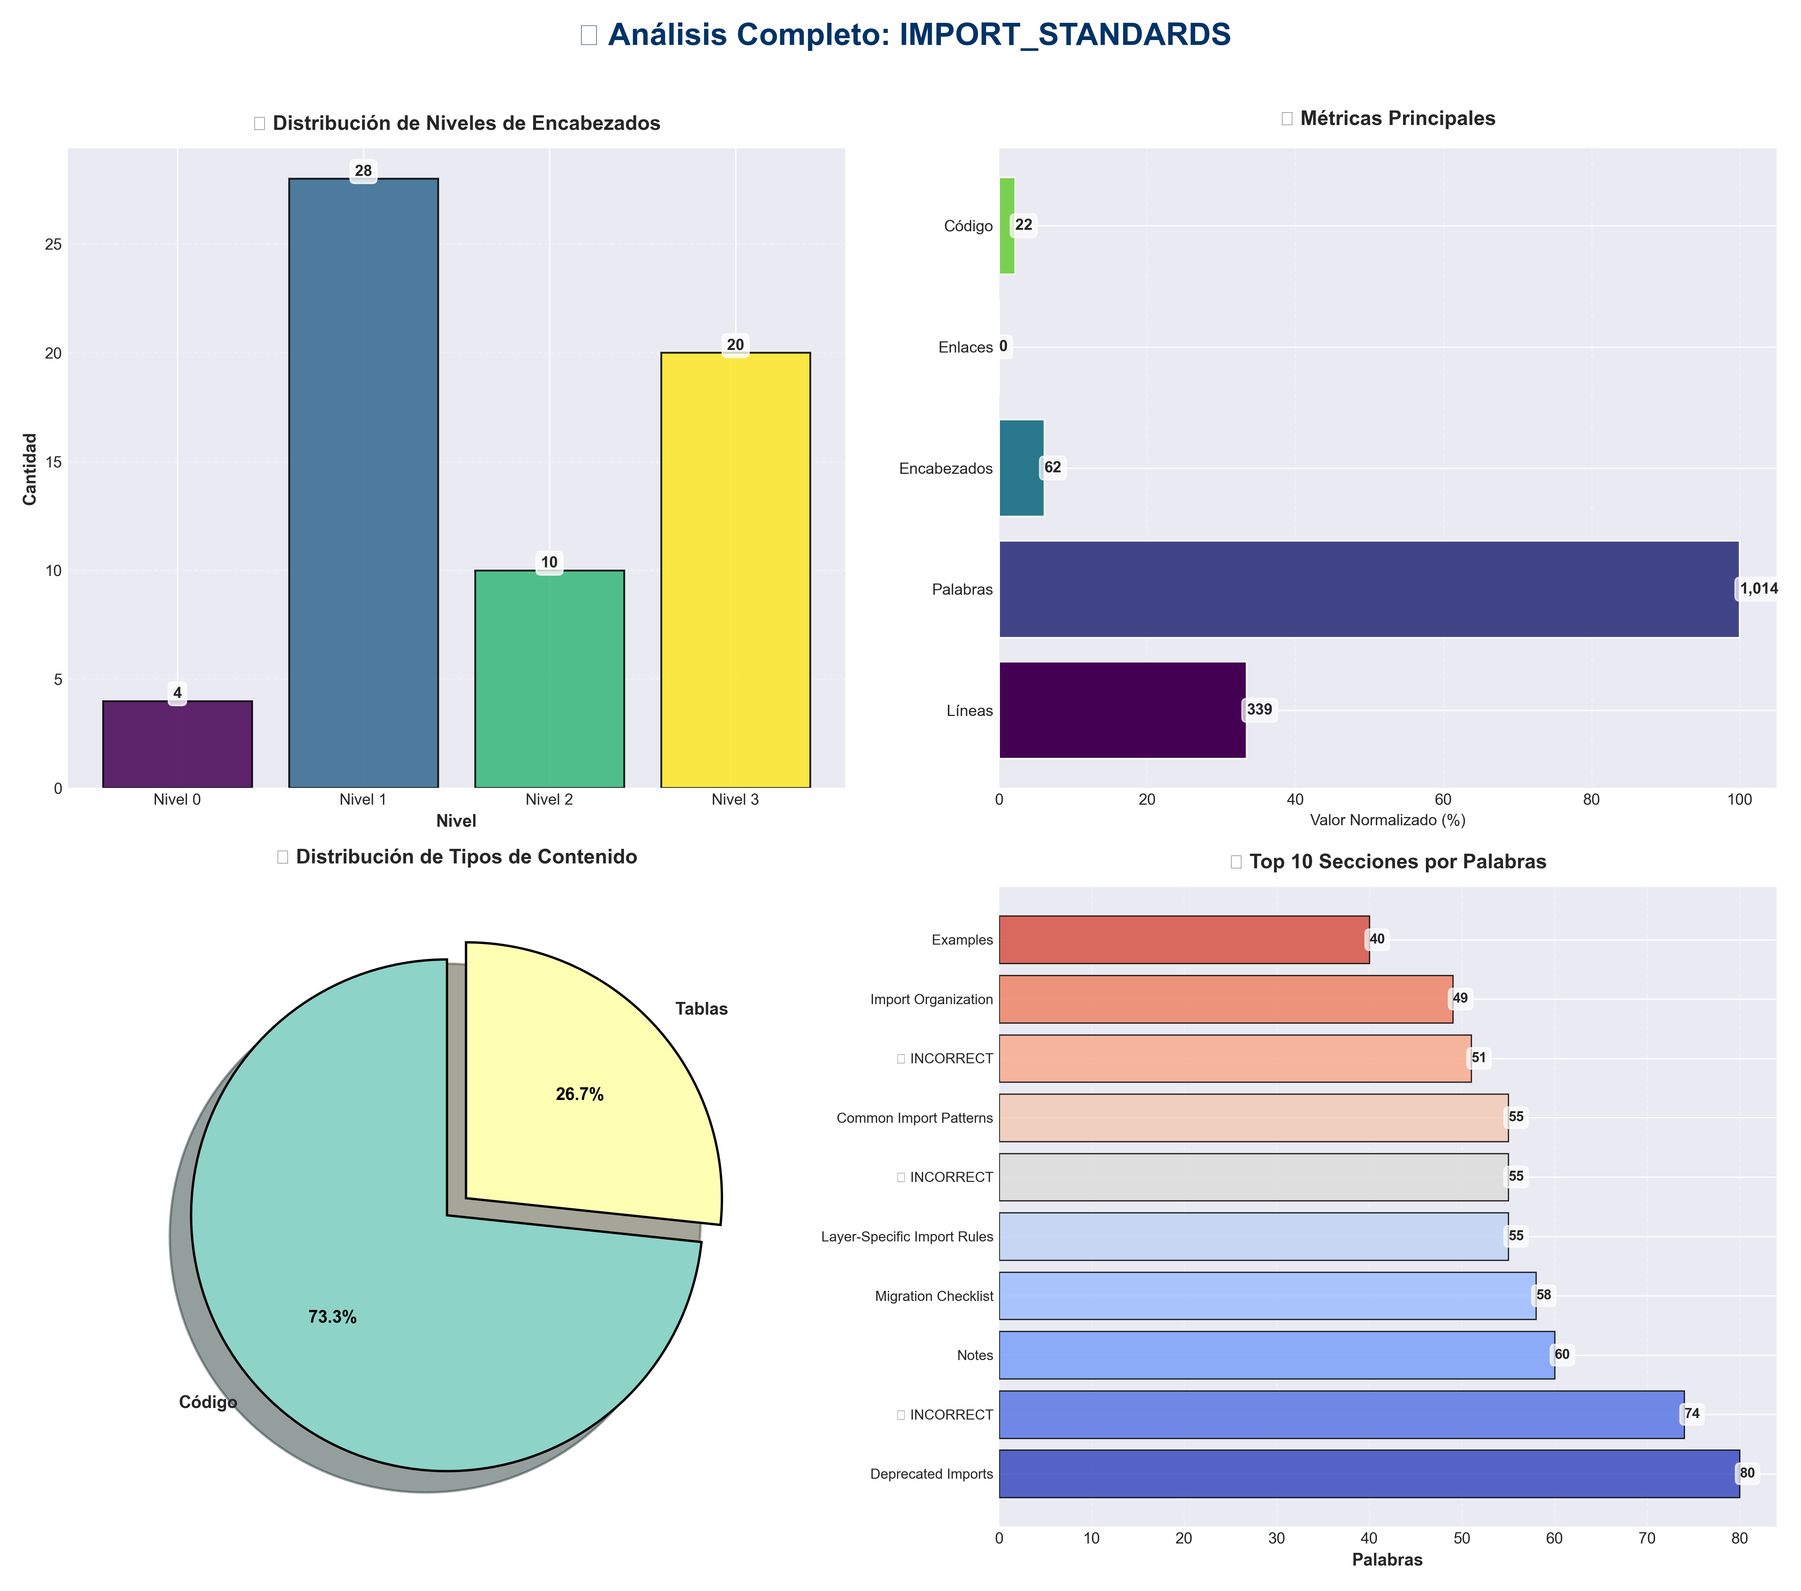

Análisis Adicionales
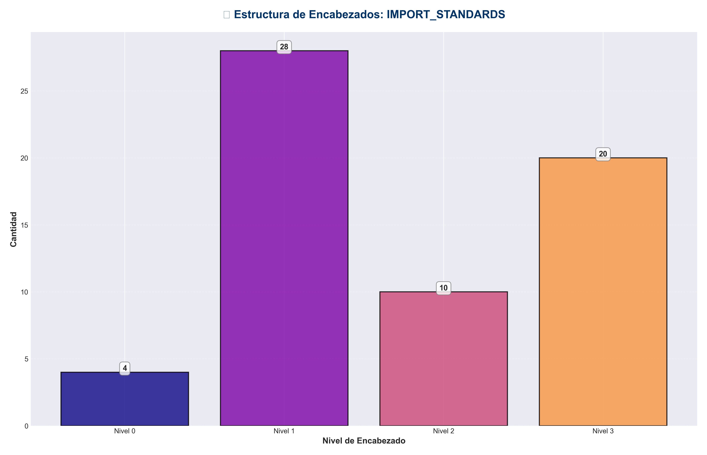

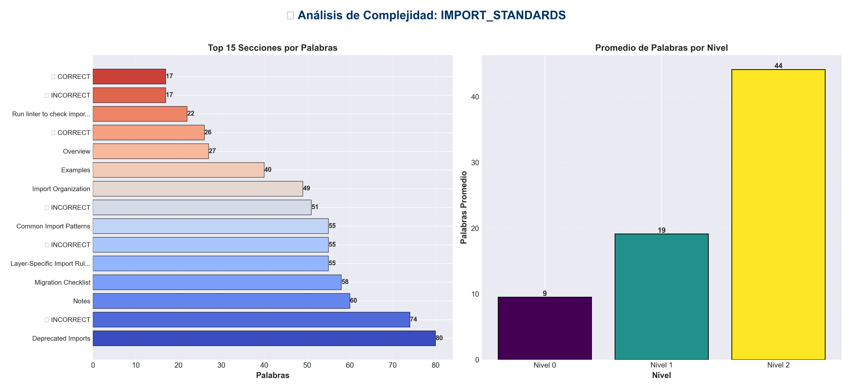

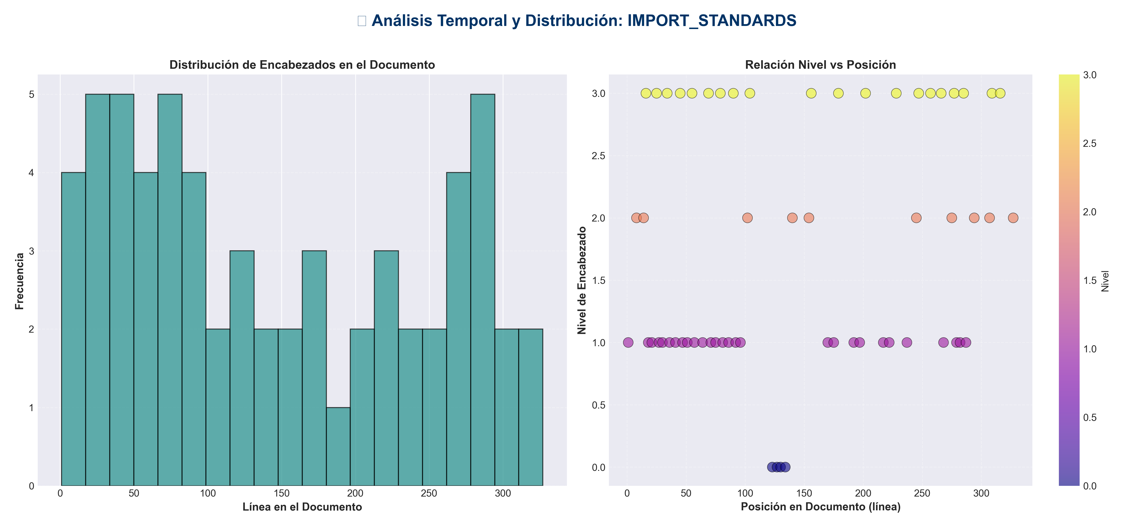

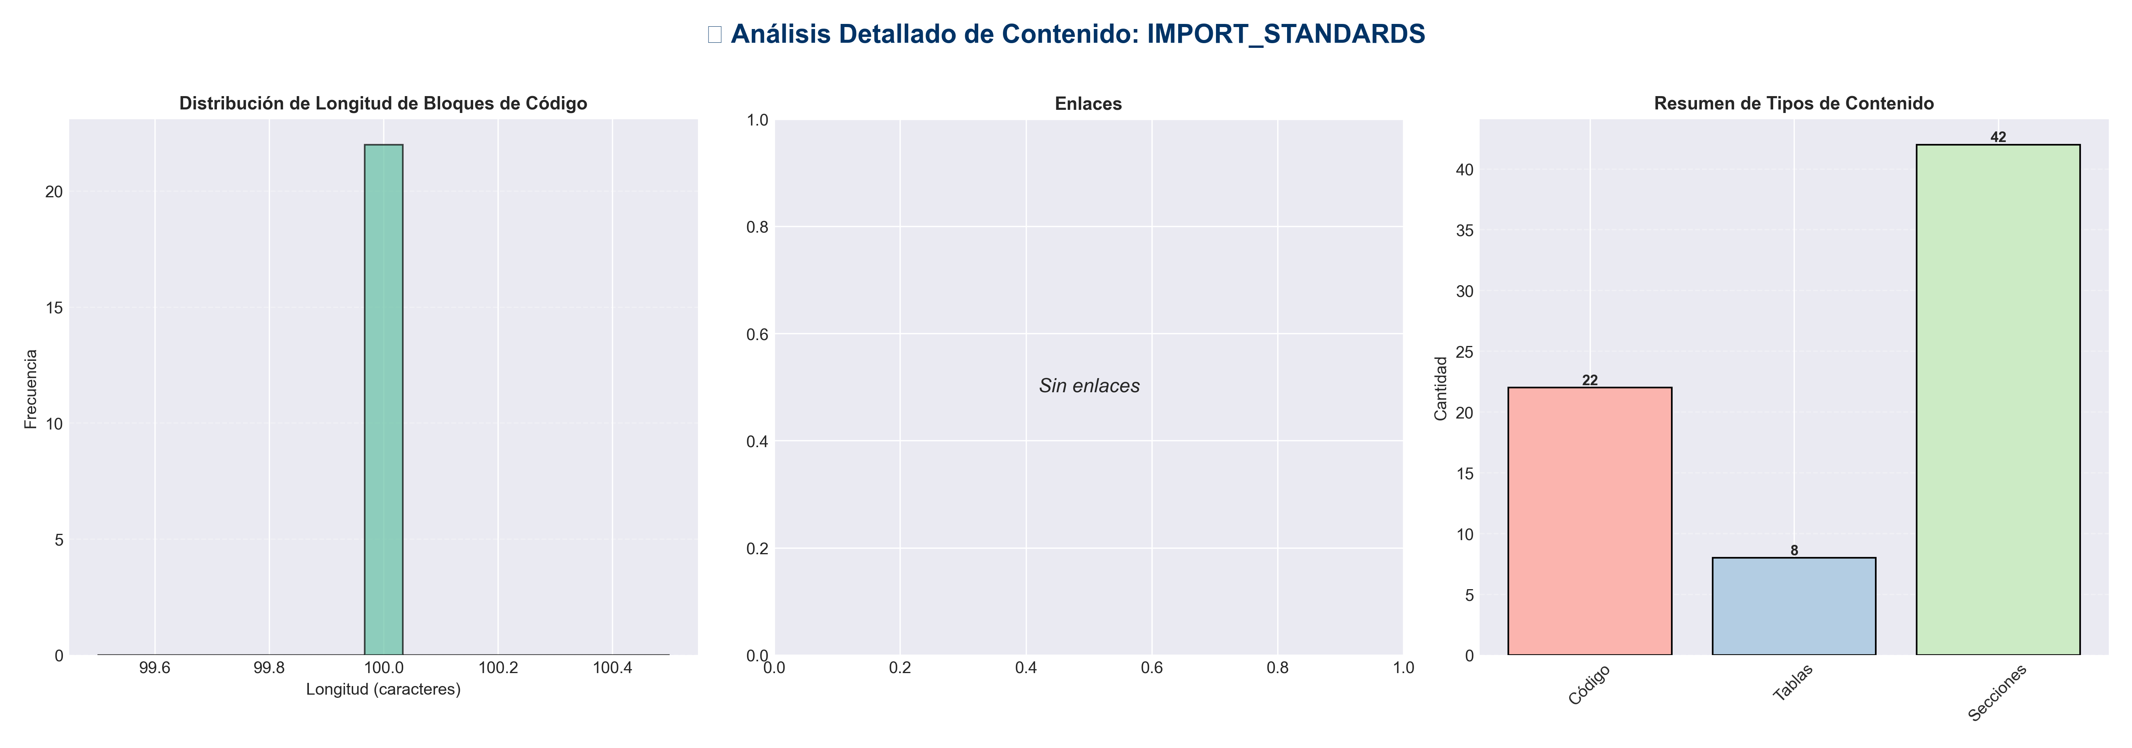

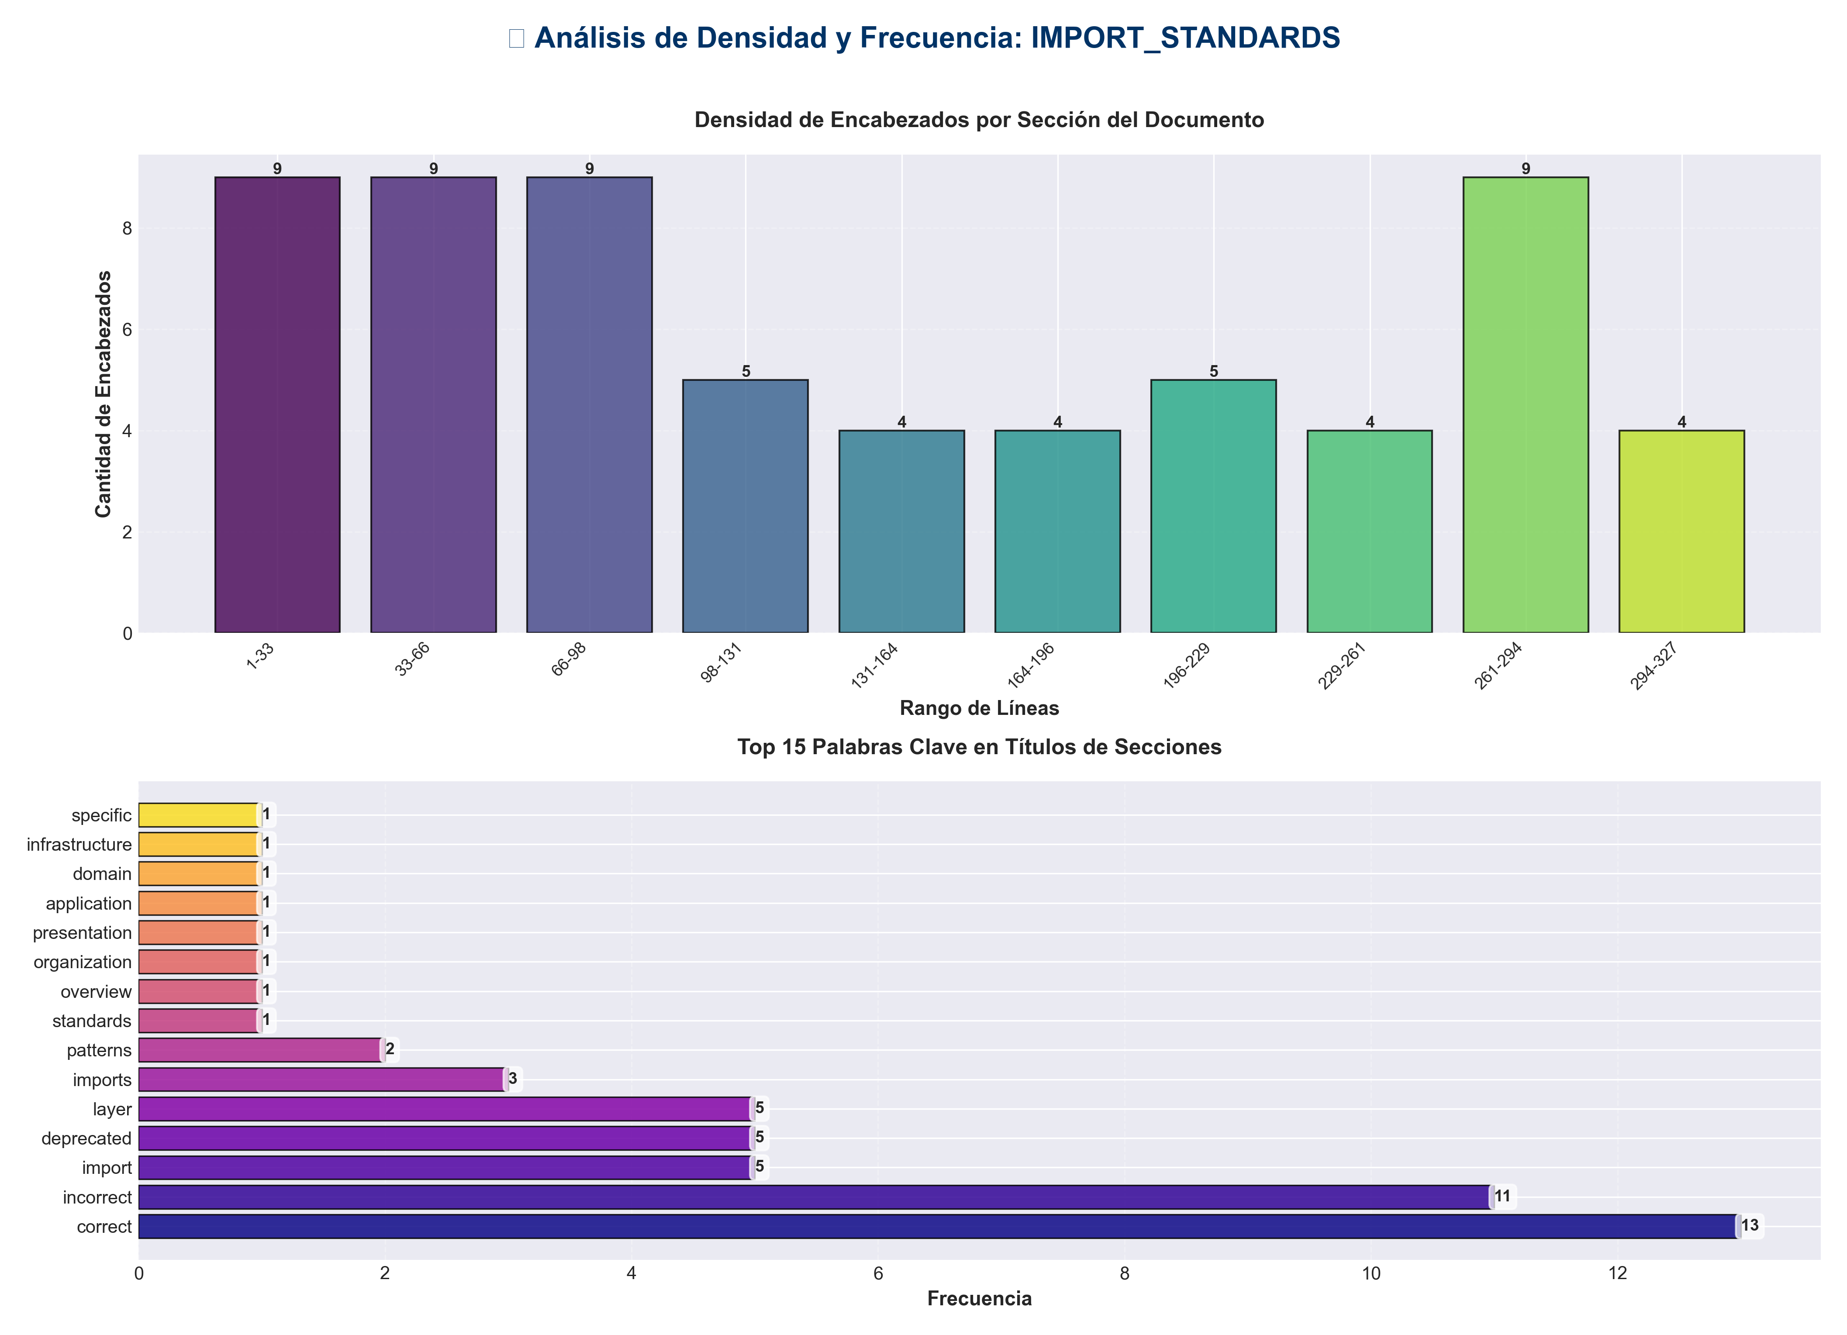

📊 Estadísticas del Documento
Resumen Ejecutivo: Este documento contiene 1,014 palabras distribuidas en 339 líneas, con 62 encabezados organizados en 42 secciones principales.

Métrica | Valor
Total de líneas | 339
Total de palabras | 1,014
Total de caracteres | 7,925
Encabezados | 62
Bloques de código | 22
Tablas | 8
Enlaces | 0
Imágenes | 0
Secciones principales | 42

📑 Índice de Secciones
Nivel | Título | Línea
1 | Import Standards | 1
2 | Overview | 8
2 | ✅ Correct Import Patterns | 14
1 | ✅ CORRECT | 18
1 | ❌ INCORRECT (deprecated) | 21
1 | ✅ CORRECT | 27
1 | ❌ INCORRECT (deprecated) | 30
1 | ✅ CORRECT | 36
1 | ❌ INCORRECT | 41
1 | ✅ CORRECT | 47
1 | ❌ INCORRECT | 51
1 | ✅ CORRECT | 57
1 | ❌ INCORRECT | 64
1 | ✅ CORRECT | 71
1 | ❌ INCORRECT (deprecated) | 75
1 | ✅ CORRECT | 81
1 | ❌ INCORRECT | 86
1 | ✅ CORRECT | 92
1 | ❌ INCORRECT | 96
2 | Import Organization | 102
0 | # Presentation Layer | 123
0 | # Application Layer | 127
0 | # Domain Layer | 130
0 | # Infrastructure Layer | 134
2 | Deprecated Imports | 140
2 | Layer-Specific Import Rules | 154
1 | ✅ CORRECT | 170
1 | ❌ INCORRECT | 175
1 | ✅ CORRECT | 192
1 | ❌ INCORRECT | 197
1 | ✅ CORRECT | 217
1 | ❌ INCORRECT | 222
1 | ✅ CORRECT | 237
2 | Common Import Patterns | 245
1 | Within api/routes/ | 268
2 | Verification | 275
1 | Find root-level imports | 279
1 | Should return no results (except in deprecated compatibility shims) | 282
1 | Run linter to check imports | 287
2 | Migration Checklist | 294
2 | Examples | 307
2 | Notes | 327

📄 Contenido

Import Standards

- **Date**: 2025-01-27
- **Status**: ✅ Enforced

- ---

Overview

This document defines the standard import paths for the production_code codebase. All imports should follow these conventions to maintain consistency and avoid import conflicts.

- ---

✅ Correct Import Patterns

API Utilities

✅ CORRECT
from api.api_utils import validate_episode_data, validate_query_data

❌ INCORRECT (deprecated)
from api_utils import validate_episode_data

Configuration Management

✅ CORRECT
from core.config_manager import ConfigManager, ModuleType, get_config_manager

❌ INCORRECT (deprecated)
from config_manager import ConfigManager

Core Utilities

✅ CORRECT
from core.utils import setup_logger
from core.api_utils import create_fastapi_app
from core.error_handling import safe_execute

❌ INCORRECT
from utils import setup_logger # If utils is at root

Services

✅ CORRECT
from services import MemoryService, PipelineService
from services.memory_service import MemoryService

❌ INCORRECT
from memory_service import MemoryService # If at root

API Components

✅ CORRECT
from api.routes import api_router, root_router
from api.routes.memory import router as memory_router
from api.dependencies import get_memory_service
from api.middleware import RequestIDMiddleware
from api.auth import OptionalAuth

❌ INCORRECT
from api_middleware import LoggingMiddleware
from api_auth import APIKeyManager

Application Factory

✅ CORRECT
from application import create_app, get_app
from application.service_container import ServiceContainer

❌ INCORRECT (deprecated)
from api_unified import app, create_api_app

Domain Modules

✅ CORRECT
from memory import create_memory_system
from redundancy import create_redundancy_suppressor
from core.paper_base import BasePaperModule

❌ INCORRECT
from memory_module import MemorySystem # If renamed

Infrastructure

✅ CORRECT
from infrastructure.providers import build_integrated_pipeline
from infrastructure.providers.pipeline_provider import build_integrated_pipeline

❌ INCORRECT
from providers import build_integrated_pipeline # If at root

- ---

Import Organization

Standard Import Order

1. **Standard Library**
import os
import sys
from pathlib import Path
from typing import Dict, List, Optional

2. **Third-Party Libraries**
from fastapi import FastAPI, HTTPException
import torch
from pydantic import BaseModel

3. **Local Application Imports (by layer)**

Presentation Layer
from api.api_utils import validate_episode_data
from api.routes import api_router

Application Layer
from services import MemoryService

Domain Layer
from core.utils import setup_logger
from memory import create_memory_system

Infrastructure Layer
from infrastructure.providers import build_integrated_pipeline

- ---

Deprecated Imports

The following import patterns are **deprecated** and should be replaced:

- ---

Layer-Specific Import Rules

Presentation Layer (`api/`, `api_*.py`, `cli*.py`)

- **Can Import From:**
- - ✅ `api/` - Other API components
- - ✅ `services/` - Application services
- - ✅ `core/` - Core utilities
- - ✅ `application/` - Application factory

- **Cannot Import From:**
- - ❌ Domain modules directly (`memory/`, `redundancy/`, etc.)
- - ❌ Infrastructure details

- **Example:**

✅ CORRECT
from api.api_utils import validate_episode_data
from services import MemoryService
from core.utils import setup_logger

❌ INCORRECT
from memory.paper_2506_15841v2 import MemoryModule # Too deep

Application Layer (`services/`, `integration_pipeline.py`)

- **Can Import From:**
- - ✅ `core/` - Core utilities
- - ✅ Domain modules (`memory/`, `redundancy/`, etc.)
- - ✅ `infrastructure/providers/` - Infrastructure factories

- **Cannot Import From:**
- - ❌ `api/` - Presentation layer
- - ❌ FastAPI/Flask directly (use services)

- **Example:**

✅ CORRECT
from core.utils import setup_logger
from memory import create_memory_system
from infrastructure.providers import build_integrated_pipeline

❌ INCORRECT
from api.routes import api_router # Presentation layer
from fastapi import FastAPI # Should use services

Domain Layer (`core/`, `memory/`, `redundancy/`, etc.)

- **Can Import From:**
- - ✅ `core/` - Core utilities
- - ✅ Other domain modules
- - ✅ Standard library
- - ✅ Third-party libraries (torch, numpy, etc.)

- **Cannot Import From:**
- - ❌ `api/` - Presentation layer
- - ❌ `services/` - Application layer
- - ❌ FastAPI/Flask - Framework dependencies

- **Example:**

✅ CORRECT
from core.paper_base import BasePaperModule
from core.utils import setup_logger
import torch

❌ INCORRECT
from api.api_utils import validate_episode_data # Presentation layer
from services import MemoryService # Application layer
from fastapi import HTTPException # Framework dependency

Infrastructure Layer (`infrastructure/`)

- **Can Import From:**
- - ✅ Domain modules
- - ✅ `core/` - Core utilities
- - ✅ External libraries (FastAPI, databases, etc.)

- **Example:**

✅ CORRECT
from core.config_manager import ConfigManager
from memory import create_memory_system
from fastapi import FastAPI

- ---

Common Import Patterns

Conditional Imports with Availability Flags
try:
from some_module import SomeClass
SOME_MODULE_AVAILABLE = True
except ImportError:
SomeClass = None
SOME_MODULE_AVAILABLE = False

Type Checking Imports
from typing import TYPE_CHECKING

if TYPE_CHECKING:
from fastapi import FastAPI
from services import MemoryService

Relative Imports (within same package)

Within api/routes/
from .memory import router as memory_router
from ..dependencies import get_memory_service

- ---

Verification

Check for Deprecated Imports

Find root-level imports

Should return no results (except in deprecated compatibility shims)

Lint Check

Run linter to check imports
ruff check . --select F401 # Unused imports
mypy . --check-untyped-defs # Type checking

- ---

Migration Checklist

When updating imports:

- - [ ] Replace root-level imports with module paths
- - [ ] Verify imports follow layer rules
- - [ ] Check for circular dependencies
- - [ ] Update tests to use new import paths
- - [ ] Run linter to verify no errors
- - [ ] Test that code still works

- ---

Examples

Before (Deprecated)
from api_utils import validate_episode_data
from config_manager import ConfigManager
from api_unified import app

After (Correct)
from api.api_utils import validate_episode_data
from core.config_manager import ConfigManager
from application import create_app

app = create_app()

- ---

Notes

- - **Backward Compatibility**: Some deprecated imports are maintained in compatibility shims (e.g., `api_utils.py`, `api_unified.py`) but emit deprecation warnings.
- - **Documentation**: Documentation files (`.md`) may show examples with deprecated imports for historical reference, but code should use correct imports.
- - **Tests**: Test files should use the same import standards as production code.

- ---

- **Last Updated**: 2025-01-27
- **Status**: ✅ Enforced

