Refactoring Quick Reference
Análisis y Documentación Completa
Generado el: 25 de November de 2025 a las 10:59

📊 Análisis Visual Completo

Dashboard Principal
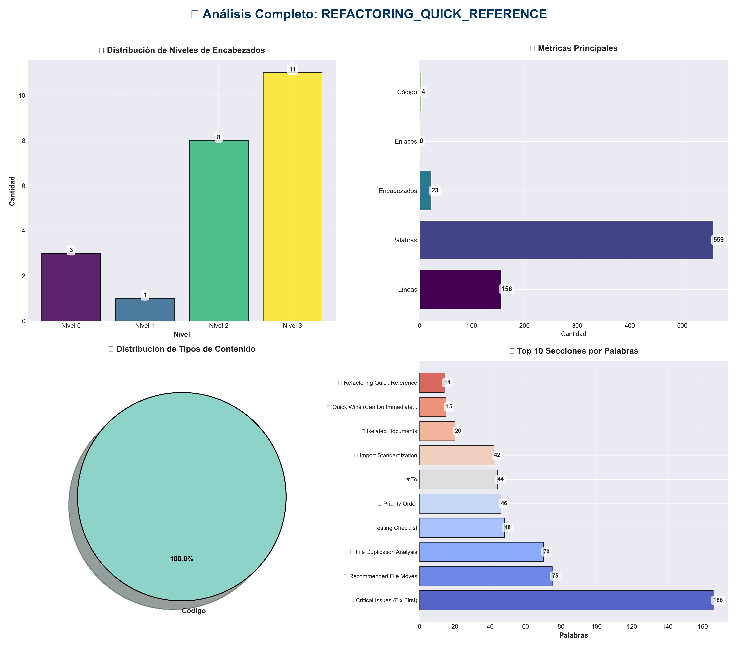

Análisis Adicionales
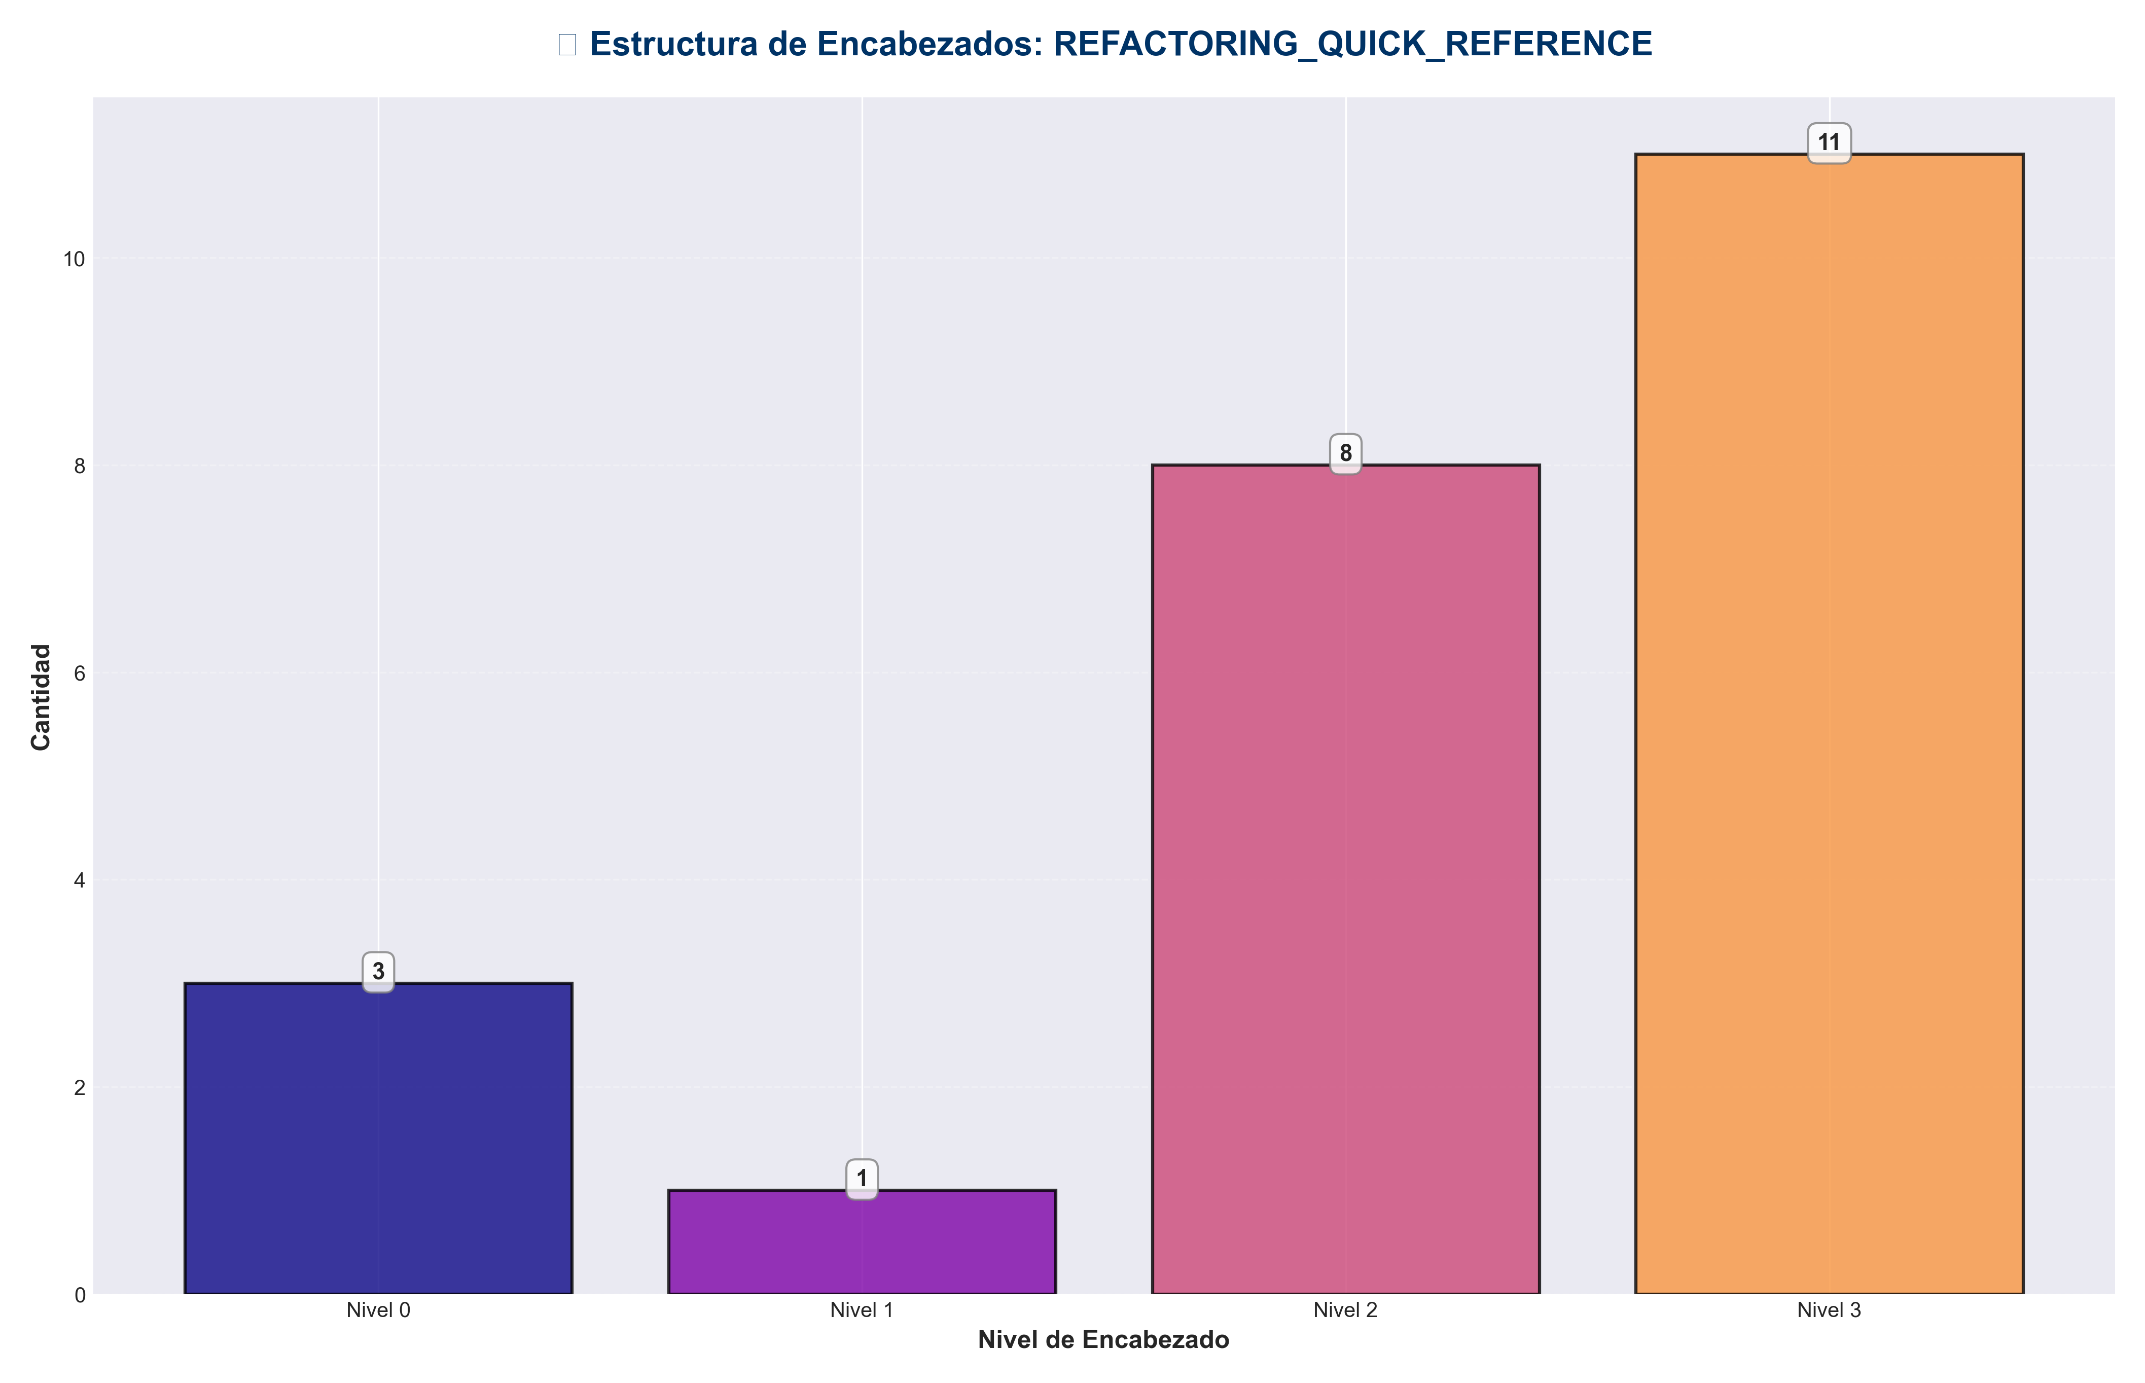

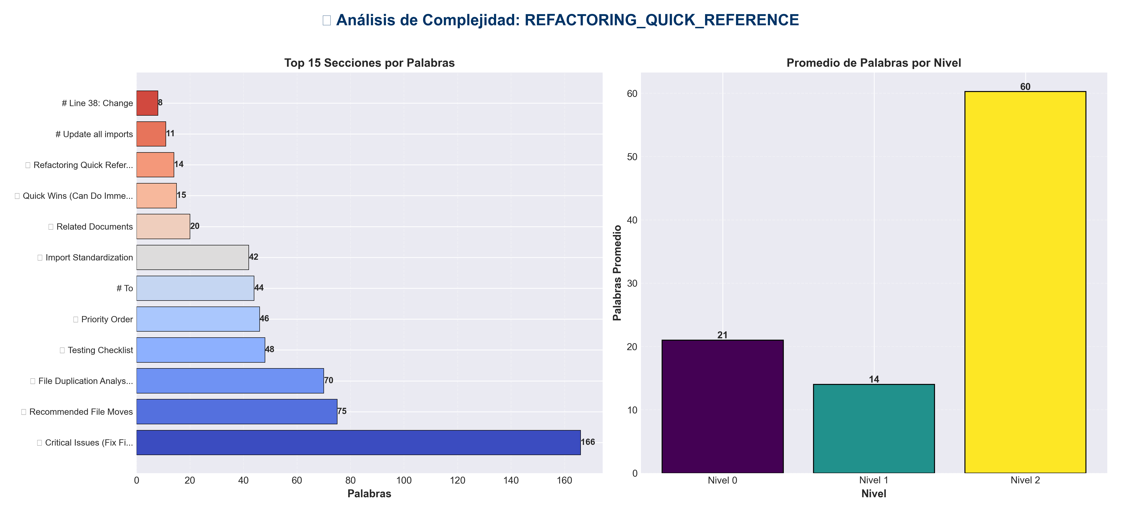

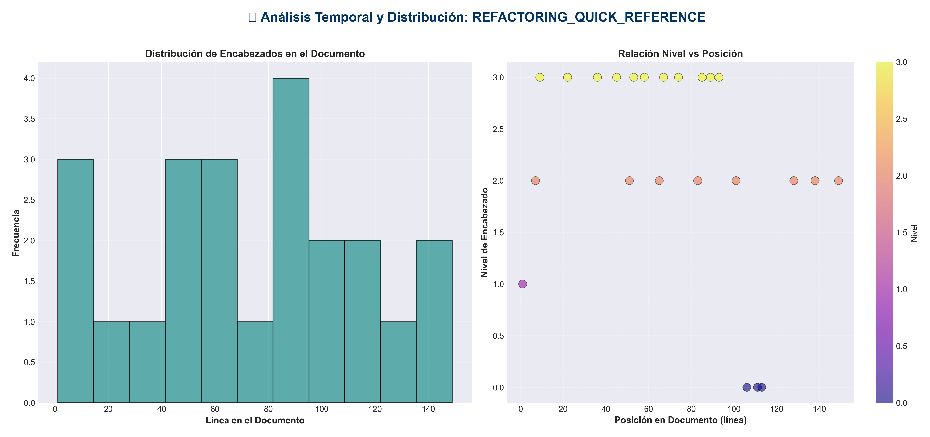

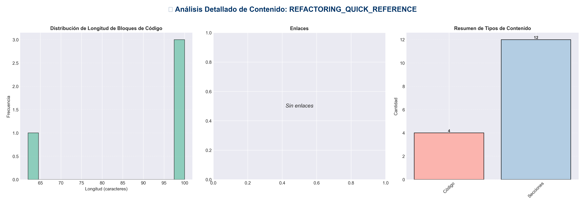

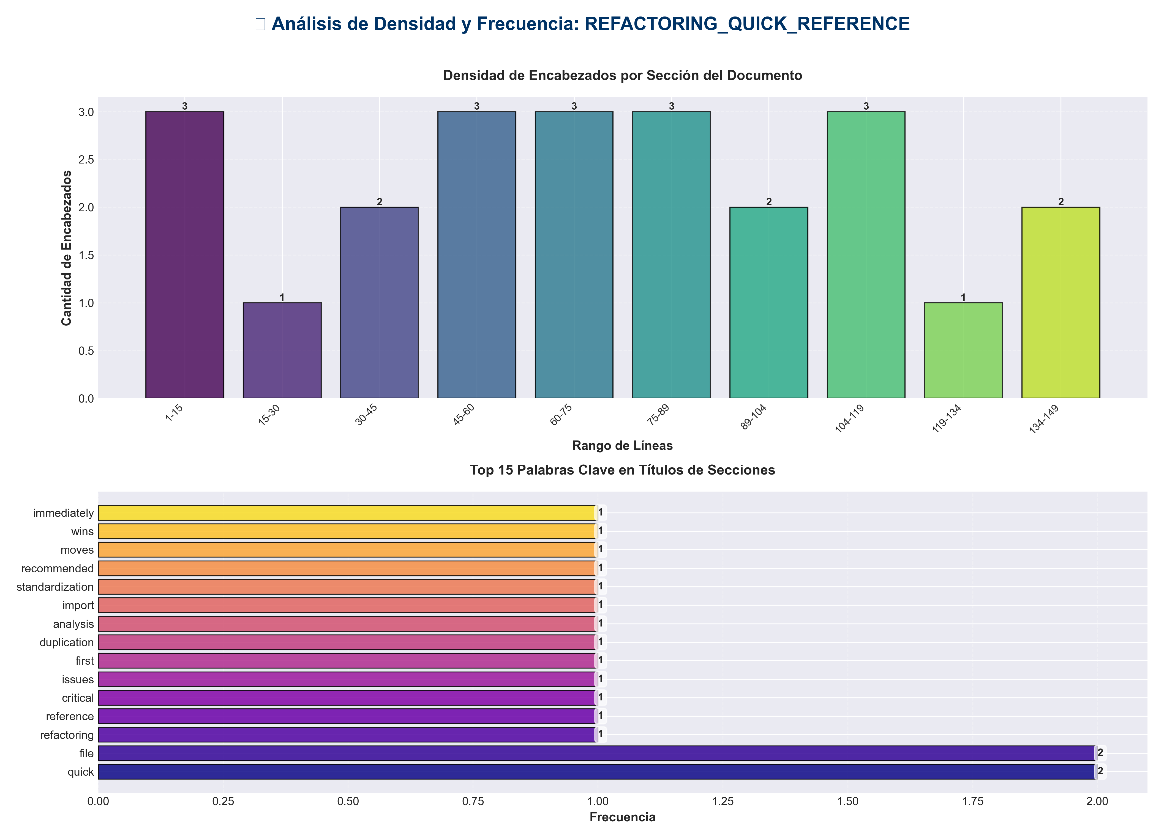

📊 Estadísticas del Documento
Resumen Ejecutivo: Este documento contiene 559 palabras distribuidas en 156 líneas, con 23 encabezados organizados en 12 secciones principales.

Métrica | Valor
Total de líneas | 156
Total de palabras | 559
Total de caracteres | 4,343
Encabezados | 23
Bloques de código | 4
Tablas | 0
Enlaces | 0
Imágenes | 0
Secciones principales | 12

📑 Índice de Secciones
Nivel | Título | Línea
1 | 🔄 Refactoring Quick Reference | 1
2 | 🚨 Critical Issues (Fix First) | 7
2 | 📋 File Duplication Analysis | 51
2 | 🔧 Import Standardization | 65
2 | 📁 Recommended File Moves | 83
2 | ✅ Quick Wins (Can Do Immediately) | 101
0 | # Update all imports | 106
0 | # Line 38: Change | 111
0 | # To | 113
2 | 🎯 Priority Order | 128
2 | 📝 Testing Checklist | 138
2 | 🔗 Related Documents | 149

📄 Contenido

🔄 Refactoring Quick Reference

- **Quick action items for refactoring the production_code directory.**

- ---

🚨 Critical Issues (Fix First)

1. Duplicate `api_utils.py` Files
- - **Root**: `api_utils.py` (268 lines) - Tensor validation
- - **Core**: `core/api_utils.py` (231 lines) - HTTP/web utilities
- - **API**: `api/api_utils.py` (180 lines) - Route validation

- **Action**: Migrate root `api_utils.py` → `api/api_utils.py`, then remove root file.

- **Files to update:**
- - `api_unified.py:38` - Change `from api_utils import` → `from api.api_utils import`
- - `tests/test_api_utils.py:13` - Update import

- ---

2. Duplicate Config Managers
- - **Root**: `config_manager.py` (521 lines)
- - **Core**: `core/config_manager.py` (exists)

- **Action**: Compare both files, consolidate into `core/config_manager.py`, update all imports.

- **Files using root config_manager:**
- - `infrastructure/providers/pipeline_provider.py:10`
- - `application/service_container.py:16`
- - `cli_unified.py:15`
- - `examples/example_config.py:9`

- ---

3. API Entry Points Confusion
- - **Old**: `api_unified.py` (1237 lines) - Doesn't use new `api/routes/` structure
- - **New**: `application.py` (122 lines) - Uses layered architecture
- - **Wrapper**: `api_server.py` (53 lines) - Uses `application.py`

- **Action**: Migrate `api_unified.py` endpoints to `api/routes/`, deprecate `api_unified.py`.

- ---

4. Directory Naming Conflict
- - **Issue**: `code/` conflicts with Python built-in `code` module
- - **Action**: Rename `code/` → `code_modules/`

- ---

📋 File Duplication Analysis

Auth Files (Different - Keep Both)
- - `api/auth.py` - Simple OptionalAuth (176 lines)
- - `api_auth.py` - Full APIKeyManager (313 lines)
- - **Decision**: Keep both, but move `api_auth.py` → `api/auth_advanced.py` or consolidate

Middleware Files (Overlapping - Consolidate)
- - `api/middleware.py` - RequestID, Logging, ErrorHandling (110 lines)
- - `api_middleware.py` - Logging, ErrorHandling, Monitoring (158 lines)
- - **Decision**: Merge `api_middleware.py` functionality into `api/middleware.py`, remove root file

- ---

🔧 Import Standardization

Current (Incorrect)
from api_utils import validate_episode_data
from config_manager import ConfigManager
from api_auth import APIKeyManager

Target (Correct)
from api.api_utils import validate_episode_data
from core.config_manager import ConfigManager
from api.auth_advanced import APIKeyManager # or consolidate

- ---

📁 Recommended File Moves

To `api/` (Presentation Layer)
- - `api_auth.py` → `api/auth_advanced.py` (or merge with `api/auth.py`)
- - `api_middleware.py` → Merge into `api/middleware.py`

To `services/` (Application Layer)
- - Keep `integration_pipeline.py` at root (or move to `services/`)
- - Keep `monitoring_system.py` at root (or move to `services/`)

Keep at Root
- - `api_server.py` - Entry point
- - `application.py` - App factory
- - `cli.py`, `cli_unified.py` - CLI entry points
- - `chat_server.py` - Chat entry point

- ---

✅ Quick Wins (Can Do Immediately)

1. **Rename `code/` directory**
mv code code_modules

Update all imports

2. **Update imports in `api_unified.py`**

Line 38: Change
from api_utils import ...

To
from api.api_utils import ...

3. **Merge middleware files**
- - Copy unique functionality from `api_middleware.py` to `api/middleware.py`
- - Remove `api_middleware.py`
- - Update imports

4. **Standardize config_manager imports**
- - Check if `core/config_manager.py` has all functionality
- - Update all root imports to `core.config_manager`

- ---

🎯 Priority Order

1. **Phase 1**: Fix import paths (low risk, high impact)
2. **Phase 2**: Consolidate duplicate files (medium risk)
3. **Phase 3**: Migrate API structure (higher risk, needs testing)
4. **Phase 4**: Directory reorganization (low risk)
5. **Phase 5**: Architecture verification (validation)

- ---

📝 Testing Checklist

After each change:
- - [ ] Run `python -m pytest tests/`
- - [ ] Check imports: `python -c "import <module>"`
- - [ ] Run linter: `ruff check .`
- - [ ] Verify no circular imports
- - [ ] Test API endpoints (if changed)

- ---

🔗 Related Documents

- - `REFACTORING_PLAN.md` - Detailed refactoring plan
- - `ARCHITECTURE.md` - Layered architecture
- - `docs/architecture/layers.md` - Layer rules

