Sankore Document Web Publication Specification

Table of Contents

Sankore Document Web Publication Specification 1
Goal 3
Publication of a document on the Web 3
HTTP transactions 6

Goal
The goal of this document is to describes the web publication of a Sankore document within Sankore. This document will show how the user will interact with Sankore in order to publish the active document on Planet Sankore. The different steps will be explained, as well as the HTTP messages that will be exchanged between the application and the server.

Publication of a document on the Web
In order the active Sankore document on Planet Sankore, the user must open the Documents view:

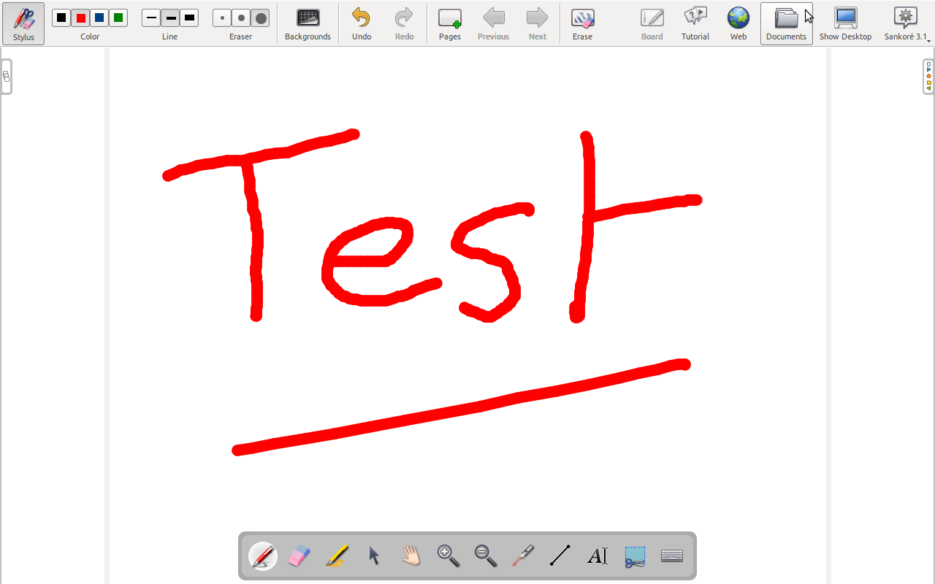

At this moment, the list of existing documents will appear on the screen. The user will have to choose “Publish document on Sankore Web” in the Export menu:

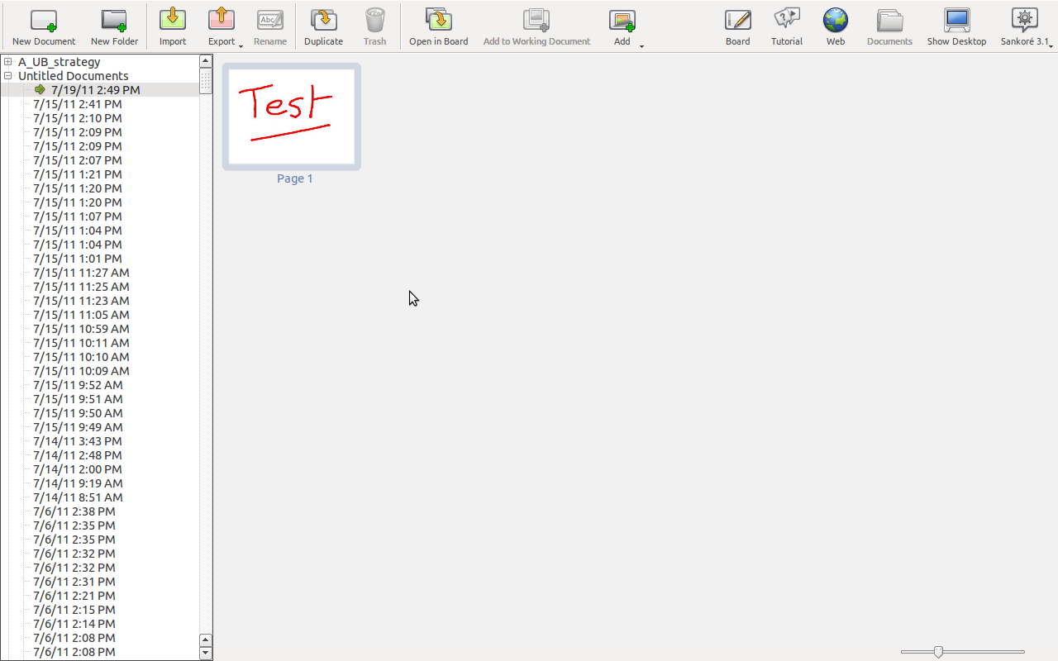

Then a dialog box will appear on the screen, asking the user to enter this informations:
- Document title
- Document description

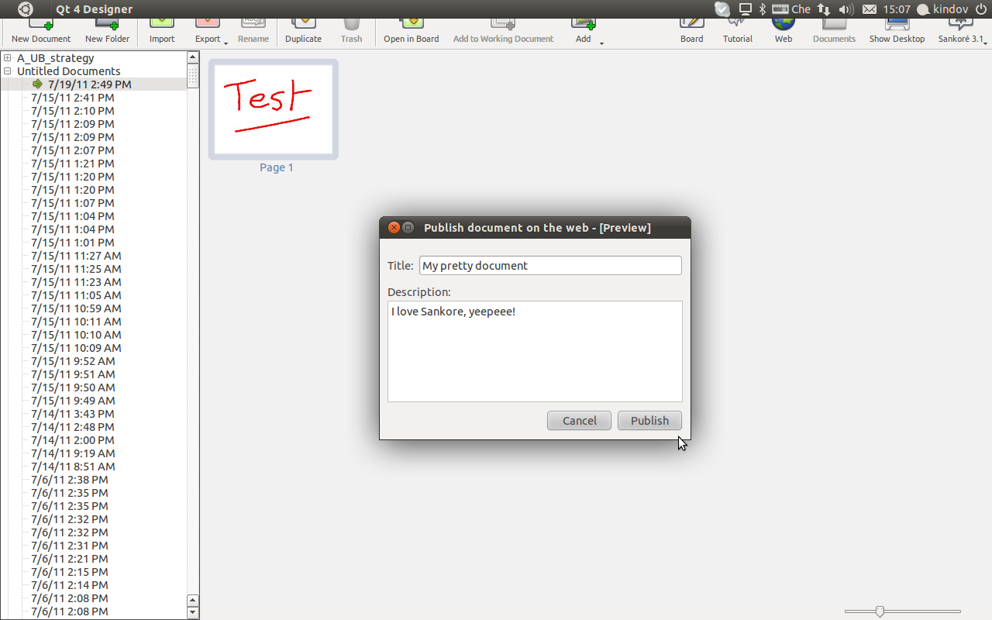
All the fields must be filled in otherwise the user will not be able to click on the “Publish” button. Once the publish button is clicked, the document will be sent on Planet Sankore. An information will come back from the server to inform the user that the document has been well published or not. If the document has been well published, an email will be sent to the user. The email will contain a link to a page that will be used to fill in the document metadata. This last part will be done outside of Sankore. Finally, the document, as well as the metadata will be reviewed and the document will be available on Planet Sankore.

HTTP transactions
This section will cover the HTTP transaction required to publish a document on Planet Sankore. Basically, two transactions will be done:
- Login
- Document transfer

Sankore

Server
(XWiki)

