Mask Specification

Table of Contents

Mask Specification 1
Goal 3
Setting the mask 3

Goal
The goal of this document is to describes the mask tool. This tool will be a native widget available from the library palette. When the user will add this widget to the board, the screen will become black and the user will be able to move a shaped hole in order to see what is behind the mask. The size and the shape of this hole can be customized.

Setting the mask
The mask will be selected in the Library palette:
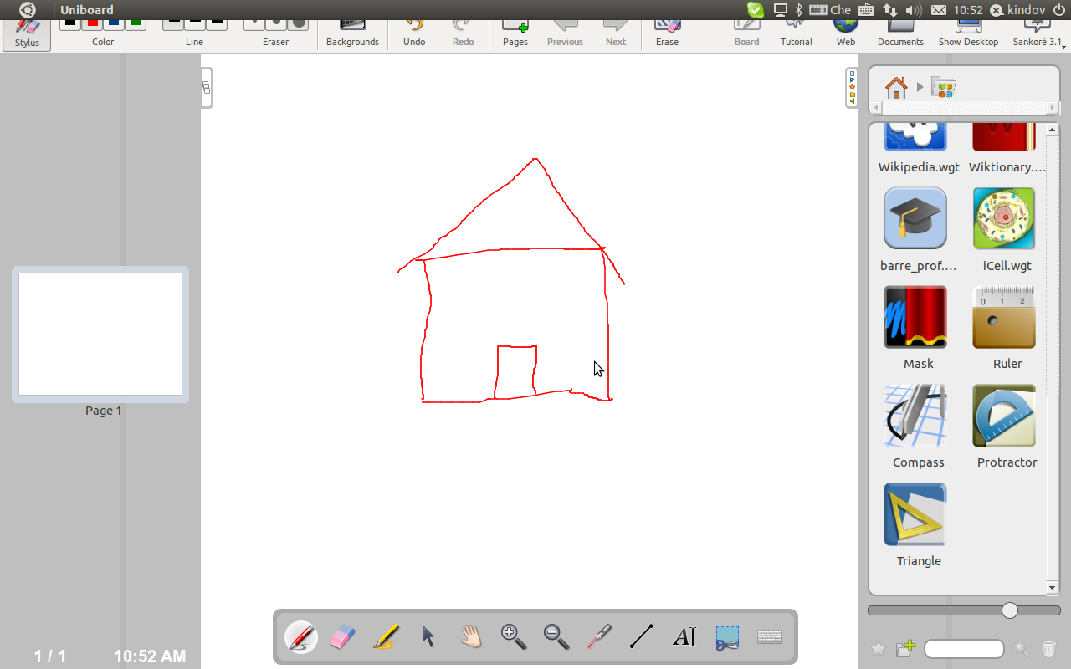
When this application is added to the board, the mask will cover all the screen and a shaped hole will be present at the mouse position when a click is done.

The size of the shape can be modified by using the slider located in the property palette, as well as its shape. A button will also be present in this palette to allow the user to quit this mode.

