Chapter 20

Tilings

chapter Objectives
Check off these skills when you feel that you have mastered them.
 Calculate the number of degrees in each angle of a given regular polygon.
c Given the number of degrees in each angle of a regular polygon, determine its number of sides.
c Define the term tiling (tessellation).
c List the three regular polygons for which a monohedral tiling exists.
c When given a mix of regular polygons, determine whether a tiling of these polygons could exist.
c Explain the difference between a periodic and a nonperiodic tiling.
c Discuss the importance of the Penrose tiles.
c Explain why fivefold symmetry in a crystal structure was thought to be impossible.
Guided Reading
Introduction
We examine some traditional and modern ideas about tiling (tessellation), the covering of an area or region of a surface with specified shapes. The beauty and complexity of such designs come from the interesting nature of the shapes themselves, the repetition of those shapes, and the symmetry or asymmetry of arrangement of the shapes.
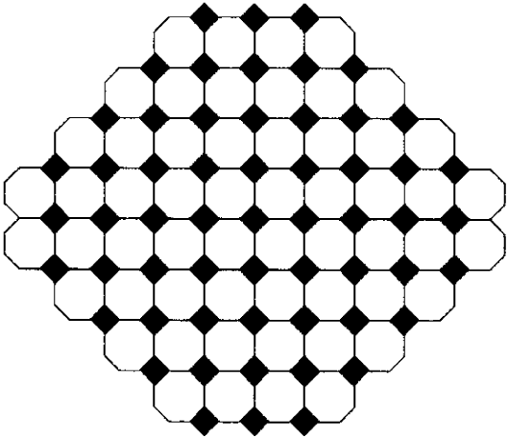

Section 20.1 Tilings with Regular Polygons

 Key idea
A tiling is monohedral if all the tiles are the same shape and size; the tiling would consist of repetitions of one figure laid down next to each other.
 Example A
Sketch an example of a monohedral tiling using a hexagon.
Solution
The answer is: There are many kinds of hexagonal tilings; here is one example.
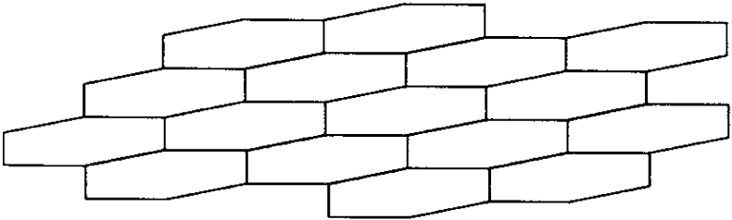

 Key idea
A tiling of the plane is a covering of that flat surface with non-overlapping figures.
 Example B
a) Draw a sketch that shows how to tile the plane with squares of two different sizes.
b) Can you do the same thing with circles?
Solution
a) The squares must fit together without spaces or overlaps. Here is a way to do it; there are many others.
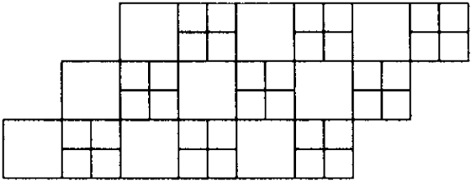
b) There is no way to fit circles together without overlapping or leaving spaces.
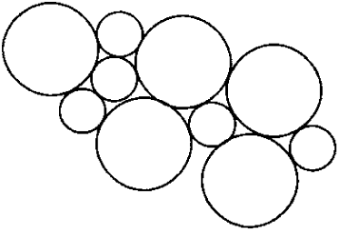

 Key idea
In an edge-to-edge tiling, the interior angles at any vertex add up to 360°. An example is the following.
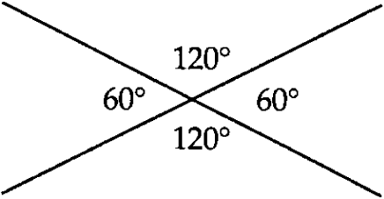

 Key idea
A regular tiling uses one tile, which is a regular polygon. Here are only three possible regular tilings.
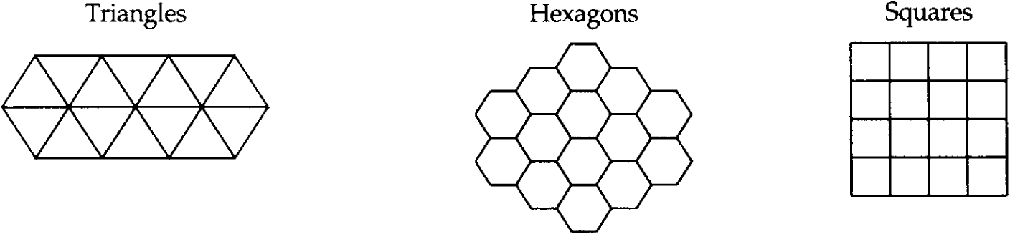
 Example C
Explain why a regular edge-to-edge tiling using octagons is impossible.
Solution
A regular tiling using a polygon with n sides is impossible if n > 6. This is because the interior angle A, shown below for hexagons and octagons, would be larger than 120° (the angle for a hexagon), so three angles would not fit around a vertex, as it does in the hexagonal tiling.
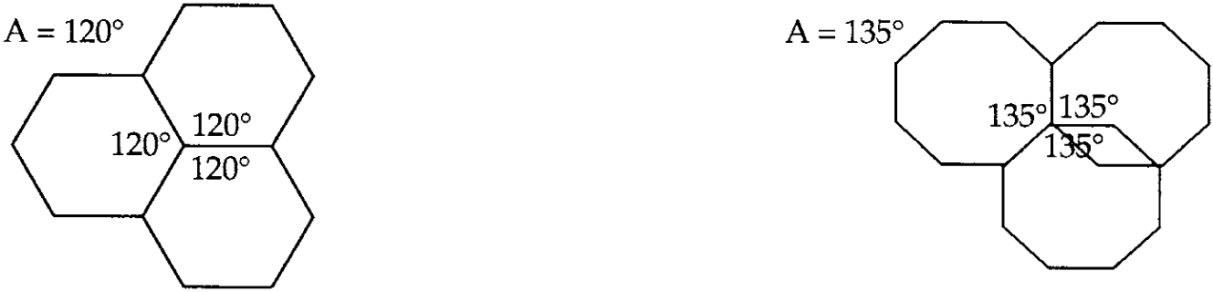

 Key idea
There are eight additional semi-regular tilings, using a mix of regular polygons with different numbers of sides.
 Question 1
What is the measure of each interior and exterior angle of
a) a regular quadrilateral?
b) a regular pentagon?
c) a regular dodecagon (12 sides)?
Answer
a) 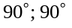
b) 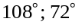
c) 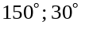

Section 20.2 Tilings with Irregular Polygons

 Key idea
It is easy to adapt the square tiling into a monohedral tiling using a parallelogram. Since two triangles together form a parallelogram, any triangle can tile the plane.
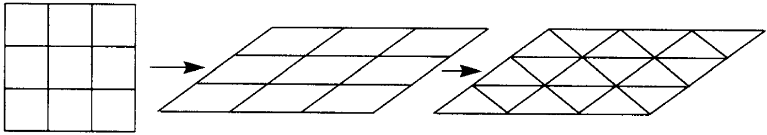

 Key idea
Any quadrilateral (four-sided figure), even one that is not convex, can tile the plane. A figure is convex if any two points on the figure (including the boundary) can be connected and the line segment formed does not go out of the figure.
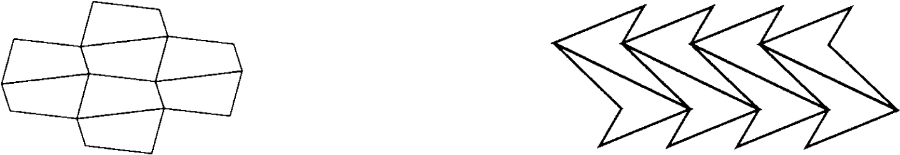
Also, any triangle can tile the plane. A scalene triangle has no two sides the same measure.
 Example D
Draw a tiling of the plane with the following figure.
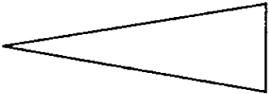
Solution
Here is an edge-to-edge tiling with the given triangle, and another one which is not edge-to-edge.
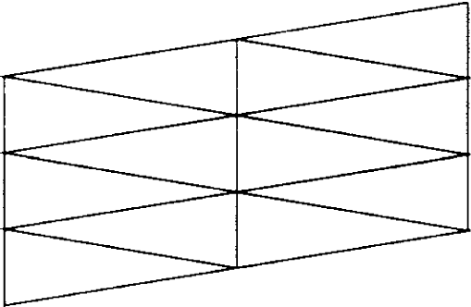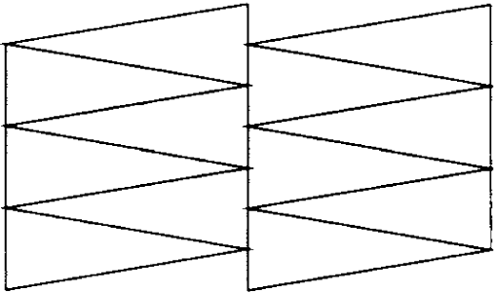
 Example E
Draw a tiling of the plane with the following figure.
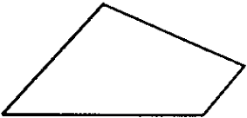
Solution
Two copies of the quadrilateral, one of which is rotated by 180°, fit together to form a parallelogram, thus forming an easy tiling.
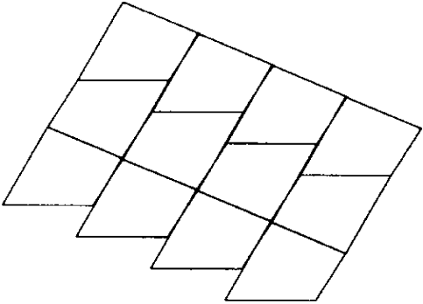

 Key idea
Only certain classes of convex pentagons and hexagons can be used to tile the plane. There are exactly three classes of convex hexagons that can tile a plane. A convex polygon with seven or more sides cannot tile the plane.

 Key idea
The work of artist M. C. Escher, famous for his prints of interlocking animals, demonstrates an intimate link between art and mathematics.
Section 20.3 Using Translations

 Key idea
The simplest way to create an Escher-like tiling is through the use of translation. The boundary of each tile must be divisible into matching pairs of opposing parts that interlock.

 Key idea
A single tile can be duplicated and used to tile by translation in two directions if certain opposite parts of the edge match each other.
Examples:
These two are based on a parallelogram tiling.
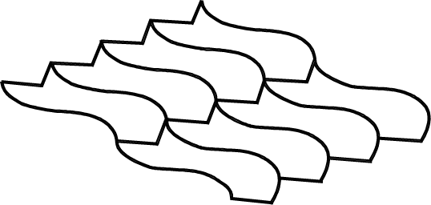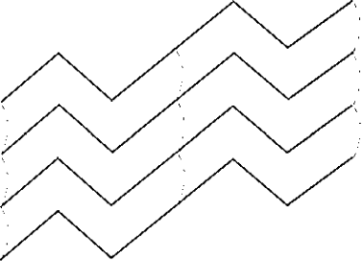
This one is based on a hexagon tiling.
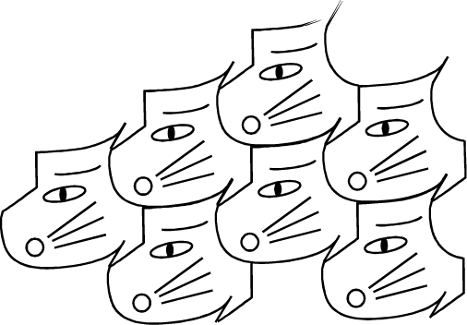
 Example F
a) Draw a square, replace opposite sides with congruent curved edges, and draw a tiling by translation with the resulting figure.
b) Can you do the same thing with a triangle?
Solution
The answer is:
a) Translating horizontally and vertically, opposite sides match up. Here is an illustration of the process for a square-based tile.
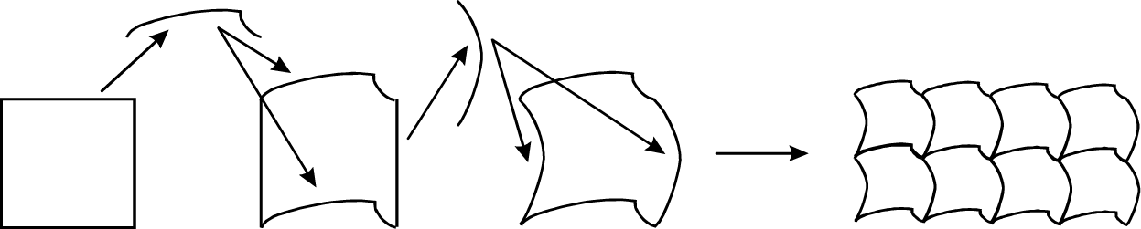
b) You cannot pair up “opposite” sides in a triangle, or any polygon with an odd number of sides. This cannot be done.

Section 20.4 Using Translations Plus Half-Turns

 Key idea
If you replace certain sides of a polygon with matching centrosymmetric segments, it may be possible to use the resulting figure to tile the plane by translations and half-turns. The Conway criterion can be used to decide if it is possible. The Conway criterion is given on page 770 of your text.
 Example G
Start with the following triangle.
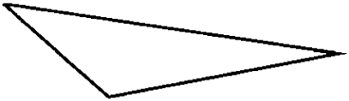
Replace the two long sides with centrosymmetric curves and sketch a tiling by translations and half-turns.
Solution
The answer is: This shows the process and the resulting tiling:
Here are the new sides. This is the tile.
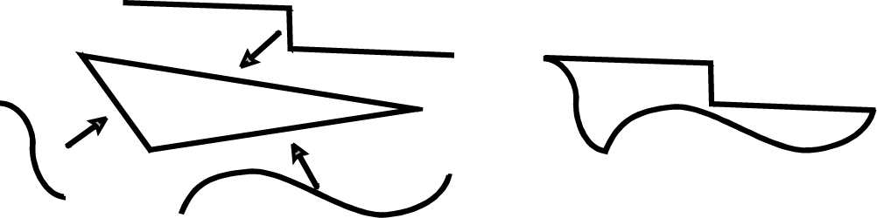
Here is the tiling.
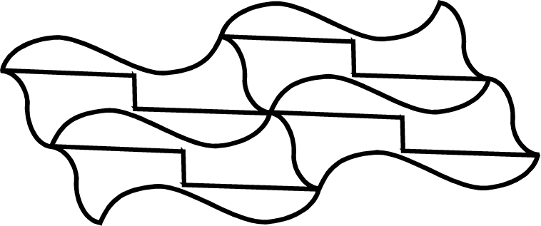

 Key idea
Many fascinating and beautiful examples of these principles are found in the designs of the renowned graphic artist M. C. Escher.

 Key idea
Periodic tilings have a fundamental region that is repeated by translation at regular intervals.

 Key idea
A fundamental region consists of a tile, or block of tiles, with which you can tile a plane using translations at regular intervals.
 Question 2
Are there two fundamental regions for this tiling?
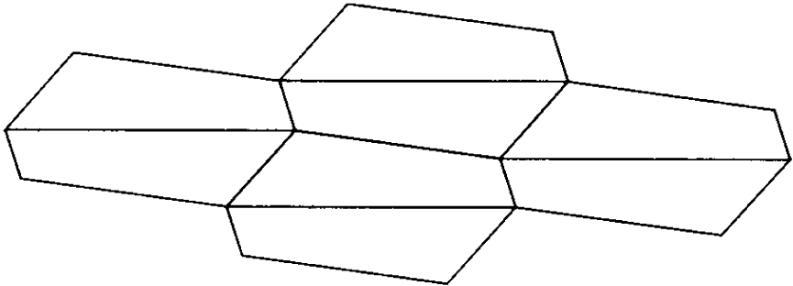
Answer
yes

Section 20.5 Nonperiodic Tilings

 Key idea
A tiling may be nonperiodic because the shape of the tiles varies, or the repetition of the pattern by translation varies. The Penrose tiles are an important example of a set of two tiles which can be used only to tile the plane nonperiodically.

 Key idea
Penrose tilings exhibit the following properties: self-similarity (inflation and deflation), the golden ratio (quasiperiodic repetition in that proportion), and partial five-fold rotational symmetry.

 Key idea
Applying principles of tiling to three dimensional crystals, Barlow’s law states that a crystal cannot have more than one center of fivefold rotational symmetry.
 Example I
What chemical crystal exhibits strict fivefold symmetry?
Solution
Crystals are periodic three-dimensional objects, and it follows from Barlow’s law that truly periodic patterns can only have twofold, threefold, fourfold, or sixfold symmetry. The answer is none; certain quasicrystals exhibit limited fivefold symmetry.
Homework Help
Exercises 1 – 10
Carefully read Section 20.1 before responding to these exercises.
Exercises 11 – 12
Carefully read Section 20.2 before responding to these exercises.
Exercises 13 – 26
Carefully read Section 20.3 before responding to these exercises.
Exercises 27 – 38
Carefully read Section 20.4 before responding to these exercises.
Exercises 39 – 50
Carefully read Section 20.5 before responding to these exercises.

Do You Know the Terms?

Cut out the following 24 flashcards to test yourself on Review Vocabulary. You can also find these flashcards at http://www.whfreeman.com/fapp7e.

Chapter 20  Tilings  Barlow’s law, or the crystallographic restriction | Chapter 20  Tilings  Centrosymmetric
Chapter 20  Tilings  Convex | Chapter 20  Tilings  Conway criterion
Chapter 20  Tilings  Edge-to-edge tiling | Chapter 20  Tilings  Equilateral triangle
Chapter 20  Tilings  Exterior angle | Chapter 20  Tilings  Fundamental region

Symmetric by 180° rotation around its center. | A law of crystallography that states that a crystal may have only rotational symmetries that are twofold, threefold, fourfold, or sixfold.
A criterion for determining whether a shape can tile by means of translations and half-turns. | A geometric figure is this if for any two points on the figure (including its boundary), all the points on the line segment joining them also belong to the figure (including its boundary).
A triangle with all three sides equal. | A tiling in which adjacent tiles meet only along full edges of each tile.
A tile or group of adjacent tiles that can tile by translation. | The angle outside a polygon formed by one side and the extension of an adjacent side.

Chapter 20  Tilings  Interior angle | Chapter 20  Tilings  Monohedral tiling
Chapter 20  Tilings  n-gon | Chapter 20  Tilings  Nonperiodic tiling
Chapter 20  Tilings  Parallelogram | Chapter 20  Tilings  Par-hexagon
Chapter 20  Tilings  Periodic tiling | Chapter 20  Tilings  Quadrilateral

A tiling with only one size and shape of tile (the tile is allowed to occur also in “turned-over,” or mirror-image, form). | The angle inside a polygon formed by two adjacent sides.
A tiling in which there is no repetition of the pattern by translation. | A polygon with n sides.
A hexagon whose opposite sides are equal and parallel. | A convex quadrilateral whose opposite sides are equal and parallel.
A polygon with four sides. | A tiling that repeats at fixed intervals in two different directions, possibly horizontal and vertical.

Chapter 20  Tilings  Regular polygon | Chapter 20  Tilings  Regular tiling
Chapter 20  Tilings  Rhombus | Chapter 20  Tilings  Scalene triangle
Chapter 20  Tilings  Semiregular tiling | Chapter 20  Tilings  Tiling
Chapter 20  Tilings  Translation | Chapter 20  Tilings  Vertex figure

A tiling by regular polygons, all of which have the same number of sides and are the same size; also, at each vertex, the same kinds of polygons must meet in the same order. | A polygon all of whose sides and angles are equal.
A triangle no two sides of which are equal. | A parallelogram all of whose sides are equal.
A covering of the plane without gaps or overlaps. | A tiling by regular polygons; all polygons with the same number of sides must be the same size.
The pattern of polygons surrounding a vertex in a tiling. | A rigid motion that moves everything a certain distance in one direction.

Practice Quiz
1. What is the measure of the exterior angle of a regular decagon?
a. 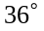
b. 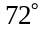
c.
2. Which of the following polygons will tile the plane?
a. regular pentagon
b. scalene triangle
c. regular octagon
3. A semi-regular tiling is made with two dodecagons and another polygon at each vertex. Use measures of interior angles to determine which other polygon is required.
a. triangle
b. square
c. hexagon
4. Squares and triangles can be used to form a semi-regular tiling of the plane. How many of each figure is needed?
a. 2 triangles, 3 squares
b. 4 triangles, 1 square
c. 3 triangles, 2 squares
5. Are Penrose Tilings non-periodic?
a. not enough information
b. no
c. yes
6. Which of the following is true?
I I: Only convex polygons will tile the plane.
II: Any quadrilateral will tile the plane.
a. Only I is true.
b. Only II is true.
c. Both I and II are true.
7. Which of the following is true?
II. It is possible to tile the plane with a square using translations.
II. It is possible to tile the plane with a square using half turns.
a. I only
b. II only
c. both I and II
8. Can the tile below be used to tile the plane?
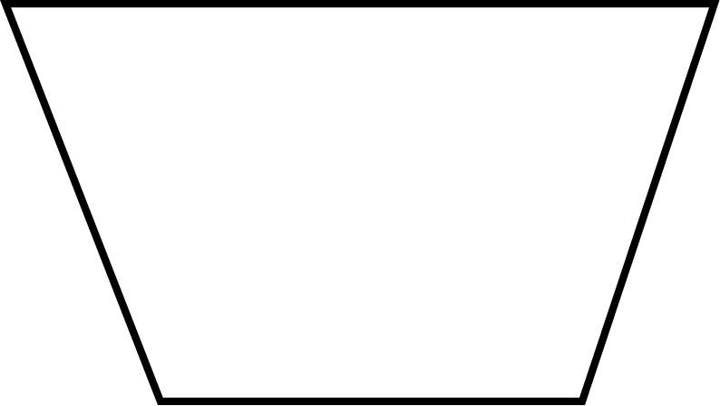
a. Yes, using only translations
b. Yes, using translations and half turns
c. No
9. The Penrose tilings use two different figures with how many sides?
a. 3 and 5
b. 4 and 4
c. 5 and 5
10. Which polygon can be altered to form an Escher-type tiling by translation only?
a. equilateral triangle
b. any convex quadrilateral
c. regular hexagon

Word Search
Refer to pages 783 – 784 of your text to obtain the Review Vocabulary. There are 25 hidden vocabulary words/expressions in the word search below. Both Barlow’s law and Crystallographic restriction appear in the word search. Also, Periodic tiling appears separately from Nonperiodic tiling, as do Regular tiling and Semiregular tiling. It should be noted that spaces and hyphens are removed as well as apostrophes. There is additional space on the back of this page for vocabulary words/expressions.
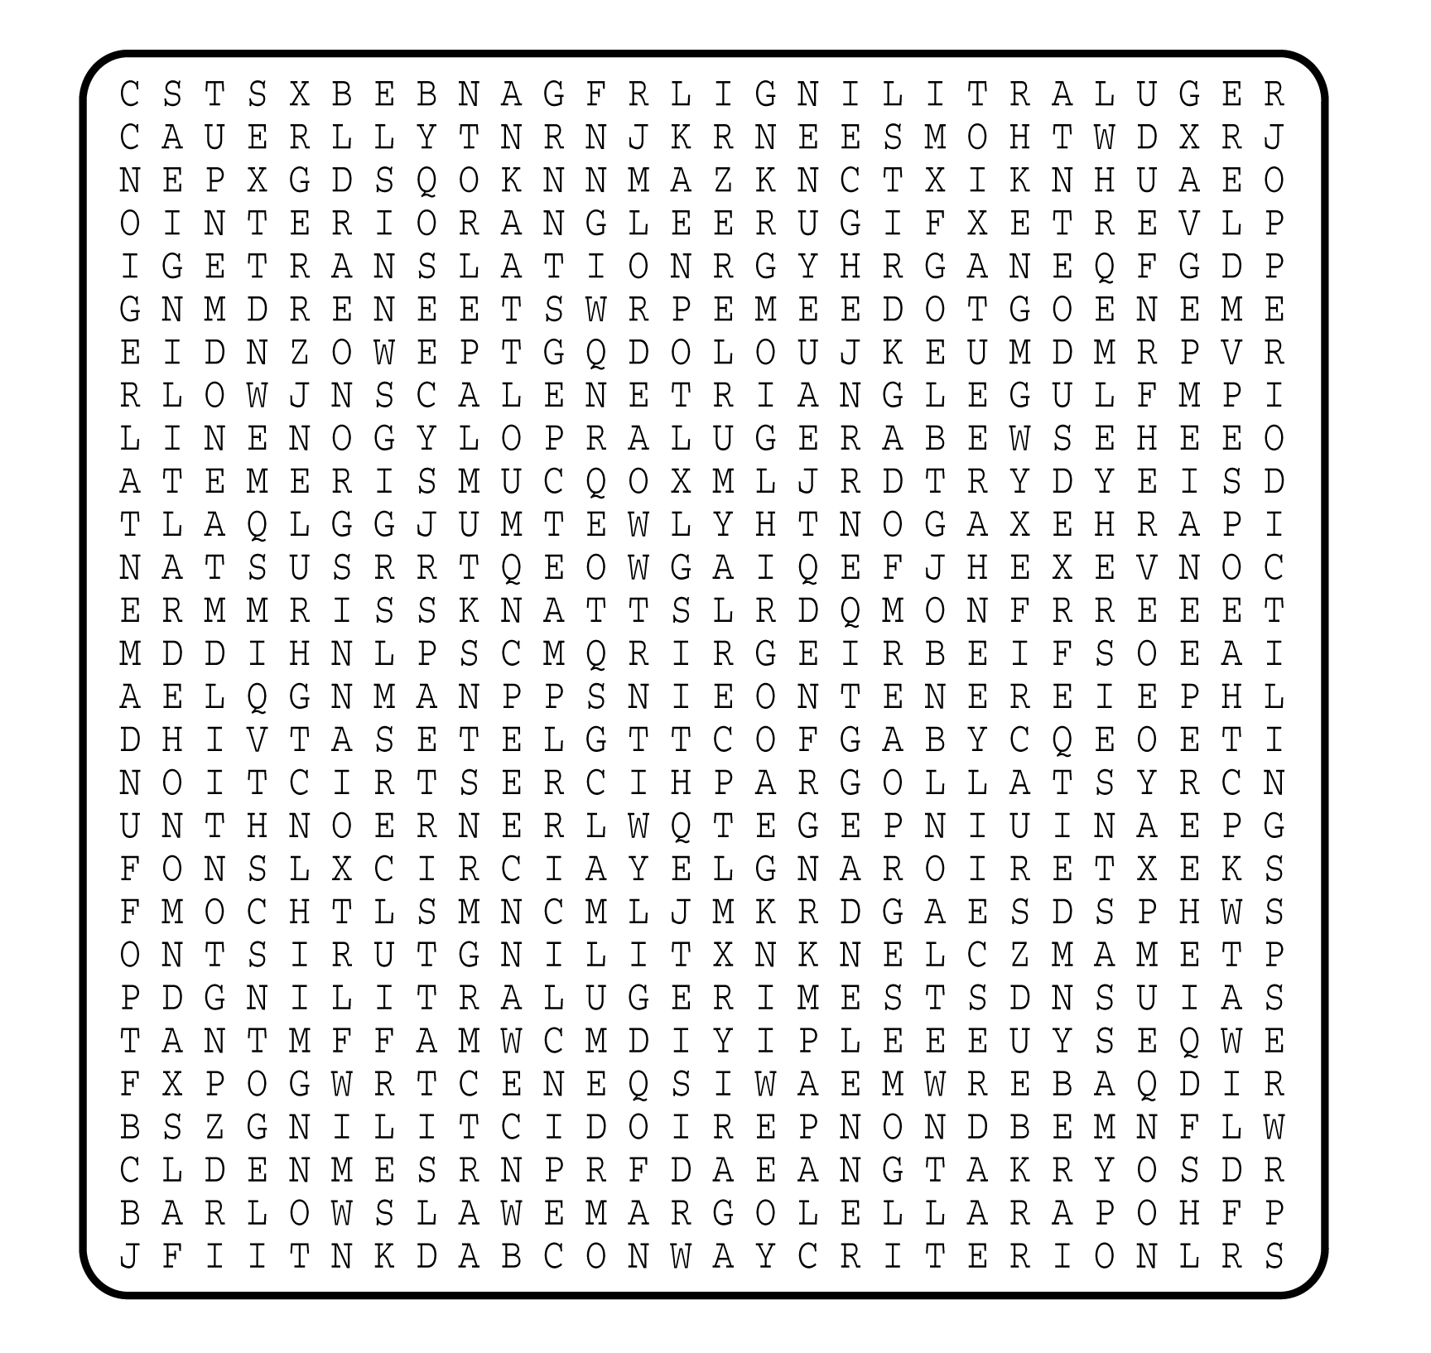

1. __________________________
2. __________________________
3. __________________________
4. __________________________
5. __________________________
6. __________________________
7. __________________________
8. __________________________
9. __________________________
10. __________________________
11. __________________________
12. __________________________
13. __________________________
14. __________________________
15. __________________________
16. __________________________
17. __________________________
18. __________________________
19. __________________________
20. __________________________
21. __________________________
22. __________________________
23. __________________________
24. __________________________
25. __________________________

