

**StateCU Documentation**

**StateCU Interface Version 7.1  
StateCU FORTRAN Version 13.10**

**July 2012**

# **StateCU Documentation**

The following sections are available in this documentation:

0.0 Disclaimer

1. Acknowledgment
2. Introduction
3. Graphical User Interface
4. Model Description
5. Input Description
6. Output Description
7. Model Operation
8. Frequently Asked Questions
9. Supporting Utilities

Appendix A – Example Files

Appendix B – StateCU Program Flow Charts and Subroutines

## 0.0 Disclaimer

This program is furnished by The State of Colorado (State) and is accepted and used by the recipient upon the expressed understanding that the State makes no warranties, express or implied, concerning the accuracy, completeness, reliability, usability, or suitability for any particular purpose of the information and data contained in this program or furnished in connection therewith, and the State shall be under no liability whatsoever to any person by reason of any use made thereof.

The program herein belongs to the State of Colorado. Therefore, the recipient further agrees not to assert any proprietary rights therein or to further represent this program to anyone as other than a State program.

## 1.0 Acknowledgment

The Blaney-Criddle implementation for StateCU was based on several subroutines of the USBR XCONS2 program. Since the USBR program also adopts the SCS Blaney-Criddle procedure, it was felt that it would be unnecessary to rewrite the source code. However, most of the subroutines were modified by the Integrated Decision Support Group (IDS) at Colorado State University to conform with a modular programming structure and the efficient use of global and local variables. The routines for the Penman-Monteith calculations were developed by IDS using equations outlined in the ASCE Manual No. 70 Evapotranspiration and Irrigation Water Requirements. The ASCE Standardized Penman-Monteith calculations were developed based on the ASCE Standardization of Reference Evapotranspiration Task Committee. The Modified Hargreaves equations used in the model were developed by Agro Engineering, Inc. Additional enhancements including water-supply limited consumptive use analyses, estimates of ground water use, the Graphical Use Interface, and StateCU Wizard were made by Leonard Rice Engineers, Inc. (LRE).

## 2.0 Introduction

The State of Colorado's Consumptive Use Model (StateCU) was developed to estimate and report crop consumptive use within the state. It consists of a FORTRAN-based computer program and an associated graphical user interface. The crop consumptive use methods employed in the program and the interface are the Modified Blaney-Criddle, the Original Blaney-Criddle, and the Pochop (for bluegrass only) methods with calculations on a monthly basis and the ASCE Standardized Penman-Monteith method with calculations on a daily basis. Other crop consumptive use methods available when the FORTRAN program is operated independently of the interface include the Penman-Monteith and the Modified Hargreaves methods, operated on a daily time step.

This document was prepared to explain the features and functions of StateCU and presumes the reader has a basic understanding of consumptive use analyses. It is intended for use by engineers, water resource planners, and others involved in water management decision making. Sections 3 and 4 provide a general description of the model and the necessary instruction to operate StateCU through the graphical user interface. Sections 5 through Appendix B provide the detail required to develop datasets and determine consumptive use estimates for a specific area.

StateCU allows several levels of analysis as follows:

* Crop Irrigation Water Requirement by CU Location
* Water Supply Limited Crop Consumptive Use by Structure
* Water Supply Limited Crop Consumptive Use by Structure Considering Ground Water
* Water Supply Limited Crop Consumptive Use by Structure and Priority

StateCU determines crop CU by ‘CU Location’. A CU Location can be a climate station, a specific diversion structure, a combination of diversion structures, or specific area of land. A CU Location is defined by latitude, associated climate stations, crop types, and acreage. A flag in the input control file specifies whether the CU Location is associated with a climate station or structure. The only analyses available with a *Climate Station Scenario* are the potential crop consumptive use and irrigation water requirement, as reflected by a simplified set of input screens displayed by the graphical user interface. The water supply limited crop consumptive use and other more complex levels of analyses are available under a *Structure Scenario*.

A number of base datasets are available through the CDSS Website to allow the user to quickly perform StateCU analyses. These include:

* Primary Climate Stations throughout Colorado (climate data not filled)
* Primary Climate Stations for the Western Slope of Colorado (climate data filled)
* Primary Climate Stations for the Arkansas Basin (climate data filled)
* Primary Irrigation Structures in the Gunnison River Basin (climate and diversion data filled)
* Primary Climate Stations for the Rio Grande Basin (climate data filled)
* Primary Irrigation Structures in the Rio Grande Basin (climate and diversion data filled)
* Primary Irrigation Structures in the San Juan/Dolores River Basin (climate and diversion data filled)
* Primary Climate Stations for the South Platte Basin (climate data filled)
* Primary Irrigation Structures in the South Platte Basin (climate and diversion data filled)
* Primary Irrigation Structures in the Upper Colorado River Basin (climate and diversion data filled)
* Primary Irrigation Structures in the White River Basin (climate and diversion data filled)
* Primary Irrigation Structures in the Yampa River Basin (climate and diversion data filled)

StateCU features a scenario creation HydroBase Wizard that allows the user to interactively build a data set to estimate potential consumptive use or water-supply limited consumptive use at user-defined location. The HydroBase Wizard allows the user to extract required input data, such a climate data, diversion records, and crop coefficients; directly from HydroBase through an internet connection.

Following is a general sequence for operating StateCU for a given level of analysis:

1. If the provided datasets are not adequate for the desired analysis, the StateCU HydroBase Wizard can be used to interactively create a dataset at a user-defined location, or the CDSS Data Management Interfaces can be used to create more complex datasets interactively with HydroBase, or the necessary input files can be developed following the formats in Section 5 of this report.
2. Run the StateCU FORTRAN model through the graphical user interface, as described in Section 3, or stand-alone as described in Section 7.
3. Evaluate results by generating output graphs and tables through the graphical user interface, or reviewing output reports generated by the StateCU FORTRAN program as described in Section 6.

The remainder of this document is organized as follows:

###### Section Title Description

3.0 Graphical User Interface Describes the StateCU model operation through

the graphical user interface, including the use of the

HydroBase Wizard.

4.0 Model Description Describes the theoretical basis for the various

levels of analysis that can be performed using

StateCU.

5.0 Input Description Describes the content and format for each input

data file.

6.0 Output Description Describes the content of each output data file.

7.0 Model Operation Describes the StateCU model operation and the

FORTRAN code development.

8.0 Frequently Asked Questions Provides answers to frequently asked questions about

creating and changing model scenarios.

9.0 Supporting Utilities Provides a brief description of the State database

(HydroBase), and the Data Management

Interfaces (DMIs) used to extract data from

HydroBase and prepare StateCU input files.

Appendix A Example Files Provides example input and output data files.

Appendix B StateCU Program Flow Charts Provides details regarding the StateCU

and Subroutines FORTRAN code organization.

## 3.0 Graphical User Interface

This section provides the following information about the graphical user interface (GUI) for StateCU:

3.1 Introduction

3.2 Main Interface

3.3 File Menu

3.4 HydroBase Wizard

3.5 Edit Menu

3.6 Run Menu

3.7 Results Menu

3.8 Help Menu

### 3.1 Introduction

The StateCU GUI allows users to perform numerous tasks easily, including modifying data files, executing StateCU and visualizing data. The StateCU GUI refers to datasets described by a ‘response file’ listing simulation input files (see Section 5 for more information about response files). It is assumed that someone using the StateCU GUI is familiar with the StateCU model functionality. New input datasets can be created by (1) revising one of the base datasets provided with the StateCU GUI, (2) rerunning the StateCU Data Management Interfaces (see Section 9), (3) building StateCU ASCII input files (see Section 5) or (4) using the StateCU HydroBase Wizard to create a scenario for a single structure or climate station (see Section 3.4).

The StateCU GUI was developed to allow the user to determine monthly crop consumptive use by the Modified or Original Blaney-Criddle methods and the Pochop Method for bluegrass, daily crop consumptive use by the ASCE Standardized Penman-Monteith method, and calculate monthly water budgets by structure.

The GUI reads the currently selected StateCU datasets into memory at the time an input dataset is selected for viewing or editing. To the extent possible, the GUI displays are configured to match the organization of StateCU input data files. However, in some cases, related information from several files is displayed or accessed through a common window. The user can choose to overwrite existing files with edited data or save the revised data to new files. In general, input file formats limit the data to a specific number of maximum characters (generally 8 characters). When saving input files through the GUI, it will determine and save the maximum allowable decimal places within the character limitation. Whenever input files are saved, the user is prompted for a new response file name. If the changes are saved, the revised input data is re-read into memory, and the next model run uses the new data.

Although the GUI allows editing of input data, it performs minimal error checking of user-supplied data. It is important that the user understands the implications of editing data and realizes that changes in more than one display may be necessary for a working dataset. Incorrect or inconsistent input will result in an error when executing StateCU and are described in a log file. The log file is created in the dataset directory and can be viewed through the GUI. It is the responsibility of the user to read error messages and react accordingly. It is recommended that the user review the log file after every model run.

The data that are shown in this chapter are not discussed in detail. For more information about the model, the data necessary to drive the model, and modeling guidelines, see Sections 4 through 9.

A typical StateCU GUI session consists of the following steps:

1. Start the StateCU GUI through the Windows Programs Command (**Programs…CDSS…StateCU**) or by double-clicking on the StateCUI icon. The StateCU GUI can also be executed from a DOS command line from the directory where the program StateCUI.exe is located. It is not necessary for the input data files to be in this same directory.
2. Create a new dataset interactively through the StateCU Wizard, or open and edit an existing dataset through options under the **File** menu (see Section 3.3)
3. View and edit data from the **Edit** menu (see Section 3.5)
4. Run the StateCU model from the **Run** menu (see Section 3.6)
5. Check for warnings and errors by selecting the **StateCU Fortran Program Log File** from the **Results** menu (Section 3.7)
6. View output from the **Results** menu (see Section 3.7)
7. Close the StateCU scenario or exit the StateCU GUI using options under the **File** menu.

Some advanced modeling options are currently supported only by the StateCU FORTRAN executable, and are not available through the GUI. See Section 4.5 for a list of these modeling options.

### 3.2 Main Interface

When GIS files are available to a scenario, the main interface window for the StateCU GUI has several components, as described below. The example shown in **Figure 1** is for a *Structure Scenario*. The main interface window is similar for a *Climate Station Scenario* except that the CU Structures list is not provided.

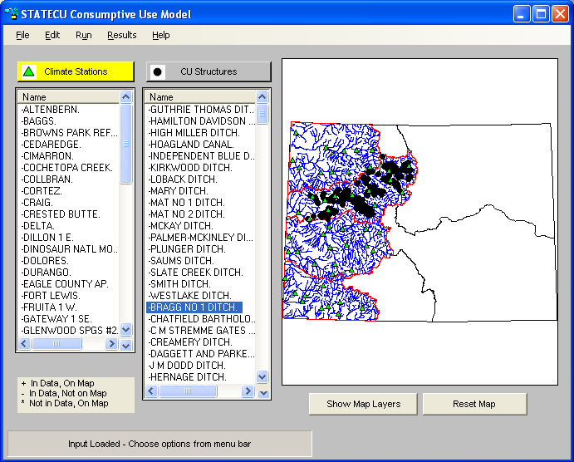

Figure 1 – Main Interface Window

**Menu Bar** The menu bar at the top of the interface contains the menus for each of the major

windows available within the interface. Each menu is discussed in detail in the following sections.

**Map Display** When the application is first opened, the Map Display contains the CDSS splashscreen. When GIS files are available to a scenario and the dataset is loaded, the map displays the available graphics overlays which may include climate station locations, CU structure locations, water district boundaries, and basin hydrology. The **Show Map Layers** button activates a new window displaying map layers and allows the user to toggle map layers on and off. Use the LEFT mouse button to draw a box to zoom in on the map and use RIGHT mouse button selects stations or structures. The **Reset Map** button re-displays the full size map.

**Climate Stations/** Upon loading a Crop Consumptive Use dataset that includes GIS files, the user can

**CU Structures** choose an individual climate station or CU structure directly from the map using the RIGHT mouse button, or by selecting the station or structure name from the lists on the bottom of the main interface window. The lists (climate stations or CU structures) identify which stations and structures are included in the loaded dataset and/or shown on the map. While both lists are shown for a *Structure Scenario*, only the climate stations are shown for a *Climate Station Scenario*.

**Status**  Instructions are displayed in the status message area, located on the bottom of the

**Messages** main interface window. This area also displays a status bar showing the input data loading progress.

### 3.3 File Menu

Commands under the **File** menu (**Figure 2**) allow existing StateCU datasets to be loaded and the GUI to be exited.

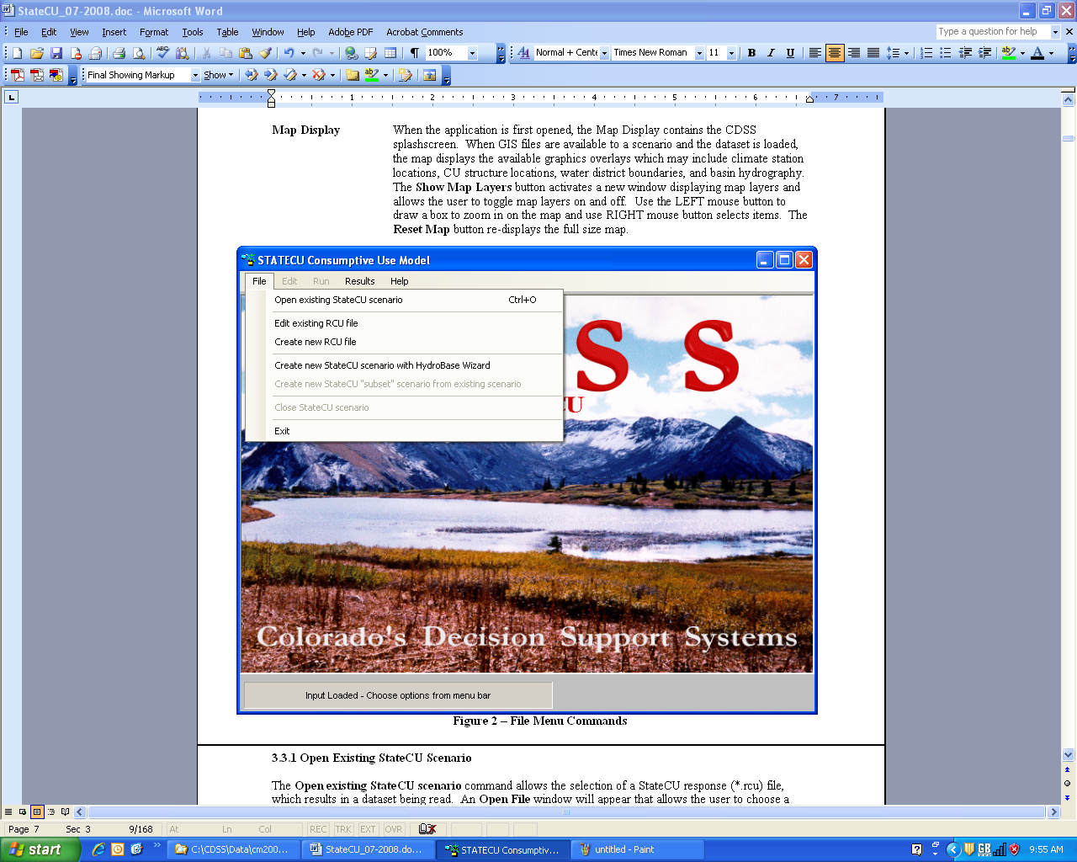

Figure 2 – File Menu Commands

#### 3.3.1 Open Existing StateCU Scenario

The **Open existing StateCU scenario** command allows the selection of a StateCU response (*.rcu) file, which results in a dataset being read. An **Open File** window will appear that allows the user to choose a response file located on any available disk drive and directory. Selecting a response file triggers the GUI to read the StateCU input files associated with that dataset.

Several base datasets are available on the CDSS website for use with the StateCU GUI corresponding to the CDSS basin modeling efforts. Base datasets with filled climate and diversion records are provided for each CDSS western slope basins (Gunnison, San Juan/Dolores, Upper Colorado, White and Yampa), the Rio Grande basin and the South Platte basin. Base climate datasets with filled climate data are available for the Arkansas and Republican basins. A statewide climate dataset is available without filling of missing climate data.

A flag in the input control file specifies whether the CU Location is associated with a climate station or structure. A *Climate Station Scenario* involves a limited number of input data files, as reflected by a simplified set of input windows displayed by the graphical user interface. The water supply limited crop consumptive use and other more complex levels of analyses are only available under a *Structure Scenario*.

#### 3.3.2 Edit Existing RCU File

The Edit existing RCU file command allows the user to edit individual input files listed in the response file of a scenario. When the Edit existing RCU file is selected from the File menu, an Open File window is activated that allows the user to choose a response file located on any available disk drive or directory. Selecting a response file activates the View/Edit Scenario File (RCU) window (Figure 3). The user can then double click on a file name, prompting another Open File window, in which the user can choose individual files located on any available disk drive or directory. Note that input files listed in the original response file that do not exist are not listed in the View/Edit Scenario File (RCU) window and will not be saved in the new response file. The Copy option under the Edit menu allows the user to copy the input file names and paste the list in an external application, such as a text editor or spreadsheet. Utilize the Edit…Select All option or individually select or deselect input file names to copy by holding down the CTRL key while selecting file names with the LEFT mouse button.

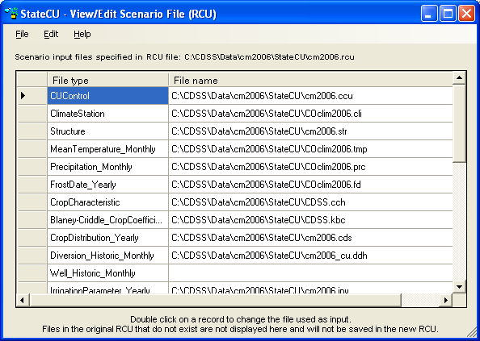

**Figure 3 – View/Edit Scenario File (RCU)**

To save the changed input files, select **Save** from the **View/Edit Scenario File (RCU)**…**File** menu. This command saves changes over the active response file. The **Save As…** command allows the response file to be saved in a different location or to a different name. Select **Input File Info** from the **Help** menu to view the path and filename of the active input file.

#### 3.3.3 Create New RCU File

The **Create new RCU file** command allows the user to create a new response file by individually selecting input files to be listed in the new response file. When the **Create new RCU file** is selected from the **File** menu, a blank **View/Edit Scenario File (RCU)** window is activated. Double click on a file name box to activate an **Open File** window, in which the user can choose individual input files located on any available disk drive or directory. Enter in all of the required input files to create the new response file. Different files are required depending on whether a *Climate Station Scenario* or a *Structure Scenario* is created. See Section 8.15 for more information on the required files for a *Climate Station Scenario* and Section 5 for more information on the required input files for a *Structure Scenario.*

The **Copy** option under the **Edit** menu allows the user to copy the input file names and paste the list in an external application, such as a text editor or spreadsheet. Utilize the **Edit…Select All** option or individually select or deselect input file names to copy by holding down the CTRL key while selecting file names with the LEFT mouse button. To save new response file, select **Save** or **Save As…** from the **File** menu. Both commands will prompt the user to name the new response file and provide the directory location to save the response file to. Once the new response file is saved, choose the **Open existing StateCU Scenario** from the **File** menu to load the new scenario**.** Select **Input File Info** from the **Help** menu to view the path and filename of the active input file.

#### 3.3.4 Create New StateCU Scenario Using HydroBase Wizard

The **Create new StateCU scenario using HydroBase Wizard** command allows the user to build a new StateCU scenario using the HydroBase Wizard. The HydroBase Wizard is an interactive tool that guides the user step-by-step through the development of a new scenario and pulls required input data directly from HydroBase through an internet connection. The HydroBase Wizard can be used to create a new *Climate Station Scenario* or a *Structure Scenario*. See Section 3.4 for more details on the HydroBase Wizard.

#### 3.3.5 Create New StateCU ‘Subset’ Scenario From Existing Scenario

The **Create new StateCU ‘subset’ scenario from existing scenario** commandallows the user to create a new StateCU scenario using a subset of the structures from a scenario currently loaded in the StateCU GUI. This option is not available until a scenario has been opened and loaded in the GUI. A *Climate Station Scenario* can only be created from a subset of an existing *Climate Station Scenario* and *Structure Scenario* can only be created from a subset of an existing *Structure Scenario.*

When this command is selected from the **File** menu, the **Create New Scenario** window (**Figure 4**) is activated, in which the user can select the structures or climate stations to be included in the new scenario. Multiple structures can be selected for inclusion in the new subset scenario by holding down the SHIFT key while selecting structures using the LEFT mouse button or the Up and Down arrow keys. The **Select All** button can be used to select all the structures in the currently loaded scenario. Individual structures can then be selected or deselected by holding down the CTRL key while selecting structures using the LEFT mouse button.

To save the desired structures in the new subset scenario, select **Save** from the **Create New Scenario**…**File** menu. This command saves changes over the active response file. The **Save As…** command allows the response file to be saved in a different location or to a different name. Select **Input File Info** from the **Help** menu to view the path and filename of the active input file.

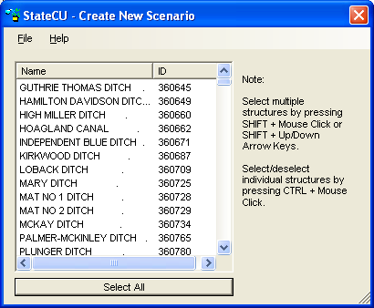

**Figure 4 – Create New Scenario**

#### 3.3.6 Close StateCU Scenario

The **Close StateCU Scenario** command closes the StateCU scenario currently loaded in the StateCU GUI without closing the StateCU GUI application. When the **Close StateCU Scenario** command is selected from the **File** menu, the GUI will close the scenario and display the CDSS splashscreen. The user can then choose to open another scenario or exit out of the GUI using options in the **File** menu.

#### 3.3.7 Exit

The **Exit** command closes the StateCU GUI. When the **Exit** command is selected from the **File** menu, the StateCU GUI gives the user an opportunity to choose not to exit.

### 3.4 HydroBase Wizard

The HydroBase Wizard is an interactive tool that guides the user step-by-step through the development of a new monthly scenario and pulls required input data directly from HydroBase through an internet connection. The HydroBase Wizard can be used to create a new monthly *Climate Station Scenario* or a *Structure Scenario*. Required data (e.g. climate data, diversion records, crop characteristics) is pulled directly from HydroBase via an active internet connection and formatted into the correct input files.

Note that the purpose of the Wizard is to create a complete and operational scenario based on HydroBase data; it is the user’s responsibility to review and edit specific data in the input files through the GUI to obtain accurate results.

Activate the Wizard by selecting the **Create new StateCU scenario using HydroBase Wizard** command through the **File** menu. **Figure 5** displays the introductory screen to the Wizard. All screens in the Wizard have an **Exit** button. Select the **OK** button to proceed to Step 1.

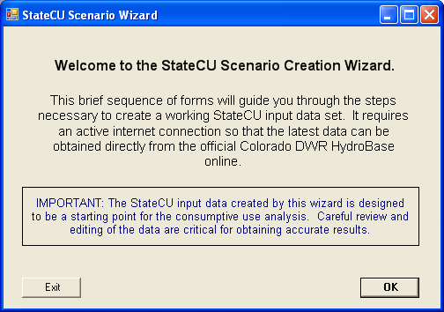

**Figure 5 – StateCU Scenario Wizard Welcome**

Step 1 of the Wizard (**Figure 6**) determines if the user would like to create a *Climate Station Scenario* or a *Structure Scenario.* Using the radio controls, select either the **Climate Station Scenario** or the **Structure Scenario**. If the **Structure Scenario** is selected, there is the option to use crop and acreage data from the data source and to use diversion data from the data source. If these options are checked, the crop, acreage and diversion data loaded in HydroBase for the specific structure the user will be modeling will be used when creating the input files. If either of these options is unchecked, the Wizard will ask for crop and acreage data to be manually entered in Step 3 and diversion data to be manually entered by the user in the GUI. If both options are unchecked, the user has the ability to create a new scenario based on a structure not found in HydroBase. See Section 3.4.2 for more information on these options.

Currently, the Wizard can only use the online DWR HydroBase via an internet connection as a source for the data. Future development may allow the Wizard to pull data from an existing scenario or from a locally loaded HydroBase. The message of ‘Connected’ in green text will appear if there is an active internet connection. If one is not available, the message will state ‘Not Connected!’ in red text and traditional file creation through the State Data Management Interfaces (DMI’s) utilizing a locally loaded HydroBase is necessary.

Enter a new scenario name, avoiding special characters, spaces or periods in the file name. All input files will receive the same scenario ‘base’ name. The Wizard saves all new scenarios to the C:\CDSS\Data\StateCUWizard directory. Click on the **Continue** button to move to the next step.

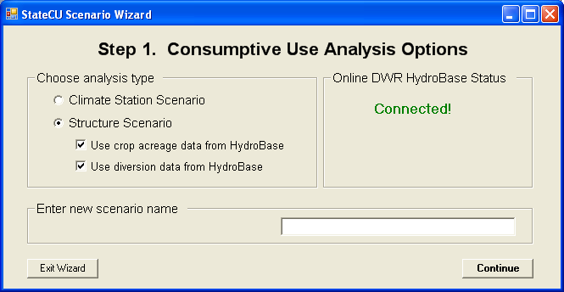

**Figure 6 – Step 1 of Wizard – Analysis Options**

The following steps in the Wizard are dependent on which type of scenario is being developed. See Section 3.4.1 for the subsequent steps to build a *Climate Station Scenario* through the Wizard, and Section 3.4.2 for the steps to build a *Structure Scenario*.

#### 3.4.1 Climate Station Scenario Creation through Wizard

A *Climate Station Scenario* created in the Wizard will determine the potential crop consumptive use and irrigation water requirement for one or more crops at a specific climate station. Step 2 of the Wizard (**Figure 7**) determines which crop(s) will be used in the analysis. Crops, and their respective characteristics, that are currently loaded in HydroBase are the only crops available for inclusion in the scenario through the Wizard. Note that although acreage and crops can vary over time, the Wizard uses the single ‘snapshot’ of crop and percentages input in this step and applies them to all years in the scenario. This data can be edited in the GUI to represent changes in cropping practices.

*Climate station scenarios* are based on a unit-acre parcel basis at a single location, therefore the percentage of each crop on a single parcel is input in this step. Narrow the crop list by using the radio controls, indicating a subset by crop type (e.g. alfalfa, grass pasture, corn), or a subset by crop coefficient type (e.g. SCS TR21, Rio Grande calibrated coefficient). Refresh the available list of crops based on the subset criteria by clicking on the green arrow in the center of the window. The resulting crop name list can be sorted by clicking on the header label. Note the subset criteria and the resulting crop name list must include all of the crops for inclusion into the scenario. For example, if the user wants to determine the consumptive use for both Alfalfa.TR21 and Grass_Pasture.DWHA, the subset criteria would be set to ‘None’ so that both crop names would appear in the crop name list. Selected crops and percentages are lost if the crop name list is refreshed.

Use the check boxes to select crops to be entered in the scenario, and enter the associated percentages. The sum of all crop percentages must equal 100 percent. To view crop characteristics for any of the listed crops, check the box next to the crop name and then click on the **View info about selected crop** button. This will activate a window listing the crop information. **Figure 8** displays the crop characteristics for the crop Alfalfa – SCS TR21. The user can not edit the crop information in this window; once the scenario has been created, the user can edit this information through the GUI. The user can also choose to apply an elevation adjustment to all TR21 Crop Coefficients, using the check box in the lower left corner of the window. The adjustment is applied to all TR21 crops selected by the user for inclusion in the scenario. Elevation adjustment preferences can also be edited through the GUI. Click on the **Continue** button after entering all the crop data to move to the next step.

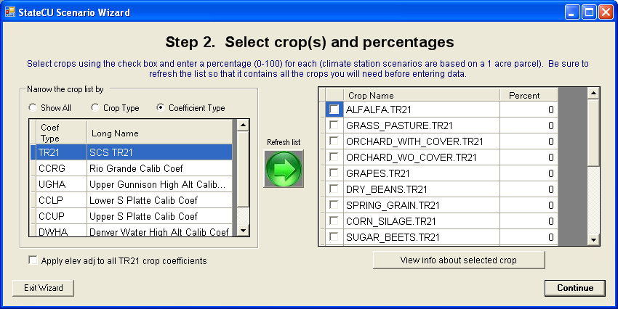

**Figure 7 – Step 2 of Wizard – Crop Selection**

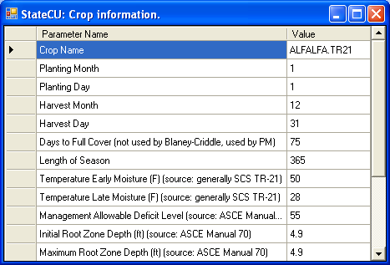

**Figure 8 – Crop Information**

Step 3 of the Wizard (**Figure 9**) determines which climate station(s) will be used in the analysis. The *Climate Station Scenario* will only include one consumptive use location, however data from multiple climate stations can be used to determine the consumptive use. If multiple climate stations are selected, the Wizard equally weights the climate data from the multiple climate stations and uses the station ID of the first climate station listed as the identifier appended by ‘_field’ for the consumptive use location. For example, if Denver (ID 2220) and Greeley (ID 3546) climate stations are both selected, the Wizard would use *2220_field*, representing the station ID from Denver as the consumptive use location identifier appended by ‘_field’, in the structure file and then include both stations in the climate station, temperature, precipitation and frost date files.

Climate stations, and their climate data, that are currently loaded in HydroBase are the only stations available for inclusion in the scenario through the Wizard. The user can either search by the name of the climate station or by the ID. To search by name, enter the name or partial name of a climate station and the subset criteria. Narrow the name search by County, by Division or by Water District, or search all available climate stations by indicating ‘Show All’. Click on the green arrow in the center of the window to refresh the list. To search by climate station ID, enter the full 4 digit or partial ID and click on the green arrow. No subset criteria are allowed when searching by ID. The resulting climate station list can be sorted by clicking on the header label.

Note the subset criteria and the resulting climate station list must include all of the climate stations to be included in the scenario. For example, if the user wants to determine the consumptive use using both Greeley and Denver data, the subset criteria could be set to ‘Division’ with the ‘Name’ box left blank so that both station names would appear in the climate station list. Selected stations are lost if the climate station list is refreshed.

Select and highlight one or more climate stations for inclusion in the scenario. Click on the **View station info** button to view climate station location information. It is recommended that the user review the start and end years, as well as the measured count of data for each climate data type to determine the extent of available data. Click on the **View Precip Data** and **View Temp Data** buttons to preview the available climate data. The user can not edit the climate data in these windows; once the scenario has been created, the user can edit the climate data through the GUI. Note that some climate stations may have only precipitation data or only temperature data (not both); therefore using a precipitation-only or temperature-only climate station in a scenario would not produce analysis results. Click on the **Continue** button after selecting all climate stations to move to the next step.

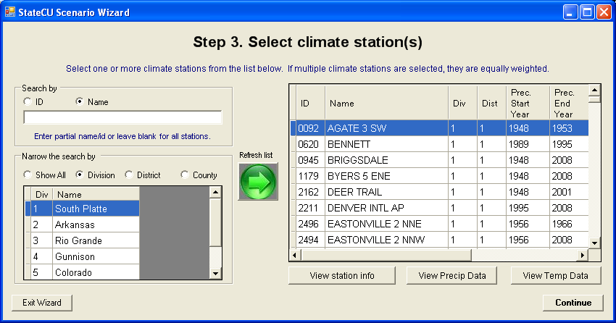

**Figure 9 – Step 3 of the Wizard – Climate Station Selection**

After completing the climate station selection in Step 3 of the Wizard, the user has determined all of the input parameters necessary to create a *Climate Station Scenario.* The Final Step of the Wizard (**Figure 10**) is to set the beginning and ending year of the analysis and enter a description of the scenario. The extent of available climate data from the climate station identifier is shown in the window to help guide the user in setting an applicable time period. Note that all time series data files will be created using these time period parameters. Through the GUI, an analysis can be adjusted to a smaller time period, but not a larger period, therefore it is recommended to define this period as large as available data can support. Missing data in the input files is indicated by -999 and consumptive use calculations can not be performed for years with any missing data. Note that options to fill missing data in this window are available only when creating *Structure Scenario*. Edit the years by typing over the default or using the up and down arrows.

Enter a description of the scenario in the three allotted lines, maximum of 120 characters per line. This information is stored in the header of the model control options file (*.ccu). Select the **Create New Scenario** to complete the creation of the scenario. The newly created *Climate Station Scenario* will automatically be loaded into StateCU, whereby the user can review and edit data, and run the consumptive use analysis.

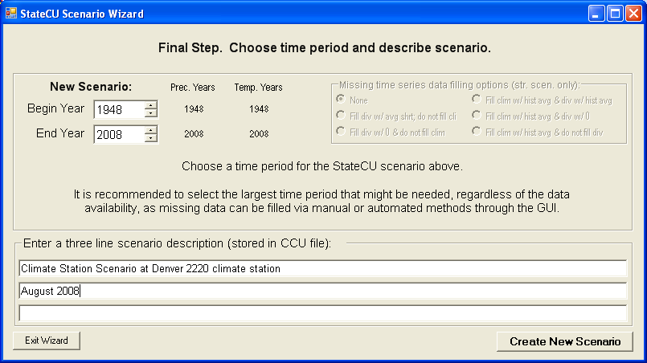

**Figure 10 – Final Step of the Wizard – Create New Scenario**

Several parameters and modeling options are not specifically input by the user into the Wizard, rather it is the responsibility of the user to review and edit these parameters through the GUI. The Wizard sets these parameters to defaults when creating the scenario. The default settings are listed in a window (**Figure 11**) that is activated once the scenario is created. The following is a list of these defaults settings:

* The Modified Blaney-Criddle consumptive use analysis method is set
* The effective precipitation method is set to the SCS method.
* Crop types and crop acreages is fixed for all years

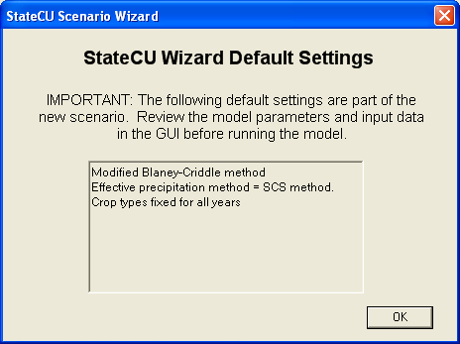

**Figure 11 – Climate Station Scenario Default Wizard Settings**

#### 3.4.2 Structure Scenario Creation through Wizard

A *Structure Scenario* created in the Wizard will determine the potential crop consumptive use, irrigation water requirement and water supply limited consumptive use for one or more crops at a specific diversion structure. Step 2 of the Wizard (**Figure 12**) determines the consumptive use location that will be used in the analysis. Diversion structures, and their respective diversion records, that are currently loaded in HydroBase are available for inclusion in the scenario through the Wizard. The user can either search by the name of the structure or by the ID. To search by name, enter the name or partial name of a diversion structure and the subset criteria. Narrow the name search by County, by Division, or by Water District or ‘Show All’ available structures. Click on the green arrow in the center of the window to refresh the list. To search by structure ID, enter the full 7-digit or partial ID and click on the green arrow. No subset criteria are allowed when searching by ID. Note that there are numerous diversion structures loaded into HydroBase and that a refined subset criteria is necessary. If a subset criteria option results in too numerous of diversion structures, the Wizard will provide a message and allow the user to redefine the criteria. The resulting structure list can be sorted by clicking on the header label.

Select and highlight a single structure from the structure list. Click on the **View structure** **info** to view structure and diversion class information. If in Step 1, the user checked the box to use diversion data from HydroBase for the selected structure, the user is able to select a structure and preview the total diversion data by clicking on the **View DivTotal.** The Wizard defaults to use structure total diversions, however the user can use the radio controls to select either total diversions or select individual diversion classes. See the following paragraph for a discussion on using diversion classes. If in Step 1, the user unchecked the box to use diversion data from HydroBase, the user will be unable to view or select diversion data and diversions will be set to zero in the direct diversion data file (*.ddh). If in Step 1, the user unchecked both boxes to use crop and diversion data from HydroBase, the Wizard allows the user to create a scenario for a new structure or location. See Section 3.4.2.1 for a discussion on this feature.

In Step 1, the user checked the box to use diversion data from HydroBase for the selected structure, the user can utilize diversion classes to create the direct diversion data file. After selecting the structure from the list, select the **Select div classes** radio control and then click the **Continue** button. This will prompt the Wizard to activate the Step 2A window (**Figure 13**), in which the user can select specific diversion classes. Preview the diversion class data by checking a diversion class from the list and clicking on the **Display diversion time series for selected record** button. Review the period of record and measured count of the data to determine the extent of the data available for the diversion class. See Chapter VIII of the Water Commissioner Handbook for information on diversion class coding. Select one or more diversion classes and click **OK.** The selected diversion classes are summed and will over-ride the default of total diversions. If no diversion classes are selected in Step 2A, the default of total diversions will be used.

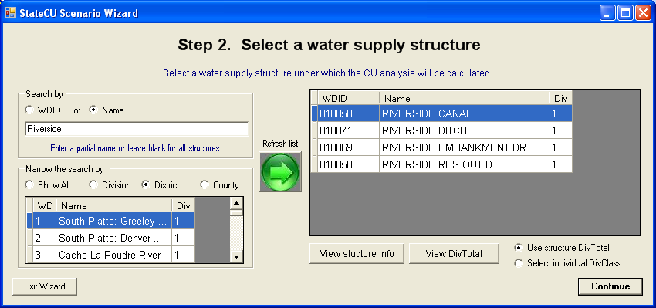

**Figure 12 – Step 2 of Wizard – Diversion Structure Selection**

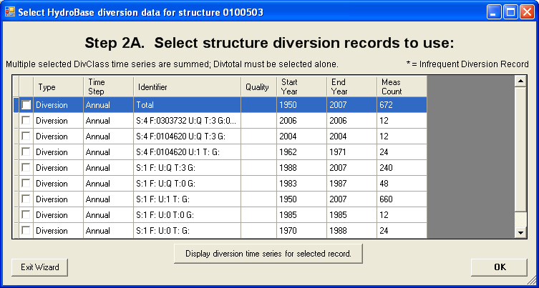

**Figure 13** **– Step 2A of Wizard – Diversion Class Selection**

Step 3 of the Wizard (**Figure 14**) determines which crop(s) will be used in the analysis. Crops, and their respective characteristics, that are currently loaded in HydroBase are the only crops available for inclusion in the scenario through the Wizard. Note that although acreage and crops can vary over time, the Wizard uses the single ‘snapshot’ of the most current CDSS acreage assessment data in this step and applies them to all years in the scenario. This data can be edited in the GUI to represent changes in cropping practices.

If in Step 1, the user checked the box to use crop data from HydroBase for the selected structure, the Wizard automatically displays the most recent GIS crop information from HydroBase in the crop selection window. The user can choose to keep the default HydroBase crop information or edit the crops or acreage as needed. No subset options exist and the green refresh arrow is disabled if the Step 1 box is checked, however all available crops are listed and can be used in the scenario. Note that the Wizard can only create a scenario using TR.21 coefficients, therefore if HydroBase has a non-TR.21 crop assigned to a specific structure the Wizard will translate these crops according to the following chart.

|  |  |
| --- | --- |
| HydroBase Crop | Translated Wizard Crop |
| Corn | Corn_Grain.TR21 |
| Small Grains | Spring_Grain.TR21 |
| Sod Farm | Grass_Pasture.TR21 |
| Sunflower | Spring_Grain.TR21 |
| Wheat | Spring_Grain.TR21 |

If in Step 1 the user unchecked the box to use crop data from HydroBase, the user can narrow the list by using the radio controls, indicating a subset by crop type (e.g. alfalfa, grass pasture, corn) or a subset by crop coefficient type (e.g. SCS TR21, Rio Grande calibrated coefficient). Refresh the available list of crops based on the subset criteria by clicking on the green arrow in the center of the window. The resulting crop name list can be sorted by clicking on the header label. Note the subset criteria and the resulting crop name list must include all of the crops for inclusion into the scenario. For example, if the user wants to determine the consumptive use for both Alfalfa.TR21 and Grass_Pasture.DWHA, the subset criteria would be set to ‘None’ so that both crop names would appear in the crop name list. Selected crops and percentages are lost if the crop name list is refreshed.

Use the check boxes to select crops to be entered in the scenario, and enter the associated acreage. To view crop characteristics for any of the listed crops, check the box next to the crop name and then click on the **View info about selected crop** button. This will activate a window listing the crop information. The user can not edit the crop information in this window; once the scenario has been created, the user can edit this information through the GUI. The user can also choose to apply an elevation adjustment to all TR21 Crop Coefficients, using the check box in the lower left corner of the window. The adjustment is applied to all TR21 crops selected by the user for inclusion in the scenario. Elevation adjustment preferences can also be edited through the GUI. Click on the **Continue** button after entering all the crop data to move to the next step.

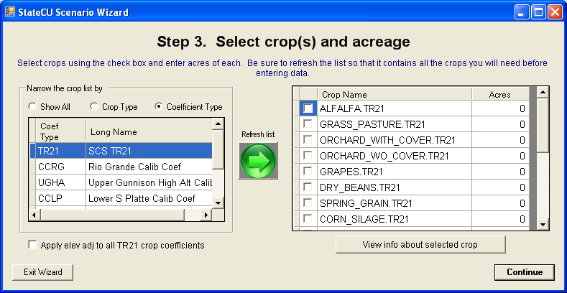

**Figure 14 – Step 3 of Wizard – Crop Selection**

Step 4 of the Wizard (**Figure 15**) determines which climate station(s) will be used in the analysis. The *Structure Scenario* will only include one consumptive use location, however data from multiple climate stations can be used to determine the consumptive use. If multiple climate stations are selected, the Wizard equally weights the climate data from the multiple climate stations for the analysis.

Climate stations, and their climate data, that are currently loaded in HydroBase are the only stations available for inclusion in the scenario through the Wizard. The user can either search by the name of the climate station or by the ID. To search by name, enter the name or partial name of a climate station and the subset criteria. Narrow the name search by County, by Division or by Water District, or search all available climate stations by indicating ‘Show All’. Click on the green arrow in the center of the window to refresh the list. To search by climate station ID, enter the full 4 digit or partial ID and click on the green arrow. No subset criteria are allowed when searching by ID. The resulting climate station list can be sorted by clicking on the header label.

Note the subset criteria and the resulting climate station list must include all of the climate stations to be included in the scenario. For example, if the user wants to determine the consumptive use using both Greeley and Denver data, the subset criteria could be set to ‘Division’ with the ‘Name’ box left blank so that both station names would appear in the climate station list. Selected stations are lost if the climate station list is refreshed.

Select and highlight one or more climate stations for inclusion in the scenario. Click on the **View station info** button to view climate station location information. It is recommended that the user review the start and end years, as well as the measured count of data for each climate data type to determine the extent of available data. Click on the **View Precip Data** and **View Temp Data** buttons to preview the available climate data. The user can not edit the climate data in these windows; once the scenario has been created, the user can edit the climate data or fill missing climate data through the GUI. Note that some climate stations may have only precipitation data or only temperature data (not both); therefore using such climate stations in a scenario would not produce analysis results. Click on the **Continue** button after selecting all climate stations to move to the next step.

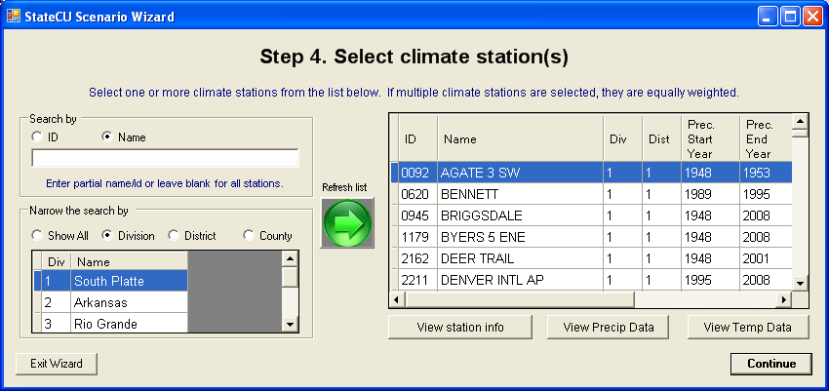

**Figure 15 – Step 4 of the Wizard – Climate Station Selection**

After completing the climate station selection in Step 4 of the Wizard, the user has determined all of the input parameters necessary to create a *Structure Scenario.* The Final Step of the Wizard (**Figure 16**) is to set the beginning and ending year of the analysis and enter a description of the scenario. Note that all time series data files will be created using these time period parameters. Through the GUI, an analysis can be adjusted to a smaller time period, but not a larger period, therefore it is recommended to define this period as large as available data can support. Missing data in the input files is indicated by -999. The user can choose to have StateCU fill missing data ‘on-the-fly’ with month averages or zeros through selecting **Missing time series data fill options** in the Final Step.Note that ‘on-the-fly’ filling will fill the missing data for the consumptive use calculations only; the original input file data will remain unchanged. Consumptive use calculations can not be performed for years with any missing data. When creating the *Structure Scenario*, the time period defaults to the beginning and ending year of available diversion data for the diversion structure. Edit the years by typing over the default or using the up and down arrows.

Enter a description of the scenario in the three allotted lines, maximum of 120 characters per line. This information is stored in the header of the model control options file (*.ccu). Select the **Create New Scenario** to complete the creation of the scenario.

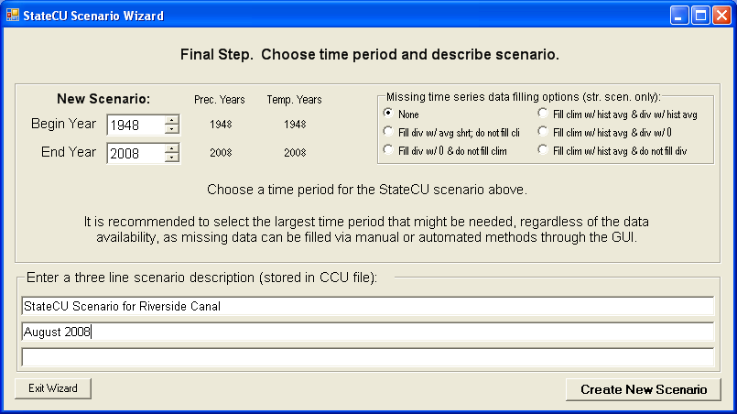

**Figure 16 – Final Step of the Wizard – Create New Scenario**

Several parameters and modeling options are not specifically input by the user into the Wizard, rather it is the responsibility of the user to review and edit these parameters through the GUI. The Wizard sets these parameters to defaults when creating the scenario. The default settings are listed in a window (**Figure 17**) that is activated once the scenario is created. The following is a list of these defaults settings:

* The Modified Blaney-Criddle consumptive use analysis method is set
* The effective precipitation method is set to the SCS method.
* Crop types and crop acreages is fixed for all years
* Canal efficiencies are set to 80%
* Acreage is all set to be flood irrigated and crop types are fixed for all years (non-variable)
  + The maximum flood irrigation efficiency is set to 45%
  + The maximum sprinkler irrigation efficiency is set to 75%
* No soil moisture accounting and structure available water capacity is set to zero

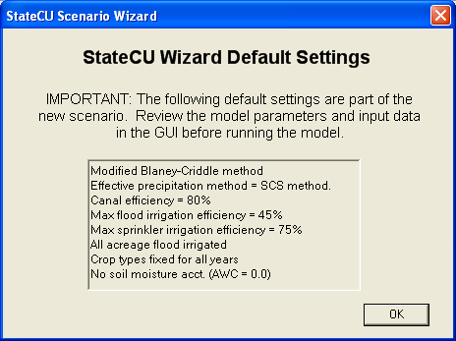

**Figure 17 – Structure Scenario Wizard Default Settings**

3.4.2.1 Create New Non-HydroBase Structure Scenario

The Wizard has the ability to create an operational and complete *Structure Scenario* for a user-specified structure or location not using information from HydroBase. The process to create this new scenario is similar to the process outlined in Section 3.4.2, except the user defines the structure ID. The main differences between the two processes take place in Step 1 and Step 2, therefore this discussion will focus on these differences. It is recommended the user thoroughly read Section 3.4.2 prior to creating a new non-HydroBase structure scenario.

In Step 1 of the Wizard (**Figure 6**), use the radio controls to select the **Structure Scenario** under analysis type and uncheck both of the boxes indicating not to use crop acreage and diversion data from HydroBase. Enter a new scenario name, avoiding special characters, spaces or periods in the file name then click on the **Continue** button to move to the next step.

In Step 2 of the Wizard (**Figure 18**), there will be an empty line at the bottom of the structure list. Enter the water district structure ID (WDID) in the first box in the bottom line. The WDID can be a maximum of 12 characters with no spaces and no periods. It is recommended that the first 2 digits of the WDID reflect the Water District in which the structure is located. If no WDID is entered, ‘Field1’ will be used as the WDID. Enter the Name in the second box of the bottom line (maximum of 40 characters) that briefly describes the new structure. Enter the numeric Water Division in which the structure is located. Note that only one new structure can be included in the scenario. By default, the direct diversion file will reflect zero diversions for the newly created structure. Highlight the new structure line and click on the **Continue** button to move to the next step. The remaining steps in creating a new non-HydroBase structure scenario are the same as outlined in Section 3.4.2. As with *Structure Scenarios* created from HydroBase, it is the user’s responsibility to review and edit input data through the GUI to obtain accurate results.

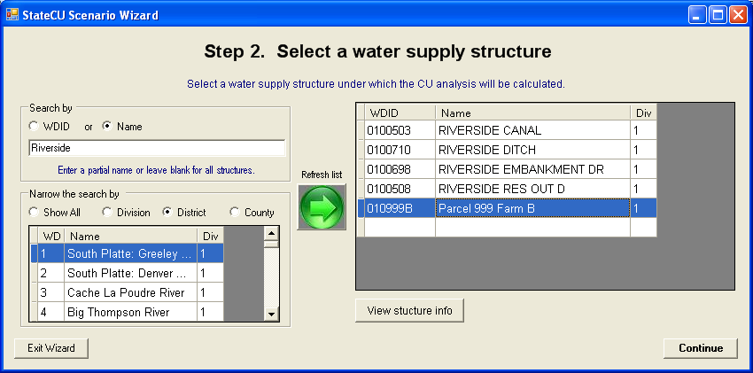

**Figure 18 – Example New Non-HydroBase Structure Scenario**

### 3.5 Edit Menu

The **Edit** menu displays the major categories of StateCU input data that can be viewed and edited. All of the menu commands shown in **Figure 19** are active for a simulation of crop consumptive use under a *Structure Scenario*, as described below. With a *Climate Station Scenario*, the Structure Information command under the **Edit** menu is not visible and the information shown under the Model Control Options and Climate Station Information windows is limited.

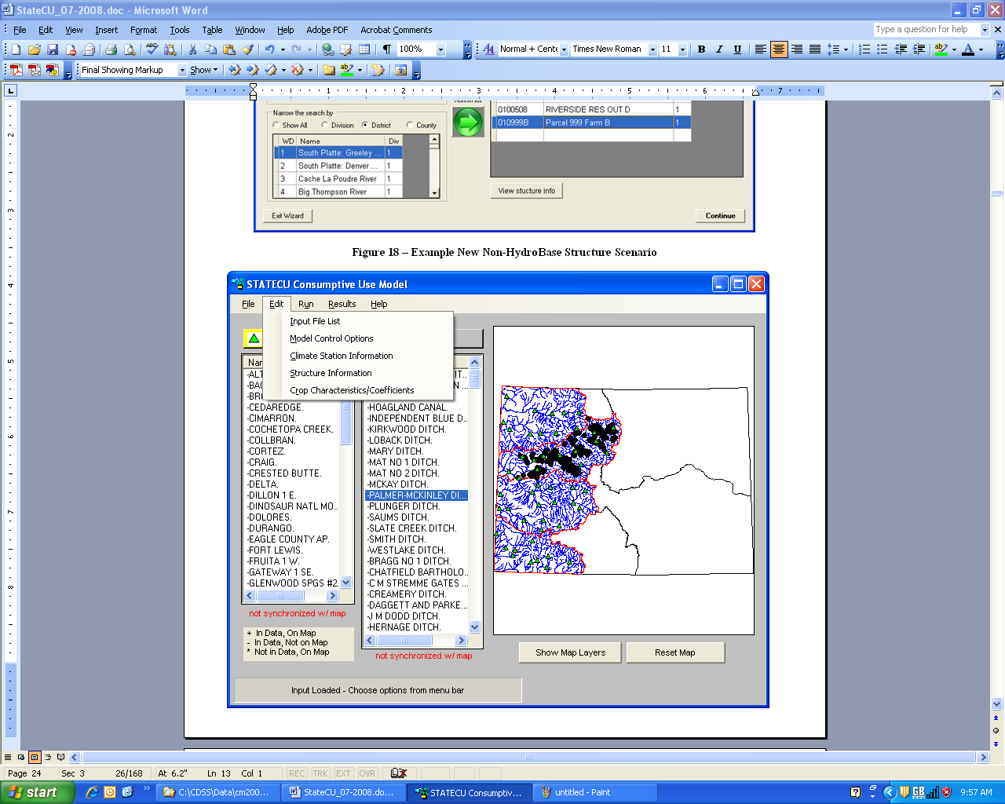

**Figure 19 – Edit Menu**

Several input data files available under the Edit Menu allow the user to view and edit input data, including climate data, crop acreage, diversion records, and irrigation efficiencies. The ‘rules’ for editing input data through the GUI are similar for each data type, therefore the editing rules will be described in this section and referenced in the following sections when each data type is discussed individually.

The user has the ability to edit the input data through specific GUI windows, accessed through the main GUI **Edit Menu**. In all cases, input data can be edited for the existing time period provided in the scenario, however the user can not extend the time period of data. Input data through the GUI is provided in grid format, similar to an Excel spreadsheet. To edit an individual data value, select a cell, type-over the original data value and press ENTER, TAB or select a different cell to ‘commit’ the changed data value. Changed data values that are not ‘committed’ are not available to be saved when the save option is selected. Press ESC prior to committing a data value to retrieve the original data value.

There are commands available under each input data GUI window **Edit** menu to help the user edit the data, including **Copy**, **Paste** and **Select All**. The user can also click on a data cell with the RIGHT mouse button to access **Copy, Paste** and **Adjust Values** options. The **Adjust Values** options include **Scale**, in which the data value can be scaled up or down by a user-input value, or **Add**, in which the user inputs a value to be added (negative values are allowed) to the selected data value. Note that each data input type has allowable values, designed to provide minimal error checking and prevent the user from inputting unreasonable data. For example, diversion data must be between 0 and 100,000 and crop acreage data must be between 0 and 200,000. If the user provides a scale or addition factor that creates unreasonable data, the GUI will provide an error message indicating the scale or add operation was not successful and the allowable values for that specific data type.

Data can be copied and pasted into and out of the GUI window from an external spreadsheet or database application. Data can also be copied from one area of the GUI window to another area. Note that only allowable values can be pasted into the GUI window. Similar to the scale and add factor checking, minimum error checking will take place on the copied value(s) and the GUI will provide an error message indicating that the pasting operation was not successful and the allowable values for that specific data type. There are four possible configurations for pasting data into a GUI window; the GUI pastes each configuration in a similar fashion as Excel. The following list discusses the configurations and how the GUI handles each pasting operation:

* Copy one cell from the original source and paste one cell into the GUI window: The copied single data value will replace the GUI data value.
* Copy one cell from the original source and paste a range of cells into the GUI window: The copied single data value will replace all of the data values in the selected range in the GUI.
* Copy a range of cells from the original source and paste to one selected cell into the GUI window: The copied range of data values will replace the same number data values in the GUI, using the single cell selected as the upper left cell of the copied range. If the range to be pasted extends into read-only columns or rows (e.g. cells containing years, annual totals, etc.), then the pasted data will be truncated at that row and column. Note that if any of the copied data values are non-allowable, then none of the cells will be pasted.
* Copy a range of cells from the original source and paste to a selected range of cells into the GUI window: The range of copied cells must be the same size and shape as the pasted range, or the GUI will not allow any data to be pasted. The copied range of data values will replace the pasted range of data values in the GUI. If the range to be pasted extends into read-only columns or rows (e.g. cells containing years, annual totals, etc.), then the pasted data will be truncated at that row and column. Note that if any of the copied data values are non-allowable, then none of the cells will be pasted.

Data read into the GUI from the input files is also minimally error-checked based on the allowable values. If data in the input files does not meet the allowable values, the data will be color-coded and the user will have to correct any non-allowable data prior to saving any data through the GUI window.

Data in the GUI windows can be viewed graphically, select the **Graph** command under the **View** menu of each GUI window. This command activates and utilizes an Excel spreadsheet to format and graph the data. If Excel is not available, then the GUI provides an error message when the **Graph** option is selected from the **View** menu. The StateCU GUI opens Excel in a separate window and the time series data are provided under a worksheet labeled **Data** (monthly data) or **Raw Data** (daily data). A graph displaying the data is provided under a separate worksheet labeled **Graph**. For daily data, the graph is a subset of the available period, for ease of viewing; the user can change the period through Excel. The user can manipulate the graph and data and save the spreadsheet independent of the StateCU analysis. Note that changes to the data in the Excel spreadsheet will not be reflected in the original input data file, unless the user copies the data back into the GUIwindow and saves that data.Note that variations to the editing rules in this general discussion will be discussed in the following sections under each data type.

#### 3.5.1 Input File List

The **Input File List** command allows the user to view and edit individual input files listed in the response file of a scenario. When the **Input File List** command is selected from the **Edit** menu, the **View/Edit Scenario File (RCU)** window (**Figure 20**) is activated. The user can then double click on a file name, prompting an **Open File** window, in which the user can choose individual files located on any available disk drive or directory. Note that any input files listed in the original response file that do not exist are not listed in the **View/Edit Scenario File (RCU)** window and will not be saved in the new response file. The **Copy** option under the **Edit** menu allows the user to copy the input file names and paste the list in an external application, such as a text editor or spreadsheet. Utilize the **Edit…Select All** option or individually select or deselect input file names to copy by holding down the CTRL key while selecting file names with the LEFT mouse button.

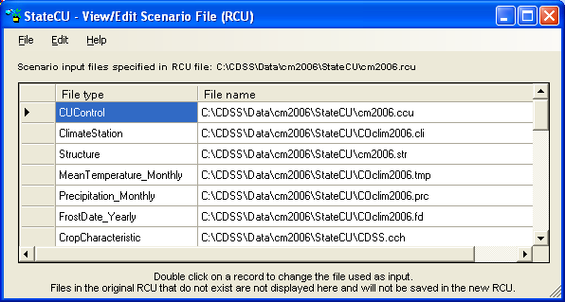

Figure 20 – Input File List Window

To save changes to the Input File List, select **Save** from the **File** menu. This command saves changes over the active response file. The **Save As…** command allows the response file to be saved in a different location or to a different name. The name of the active response file displayed in the **View/Edit Scenario File (RCU)** window can be determined by selecting the **Input File Info** command under the **Help**menu (**Figure 21**).

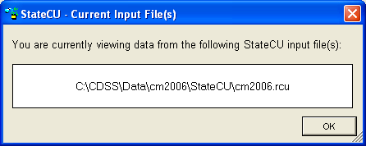

Figure 21 – Input File Information Window

A File menu and Help menu similar to those shown above are provided for each command under the Edit menu.

#### 3.5.2 Model Control Options

The **Model Control Options**window displays the information and parameters that control a StateCU execution. With a *Structure Scenario*, the information is organized by three data groups which appear as ‘folder tabs’: **General**, **Analysis Options**, and **More Options**. The information available under each data group is viewed by clicking the folder tabs. Only the information shown under the General tab and a limited set of options under the Analysis Options tabs are provided for a *Climate Station Scenario*. The following should be noted when editing the model control parameters:

**General** (**Figure 22**)**:**

* **Simulation Description** – Three lines are available to describe the simulation.
* **Selected Analysis Period** – Must be a subset of the **Available Record** (which is the first and last year of data that is available in every input file containing time series data).

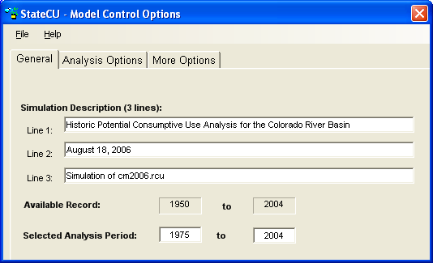

Figure 22 – Model Control Options – General

**Analysis Options** (**Figure 23**)**:**

* **CU Method Time Step** – This option indicates whether the scenario uses a monthly consumptive use method (i.e. Original Blaney-Criddle, Modified Blaney-Criddle, or Pochop) or a daily method (i.e. ASCE Penman-Monteith). Daily climate data files must be included in the response file for the daily option to be activated.
* **Effective Precipitation Methods –** This option displays the effective precipitation methods that are available for the scenario. If the effective precipitation method is turned off (e.g. ‘None’), then StateCU estimates the total potential crop consumptive use. The effective precipitation methods available under a monthly consumptive use analysis include the SCS TR-21 method and the USBR method, as described below in Section 4.1.2. Under a daily consumptive use analysis, the user can apply either a monthly or daily effective precipitation method. The daily effective precipitation methods include maximum effective inches per day, a fraction of the daily precipitation that is effective, or the SCS NEH4 method, as described below in Section 4.1.6.

The follow*i*ng Analysis Options are only available under a *Structure Scenario*:

* **Water Supply** – This option should be selected to calculate water supply-limited crop consumptive use. Water supply information must be available for the Selected Analysis Period.
* **Water Rights** – This option should be selected to group consumptive use as senior or junior to a user-supplied administration number(s). This option is only available if the Water Supply option is selected and a direct diversion rights file (*.ddr) is included in the scenario. The administration processing method and numbers can be viewed and edited by selecting the **View/Edit Administration Processing Method** command button as described in Section 3.5.2.1.
* **Ground Water** – This option should be selected to consider ground water supply (not available if Water Rights option is selected).
* **Soil Moisture –** This option should be selected to consider water stored in the soil moisture zone as a water supply for serving crop consumptive use (only available if the Water Supply option is selected). Soil Moisture variables are described in Section 3.5.2.4.
* **Drain/Tailwater** – This option should be selected if the scenario includes a drain file (*.dra) that contains supplemental tailwater, drain flows or other off-river supplies not included in diversion records. If the drain file contains negative values, indicating non-irrigation diversions in the diversion file that need to be offset, select the ‘Yes – allow neg values’ drain option. See Section 5.28 for more information on drain file usage.

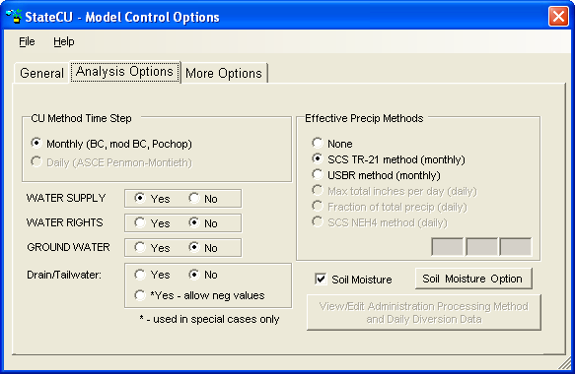

Figure 23 – Model Control Options – Analysis Options

**More Options** (**Figure 24**)**:**

* **Summary of Input Data –** This option allows a Basic or Detailed summary of all input used in the model (*.sum).
* **Missing Data Fill Options** – This option allows missing climate and diversion data to be filled ‘on-the-fly’ to provide for a more complete consumptive use analysis. Utilizing one of these options allows StateCU to fill missing climate and/or diversion data within the consumptive use simulation, however does not replace missing data in the input file. The user can choose the following filling options:
  + No time series data filling
  + To fill missing diversion records based on average shortages and no filling of climate data
  + To fill missing diversion records with zeros and no filling of climate data
  + To fill both missing climate and diversion data with historic monthly averages
  + To fill missing climate data with historic monthly averages and diversions with zeros
  + To fill missing climate data with historic monthly averages and leave diversion data missing.

Note that other options for filling missing climate and diversion data in input files are available through the TSTool DMI. Missing records can also be filled by editing or copying data through the GUI.

* **Model Output Data Options –** This option allows several levels of output data to be generated. Option 1 provides a matrix formatted crop irrigation water requirement summary (*.cir) and water supply limited consumptive use summary (*.wsl) when water supply is considered. Option 2 provides the output from Option 1 plus a summary water budget (*.swb). Option 3 provides the output from Option 2 plus a detailed ‘by structure’ water budget (*.dwb). In addition to the output generated by Options 1 through 3, the user can also choose to create a detailed water budget report by land category for a single structure (*.4wb), selected from a pull down list.
* **StateMod Formatted file of Irrigation Water Requirement –** This option creates an output file of irrigation water requirement (*.ddc) in the standard StateMod format.

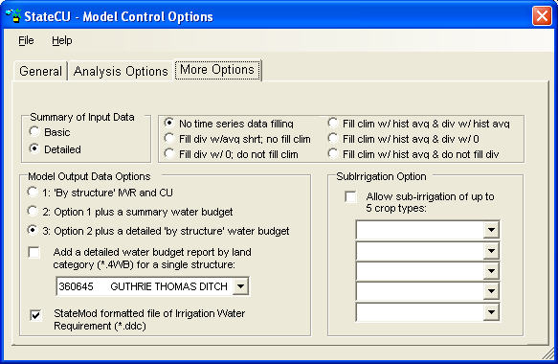

Figure 24 – Model Control Options – More Options

When the **Save** or **Save As…** command is selected from the File menu, the user will be prompted for a new control (*.ccu) file name and the associated response file name. The new control file name will be written to the response (*.rcu) file. Changes made under any of the tabs will be saved.

3.5.2.1 View/Edit Administration Processing Method and Daily Diversion Data

The **View/Edit Administration Processing Methodand Daily Diversion Data** command button on the **Analysis Options** tab in the **Model Control Options** window activates the **Diversion/Administration Processing** window (**Figure 25**). This window displays the information and parameters that control the determination of senior or junior diversions in a StateCU execution and the associated crop consumptive use characterized by priority (only available for a *Structure Scenario*).

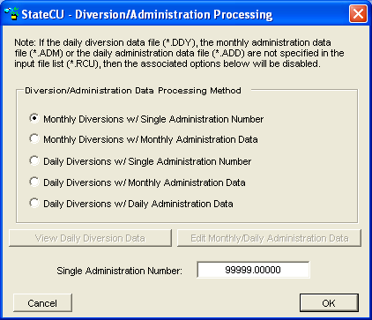

**Figure 25 – Diversions/Administration Processing Window**

If water rights are being considered in the analysis (see Section 3.5.2), the user can select an option that will be used to ‘color’ the water supplies by user-defined administration number(s). The user can use daily or monthly diversion data, and apply daily, monthly, or a single administration number to those diversions. The available options are:

1. Monthly diversion records and a single administration number.
2. Monthly diversion records and monthly administration data.
3. Daily diversion records and a single administration number.
4. Daily diversion records and monthly administration data.
5. Daily diversion records and daily administration data.

The first two options are available if a monthly historical direct diversion data file (*.ddh) is specified in the simulation input file list. The last three options are available if a daily water supply data file (*.ddy) is specified in the simulation input file list. User input monthly (second and fourth options) and daily (fifth option) administration numbers are stored in *.adm and *.add files, respectively, and are required to be on a calendar year basis. A single administration value (first and third options) is stored in the model control options file (*.ccu) with other model control parameters. See Section 3.5.1 for discussion on how to add these files to the simulation input list. See Section 5 for the format of these administration and diversion data files. If a daily diversion file is used to process water rights, daily diversions must add up to the total monthly diversions in the historical diversion data file (*.ddh).

To edit a single administration number, select either the first or third option and enter values in the **Single Administration Number** box. The user can view and edit diversion data and monthly or daily administration numbers (see Section 3.5).

To save changes to the processing method and, if option 1 or option 3 are selected, changes to the single administration number, select the **OK**command button and then select the **Save** or **Save As…** command from the **File** menu on the **Model Control Parameters** window. The save reloads the simulation input data files.

3.5.2.2 View Daily Diversion Data Window

Selecting the **View Daily Diversion Data** command button on the **Diversions/Administration Processing**window activates the **View/Edit Historical Daily Diversion Data** window (**Figure 26**). This option is only available if a daily diversion file has been defined in the simulation input file list and a one of the daily diversion processing methods is selected on the **Diversion/Administration Processing** window. The user may select a structure to be viewed from the list of structures on the left side of the window; the diversion data will automatically refresh when a structure is selected. Daily diversion data can not be negative. Daily diversion data has units of cubic feet per second (cfs), with monthly totals in acre-feet.

The user has the ability to edit the diversion data through this window. See Section 3.5 for more information on how to edit data. To save changes to the daily diversion data for all structures, select the **Save** or **Save As…** command from the **View/Edit Historical Daily Diversion Data…File** menu.

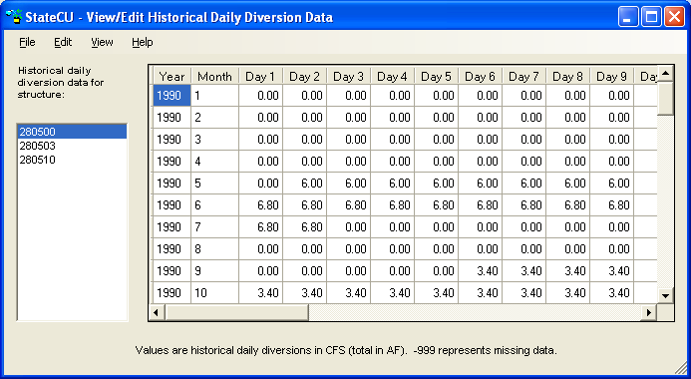

Figure 26 – View Daily Diversion Data Window

3.5.2.3 Edit Monthly/Daily Administration Data

Selecting the **Edit Monthly/Daily Administration Data** command button on the **Diversions/Administration Processing**window activates the **View/Edit Administration Data** window (**Figure 27**). This option is only available if a monthly or daily administration file has been defined in the simulation input file list and one of the monthly or daily administration data processing methods is selected on the **Diversion/Administration Processing** window.

The user has the ability to edit the administration data through this window. See Section 3.5 for general information on how to edit data, however note that Scale and Add functions are disabled for this data type. Administration data must be a number between 0 and 99999. Changes to the administration data, select the **Save** or **Save As…** command from the **View/Edit Historical Administration Data…File** menu.The user will be prompted for a new monthly (*.adm) or daily (*.add) administration data file name and associated response file name. The administration data file name is written to the response (*.rcu) file.

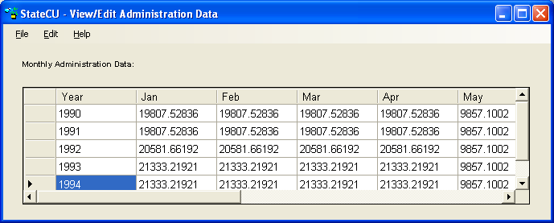

Figure 27 – View/Edit Administration Data Window

3.5.2.4 View/Edit Soil Moisture Variables

The **Soil Moisture Option** button (only available for a *Structure Scenario*) on the **Model Control Options** window activates the **Soil Moisture Variables** window (**Figure 28**) which displays the information and parameters that control modeling of soil moisture in a StateCU execution.

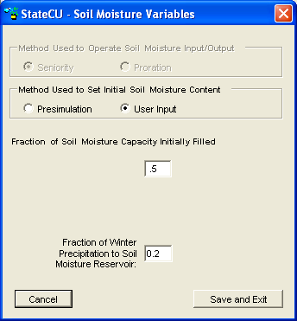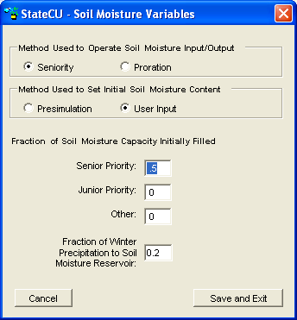

**Figure 28 - Soil Moisture Variables Window (with and without Water Rights)**

If the **Water Rights** option under the **Model Control Options** window is selected (see Section 3.5.2), the user can select an option in this window to operate the soil moisture reservoir on a ‘senior priority water first’ basis. If the **Seniority** option is selected, then any senior priority water available to the soil moisture reservoir is allowed to displace junior priority water existing in the reservoir. This option also allows the senior priority water in the soil moisture reservoir to be used (withdrawn) prior to the use of junior priority water. The effect of this **Seniority** option is to potentially increase the amount of consumptive use assigned to the senior priorities. If water rights are not being considered or the **Seniority** option is not selected, then the soil moisture reservoir will be operated on a ‘prorated’ basis. In **Proration** operation, soil moisture will be filled with the first available water and there will be no displacement of water already in storage. If considering water rights, soil moisture will be used under **Proration** operations based on the proportion of soil moisture in the various accounts. For example, if 10 acre-feet was withdrawn from a soil moisture reservoir where the senior priority soil moisture comprised 30 percent of the soil moisture and the junior priority soil moisture was 70 percent, then 3 acre-feet would be considered senior priority water and 7 acre-feet would be considered junior priority water.

The user can also select an option to allow initial soil moisture to be either set based on a **Presimulation** (of the same number of years as the true simulation) or by **User Input** values. The **Presimulation** mode starts out with soil moisture contents at zero and through a consumptive use simulation, allows the ending soil moisture values on a structure-by-structure basis to be assigned as the initial soil moisture values for the simulation. If **User Input** values are used, the user-defined percentages should add up to the percentage of total soil moisture estimated to be full at the start of the simulation. If considering water rights, the user is given an option of setting the percentages of the soil moisture capacity filled with **Senior Priority** (to the user-defined administration number) water, **Junior Priority** water, or **Other (**water not assigned to a priority). The user-defined values are applied in a consumptive use simulation to each structure being analyzed, regardless of that structure’s mix of junior and senior water rights.

The user can also choose to consider **Winter Precipitation to Soil Moisture** by entering the percentage of winter precipitation to be attributed to the soil moisture. The default is 20 percent, indicating a maximum of 20 percent of winter precipitation will be stored in soil moisture depending on available soil reservoir capacity. See Section 4.1.2.2 for details regarding the use of winter precipitation. To save changes, select the **Save and Exit**command button and then select the **Save** or **Save As…** command from the **Model Control Parameters** window. The save reloads the simulation input data files.

#### 3.5.3 Climate Station Information

The **Climate Station Information** window allows the user to view and edit location information and climate data for a selected climate station. An example is shown in **Figure 29** for a *Climate Station Scenario*. The **Climate Station Information** window is similar under both scenarios except for the following differences under a *Structure Scenario*:

* A field location can not be added. This option is only available under a *Climate Station Scenario* and allows the user to apply weighted climate station data and an orographic adjustment to climate station data (see Section 4.1.7).
* Climate station assignments and the crop types and acreages are associated with the actual structure and therefore viewed through the **Structure Information** window.

Each climate station is identified by its name, station ID, and a column indicating whether the climate station is included in the current scenario (see the **Help…About Climate Stations** menu for more information). To view and edit the climate station location information, select a climate station from the list and then view or edit the **Location1** (e.g. county), **Location2** (e.g. USGS Hydrologic Unit Code), **Latitude**, and **Elevation** data directly from the **Climate Station Information** window. With a daily consumptive use method, the **Temperature Instrument Height** and **Wind Instrument Height** can also be edited (entered in feet). If the user does not provide a temperature or wind instrument height, then the standard heights specified for the CoAgMet stations are used (4.92 feet = 1.5 meters for the temperature instrument and 6.56 feet = 2.0 meters for the wind instrument).

Changes made to any of the parameters under the Climate Station Data or Field Data entries must be saved before selecting a different climate station or field location from the list box. When the **Save** or **Save As…** command is selected from the **File** menu, the user will be prompted for a new climate station assignments (*.cli) file name and associated response file name. The climate station assignments file name is written to the response (*.rcu) file.

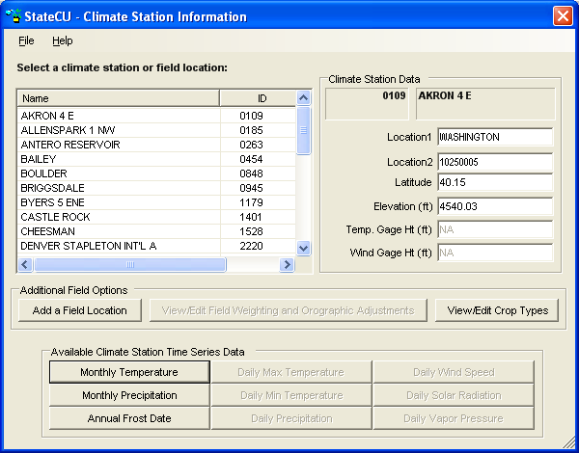

**Figure 29 – Climate Station Information Window with a *Climate Station***

3.5.3.1 View/Edit Historical Climate Data

To view the monthly climate data, select a climate station from the list in the **Climate Station Information** window and then click on one of the data buttons under the **Available Climate Station Time Series Data** group. An example of the **Monthly Precipitation** window and results displayed from the **View…Graph** menu are provided in **Figure 30**. The other daily and monthly data windows are similar.

The user has the ability to edit the climate data through this window. See Section 3.5 for information on how to edit data through the GUI. When **Save** or **Save As…** is selected, the user will be prompted for a climate data file name (e.g. *.prc, *.tmp) and associated response file name. The new crop distribution file name is written to the response (*.rcu) file.

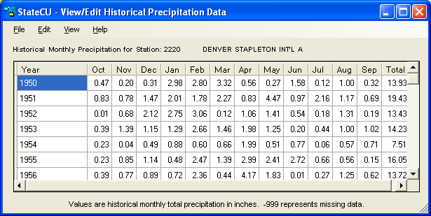



Figure 30 –View/Edit Historical Climate Data

***3.5.3.2 View/Edit Crop Types***

With a *Climate Station Scenario*, the crop types are associated directly with the climate station (or field location if one has been added) and the analysis is performed on a unit acreage basis. With a *Structure Scenario*, the crop types are associated with the structure location and the analysis is performed for a specified total acreage and acreages of each crop type (See Section 3.5.4).

To view and edit the crop information, select a climate station from the list in the **Climate Station Information** window and then click the **View/Edit Crop Types** command button. The **View/Edit Crop Acreage Data** window provides the list of all available crop types in the crop characteristic (*.cch) file included in the scenario and the fraction of land associated with each crop type for each year of the analysis period in the upper portion of the window (**Figure 31)**. The lower portion of the window sums the acreage percentages by year and can not be explicitly edited. Editing acreage percentages in the upper portion of the window will change the total acreage in the lower portion of the window. See Section 3.5 for general information on how to edit data through the GUI. Note that for a *Climate Station Scenario,* the sum of all crop percentages must equal 100 percent.

When **Save** or **Save As…** is selected, the user will be prompted for a new crop distribution (*.cds) file name and associated response file name. The new crop distribution file name is written to the response (*.rcu) file.

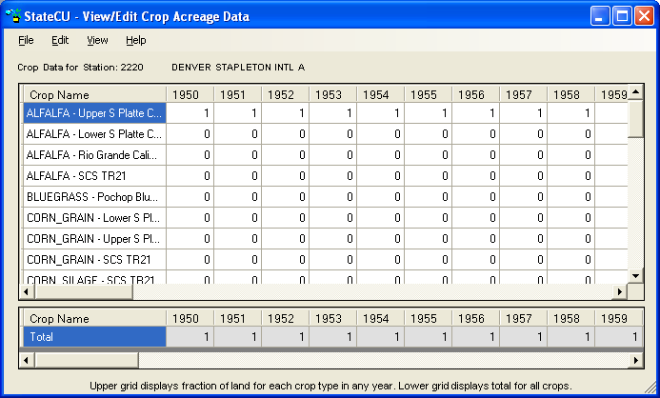

Figure 31 – Crop Information Window for a *Climate Station Scenario*

***3.5.3.3 Field Location***

Climate station data typically represent climate data at the location of a climate station. With a *Climate Station Scenario*, a field location can be added and climate station data can be adjusted to the field location by specifying a latitude and elevation that are representative of the field location, assigning climate data from an individual climate station or weighting data from up to five different climate stations, and/or applying an orographic adjustment. Select the **Add a Field Location** from the **Climate Station Information** window to input a new field location in the **Climate Station Assignment** window (**Figure 32**).

* **Field ID and Field Name** – A unique **Field ID** and **Field Name** must be assigned by the user. Note that the Field ID can contain a combination of letters and numbers but no spaces. The Field ID can not be the same as a climate station ID included in the scenario.
* **Latitude and Elevation** – If latitude and elevation are not provided by the user, the program uses the latitude and elevations of the climate station(s) assigned (if more than one climate station is assigned, StateCU will calculate a latitude based on the temperature weights and the associated climate station latitudes).
* **Climate Station ID/Name** – If a climate station was highlighted when the **Add a Field Location** command button was selected, then the first climate station listed in the **Climate Station Assignment** window is the highlighted station. Climate stations can be added or changed by selecting from the dropdown list of available stations.
* **Station Data Weighting** – StateCU calculates the temperature and precipitation data for the field location using the data from each climate station assigned (up to five different stations), proportioned by the associated station weights (fractions), as described in Section 4.1.7. With a daily analysis, a weight (fraction) is specified for weighting the precipitation data and a temperature/other (fraction) is used to weight all of the other climate data. The GUI provides a warning but allows the user to continue if the weights for a given parameter (i.e. temperature data or precipitation data) do not each sum to 1.0.
* **Orographic Adjustment** – With a monthly consumptive use analysis method (Modified Blaney-Criddle, Original Blaney-Criddle, or Pochop), if elevations are provided for both the field location and the assigned climate station(s), then a temperature orographic adjustment can be used to adjust the monthly temperature data to the field location, as described in Section 4.1.7. This option is only available once a field elevation is provided, and must be turned on by selecting the **On/Off** option for the associated climate station(s). If the user chooses to apply an orographic adjustment to precipitation data, enter a factor that represents the average annual precipitation at the field location compared to the average annual precipitation at the climate station. This factor is applied to monthly precipitation data. When the orographic adjustment is initially turned ‘on’ through the StateCU GUI, the GUI displays the default temperature adjustment of 3.6 degrees Fahrenheit per 1,000 feet and the default precipitation adjustment of 1.0 (no adjustment). These default adjustments can be changed and saved through the GUI. An orographic adjustment is not currently allowed for the daily ASCE Standardized Penman-Monteith method.

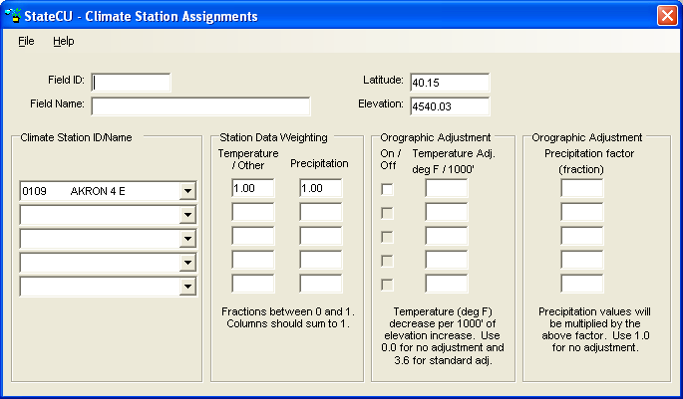

Figure 32 – Climate Station Assignments Window

When the **Save** or **Save As…** command is selected from the **Climate Station Assignments** window, the **Crop Information** window is activated allowing the user to input crop and acreage information to the new field location. Initially the GUI assigns the crop type for the new field location to the crop type associated with the first climate station assigned. The crop information can be edited in the Crop Information window as discussed in Section 3.5. When the **Save** or **Save As…** command is selected from the **Crop Information** window, the changes are made to the structure information (*.str) and crop distribution (*.cds) files and both files are written to the response (*.rcu) file.

Once a field location is created, it is added to the list of climate stations in the **Climate Station Information** window, and the climate stations and station data weighting can be viewed and edited by selecting the **View/Edit Field Weighting and Orographic Adjustment** command button from the **Climate Station Information** window.The associated crop distribution information can be viewed and edited by selecting the **View/Edit Crop Types** command button.The proportioned climate data can not be viewed directly – only the data associated with the climate stations used to create the field location can be viewed by selecting the original climate station(s) from the **Climate Station Information** window.Note that if the user does not provide a latitude for the field location (on the **Climate Station Information** window), the program will calculate a weighted latitude based on the latitude of the individual climate stations and the user-specified temperature weights.

#### 3.5.4 Structure Information

The **Structure Information** window (**Figure 33**) is only available for a *Structure Scenario* and allows the user to view and edit information from the input files required to define structure-specific parameters. These files include the structure location information (*.str) file, the parcel crop distribution (*.cds) file, the historic direct diversion (*.ddh) file, the water rights (*.ddr) file, the irrigation parameter yearly data (*.ipy) file, and the ground water pumping volume data (*.pvh) file. To revise information associated with a structure, select the structure from the structure list. The following should be noted when editing the structure information:

* **Structure Information** – The user can view and edit location identifiers (Location1, Location 2) typically representing County and USGS Hydrologic Unit Code respectively, in addition to latitude, elevation, and soil moisture capacity. If latitude is not provided, the program uses the latitude of the climate station(s) assigned. If soil moisture is not entered, no soil reservoir capacity will be estimated for the structure.
* **Climate Station Assignments** – Climate station assignments for a structure can be viewed and edited.
* **Historical Surface Water Diversion –** Historic surface water supply data for a structure can be viewed and edited. Missing data is indicated by a -999 value.
* **Historical Ground Water Pumping Data** – Historic ground water supply data for a structure can be viewed and edited. Missing data is indicated by a -999 value.
* **Crop Acreage Data –** Crop types and acreage for a structure can be viewed and edited.
* **Efficiency Information –** Conveyance and irrigation efficiency information for a structure can be viewed and edited.
* **Irrig. Method and Max Pumping Rate Data –** Irrigation method (flood or sprinkler), water source (surface water or ground water) information, ground water mode and monthly pumping limits for a structure can be viewed and edited.
* **Water Rights Information –** If a water rights analysis has been chosen, water rights associated with a structure can be viewed (non-editable) in the **Water Rights Information** box in the lower right corner of the **Structure Information** window.

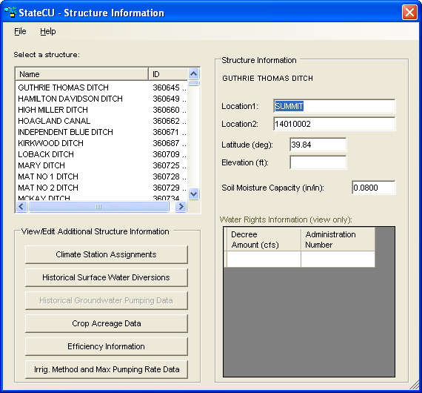

Figure 33 – Structure Information Window

When the **Save** or **Save As…** command is selected from the **Structure Information** window, only changes made to the location information are saved. The new structure location (*.str) file name is written to the response (*.rcu) file. Changes made to any of the other structure information related windows which are accessed from the **Structure Information** window must be saved directly under the associated windows.

3.5.4.1 Climate Station Assignments

The **Climate Station Assignments** window is similar to the window used to add a field location under a *Climate Station Scenario* (Section 3.5.3.3 & **Figure 32**). It allows the user to view and modify the climate stations and weights assigned to each structure. With a monthly consumptive use analysis, StateCU calculates the temperature and precipitation data for a structure using the data from each selected climate station, proportioned by the associated weights (fractions). With a daily consumptive use analysis, StateCU calculates the maximum temperature, minimum temperature, wind speed, solar radiation, and vapor pressure for a structure using the data from each selected climate station, proportioned by the associated ‘Temperature/Other’ weights and the precipitation is calculated using the ‘Precipitation’ weights.

With a *Structure Scenario* and a monthly consumptive use analysis method (Modified Blaney-Criddle, Original Blaney-Criddle, or Pochop), the user has the option to adjust temperature and precipitation data through orographic adjustments. If elevations are provided for both the structure and the assigned climate station(s), then a temperature orographic adjustment can be used to adjust the monthly temperature data to a structure, as described in Section 4.1.7. Select **On/Off** options for each climate station under the **Climate Station Assignments** window for the selected structure to turn temperature and precipitation orographic adjustments on or off.

If the user chooses to apply an orographic adjustment to precipitation data, enter a factor that represents the average annual precipitation at the structure compared to the average annual precipitation at the climate station. This factor is applied to monthly precipitation data. When the orographic adjustments are initially turned ‘on’ through the StateCU GUI, the GUI displays the default temperature adjustment of 3.6 degrees Fahrenheit per 1,000 feet and the default precipitation adjustment of 1.0 (no adjustment). These default adjustments can be changed and saved through the GUI. An orographic adjustment is not currently allowed for the daily ASCE Standardized Penman-Monteith method.

When **Save** or **Save As…** are selected from this window, the user will be prompted for a new structure location (*.str) file name and the associated response file name. The new structure location file name will be written to the response (*.rcu) file.

##### 

3.5.4.2 View Historical Surface Water Diversions

The **View/Edit Historical Diversion Data** window allows the user to view historic water supply data for the selected structure under the **Structure Information**window (**Figure 34**). Monthly surface water supply data is displayed for each year contained in the historical direct diversion (*.ddh) file. The user has the ability to edit the diversion data through this window. See Section 3.5 for general information on how to edit data through the GUI.

When **Save** or **Save As…** are selected from this window, the user will be prompted for a new historical direct diversion (*.ddh) file name and the associated response file name. The new historical direct diversion file name will be written to the response (*.rcu) file.

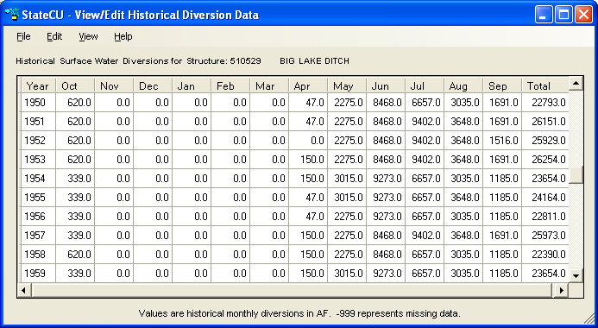

**Figure 34 – View/Edit Historic Diversion Data Window**

***3.5.4.3 View Historical Ground Water Pumping Data***

The **View/Edit Historical Pumping Data** window allows the user to view historic pumping data for the selected structure under the **Structure Information**window. Note that the user must select the Ground Water Analysis Option in the **Model Control Options** window to enable the **Historical Ground Water Pumping Data** button. Monthly pumping data is displayed for each structure contained in the ground water pumping file (*.pvh) file. Note that pumping data is not required for all structures listed in the structure file (*.str). The pumping data window is similar to the historical diversion data window, as shown in **Figure 34**, in both display and functionality. The user has the ability to edit, copy, paste, graph and save pumping data through the same methods as described in Section 3.5.

***3.5.4.4 View/Edit Crop Acreage Data***

The **View/Edit Crop Acreage Data** window with a *Structure Scenario* is similar to the window used to view the crop types assigned to a climate station or field location with a *Climate Station Scenario*, except it reflects actual irrigated acreage, not percentages (**Figure 35**). With a *Structure Scenario*, the total acreage is specified and the portion of each crop type is specified as acres. For a given year, the GUI requires the sum of the acreage under each crop type to equal the total acreage. The **View/Edit Crop Acreage Data** window displays the crops for which there is acreage data at the top of the crop list in the upper portion of the window. The lower portion of the window sums the acreage by year and can not be explicitly edited. Editing acreage in the upper portion of the window will change the total acreage in the lower portion of the window. Note that only crops included in the crop characteristic and crop coefficient files are shown and can be assigned acreage. See Section 3.5 for general information on how to edit data through the GUI.

When the **Save** or **Save As…** command is selected from the **Crop Information** window, the changes will be made to the crop distribution (*.cds) file and the new file name will be written to the response (*.rcu) file.

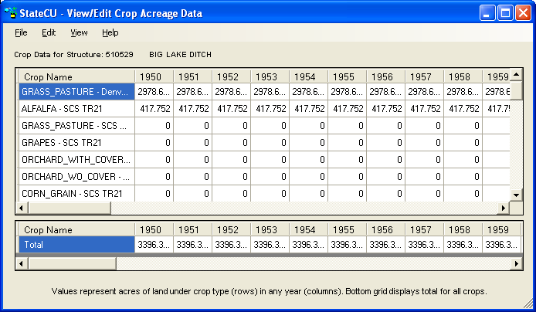

**Figure 35 – Crop Information Window with a *Structure Scenario***

***3.5.4.5 View/Edit Historical Efficiency Data***

The **Water Use Efficiencies** window (**Figure 36**) allows the user to view and edit the annual conveyance and maximum irrigation efficiencies for the selected structure under the **Structure Information**window. Enter annual canal conveyance efficiency, maximum flood irrigation application efficiency and maximum sprinkler irrigation application efficiency parameters for each structure. The user has the ability to edit the efficiency data through this window. See Section 3.5 on general information on how to edit data through the GUI. Efficiency data must be input as a decimal (values 0 through 1 are allowable). Missing efficiency data (-999) is not allowed in the irrigation parameter yearly data file (*.ipy).

When **Save** or **Save As…** is selected, the user will be prompted for a new irrigation parameter yearly data (*.ipy) file name and associated response file name. The new irrigation parameter yearly file name will be written to the response (*.rcu) file.

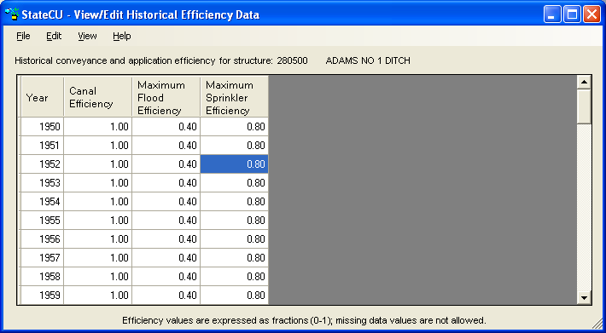

Figure 36 – View/Edit Historical Efficiency Data Window

***3.5.4.6 View/Edit Irrigation Method and Maximum Pumping Rate Data***

The **View/Edit Historical Irrigation Method Data** window (**Figure 37**) allows the user to view and edit annual acreage data associated with source and irrigation application method for the selected structure under the **Structure Information**window.

Acreages associated with surface water-only flood irrigation, surface water-only sprinkler irrigation, surface and ground water flood irrigation, and surface and ground water sprinkler irrigation are stored in the irrigation parameter yearly data (*.ipy) file. If land is only served by ground water, it should be assigned to the surface and ground water categories. The annual acreage data by crop type are stored in the crop distribution (*.cds) file. For a given year, the StateCU GUI requires the sum of the acreages in all four land use categories to equal the total irrigated acreage listed by crop type in the crop distribution (*.cds) file. For comparison, the GUI displays the total irrigated acreage from the crop distribution (*.cds) file next to the Total IPY file acreage column in this window. Any changes to the total irrigated acreage should first be made to the crop distribution file under the **Crop Acreage Data** window (Section 3.5.4.4). Once the revised total irrigated acreage by crop type is saved through the **Crop Acreage Data** window, the user can revise the acreage listed under the four land use categories in the **View/Edit Historical Irrigation Method Data** window. If the acreages listed in the irrigation parameter yearly file do not match the acreage stored in the crop distribution file, StateCU will scale the *.ipy acreages to match the *.cds acreages during the consumptive use analysis. The scaled data will not override the data stored in the irrigation parameter yearly file. After running StateCU, the log file will list the number of structures that were scaled to match. The maximum pumping rate and ground water mode can also be viewed and edited from this window. See Section 4.3 for information on ground water modes 1, 2 and 3. Note that data associated with ground water supply in the *.ipy file will only be considered in a structure scenario when the ground water supply option has been set in the Model Control Options window (see Section 3.5.2).

The user has the ability to edit the *.ipy acreage, pumping and ground water mode data through this window. See Section 3.5 for general information on how to edit data through the GUI. The user can not edit the Total CDS file acreage through this window; it is displayed as a comparison to the Total IPY file acreage data. No negative acreage data can be stored in the irrigation parameter yearly file.

When **Save** or **Save As…** is selected, the user will be prompted for a new irrigation parameter yearly data (*.ipy) file name and associated response file name. The new irrigation parameter yearly data file name will be written to the response (*.rcu) file.

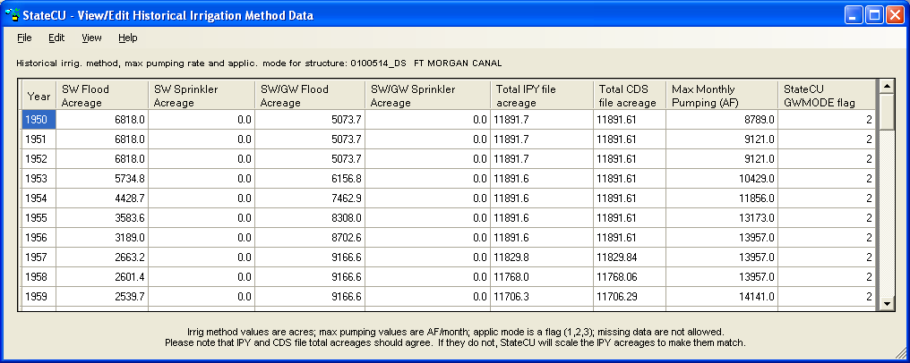

Figure 37 – View/Edit Historical Irrigation Method Data

#### 3.5.5 Crop Characteristics/Coefficients

The **Crop Characteristics/Coefficients** window (**Figure 38**) displays information contained in the crop characteristics file (*.cch). The user can revise the criteria that set the beginning and ending of the growing season, other growing season constraints, maximum root zone depth, and maximum application depth for each crop and cutting parameters for alfalfa by selecting the crop from the croplist. The beginning and ending of the growing season specifications are compared to the other growing season constraints to determine the actual beginning and ending of growing season applied with the model. The latest date is used for the beginning of the growing season and the earliest date is used for the end of the growing season. For example, if the Earliest Growing Season Start Date is specified as May 15 and the Begin Growing Season Specification based on temperature results in a start date of April 28, the Earliest Growing Season Start Date is used.

Individual parameters for a selected crop type can be revised by using the radio controls and entering new information. Crop characteristics associated with a crop type that was not included in the loaded dataset can not be created through the GUI but rather must be added to the crop characteristic file through a text editor or StateDMI. When **Save** or **Save As…** is selected from this window, the user will be prompted for a new crop characteristic file name and the associated response file name. The new crop characteristic file name will be written to the response (*.rcu) file.

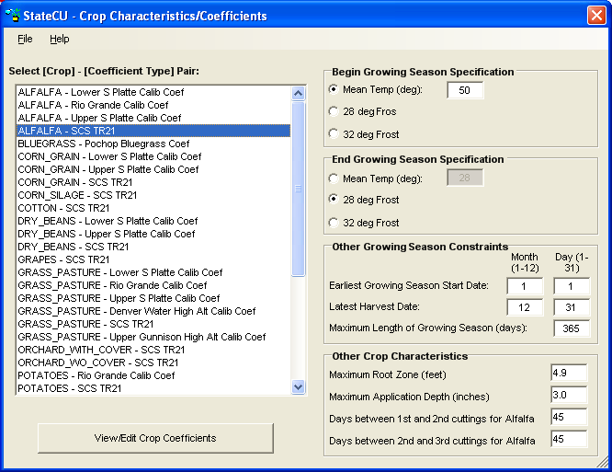

Figure 38 – Crop Characteristics/Coefficients Window

3.5.5.1 View/Edit Crop Coefficients

The **View/Edit Crop Coefficients** command button activates the **Crop Coefficients**window**(Figure 39)** whichdisplays the crop coefficients for the selected crop type. Crop coefficients are developed for a particular consumptive use method (e.g. Original Blaney-Criddle, Modified Blaney-Criddle, Pochop, or ASCE Standardized Penman-Monteith) which is specified in the crop coefficient file. The StateCU GUI displays the ‘valid’ consumptive use methods for a selected crop type and does not allow the user to switch between methods except to add or take away the elevation adjustment within the Modified or Original Blaney-Criddle methods. Note that the elevation adjustment is specified for a particular crop type, as discussed in Section 4.1.1.2. If an elevation adjustment is specified for the ALFALFA.TR21 crop coefficients, then the elevation adjustment is applied to the ALFALFA.TR21 portion of the scenario for any climate station (under a *Climate Station Scenario*) or structure (under a *Structure Scenario*) with the crop type of ALFALFA.TR21 specified. Crop coefficients associated with a crop type that was not included in the loaded dataset can not be created through the GUI, but rather must be added to the crop coefficient file through a text editor or StateDMI.

The user has the ability to edit the crop coefficient information through this window, however can not edit the Day of Year or the Percent of Season column. See Section 3.5 for general information on how to edit data through the GUI. Note that the Add and Scale functions are disabled for this data type.

When **Save** or **Save As…** is selected from this window, the user will be prompted for a new crop coefficient file name (*.kbc) and the associated response file name. The new crop coefficient file name will be written to the response (*.rcu) file.

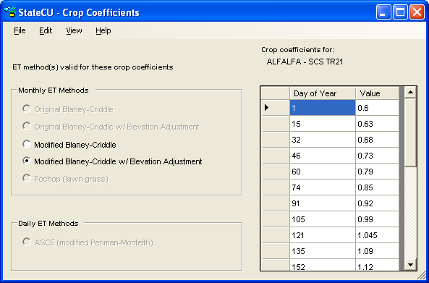

Figure 39 – Crop Coefficients Window

### 3.6 Run Menu

The **Run Simulation** command is activated once a dataset has been loaded. When a run is initiated, the StateCU GUI shells out to a DOS window to execute the StateCU program. The process status and any warning or error messages are displayed in the DOS window during StateCU execution. If the execution is successful, the DOS window will either close automatically or prompt the user to press the Enter key, and the user will be returned to the GUI to view output (Section 3.7 below). If the execution is unsuccessful, the StateCU generated log file will be displayed on the screen with a description of the error that caused the program to terminate. The user should view the **StateCU Fortran Program Log File** located in the **Results** menu or through a text editor even with a successful execution, as it may contain warnings or other pertinent information.

### 3.7 Results Menu

The **Results** menu options (**Figure 40**) allow the user to access the following output files:

* **Input Summary File** (*.sum)
* **StateCU Model Log File** (*.log)
* **Detailed CU Output File** (*.obc or *.opm)
* **Detailed Water Budget Output File** (*.dwb)
* **Detailed 4 Land Category Water Budget Output File** (*.4wb)
* **Scenario Water Budget Output File** (*.swb)
* **Time Series Data Report Generator** (*.bd1)

Note that the Detailed CU Output File has an extension of *.obc for the monthly consumptive use methods (Modified Blaney-Criddle, Original Blaney-Criddle, or Pochop) and an extension of *.opm for the daily ASCE Standardized Penman-Monteith method. The output files available under the **Results** menu depend on the settings under the **More Options** tab of the **Model Control Options** window (Section 3.5.2). The StateCU FORTRAN model generates all the output file options, with the exception of the Report Generator, and the GUI opens these output files using Microsoft Notepad. Section 6.0 discusses the each of these FORTRAN output options in detail. The **Time Series Data Report Generator** is discussed below in Section 3.7.1.

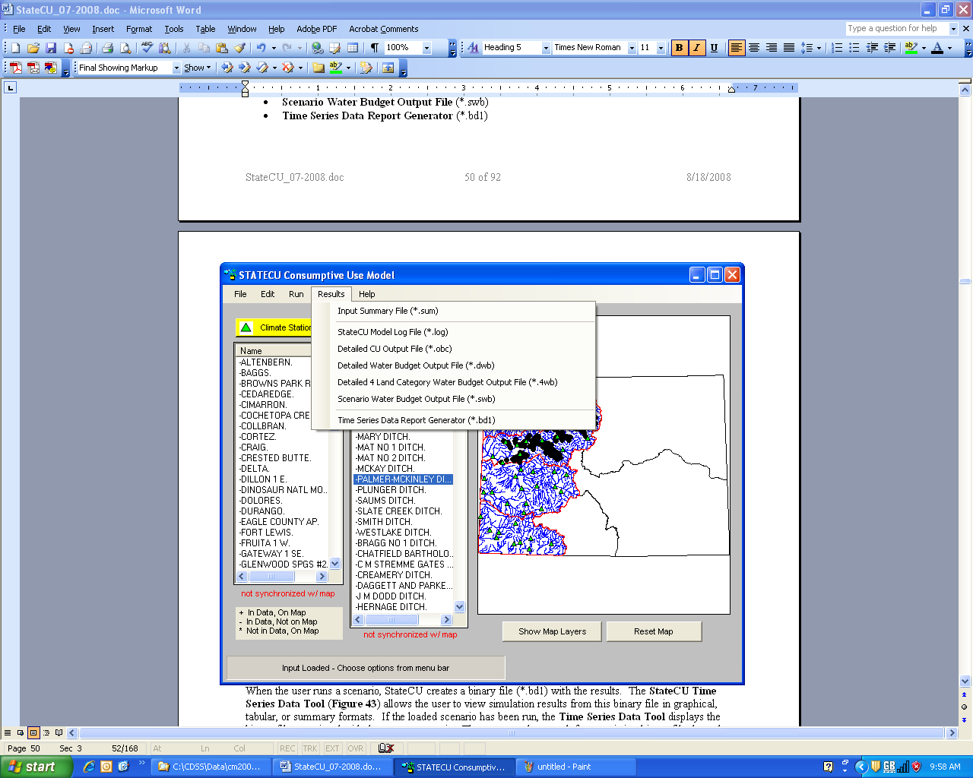

Figure 40 – Results Menu Commands

#### 3.7.1 Time Series Data Report Generator

When the user runs a scenario, StateCU creates a binary file (*.bd1) with the results. The **StateCU Time Series Data Tool** (**Figure 41**) allows the user to view simulation results from this binary file in graphical, tabular, or summary formats. If the loaded scenario has been run, the **Time Series Data Tool** displays the binary file associated with the current scenario. The user can also search for an existing binary file through either selecting the **Browse for File** command button. Using this approach, results from multiple scenario runs can be compared.

Once a binary file is loaded, the user can view data associated with a climate station or structure by selecting the **Add Row from Data Source** command button. Once a row has been added, clicking on the **ID (Name)** field will provide the user with a list of available climate stations (for a *Climate Station Scenario*) or structures (for a *Structure Scenario*), or the user can select ‘All Structures’ stored in the binary file. The user must select one of the climate stations or structures in the list or other summary structure options to populate the **ID (Name)** field. Clicking on the **Data Type** field will provide the user with a list of available data for the current input dataset. Again, the user must click on one of the data types in the list to populate the **Data Type** field. The **Begin Year** and **End Year** can be selected to view a subset of the available period of record. Repeat the process discussed above to add as many rows as desired. The user can choose to save a created list of structures and data types by selecting the **Save Current Record Set** option under the **File** menu. The user can delete a series from the graph template by clicking on a row and selecting the **Delete Selected Row** command button or delete all rows by selecting the **Delete All Rows** command button. Select the **Open Existing Record Set** from the **File** menu to reload a previously created template.

The list of available data types is dependent upon the type of scenario, level of analysis and modeling options use to create the simulation binary file, as defined in the CU control file. Options may include: potential consumptive use, water supply limited consumptive use, surface water supply, ground water supply, consumptive use from direct diversions, consumptive use from ground water, consumptive use from soil reservoir, calculated surface water efficiencies, and calculated ground water efficiencies. Ground water output options are available only for scenarios that include ground water input data. Note that some output types and reports have restrictions on the number of structures or data types that can be included in the report or summary.

Note that under a daily analysis (e.g. ASCE Standardized Penman-Monteith), only the monthly totals can be viewed through the Time Series Data Tool. Daily results can be viewed from the *.opm output file.

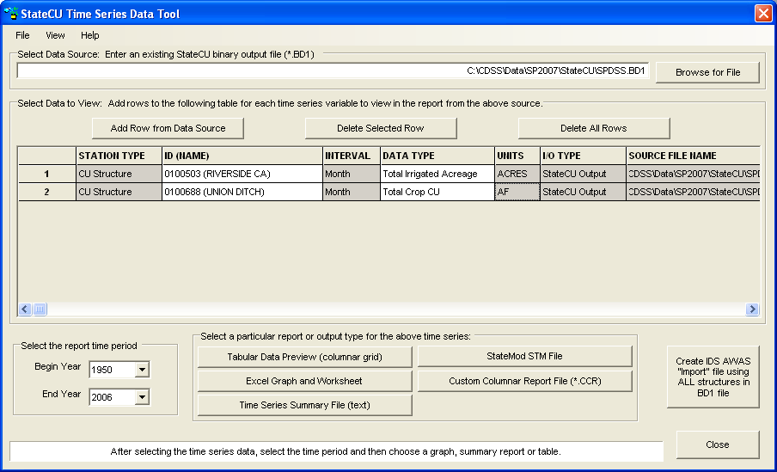

Figure 41 - Time Series Data Tool

To create and view a graph, select the **Excel Graph and Worksheet**command button. The **Tabular Data Preview, Time Series Summary File**, and **StateMod STM File** command buttons can also be selected to view and save the data in tabular and summary formats used in the State’s other DMIs. The **Custom Columnar Report File** command is used to view and compare two or more columns of data generated for one structure. Select the **Create IDS AWAS ‘Import’ File** button to format the data from all structures stored in the binary file into AWAS import files for use in an IDS AWAS analysis. Data stored in a binary file can also be viewed through TSTool. To view the binary file in TSTool, open the TSTool application, select ‘StateCUB’ as the input type, and navigate to the *.bd1 file through the standard ‘Open File’ window. The available binary file parameters can then be accessed, modified and viewed through TSTool.

##### 3.7.1.1 Times Series Graph and Worksheet

The StateCU GUI uses Excel to display graphical results (**Figure 42**) selected when the **Time Series Graph (Excel)**command button is selected from the **Time Series Data Tool**. The StateCU GUI opens Excel in a separate window and the time series data are provided under a worksheet labeled **Data**. Each row specified under the **Time Series Data Tool** is provided in a separate column of the Excel worksheet, and labeled with the **ID (Name)**, **Data Type**, **Units**, and the binary file name and path. A single graph displaying all of the exported data is provided under a separate worksheet labeled **Graph**. Note that units may not be consistent. The StateCU GUI does not automatically save the results exported to Excel, however the Excel window will prompt the user for changes before closing. If Excel is not available on the user’s computer, the **Time Series Graph** option is not available.



Figure 42 – Time Series Data Tool Graphical Results

##### 3.7.1.2 Tabular Data Preview

The StateCU GUI displays data in tabular format (**Figure 43**) when the **Tabular Data Preview** command button is selected from the **Time Series Data Tool**. The StateCU GUI opens a separate window displaying each row specified under the **Time Series Data Tool** in a separate column labeled with the **ID (Name)**, **Data Type**, **Units**, and the binary file name and path. The tabular results can be saved to a tab-delimited text file by selecting the **Export Data** command button. View the tabular data using Excel by selecting the **Time Series Graph and Worksheet** button or view a text file of the data using Notepad by selecting the **Times Series Summary** **File** button, both located at the bottom of the **Time Series Table** window. Data can not be saved through the tabular preview window; however the data can be saved through each of the viewing and exporting options available at the bottom of the window. Select the **Close** button to return to the **Time Series Data Tool** window.

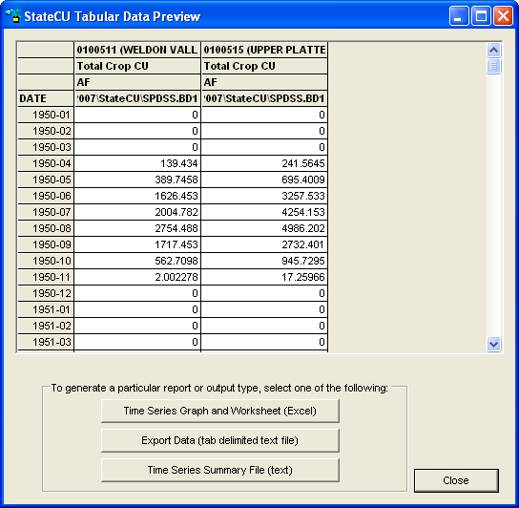

Figure 43 – Time Series Table

##### 3.7.1.3 Time Series Summary

The StateCU GUI uses Microsoft Notepad to display summary results (**Figure 44**) when the **Time Series Summary File**button is selected from the **Time Series Data Tool**. The StateCU GUI opens Notepad in a separate window. Each row specified under the **Time Series Data Tool** is provided as a standard summary report within the file, similar to that used by the State’s other DMIs. The StateCU GUI does not automatically save the results exported to Notepad. To save results, the user must save the summary report from Notepad before closing the Notepad window.

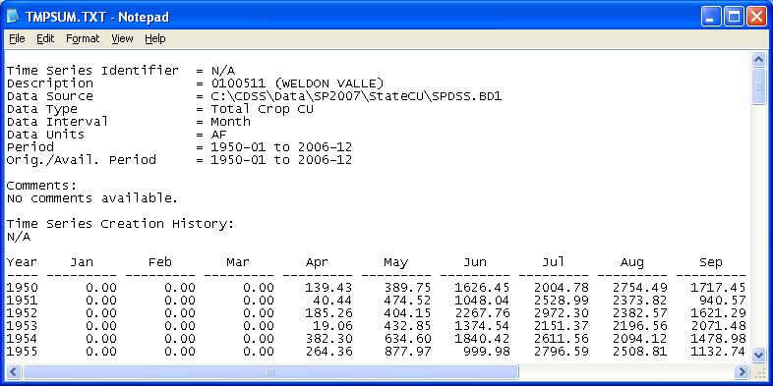

Figure 44 –Time Series Summary File

##### 3.7.1.4 StateMod STM File

Model results can be output as a StateMod formatted file (*.stm) by selecting the **StateMod STM File** button from the **Time Series Data Tool**. The **StateMod STM File** command is not used to display data, only to format and save data in a standard format used by the State’s other DMIs. The created *.stm file includes comments on StateCU report options used to generate the output, the name of the structure, data type, time period and file path name. A single StateMod output file can contain data from multiple CU Structures, however the same Data Type must be selected for each CU Structure (e.g. create one *.stm file containing irrigation water requirement data and a separate *.stm file containing total consumptive use). The *.stm file can be viewed through a text editor.

##### 3.7.1.5 Custom Columnar Report File

Simulation results for a single structure can be output to a custom column report (*.ccr) file by selecting the **Custom Columnar Report File** button from the **Time Series Data Tool**. This command is not used to display data, only to format and save data in a column format to compare multiple data types for a single structure. The created *.ccr file includes comments on StateCU report options used to generate the output, the name of the structure, data type(s), time period and file path name. The *.ccr file can be viewed through a text editor; an example *.ccr is shown in **Figure 45**.

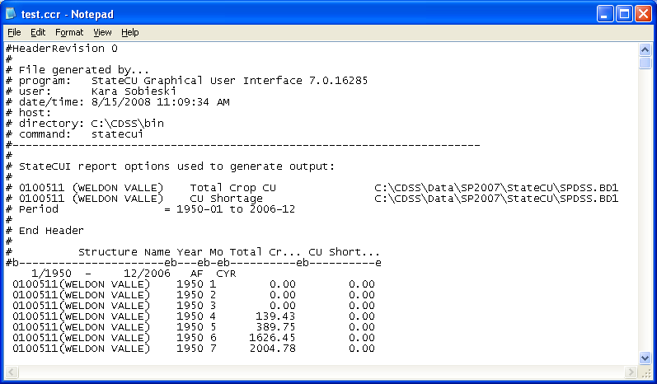

Figure 45 –Custom Columnar Report File

##### 3.7.1.6 IDS AWAS ‘Import’ File

The user can export monthly pumping and non-consumed applied water estimates from the **Time Series Data Tool** in a format that can be imported directly to the IDS Alluvial Water Accounting System (AWAS) program. IDS AWAS can then estimate the lagged stream depletions and accretions data based on user-specified aquifer parameters (e.g. Glover, SDF factors). The user can not specify which structures to include with this option; all structures available in the binary file will be included in the AWAS ‘Import’ file. For more information on the IDS AWAS program, see the Integrated Decision Support Group webpage at [www.ids.colostate.edu](http://www.ids.colostate.edu). The IDS AWAS ‘Import’ file creation command is currently supported by version of IDS AWAS, Version 1.5.36. IDS personnel have indicated that future versions of IDS AWAS will continue to support this feature. Note that non-consumed applied water does not include water lost during conveyance to the farm.

After loading the binary file, click on the **Create IDS AWAS ‘Import’ File** button. The GUI opens a window in which the user can rename the AWAS ‘Import’ file and indicate the directory to save the text file to. The GUI then opens a window asking the user to enter the percentage of unused water that is unlagged surface return flows (**Figure 46**). The default is zero percent; however the user can override the default with another percentage value then click **OK**. Note that the portion of unused water that is designated as unlagged surface return flows is assigned an SDF factor of zero, indicating immediate surface returns. Aquifer parameters can be edited in the AWAS program. The AWAS ‘Import’ file is then created and consists of three time series files; ground water pumping data, unlagged surface water return flow data, and lagged ground water return flow data. These time series are ready to be imported into the IDS AWAS program. An example of this file is shown in **Figure 47**. See Section 8.16 for more information on creating an AWAS ‘Import’ file.

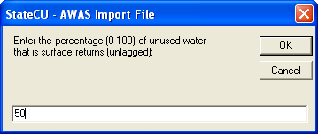

Figure 46 – AWAS Import File – Surface Return Flow Percentage

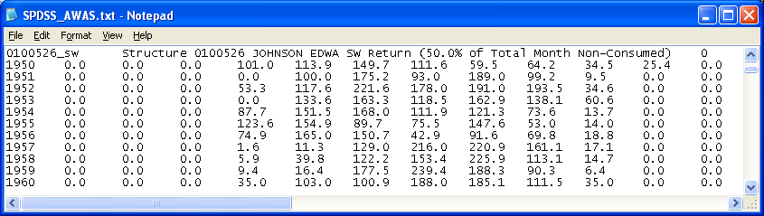

Figure 47 – AWAS Import File

**3.8 Help Menu**  
The **Help** menu (**Figure 48**) commands allow the user to display the software version information (**About StateCU**) and information about the default map features (**About Map Features)**. The information shown under each of these options is only for the user’s information, no input parameters can be edited through these commands.

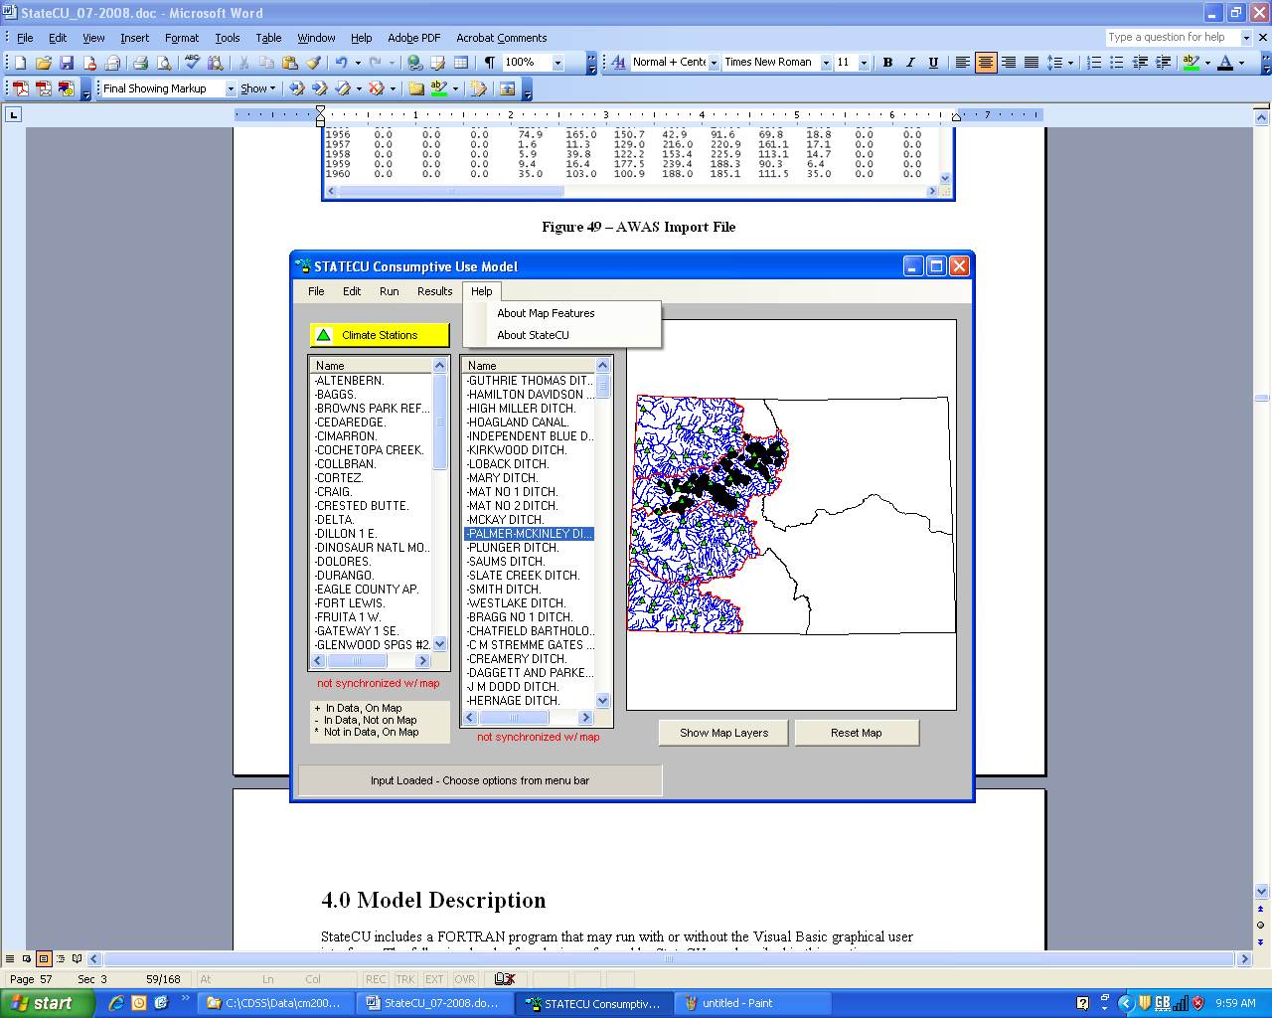

Figure 48– Help Menu Commands

## 4.0 Model Description

StateCU includes a FORTRAN program that may run with or without the Visual Basic graphical user interface. The following levels of analysis performed by StateCU are described in this section:

4.1 Crop Irrigation Water Requirement by CU Location

4.2 Water Supply Limited Crop Consumptive Use by Structure

4.3 Water Supply Limited Crop Consumptive Use by Structure Considering Ground Water

4.4 Water Supply Limited Crop Consumptive Use by Structure and Priority

4.5 StateCU Advanced Modeling Options

### 4.1 Crop Irrigation Water Requirement by Location

Monthly crop evapotranspiration (ET), or potential consumptive use (PCU), can be determined at a specific location (climate station, structure, farm, etc.) using the Soil Conservation Service (SCS) Blaney-Criddle method outlined in Irrigation Water Requirements Technical Release 21 (SCS TR-21, 1970), the FAO-24 original Blaney-Criddle method (FAO, 1977), or the Pochop Method for bluegrass outlined in Elevation – A Bias Error in SCS Blaney-Criddle ET Estimates (ASAE, 1984). Daily ET can be determined using the Penman-Monteith, ASCE Standardized Penman-Monteith, or Modified Hargreaves approach. The potential consumptive use for a CU location is determined based a unit acreage and corresponding crop type assigned to a climate station (*Climate Station Scenario*) or an actual acreage and crop types associated with a structure (*Structure Scenario*).

The potential crop consumptive use estimates can be reduced by an amount of monthly or daily precipitation considered effective at serving crop needs to determine the irrigation water requirement. In the case of a monthly consumptive use method, only monthly effective precipitation methods are available. With a daily consumptive use method, both monthly and daily effective precipitation methods are available.

#### 4.1.1 Monthly Potential Consumptive Use

***4.1.1.1 SCS TR-21 Modified or Original Blaney-Criddle Method***

StateCU allows either the SCS TR-21 modified Blaney-Criddle or the original Blaney-Criddle procedure to estimate monthly evapotranspiration (ET). The empirical equation relates ET with mean air temperature and mean percentage daytime hours. The SCS TR-21 method was modified from the original Blaney-Criddle method to reasonably estimate short-period consumptive use. The modifications include the use of (1) climatic coefficients that are directly related to the mean air temperature for each of the consecutive short periods which constitutes the growing season and (2) coefficients which reflect the influence of the crop growth rates on consumptive use rates (SCS TR-21).

The basic relationship assumes that ET varies directly with the products of mean monthly air temperature and monthly percentage of annual daylight hours for an actively growing crop with adequate soil moisture. This is expressed mathematically as:

u = k*f (1)

U = KF = the sum of all k*f (2)

where **U** is the estimated ET in inches for the growing season; **K** is the empirical consumptive use coefficient for the growing season; **F** is the sum of monthly consumptive use factors for the growing season; **k** is the monthly consumptive use crop coefficient by month and crop; u is the monthly consumptive use of the crop in inches; and **f = t * p/100**, where **t** is the mean monthly air temperature and **p** is the mean monthly percentage of annual daytime hours.

The SCS TR-21 modification includes the use of a composite climatic crop coefficient:

K = kt*kc (3)

where **kt = 0.0173t – 0.314** with the modified Blaney-Criddle method and **kt = 1** with the original method; and **kc** is the coefficient reflecting the growth stage of the crop. The values are obtained from the crop growth stage coefficient curves prepared for each crop. Examples of crop curves for 25 crops are provided in SCS TR-21.

***4.1.1.2 SCS TR-21 Modified or Original Blaney-Criddle Method with ET Elevation Adjustment***

The ASCE Manuals and Reports on Engineering Practice No. 70, Evapotranspiration and Irrigation Water Requirements (1990), recommends elevation adjustments for both the SCS and the FAO-24 Blaney-Criddle methods of 10% adjustment upward for each 1,000 meters increase in elevation above sea level. The adjustment corrects for lower mean temperatures that occur at higher elevations at a given level of solar radiation (i.e. mean temperatures do not reflect crops’ reactions to warm daytime temperatures and cool nights). The adjustment is applied to the potential consumptive use estimate and can be applied to any crop type. Note, however, that if locally calibrated crop coefficients are used in lieu of standard SCS or FAO-24 crop coefficients, the mean temperature correction is represented, and an additional elevation adjustment should not be applied.

***4.1.1.3 Pochop Method***

StateCU also allows the use of the Pochop Method for bluegrass (lawn grass). StateCU applies the recommended modifications to the SCS Blaney-Criddle formula to calculate bluegrass potential consumptive use with the Pochop Method. The original research by Pochop, et.al. also described a methodology for adjusting alfalfa. Based on discussions with Pochop, the Colorado Division of Water Resources no longer applies this methodology to adjust the calculated PCU for alfalfa and this method should **only** be used with bluegrass. The recommended crop naming convention to distinguish a crop with the Pochop Method is ‘BLUEGRASS.POCHOP’.

The three modifications included in StateCU, as recommended for the Pochop Method are as follows:

1. Temperature Coefficient – The bluegrass temperature coefficient (kt) in English units is calculated as: kt = 0.00328t + 0.65011 (4)

where **t** = temperature in degrees F.

1. Crop Growth State Coefficients – Following are the calibrated bluegrass crop growth stage coefficients (kc):

|  |  |
| --- | --- |
| Month | Coefficient (kc) |
| April | 0.97 |
| May | 1.00 |
| June | 1.10 |
| July | 1.06 |
| August | 0.98 |
| September | 0.97 |
| October | 0.89 |

1. Elevation Adjustment – The base elevation for the bluegrass crop growth stage coefficients shown above is 4,429 feet (1,350 meters). The Pochop Method recommends elevation adjustments to account for increased or decreased evapotranspiration at elevations above or below the ‘base’ elevation as follows:

April, May, and September

2.9% per 1,000 feet (9.4% per 1,000 meters) above or below the base elevation

June through August

2.3% per 1,000 feet (7.6% per 1,000 meters) above or below the base elevation

The Pochop Method includes at elevation adjustment in the equation, therefore an additional elevation adjustment should not be applied.

#### 4.1.2 Monthly Effective Precipitation

***4.1.2.1 Irrigation Season Precipitation***

Effective precipitation (i.e. effective rainfall, Re) is the component of precipitation that is available to meet consumptive use. It does not include precipitation lost through runoff and deep percolation below the root zone. StateCU estimates the monthly effective precipitation using one of two methods. The first method is based on the SCS methodology in which effective precipitation is dependent on the net depth of application and average monthly consumptive use. It is expressed mathematically as follows:

Re = (0.7091*Rt0.82416 – 0.11556)*(10(0.02426*cu))*F (4)

where: **Re** is the average monthly effective precipitation; **Rt** is the total monthly precipitation; **cu** is the average monthly consumptive use; **F** is a function of **D**; and **D** is the net depth of application **(F = 0.531747 + 0.295164(D) – 0.057697(D2) + 0.003804(D3)**. It should be noted that **Re** can not exceed average monthly precipitation or **cu**. When this happens, **Re** is set equal to the lesser of the two.

The second method is based on the United State Bureau of Reclamation (USBR) methodology in which the effective precipitation (**Re**) is linearly related to the monthly precipitation (**Rt**). Different linear relationships are used for different ranges of precipitation. They are expressed as follows:

Re = 0.95 * Rt Rt<1.0 inch (6)

Re = 0.90 * (Rt – 1.0) + 0.95 1.0<Rt<2.0 inches (7)

Re = 0.82 * (Rt – 2.0) + 1.85 2.0<Rt<3.0 inches (8)

Re = 0.65 * (Rt – 3.0) + 2.67 3.0<Rt<4.0 inches (9)

Re = 0.45 * (Rt – 4.0) + 3.32 4.0<Rt<5.0 inches (10)

Re = 0.25 * (Rt – 5.0) + 3.77 5.0<Rt<6.0 inches (11)

Re = 0.05 * (Rt – 6.0) + 4.02 Rt>6.0 inches (12)

Monthly effective precipitation methods can be used with both monthly and daily consumptive use analyses. When a monthly effective precipitation method is used in daily consumptive use analyses, StateCU requires a daily precipitation file that is summed on a monthly basis by the program and then applies either the SCS or USBR effective precipitation calculations depending on the user input.

***4.1.2.2 Non-Irrigation Season (Winter) Precipitation***

The StateCU soil moisture accounting system allows the user to select the option to add a percentage of total winter (non-growing season) precipitation to the soil moisture ‘reservoir’ so that it is available for the crops to use at the beginning of the growing season. Total winter precipitation volume is calculated as total non-irrigation season precipitation times that year’s irrigated acreage, reduced by the user-defined effectivepercentage. These volumes are further reduced, as necessary, so their total will fit into the available capacity of the soil moisture reservoir (total capacity less water stored during previous irrigation season).

In this context ‘winter’ is defined as the non-growing season for the entire collection of crops under the structure, i.e. when the calculated potential ET for the structure is zero. Since crop seasons vary and structures often have multiple crops, this assures that there is not winter carry-over in the soil reservoir under some crops in the same month that other crops might be using soil moisture. It also assures there is no double accounting of precipitation distribution – precipitation can not be effective in meeting crop demands under a ditch at the same time it is being stored in the soil zone as winter carry-over.

In the first month of each year that potential ET for the collection of crops under a structure is greater than zero, the accumulated winter precipitation soil moisture volumes from the previous months are available and are used to reduce the irrigation water requirement (IWR) of the crops under the structure. This is done before using other sources (surface water diversions, other soil moisture, or ground water pumping). At this point in the calculations the IWR has already been calculated as the crop potential ET minus the current month’s effective precipitation.

If the current month’s surface water diversions are in excess of what is needed to meet the remaining IWR, that water (at the same application efficiency) is used to fill empty space in the soil moisture reservoir. If the soil moisture reservoir is full and there is still winter precipitation carry-over in the soil, it will be replaced (i.e. ‘pushed out’) by the surface water diversions to the extent necessary. This common approach maximizes the use of diverted water to meet crop consumptive use.

#### 4.1.3 Daily Penman-Monteith Crop ET

The Penman-Monteith method for determining daily reference crop ET uses minimum and maximum temperature, vapor pressure, solar radiation and wind run data. Reference crop ET for alfalfa is the rate at which water, if available, is removed by the processes of evaporation and transpiration from soil and plant surfaces expressed as the depth of water used by a standard reference crop per unit time.

The Penman-Monteith equations used to determine daily ET are from the ASCE Manual No. 70 Evapotranspiration and Irrigation Water Requirements (ASCE-70) for alfalfa as follows:

(Rn-G) + ((5360/T – 4.02) U(ea – ed))

ETr = ~~------------------------------------------------~~ (13)

  + (1 +  – 33U)

where **ETr** is the vapor flux density for the base reference in mega joules per day per area in meters squared (MJm-2d-1) of alfalfa; **Rn** is the net radiation flux density to the plant canopy (MJm-2d-1) ; **G** is the soil heat flux density (MJm-2d-1) ; **** is the slope of the saturation vapor pressure curve [kPa(oC)-1]; **** is the psychometric constant [kPa(oC)-1]; **ea** and **ed** are the saturation vapor pressures at the current and dew-point air temperature, respectively (kPa); **** is the atmospheric density (Kgm-3); **** is the latent heat of vaporization (MJKg-1); and **U** is the wind speed (ms-1).

The daily ET of a particular crop is estimated from the expression:

ET = kc * ETr (14)

where **kc** is the experimentally derived crop coefficient. The crop coefficients are empirical ratios of specific crop ET to the ET of the reference crop. The **kc** is derived from control experiments and its value depends on the crop’s growth stage, crop canopy characteristics, and surface soil moisture conditions. The same reference ET values should be used to estimate the ET as were used in developing the **kc** values. It should be noted that the monthly crop coefficients developed for the SCS TR-21 Blaney-Criddle method should not be used for Equation 14.

#### 4.1.4 Daily ASCE Standardized Penman-Monteith Crop ET

The Penman-Monteith method was ranked as the number one (most accurate) method for potential consumptive use determinations in a detailed review presented by Jensen (1970). The primary required inputs to the 1965 implementation of the Penman-Monteith equation include temperatures (maximum and minimum air, and dewpoint), solar radiation, vapor pressure and wind speed. Jensen describes many secondary equations (i.e. air density, latent heat of vaporization, canopy resistance) used in the Penman-Monteith calculation. The result is a very technical and complicated calculation process to arrive at a Penman-Monteith consumptive use value.

In 1999, the Irrigation Association requested a technical committee of the American Society of Civil Engineers (ASCE) that is involved with evapotranspiration to propose one standardized equation and set of procedures for calculating evapotranspiration. The goal was a consistent model that would have wide acceptance. A subcommittee (task force), chaired by Ivan Walter of Colorado, initiated meetings and debates to arrive at a standardized equation. The result of this process was that two equations (one for a short crop named ETo and one for a taller crop named ETr) were developed. These equations were based on framework suggested in a FAO56 (Allen, 1998) document that assumed a constant for the psychometric constant, simplified the air density term and simplified the vapor aerodynamic resistance term. For each type of reference crop (short or tall), constants were assigned in the ASCE Standardized Penman-Monteith equation for the vegetation height, latent heat of vaporization, and surface resistance. The resulting equation for ET (for both short and taller crops) is:

.408 ∆(Rn - G) + γ(Cn/(T+273)) U2(eso-ea)

ETsz= ------------------------------------------------------------------- (15)

∆ + γ(1+CdU2)

Where ETsz is the standardized reference crop evapotranspiration for a short or tall reference crop, ∆ is the slope of saturated vapor pressure curve, Rn is the net radiation flux, G is the sensible heat flux into the soil, γ is the psychometric constant, Cn is the numerator constant for the reference crop type and time step (see table below), T is the temperature (usually daily mean air temperature), U2 is the wind speed, eso is the mean saturated vapor pressure, ea is the mean daily ambient vapor pressure, Cd is the denominator constant for the reference crop type and time step (see table below).

**Values of Cn and Cd**

|  |  |  |  |  |
| --- | --- | --- | --- | --- |
| Calculation Time Step | Short Reference Crop (ETos) | | Tall Reference Crop (ETrs) | |
|  | Cn | Cd | Cn | Cd |
| Daily | 900 | .34 | 1600 | .38 |
| Hourly, daytime | 37 | .24 | 66 | .25 |
| Hourly, nighttime | 37 | .96 | 66 | 1.7 |

The units of the variables in the ASCE Standardized Penman-Monteith Equation and more detail on the calculation process can be found in the manual and associated appendices for the ASCE Standardized Penman-Monteith equation available from [www.kimberly.uidaho.edu/water/asceewri/](http://www.kimberly.uidaho.edu/water/asceewri/).

While the ASCE Standardized Penman-Monteith equation remains complicated, considerable simplification and standardization has been performed compared to previous versions of the Penman-Monteith equation. Real life performance tests reported at an April 2004 seminar (Colorado Bar, 2004), demonstrate good agreement between results using the ASCE Standardized Penman-Monteith equation and measured evapotranspiration. This equation appears to have the support of most of the experts in crop consumptive use calculations. StateCU supports the ASCE Standardized Penman-Monteith methodology for tall (alfalfa-based) crops.

#### 4.1.5 Daily Modified Hargreaves Crop ET

StateCU uses a Modified Hargreaves radiation method to estimate ET that was developed by Agro Engineering, Inc. This method was specifically developed for the San Luis Valley and should be used with caution in other areas. The original Hargreaves method used temperature and radiation data to estimate ET for an Alta fescue grass crop. The Modified Hargreaves approach includes a wind function to recognize the advective transfer of water away from plant stomatal openings under windy conditions as follows:

ETo = (F * Rs * Tavg)/1498.6 (16)

where **Rs** is the incoming short wave solar radiation in langleys (cal/cm2/day) and **Tavg** is the average daily temperature in degrees Fahrenheit. The 1498.6 term represents the latent heat of vaporization at 55 degrees Fahrenheit multiplied by the density of water. The latent heat of vaporization term converts the solar radiation from langleys to inches of water per day. The following wind function, **F**, is used in the model. Note that this function was developed for the San Luis Valley, and may not be appropriate for other areas.

0.0080 If U2 < 80

F = 0.0085 If 80 < U2 < 120 (17)

0.0090 If U2 > 120

where **U2** represents the wind run at a two meter height in miles per day. The wind function has units of (oF-1).

A crop coefficient is used to convert the reference ET into the actual ET used by the crop. The crop coefficients are a function of crop variety, canopy development, and stage of growth. The actual ET is calculated as follows:

ET = Kc * ETo (18)

where **Kc** is the crop coefficient for a crop growing under conditions of optimum fertility and soil moisture and achieving full production and water use potential. The crop coefficient is calculated as follows:

K1 If Dplant < D < D10%

K1+(K2-K1) * (D-D10%)/(Dcover-D10%) If D10% < D < Dcover

Kc = K2 If Dcover < D < Dmature (19)

K2+(K3-K2) * (D-Dmature)/(Dharvest-Dmature) If Dmature < D < Dharvest

K3 If Dharvest < D

where **D** is the current day of the year, **D10%** is the date of 10 percent cover, **Dcover**is the date of effective full cover, **Dmature**is the date of the start of maturity, and **Dharvest**  is the date of harvest. Note that for alfalfa and pasture grass, **D** can exceed the harvest date. **K1**, **K2**, and **K3** are the values of the crop coefficient at 10 percent cover, effective full cover, and harvest respectively.

#### 4.1.6 Daily Effective Precipitation

Daily effective precipitation (i.e. effective rainfall, Re) may be estimated in StateCU using three methods that can be selected by the user. Daily effective precipitation methods can only be used with daily consumptive use analyses. The first method uses a user-specified maximum effective precipitation in inches per day. In this method the effective precipitation (Re) is equal to the total daily precipitation (Rt) if Rt is less than or equal to the user-specified maximum effective rainfall. If Rt is greater than the user-specified maximum, the Re is assumed to be equal to the user-specified maximum effective rainfall.

The second method estimates a fixed percentage of total rainfall as effective as follows:

Re = F * Rt (20)

where **Re** is the daily effective precipitation; **F** is a user-specified factor with the value ranging from 0 to 1, and **Rt** is the daily total rainfall.

The third method is based on the SCS NEH4 method for estimating direct runoff from storm rainfall (SCS NEH, 1964). Effective precipitation is calculated from the difference of the total daily precipitation and the estimated runoff. The direct runoff is estimated from the following expression:

Ro = (P–(0.2*S))2 / (P+(0.8*S)) (21)

where **Ro** is the runoff; **P** is the potential maximum runoff; and **S** is the potential maximum abstraction. The potential maximum runoff can be assumed equal to the total precipitation of the day. The **S** value can be calculated from the expression:

S = (1000/CN-10) (22)

where the parameter **CN** is the runoff curve number or hydrologic soil cover complex number. The three required **CN** values, provided to StateCU by the user, represent CN values for antecedent moisture conditions I, II, and III estimated based on the soil type, and the land use and treatment classes. StateCU determines which antecedent moisture condition applies based on the total precipitation in the 5-day period preceding the storm.

#### 4.1.7 Climate Station Weighting and Orographic Adjustments

Climate station data can be combined and ‘weighted’ to better represent the location of irrigated lands. StateCU allows the user to assign up to five climate stations and corresponding weights factors. If the location of irrigated lands is midway between two climate stations, the user can select both climate stations with a weight of 50 percent each. For each month, the temperature used in the ET calculation will be 0.50 times the first climate station plus 0.50 times the second climate station. The precipitation data can also be weighted for the effective precipitation calculation.

An orographic adjustment can be used to adjust climate station data to the location of the irrigated lands. This type of adjustment is commonly applied when irrigated lands are at a location that varies significantly from nearby climate stations. Data from multiple climate stations can also be weighted then used in the adjustment, for instance in areas with better climate station coverage.

StateCU currently allows an orographic adjustment only with the monthly consumptive use methods (Modified Blaney-Criddle, Original Blaney-Criddle, or Pochop). There is a separate adjustment factor for temperature and precipitation data. The temperature adjustment is based on a user-specified degree Fahrenheit per 1,000 foot rise in elevation between the structure elevation and the climate station elevation. If the climate station is located at a lower elevation than the structure, then the temperature values are adjusted downward. If the climate station is located at a higher elevation than the structure, then the temperature values are adjusted upward. The precipitation adjustment is based on a user-specified ratio that is used to adjust the total precipitation data at the climate station. Commonly used adjustments are as follows:

**Temperature Adjustment -** Adjust the temperature down by 3.6 degrees per 1,000 feet rise in elevation (based on the standard meteorological Environmental Lapse Rate).

**Precipitation Adjustment -** Using annual precipitation maps, compute the ratio of the annual precipitation at the location of the irrigated acreage divided by the annual precipitation at the climate station, then multiply the monthly values at the climate station by the ratio to estimate monthly values at the irrigated lands.

When the orographic adjustment is initially selected through the StateCU GUI, the GUI displays the default temperature adjustment of 3.6 degrees Fahrenheit per 1,000 feet and the default precipitation adjustment of 1.0 (no adjustment). These default adjustments can be changed and saved through the GUI.

Note that orographic adjustment is independent of the ET elevation adjustment and may be applied to temperature data that is then used in the Modified or Original Blaney-Criddle method with elevation adjustment. A separate elevation adjustment is already built into the Pochop method.

#### 4.1.8 Crop Coefficients

StateCU allows user-specified crop coefficients to be entered and applied with any of the PCU methods. The recommended crop naming convention to distinguish between crop coefficients is ‘CROP_NAME.XXXX’ where the ‘XXXX’ extension describes the type of coefficients. StateCU automatically recognizes the following crop coefficient identifiers associated with crop coefficients from the original ET methods or calibrated crop coefficients developed and documented under CDSS efforts and other planning efforts:

|  |  |  |  |
| --- | --- | --- | --- |
| **Source** | **Identifier** | **CU Method** | **Description** |
| SCS TR-21 | CROP_NAME .TR21 | Modified B-C | SCS TR-21 crop coefficients |
| SPDSS Calibrated Coefficients 1 | CROP_NAME.CCUP  CROP_NAME.CCLP | Modified B-C | Upper South Platte and Lower South Platte coefficientsdeveloped by calibrating modified Blaney-Criddle to the ASCE Penman-Monteith method |
| RGDSS Calibrated Coefficients 2 | CROP_NAME.CCRG | Modified B-C | developed by calibrating modified Blaney-Criddle to the Daily Modified Hargreaves method |
| Denver Water South Park Study Calibrated Coefficients 3 | CROP_NAME.DWHA | Original B-C | high altitude grass pasture coefficients developed for Denver Water by calibrating lysimeter data to the original Blaney-Criddle method |
| Calibrated Coefficients for the Upper Gunnison Subordination Report | CROP_NAME.UGHA | Original B-C | high altitude grass pasture coefficients developed and used by the UGRWCD for the ‘Subordination of the Wayne N. Aspinall Unit Water Rights within the Upper Gunnison Basin’ annual report |
| Pochop Method | CROP_NAME.POCHOP | Pochop | bluegrass crop coefficients developed for use with the Pochop Method |
| ASCE Standardized Penman-Monteith | CROP_NAME.ASCEPM | ASCE Std P-M | ASCE Standardized Penman-Monteith crop coefficients |
| Agro Engineering, Inc. | CROP_NAME.MHG | Modified Hargreaves | Daily Modified Hargreaves crop coefficients |

1 The Upper South Platte calibrated coefficients were developed for use in Water District 1, 2, and the lower portions of Water Districts 3, 4, 5, 6, 7, 8, and 9 (below 6,500 feet). The Lower South Platte calibrated coefficients were developed for use in Water District 64. See SPDSS Task 59.1 technical memorandum for more information.

2 See RGDSS Historic Crop Consumptive Use Analysis report.

3 The high altitude portion of the SPDSS study area is defined as areas west of the foothills (above 6,500 feet) including Water Districts 23, 47, 48, 76, and 80 and the upper portions of Water Districts 3, 4, 5, 6, 7, 8, 9. See SPDSS Task 59.1 technical memorandum for more information.

StateCU also recognizes other crop coefficient identifiers, although the user must appropriately indicate the consumptive use method using the flag in the control file (flag1 in the *.ccu file) and in the case of a monthly consumptive use analysis, the flag in the crop coefficient file (ktsw in the *.kbc file).

There are two common approaches to developing ‘locally calibrated coefficients’. The first approach involves developing calibrated crop coefficients using data from local studies. This method has been predominantly applied to high altitude irrigated grasses based on lysimeter studies but could be developed for any crop type. Locally calibrated crop coefficients should be applied with the PCU equation under which they were originally developed.

The second approach involves calibrating coefficients based on a more accurate but data-intensive method and then applying the calibrated, less precise method back in time. This approach can be valuable at locations where the data required for the more precise method is limited while the data for the less precise method is more complete. For example, locally calibrated coefficients can be developed using a daily PCU method (i.e., ASCE Standardized Penman-Monteith) then adjusting the SCS Blaney-Criddle coefficients. The daily method is applied with daily data for the same period as the SCS Blaney-Criddle method with monthly data. The ratio of the average monthly PCU from the daily method to the average monthly PCU from the SCS Blaney-Criddle method is used to adjust the SCS Blaney-Criddle coefficients until the average monthly PCU estimates match. The calibrated SCS Blaney-Criddle coefficients are then applied with the SCS Blaney-Criddle method back in time. This method can be applied to any crop type.

### 4.2 Water Supply Limited Crop Consumptive Use by Structure

If water supply information is available, the user can choose to determine water supply limited consumption on a monthly basis. The water budget routine is not available on a daily basis. If the scenario is based on a daily consumptive use method, then the daily potential consumptive use or irrigation water requirement is summed on a monthly basis and used to estimate monthly water supply limited consumption.

With a water supply limited consumptive use analysis, the user can use the model to account for storage in the soil moisture reservoir. The model calculation process for water supply limited consumptive use is the same with and without soil moisture accounting; if soil moisture is not considered, the capacity of the soil moisture reservoir is simply set to zero. The starting soil moisture can be initialized by the user or can be determined by running a presimulation analysis and setting initial soil reservoir contents based on ending presimulation contents.

The user can choose to account for winter carry-over precipitation in the water supply limited analysis. A user-supplied percentage of winter precipitation is stored in the soil reservoir, if capacity is available, and used directly to reduce irrigation water requirements during the irrigation season. Similar to effective precipitation during the irrigation season, it is not accounted for under the crop consumptive use category, as it is not an irrigation supply.

StateCU estimates monthly historical water supply available to the crops, based on historical diversion records, conveyance efficiency, and maximum irrigation application efficiency input for each structure. Maximum application efficiency is determined for each structure based on the acreage split between sprinkler and flood irrigation methods, defined by the user and described in Section 5.15. The water supply for the crop is compared on a monthly basis to the irrigation water requirement. When the water supply exceeds the potential crop needs, the crop requirements become the actual consumptive use, the excess supply is used to fill the soil moisture reservoir up to its capacity, and any remaining water is not used. When the water supply is less than the irrigation water requirement, the water supply plus additional available water taken from the soil moisture zone, becomes available for consumptive use. The soil moisture reservoir capacity is determined based on a user-supplied soil moisture capacity for each structure, in inches per inch, and the associated root depth of the crop types.

If lands are irrigated or supplemented with tailwater, drain flows, or other off-river supplies that are not included in historical diversion records, the user can include those supplies in the analysis by including a separate monthly drain flow file (*.dra). Similar to historical diversions, this supply can be used to meet irrigation water requirements directly and excess can be stored in the soil moisture reservoir. Crop supply from the drain file is limited by maximum application efficiency, but is not reduced by conveyance loss.

The drain file also can be used to ‘remove’ diversions that are included in the historical river supply but are not available for irrigation, such as diversions to on-ditch reservoirs or to recharge sites. Negative values in the drain file will reduce the amount of water available to the crop at the farm level.

Missing water supply is indicated by a –999 value in the historic water supply data file. If water supply is missing for a given month, then water supply limited calculations are not made for the year with missing water supply data. The program has several options to fill ‘on-the-fly’ missing diversion data or estimate water supply limited consumptive use through the proration concept. To determine ‘prorated’ water supply limited consumptive use, the ‘calculated’ shortages of consumptive use are summarized by Water District and by month and applied to the irrigation water requirements for structures with missing data. The historic supply estimated for a structure with missing diversion records is based on the ‘prorated’ water supply limited consumptive use divided by the use efficiency. Detailed water budget output produced by the program indicates whether water budget terms were ‘Calculated’ or ‘Prorated’. If there are no other structures in the scenario for that water district, StateCU sets missing surface water diversions to meet the full supply.

The user has options to fill ‘on-the-fly’ missing diversion data for use during analysis without modifying the historical water supply file or original input data files. The user can fill missing diversion records with the average monthly diversions based on data in the historic water supply file. Note that if there are no diversion data for a particular month through the entire analysis period, then a historic average can not be calculated and the missing data can not be filled. Also, note that there is not a minimum sample size for creating a historical average (i.e. a historical average could be calculated based on one data point and used to fill the entire record). The user can also fill missing diversion records with zeros.

The structure water balance accounts for the use of water supplies to satisfy irrigation water requirement (**CUi**). The amount of water stored and used from the soil moisture reservoir and irrigation diversions are tracked on a monthly basis as follows:

when SW >= CUi:

CUw = CUi (23)

SSf = SSi + min[(SSm-SSi),(SW-CUi)] (24)

SR = SW-CUi-(SSf-SSi) (25)

when SW < CUi:

Cuw = SW + min [(CUi – SW), SSi] (26)

SSf = SSi – min[(CUi – SW), SSi] (27)

SR = 0 (28)

where **SW** is surface water available to the crop (river diversion*conveyance efficiency* maximum application efficiency); **Cuw** is water supply limited consumptive use; **SSm** is the maximum soil moisture reservoir storage; **SSi** is the initial soil moisture reservoir storage, **SSf** is the final soil moisture reservoir storage, **SR** is the return from surface water not consumed by crops.

### 4.3 Water Supply Limited Crop Consumptive Use by Structure Considering Ground Water

If ground water information is available, the user can choose to consider ground water supply in the calculation of water supply limited consumption. Estimates of monthly historical surface water supply available to the crops, based on historical diversion records and maximum irrigation efficiency from the river to the crop, are input for each structure. In addition, estimates of historic monthly pumping can be input if available, or monthly pumping capacity can be input to limit the StateCU estimate of pumping. As described in Section 5.15, the annual time series input file provides the annual acreage under a ditch that is flood irrigated by surface water; sprinkler irrigated by surface water; flood irrigated by surface water and supplemented by ground water; and sprinkler irrigated by surface water and supplemented by ground water.

StateCU provides three approaches for considering both surface water and ground water supplies. The approach can vary by structure and by year, as defined by the variable **gmode** in the annual time series input file (see Section 5.15). Soil moisture accounting is as described in Section 4.2 for all approaches on acreage with a surface water source. If pumping estimates are not available, StateCU only estimates pumping to meet irrigation water requirement; excess ground water is not withdrawn to fill the soil moisture reservoir. If a historical pumping file (*.pvh) is provided with the model scenario, excess ground water will be used to fill the soil moisture reservoir if storage is available. Total well capacity defined for the structures in the irrigation parameter input file is distributed to ground water sprinkler and ground water flood lands based on acreage. If pumping estimates are provided to StateCU, they are distributed to ground water sprinkler and ground water flood lands in proportion to remaining crop demands. Note that if pumping estimates are provided in the historical pumping file (*.pvh), then the well capacity assigned in the irrigation parameter file is not used. Missing surface water supply is handled as described in Section 4.2, with the surface water portion of supply estimated through proration.

**gmode**=1 - Maximize Supply Approach

The following sequence is used to maximize available surface water and ground water supplies by ditch system. This approach allows demand for irrigated parcels within a ditch system served by sprinklers to be met by available ground water and allows parcels without a ground water supply to have first ‘priority’ for available surface water.

1. Ground water is pumped to meet the irrigation water requirement on sprinkler irrigated acreage identified as having a ground water source using the maximum sprinkler efficiency, limited by the acreage-prorated permitted pumping capacity.
2. Surface water is applied to meet the irrigation water requirement for acreage without a ground water source at the appropriate application efficiency (prorated based on the flood irrigated surface water acreage and the sprinkler irrigated surface water acreage).
3. Any remaining surface water is applied to meet the irrigation water requirement for flood irrigated acreage identified as having a ground water source at the maximum flood irrigation efficiency.
4. Any remaining surface water goes to soil moisture storage or is available for return flow.
5. Ground water is pumped to meet any remaining irrigation water requirement on flood irrigated lands identified as having a ground water source using the maximum flood efficiency, limited by the acreage-prorated permitted pumping capacity.

**gmode**=2 - Mutual Ditch Approach

The following sequence is used if the ‘mutual ditch’ approach is chosen. This approach provides equal shares of surface water to all acreage under a ditch system, regardless of application method or whether individual parcels also have the ability to use ground water.

1. Surface water is applied evenly to all acreage under a ditch system to meet the total irrigation water requirement.
2. Ground water is pumped to meet any remaining irrigation water requirement on sprinkler irrigated acreage identified as having a ground water source using the maximum sprinkler efficiency, limited by the acreage-prorated permitted pumping capacity.
3. Ground water is pumped to meet any remaining irrigation water requirement on flood irrigated acreage identified as having a ground water source using the maximum flood efficiency, limited by the acreage-prorated permitted pumping capacity.

**gmode**=3 - Mutual Ditch Approach with Ground Water Pumped to Meet Sprinkler Acreage Irrigation Water Requirements

The following sequence is used if the ‘mutual ditch’ approach is chosen, but sprinkler irrigated acreage use ground water to meet their irrigation water requirements. This approach allows surface water shares to be available for recharge, if a ground water supply is available to meet crop demands, even if irrigation water requirements on lands only using surface water are not met.

1. Surface water is allocated to all acreage under a ditch system. Acreage served only by surface water or flood irrigated acreage with available ground water apply their share of surface water to meet irrigation water requirements.
2. Ground water is pumped to meet irrigation water requirement on sprinkler irrigated acreage identified as having a ground water source using the maximum sprinkler efficiency, limited by acreage-prorated permitted pumping capacity. Surface water shares for this acreage are made ‘available for recharge’.
3. Ground water is pumped to meet any remaining irrigation water requirement on flood irrigated lands identified as having a ground water source using the maximum flood efficiency, limited by acreage-prorated permitted pumping capacity.

### 4.4 Water Supply Limited Crop Consumptive Use Determination by Structure and Priority

There are often several water rights used to irrigate acreage associated with a structure. StateCU allows a user to define a single administration number to differentiate senior water rights from junior water rights. StateCU also allows the administration number to reflect historic call data on a monthly or daily time step. Consistent with Colorado water law, water supply limited crop consumptive use by priority first assigns diversions to senior priorities and then to junior priorities. In addition, an ‘other’ category of river diversions is used in the analysis to reflect diversions (and associated depletions) that exceed the decreed water rights associated with a structure or farm supplies not diverted at the river (supplied in the drain file, *.dra). The water coloring junior or senior to a user-defined administration number is maintained through the consumptive use analysis, including water placed and withdrawn from soil moisture.

If the user chooses to consider soil moisture in the analysis, as described in Section 4.2, water is stored in separate soil ‘accounts’ (senior, junior, other) based on the priority of the water diverted. If excess senior water is available to the soil reservoir and the soil reservoir is full, junior water will be ‘spilled’ to make room for the senior water. There are two options in the model control file (*.ccu) for extracting water from the soil zone to meet crop demands: based on proration and based on priority. If the proration option is selected, water is extracted from the soil zone from the senior, junior, and other ‘accounts’ in proportion to the amount of water in each account. If the priority option is selected, senior water is used first to meet crop demands.

If the user chooses to prorate consumptive use for structures with missing water supply data, as described in Section 4.2, historic diversions are estimated by dividing the prorated water supply limited consumptive use by the use efficiency associated with the structure. This estimated water supply is then distributed into water right priorities based on the water rights associated with the structure. Detailed water budget output produced by the program indicates whether water budget terms were ‘Calculated’ or ‘Prorated’.

Because the total monthly diversion used in the water-supply limited calculation may not reflect junior water rights that are in priority only a portion of the month, StateCU allows daily diversion to be used to determine the percent of monthly diversions that are senior or junior to the input administration numbers(s).

### 4.5 StateCU Advanced Modeling Options

## This section discusses advanced modeling options that are currently supported by the FORTRAN executable, but not yet supported by the StateCU GUI. Manipulation of individual input files, generally through a text editor, is necessary to implement these modeling options. Once the files have been edited, the StateCU scenarios can be simulated through the GUI or using the StateCU FORTRAN executable accessed through a DOS command prompt. Note that if the scenario is simulated through the GUI, any additional edits made through the GUI may overwrite the edits made externally.

## Each section below provides a summary of the advanced modeling option and the revisions to specific input files necessary to implement the option.

**4.5.1 Advanced Output Options**

StateCU generates a large amount of output data for each model scenario, therefore StateCU allows the user to manage the level of output information for each scenario. Many of these ‘levels’ of output can be set through the StateCU GUI, as shown in Section 3.5.2. There are additional output options not available through the StateCU GUI that can be implemented by setting the **typout** variable to select values in the Model Control File (*ccu), as indicated in Section 5.4. The following summarizes these output options:

* *Typout = 5* provides the same output information as *Typout* = 3, plus a Detailed Water Budget by Land Category summary (*.4wb) for all structures in the scenario. Note that depending on the scenario size, this generates a significantly large output file. If information is required for only a handful of structures, use the *Typout* = 4 option available through the GUI.
* *Typout=11* provides the same output information as *Typout* = 1, plus includes Scenario Totals and Water District Totals in the binary output (*.bd1)
* *Typout=12* provides the same output information *Typout* = 2, plus includes Scenario Totals and Water District Totals in the binary output (*.bd1)
* *Typout=13* provides the same output information *Typout* = 3, plus includes Scenario Totals and Water District Totals in the binary output (*.bd1)
* *Typout=14* provides the same output information *Typout* = 4, plus includes Scenario Totals and Water District Totals in the binary output (*.bd1)
* *Typout=15* provides the same output information *Typout* = 5, plus includes Scenario Totals and Water District Totals in the binary output (*.bd1)

**4.5.2 Deficit Irrigation**

StateCU allows the user to estimate ground water diversions (pumping) to meet all or only a portion of the remaining irrigation water requirement after available surface water diversions have been applied. The StateCU default is to estimate ground water diversions to meet all of the remaining irrigation water requirement; ‘deficit irrigation’ occurs when ground water diversions are estimated to meet only a portion of the remaining irrigation water requirement. The ‘deficit irrigation’ model option is implemented by including a whole number percent (0 to 100) for the **def_irr** variable in the Model Control File (*.ccu), as indicated in Section 5.4. Note that when **def_irr** >0, the pumping reduction is only applied to structures with acreage served by ground water as specified in the Irrigation Parameter Yearly file (*.ipy) that have no historical pumping specified in the Well Historic Pumping file (*.pvh).

**4.5.3 Replacement Crop Requirement**

StateCU allows the user to include an externally-developed crop requirement file for some or all structures in a scenario that can be used in place of the StateCU-estimated crop requirement, as discussed in Sections 5.29 and 5.30. This modeling option allows the user to bypass the crop consumptive use functionality in StateCU, while taking advantage of the water budget functionality in StateCU. This option is implemented by including a monthly Replacement Crop Requirement File (*.rcr) with all structures in a scenario or a Partial Crop Requirement File (*.pcr) with a portion of the structures in a scenario, designated by the **Replacement_Crop_Requirement** and **Partial_Crop_Requirement** variables in the Response File (*.rcu). Although the crop consumptive use functionality is bypassed when a replacement crop requirement file is included, “dummy “placeholder files must be included in the response file for climate and crop files (e.g. climate station file, temperature file, crop distribution file). Note that soil moisture parameters are based on information in the crop distribution file (*.cds) and care should be taken to reflect actual crops in this placeholder file.

**4.5.4 Scenarios with Numerous Structures**

The StateCU GUI has the capability to process scenarios with up to 900 structures, due to array limitations in the VB.NET environment. The StateCU FORTRAN executable has the capability to process scenarios up to 1,200 structures, although a warning that greater than 900 structures are included will be printed in the log file. For scenarios with a very large number of structures, it is recommended that the user simulate the scenario using the FORTRAN executable via a DOS command line window.

## 5.0 Input Description

This section describes the input files required to operate the StateCU model. Sample datasets are provided in Appendix A. The following are described in this section:

5.1 Input File Development

5.2 Remarks

5.3 StateCU Response File (*.rcu)

5.4 Model Control File (*.ccu)

5.5 Climate Station Information File (*.cli)

5.6 Structure Location File (*.str)

5.7 Monthly Temperature File (*.tmp)

5.8 Monthly Precipitation File (*.prc)

5.9 Frost Date File (*.fd)

5.10 Crop Characteristic File (*.cch)

5.11 Blaney-Criddle Crop Coefficient File (*.kbc)

5.12 Crop Distribution File (*.cds)

5.13 Historical Direct Diversion File (*.ddh)

5.14 Ground Water Pumping File (*.pvh)

5.15 Irrigation Parameter Yearly Data File (*.ipy)

5.16 Direct Diversion Rights File (*.ddr)

5.17 Monthly Administration Number Time Series File (*.adm)

5.18 Daily Administration Number Time Series File (*.add)

5.19 Daily Historical Diversion File (*.ddy)

5.20 Penman-Monteith Crop Coefficient File (*.kpm)

5.21 Modified Hargreaves Crop Coefficient File (*.kmh)

5.22 Daily Maximum Temperature File (*.tmx)

5.23 Daily Minimum Temperature File (*.tmn)

5.24 Daily Precipitation File (*.pdy)

5.25 Daily Solar Radiation File (*.sol)

5.26 Daily Vapor Pressure File (*.vap)

5.27 Daily Wind Speed File (*.wnd)

5.28 Monthly Drain File (*.dra)

5.29 Monthly Replacement Crop Requirement (*.rcr)

5.30 Monthly Partial Crop Requirement (*.pcr)

5.31 GUI-Specific GIS Shape Files

### 5.1 Input File Development

Input files for the base CDSS datasets have been created using the CDSS Data Management Interfaces developed to extract and format data from HydroBase. New datasets can be developed 1) by revising one of the base datasets provided with the StateCU GUI, 2) interactively through the StateCU HydroBaseWizard, 3) by running the CDSS Data Management Interfaces (see Section 9), or 4) by building StateCU ASCII input files using the format provided in this section. Caution should be used when editing or creating the ASCII input files with a text editor, as StateCU is sensitive to format, and specifically does not recognize tabs. The StateCU GUI has full editing capabilities.

### 5.2 Remarks

The naming convention presented in each section (e.g. Model Control File *.ccu, Crop Distribution File *.cds, etc. where * refers to a basin or simulation) is recommended for simulation management but is not required. The only exception is the StateCU Response File (*.rcu). This file must have a *.rcu extension for StateCU to recognize it as the scenario control file. The list of filenames in the StateCU Response File (*.rcu) must be identified by a defined file description. The number of input files will vary depending on the type of analysis that will be simulated. When naming scenario input files, avoid special characters, spaces, or periods (excluding periods before an extension). Additional information is provided below.

In general, the top of each dataset contains a variable number of comment cards identified by a ‘#’ in column 1. Monthly time series data contain values for each month of the study period, or must contain a –999 place holder which indicates a value is not available. StateCU will accept missing values in the time series files. When temperature, frost date, precipitation, or water supply information is missing for any month during a year, consumptive use will not be calculated for that year. The output reflects this with –999 place holder in the affected output files.

StateCU calculations are based on individual irrigation structures or climate station locations identifiers and their associated crop distribution, acreage, nearby climate stations and, potentially, water supply, water rights, soil moisture capacities, and return flow patterns. Therefore, if simulation files are prepared outside of the CDSS database management environment, care must be taken to assure that structure or climate station identifiers are consistent between files.

During execution, StateCU creates a log file (*.log) that stamps information regarding model steps, warnings when defaults are used, and error messages describing problems encountered.

### 5.3 StateCU Response File (*.rcu)

The StateCU response file contains the names of input data files required to run the model. The input files can be listed in any order; the order shown below is only for example. However, the file names must be identified by the appropriate defined file description, which is case sensitive. The required file descriptions associated with each file type are provided below. For example, if the Crop Distribution File (*.cds) was named ‘crop.txt’, the response file input line would show ‘CropDistribution_Yearly = crop.txt’. The response file is required for all model runs. All potential input file types are listed, although only a subset is required depending on the analysis option. An example file is provided in Appendix A.

**Program**

###### Variable Description

Format (a200, includes path plus filename)

CUControl = *.ccu

ClimateStation = *.cli

Structure = *.str

MeanTemperature_Monthly = *.tmp

Precipitation_Monthly = *.prc

FrostDate_Yearly = *.fd

CropCharacteristic = *.cch

Blaney-Criddle_CropCoefficient = *.kbc

CropDistribution_Yearly = *.cds

Diversion_Historic_Monthly = *.ddh

Well_Historic_Monthly = *.pvh

IrrigationParameter_Yearly = *.ipy

Diversion_Right = *.ddr

AdministrationDate_Monthly = *.adm

AdministrationDate_Daily = *.add

Diversion_Historic_Daily = *.ddy

Penman_CropCoefficient = *.kpm

ModifiedHargreaves_CropCoefficient = *.kmh

MaxTemperature_Daily = *.tmx

MinTemperature_Daily = *.tmn

Precipitation_Daily = *.pdy

SolarRadiation_Daily = *.sol

VaporPressure_Daily = *.vap

Wind_Daily = *.wnd

Drain_Historic_Monthly = *.dra

Replacement_Crop_Requirement =*.rcr

Partial_Crop_Requirement =*.pcr

gis_state = *.shp

gis_basins = *.shp

gis_rivers = *.shp

gis_structures = *.shp

gis_climate_stations = *.shp

### 5.4 Model Control File (*.ccu)

The StateCU model control file (*.ccu) contains information to control the model simulation. The model control file is required for all model runs. An example is provided in Appendix A.

**Row- Program**

**Data Variable Description**

Row 1-3 Format (a120)

1-1 title(1) Simulation description

2-1 title(2) Simulation description

3-1 title(3) Simulation description

Row 4-5 Free Format

4-1 nyr1 Beginning year of simulation

4-2 nyr2 Ending year of simulation

5-1 flag1 Switch for consumptive use option; 1=Blaney-Criddle (SCS Modified, Original, or Pochop), 3=Penman-Monteith, 4=Modified Hargreaves, 5=ASCE Standardized Penman-Monteith. Note that option 2 is not available.

Row 6 Format (4i4) – only reads first variable if rn_xco<3

6-1 rn_xco Switch for effective precipitation method; 0=none, 1=monthly SCS Method, 2=monthly USBR Method, 3=daily total inches per day method, 4=daily fraction of total daily rainfall method, 5=SCS NEH Method

6-2 cn(1) Total inches effective (rn_xco=3), Fraction of total rainfall (rn_xco=4), Runoff Curve I (rn_xco=5)

6-3 cn(2) Runoff Curve Number II (rn_xco=5)

6-4 cn(3) Runoff Curve Number III (rn_xco=5)

Row 7-20 Free Format

7-1 iclim Switch for model analysis type; 0=Climate Station Scenario (unit CU), 1=Structure Scenario

8-1 isuply Switch for water supply option;

0=potential consumptive use only

1=water supply limited by structure,

2=water supply limited by structure, and priority class (water rights considered),

4=ground water considered

Note option 3 is not available

9-1 sout Switch for input summary (*.sum output file); 0=basic, 1=detailed

10-1 ism Switch to consider soil moisture; 0=no, 1=yes, user initialized; 2=yes, run presimulation to initialize)

11-1 psenmo Initial soil moisture content for senior priority water, as a percent of

capacity (required field, used if ism=1)

11-2 pjunmo Initial soil moisture content for junior priority water, as a percent of

capacity (required field, used if ism=1)

11-3 pothmo Initial soil moisture content for other priority water, as a percent of

capacity required field, used if ism=1)

12-1 iprtysm Switch to use water from the soil moisture reservoir priority accounts; 0=by proration, 1=by priority, senior first (if isuply = 2)

13-1 ismcar Default winter carry over soil moisture coefficient, percent (0 to 100)

14-1 typout Default output report level for all structures;

1 = Input summary (*.sum), crop irrigation water requirement summary (*.cir) and water supply limited cu summary (*.wsl) when water supply is considered

2 = level 1 output plus farm water budget for simulation (*.swb)

3 = level 2 output plus farm water budget by structure (*.dwb)

4 = level 3 output plus detailed water budget by land category for a defined structure (*.4wb)

5 = level 3 output plus detailed water budget by land category for all structures in the scenario (*.4wb)

11 = level 1 output, also includes Basin and Water District Totals in binary output (*.bd1)

12 = level 2 output, also includes Basin and Water District Totals in binary output (*.bd1)

13 = level 3 output, also includes Basin and Water District Totals in binary output (*.bd1)

14 = level 4 output, also includes Basin and Water District Totals in binary output (*.bd1)

15 = level 5 output, also includes Basin and Water District Totals in binary output (*.bd1)

14-2 4wb Structure ID for detailed water budget by land category output   
 (required if typout=4)

15-1 iflood Number of subirrigated crops; if iflood>1, then read iflood lines of crop names

16-1 ddcsw Switch to create StateMod format irrigation water requirement and average monthly surface water system efficiency output files. Ground water pumping and average monthly ground water application efficiency output files will also be written ( if isuply=4). 0=no, 1=create output in calendar year.

17-1 idaily Switch to identify how priorities are assigned to diversions (if isuply=2);

1 = daily diversions with daily administration numbers

2 = daily diversions with monthly administration numbers

3 = daily diversions with a single administration number

4 = monthly diversions with monthly administration numbers

5 = monthly diversions with a single administration number

18-1 adminent Single administration number to define senior, junior water rights (with idaily = 3  
 or idaily = 5)

19-1 idrain Flag to consider supply from drains provided in the *.dra file

0 = do not consider drain flows

1 = consider drain flows

2 = allow negative drain flows to ‘offset’ diversions to non-agricultural use

20-1 imiss Flag to fill missing data;

0 = no filling

1 = fill water supply-limited CU results (when diversion records are missing)

based on Water District shortages

2 = fill missing climate station data and missing diversion records with historical

monthly averages

3 = fill missing climate station data with historical monthly averages, fill

missing diversion records with zeros

4 = fill missing climate station data with historical monthly averages, do not

fill missing diversion records

5 = fill missing diversion records with zeros, do not fill missing climate data

21-1 def_irr Flag to simulate deficit irrigation pumping, percentage (0 to 100)

Note that when iflood >0, lines 16 through 20 are incremented by iflood. StateCU only reads the first 6 characters of the identified iflood subirrigated crops, so for instance if the user requests additional information for the subirrigated crop ‘ALFALFA’, Alfalfa crops assigned to any coefficient extensions will be included (ex. ALFALFA.TR21 and ALFALFA.CCUP).

Note that when def_irr >0, the IWR pumping reduction is only applied to structures with acreage served by ground water, as specified in the Irrigation Parameter Yearly file (*.ipy). that have no historical pumping specified in the Well Historic Pumping file (*.pvh).

### 5.5 Climate Station Information File (*.cli)

The Climate Station Information File provides climate station location information. The climate station information file is required for all crop consumptive use model runs. When a monthly consumptive use analysis is chosen (flag1=1 in the Model Control File, see Section 5.4), there must be a one-to-one correspondence between climate stations listed in the climate station data file (*.cli) and climate station data included in the monthly temperature file (*.tmp), the monthly precipitation file (*.prc), and the frost date file (*.fd). When a daily consumptive use analysis is chosen (flag1=3, 4, or 5 in the Model Control File, see Section 5.4), there must be a one-to-one correspondence between the climate stations listed in the climate station data file (*.cli) and the climate station data included in the frost date (*.fd), daily maximum temperature (*.tmx), daily minimum temperature (*.tmn), daily precipitation (*.pdy), daily solar radiation (*.sol), daily vapor pressure (*.vap), and daily wind speed (*.wnd) files. Instrument heights for temperature and wind measurements are only used in a daily consumptive use analysis. If height information is missing from the *.cli file, StateCU will use 4.92 feet (1.5 meters) and 6.56 feet (2.0 meters), which represent the standard instrument height for Colorado Agricultural Meteorological Network (CoAgMet) stations. An example file is provided in Appendix A.

**Row- Program**

**Data Variable Description**

Row 1 Format (a12, f6.2, f9.2, 2x, a20, a8, 2x, a24)

1-1 wsid(1) Climate Station ID

1-2 wlat(1) Station latitude

1-3 welev(1) Station elevation

1-4 Location1 (County or other location information, not used in program)

1-5 Location2 (HUC or other location information, not used in program)

1-6 Station name (not used in program)

1-7 zh(1) Height of humidity and temperature measurements (feet, daily analysis only)

1-8 zm(1) Height of wind speed measurement (feet, daily analysis only)

Repeat for the number of climate stations

### 5.6 Structure Location File (*.str)

StateCU allows two types of crop consumptive use analysis: (1) Climate Station Scenario – based on a unit acreage at a climate station location, or (2) Structure Scenario – based on a specified acreage at a structure location. The **iclim** flag in the StateCU model control file (*.ccu) specifies whether the analysis is a Climate Station Scenario (iclim = 0) or a Structure Scenario (iclim = 1). The structure file provides non-time variant properties for the consumptive use locations. **A structure location file must be provided for both types of analysis.** With a Climate Station Scenario, the structure ID and name will be identical to the climate station ID and name in the climate station (*.cli) file and the precipitation and temperature weights will be set to 1.0 unless the structure is representing a field location or weighted climate station. In that case, up to five different climate stations and corresponding temperature and precipitation weights can be specified (see Section 4.1.7). In addition, an orographic adjustment can be specified for selected climate stations, as described in Section 4.1.7. The structure information file is required for all crop consumptive use model runs. An example file is provided in Appendix A.

**Row- Program**

**Data Variable Description**

Row 1 Format (a12, f6.2, f9.2, 2x, a10, 10x, i8, 2x, a24, 4x, f8.4)

1-1 bas_id(1) Structure ID, stored in first 12 characters of bas_id(i)

1-2 blat(1) Structure latitude

1-3 blev(1) Structure elevation

1-4 ttcount(1) Location1 (County or other location information)

1-5 tthuc(1) Location2 (HUC or other location information)

1-6 bas_id(1) Structure name, stored in last 24 characters of bas_id(i)

1-7 ncli Total number of climate stations

1-8 awrc(1) Soil moisture capacity (water supply limited analysis only, inches/inch)

Row 2 Format (a12, f6.2, 3f9.2)

2-1 wsid(1) Climate Station ID

2-2 wws(1) Temperature and Frost Date Weight (fraction)

2-3 wrs(1) Precipitation weight (fraction)

2-4 ota(1) Orographic adjustment in degF per 1000 feet for temperature (blank or 0 if no  
 orographic adjustment)

2-5 opa(1) Orographic adjustment factor for precipitation (blank or 1 if no orographic  
 adjustment)

Repeat for the number of climate stations (up to 5 per structure/blended climate station)

Repeat for the number of irrigation structures

### 5.7 Monthly Temperature File (*.tmp)

The StateCU monthly temperature file contains average monthly temperature values in degrees Fahrenheit for each temperature station for years **gnyr1** through **gnyr2**, described below. The monthly temperature file is used for the monthly Blaney-Criddle ET methods (**flag1**=1 in the model control file, Section 5.4). Missing data is accepted using a –999 place holder. The data must be in calendar year format for the StateCU program. The file must contain data (or -999) for all years in the simulation between **nyr1** and **nyr2**,defined in the model control file (see Section 5.4). There must be a one-to-one correspondence between climate stations listed in the climate station data file (*.cli) and climate station data included in the monthly temperature file. An example is provided in Appendix A.

**Row- Program**

**Data Variable Description**

Row 1 Format (6x, i4, 11x, i4, 7x, a3)

1-1 gnyr1 Beginning year of temperature data

1-2 gnyr2 Ending year of temperature data

1-3 idum3 CYR for calendar year

Row 2 Format (i4, 1x, a12, 12(f8.2))

2-1 tyr Year

2-2 tid Temperature station ID

2-3 tmpt(1,tyr,1-12) Average temperature for months 1-12 (Degrees Fahrenheit)

Repeat for the number of temperature stations

Repeat for each year **gnyr1** through **gnyr2**

### 5.8 Monthly Precipitation File (*.prc)

The StateCU monthly precipitation file contains total monthly precipitation values in inches for each precipitation station for years **gnyr1** through **gnyr2**, described below. The monthly precipitation file is used for the monthly Blaney-Criddle ET methods (**flag1**=1 in the model control file, Section 5.4). Missing data is accepted using a –999 place holder. The data must be in calendar year format. The file must contain data (or -999) for all years in the simulation between **nyr1** and **nyr2**, defined in the model control file (see Section 5.4). There must be a one-to-one correspondence between climate stations listed in the climate station data file (*.cli) and the climate station data included in the monthly precipitation file. An example is provided in Appendix A.

###### Row- Program Data Variable Description

Row 1 Format (6x, i4, 11x, i4, 7x, a3)

1-1 gnyr1 Beginning year of precipitation data

1-2 gnyr2 Ending year of precipitation data

1-3 idum3 CYR for calendar year

Row 2 Format (i4, 1x, a12, 12(f8.2))

2-1 tyr Year

2-2 tid Precipitation station ID

2-3 tmpt (1, tyr,1-12) Total precipitation for months 1-12 (inches)

Repeat for the number of precipitation stations

Repeat for each year **gnyr1** through **gnyr2**

### 5.9 Frost Date File (*.fd)

The StateCU frost date file contains the last days in the spring when the average monthly temperature values are below 28 degrees and 32 degrees Fahrenheit, and the first days in the fall when the average monthly temperature values are below 28 degrees and 32 degrees Fahrenheit. The frost date data file is required for monthly and daily ET methods. Frost date data is provided for each climate station for years **t1** through **t2**, described below. Missing data is accepted using a –999 place holder. The file must contain values (or -999) for all years in the simulation between **nyr1** and **nyr2**, defined in the model control file (see Section 5.4). There must be a one-to-one correspondence between climate stations listed in the climate station data file (*.cli) and climate data included in the frost date file. An example is provided in Appendix A.

###### Row- Program Data Variable Description

Row 1 Format (6x,i4,11x,i4,7x,a3)

1-1 t1 Beginning year of frost date data

1-2 t2 Ending year of frost date data

1-3 idum3 CYR for calendar year

Row 2 Format (i4,1x,a10,5x,a5,3(3x,a5))

2-1 tyr Year

2-2 tid Frost station ID

2-3 fd1 Spring 28 degree frost date

2-4 fd2 Spring 32 degree frost date

2-5 fd3 Fall 32 degree frost date

2-6 fd4 Fall 28 degree frost date

Repeat for the number of temperature stations

Repeat for each year **t1** through **t2**

### 5.10 Crop Characteristic File (*.cch)

The crop characteristic file (*.cch) contains information such as planting, harvesting, and root depth for the crop types used in the analysis. This file is read for monthly and daily ET methods. Note that not all fields are used in a monthly ET analysis, as indicated below. Missing data is accepted using a –999 placeholder. There must be a one-to-one correspondence between crop names in the crop characteristic file and Blaney-Criddle crop coefficient file (*.kbc) if **flag1** is set to 1, or the Penman-Monteith crop coefficient file (*.kpm) if **flag1** is set to 3 or 5. The recommended naming convention to identify crops with their crop coefficients is ‘Crop_Name.XXX’ as described in Section 4.1.7. An example is provided in Appendix A.

**Row- Program**

**Data Variable Description**

Row 1 Format (a30,10(i6),4(f6.1),4(i5))

1-1 cropn Crop name

1-2 ckey(1) Model crop number (not used in StateCU)

* 1. gdate1(1) Planting month
  2. gdate2(1) Planting day
  3. gdate3(1) Harvest month
  4. gdate4(1) Harvest day
  5. gdate5(1) Days to full cover (only used for daily analysis)
  6. gdates(1) Length of season
  7. tmois1(1) Temperature early moisture (degrees Fahrenheit)
  8. tmois2(1) Temperature late moisture (degrees Fahrenheit)
  9. mad(1) Management allowable deficit level (not used in StateCU)
  10. irx(1) Initial root zone depth (inches) (not used in StateCU)
  11. frx(1) Maximum root zone depth (inches)
  12. awc(1) Available water holding capacity (note this value is overwritten by

available water holding capacity defined in the structure (*.str) file)

* 1. apd(1) Maximum application depth (inches, only used for daily analysis)
  2. tflg1(1) Spring frost date flag; 0=mean, 1=28 degree, 2=32 degree
  3. tflg2(1) Fall frost date flag; 0=mean, 1=28 degree, 2=32 degree
  4. cut2(1) Days between 1st and 2nd cuttings (for **cropn** = ‘ALFALFA’ only)
  5. cut3(1) Days between 2nd and 3rd cuttings (for **cropn** = ‘ALFALFA’ only)

Repeat for each crop type defined

### 5.11 Blaney-Criddle Crop Coefficient File (*.kbc)

The crop coefficient file (*.kbc) contains Blaney-Criddle crop coefficient curves for the SCS modified Blaney-Criddle or original Blaney-Criddle method. This file is read when **flag1** is set to 1 in the model control file (see Section 5.4). There must be a one-to-one correspondence between crop names in the crop characteristic file (*.cch) and Blaney-Criddle crop coefficient file. The recommended naming convention to identify crops with their crop coefficients is ‘Crop_Name.XXXX’ as described in Section 4.1.7. An example is provided in Exhibit A.

**Row- Program**

**Data Variable Description**

Row 1 (a80)

1-1 remark Title

Row 2-4 Free Format

2-1 nc Number of crop coefficient curves

3-1 id Crop number (not used in StateCU)

3-2 cropn Crop name

3-3 flag Growth curve type; Day=perennial crop, Percent=annual crop

3-4 ktsw Switch to use SCS modified Blaney-Criddle (ktsw=0 or no value), original Blaney-Criddle (ktsw=1), modified Blaney-Criddle with elevation adjustment (ktsw=2), original Blaney-Criddle with elevation adjustment (ktsw=3), or Pochop Method (ktsw=4) for estimating potential ET for this crop

4-1 nckcp(j) Day of the year for perennial crop types, for crop j

nckca(j) Percent of growing season for annual crop types, for crop j

4-2 ckcp(1,j) Corresponding crop coefficient for perennial crop types, for crop j

ckca(1,j) Corresponding crop coefficient for annual crop types, for crop j

Read 25 day/crop coefficient pairs (Row 4) for perennial crop types

Read 21 percent/crop coefficient pairs (Row 4) for annual crop types

Repeat for the number of crop coefficient curves, **nc**

### 5.12 Crop Distribution File (*.cds)

The crop distribution file (*.cds) contains total acreage and associated crop acreage for structures. The file can contain more structures than defined by the structure location (*.str) file, but must include all structures being simulated. This file is read for monthly and daily ET methods. The recommended naming convention to identify crops with their crop coefficients is ‘Crop_Name.XXXX’ as described in Section 4.1.7. Crop names in the *.cds file must correspond to an identical crop name in the crop coefficient (*.kbc or *.kpm) and crop characteristic file (*.cch). Note that because of formatting constraints, total acreage must be less than 10 digits. An example is provided in Appendix A.

**Row- Program**

**Data Variable Description**

Row 1 Format (6x,i4,11x,i4,7x,a3)

1-1 gnyr1 Beginning year of crop data

1-2 gnyr2 Ending year of crop data

1-3 idum3 CYR for calendar year

Row 2 Format(i4,1x,a12,18x,f10.0, i10)

2-1 tyr Year

2-2 tid Irrigation structure ID

2-3 ttacre Total acreage served by structure in specified year

2-4 tncrop Number of crop types for this year and structure ID

Row 3 Format(5x, a30, f10.3, f10.3)

3-1 cropn Crop name

3-2 tpct(1) Decimal fraction of total acreage planted with specified crop (no longer used by   
 StateCU)  
3-3 cacre(1) Total acreage planted with specified crop

Repeat for all crop types, decimal fractions must add up to 1.0

Repeat for the number of structures – can be more

structures than defined by structure location (*.str) file, but must include all

structures of interest

Repeat for each year of data – total years can be more than study period

defined in the model control file by **nyr1** and **nyr2** (see Section 5.4)

### 5.13 Historical Direct Diversion File (*.ddh)

The historical direct diversion file (*.ddh), provides historic monthly diversions for a list of structures. For the base datasets, it is the same file used by the Water Resources Planning Model, StateMod, which contains actual diversions for explicitly and aggregated modeled structures. Water supply contained in the historical direct diversion file (*.ddh) represents river headgate diversions, not the supply delivered to the crop. StateCU uses the ditch and application efficiencies read in the irrigation parameter yearly data (*.ipy) file to estimate the water available to the crop. Missing data is accepted using a –999 placeholder. The file can contain more structures than defined by the structure location file (*.str). If structures defined in the structure location file (*.str) are not included in the historical direct diversion file, for instance because they are irrigated only with ground water, StateCU sets historical direct diversions to ‘0’. The total years can be more than the study defined in the model control file by **nyr1** and **nyr2** (see Section 5.4). The data can be in calendar year or water year. This file is only read if a water supply option is defined in the model control file (**isuply**>0). An example is provided in Appendix A.

###### Row- Program Data Variable Description

Row 1 Format (6x,i4,11x,i4,7x,a3)

1-1 gnyr1 Beginning year of diversion data

1-2 gnyr2 Ending year of diversion data

1-3 idum3 CYR for calendar year or WYR for water year

Row 2 Format (i4,1x,a12,12(f8.2))

2-1 tyr Year

2-2 tid Structure ID

2-3 divsup(1,tyr,1-12) Diversions for months 1-12 (acre-feet)

Repeat for the number of diversion structures

Repeat for each year **gnyr1** through **gnyr2**

### 5.14 Ground Water Pumping file (*.pvh)

The ground water pumping file (*.pvh) provides estimated or measured monthly pumping for a list of structures. Ground water supply contained in the pumping file represents volumes pumped at the wells, not the supply delivered to the crop. StateCU uses the appropriate application efficiency read in the irrigation parameter yearly data (*.ipy) file, which depends on the irrigation method defined for the irrigated parcels, to estimate the water available to the crop. Missing data is accepted using a –999 placeholder. The file can contain only structures that have historic ground water information. Note that historical pumping data is not limited by the well capacity provided in the *.ipy. The total years can be more than the study defined in the model control file by **nyr1** and **nyr2** (see Section 5.4). This file is only read if a ground water supply option is defined in the model control file (**isuply**=4), however, the ground water pumping file is not required. The data can be in calendar year or water year. An example is provided in Appendix A.

###### Row- Program Data Variable Description

Row 1 Format (6x, i4, 11x, i4, 7x, a3)

1-1 gnyr1 Beginning year of pumping data

1-2 gnyr2 Ending year of pumping data

1-3 idum3 CYR for calendar year or WYR for water year

Row 2 Format (i4, 1x, a12,12(f8.2))

2-1 tyr Year

2-2 tid Structure ID

2-3 prate(1,tyr,1-12) Pumping for months 1-12 (acre-feet)

Repeat for the number of diversion structures

Repeat for each year **gnyr1** through **gnyr2**

### 5.15 Irrigation Parameter Yearly Data file (*.ipy)

The irrigation parameter yearly data file (*.ipy) contains general structure information required to run supply-limited consumptive use analyses, including conveyance efficiencies, maximum flood irrigation efficiencies, maximum sprinkler efficiencies, acreage flood irrigated only with surface water, acreage sprinkler irrigated only with surface water, acreage flood irrigated with surface and ground water, acreage sprinkler irrigated with surface and ground water, maximum monthly permitted pumping volume, ground water use mode, and total irrigated acreage. The conveyance efficiency accounts for losses between the river headgate and the farm headgate, including losses through canals, ditches and laterals. The maximum flood irrigation and sprinkler efficiencies account for application losses between the farm headgate or well and the crops. The ground water use mode determines how surface water and ground water will be used to satisfy irrigation water requirements, see Section 4.3. Note that data associated with ground water supply in the *.ipy file will only be considered in a structure scenario when the ground water supply option has been set in the model control file (isuply=4). An example is provided in Appendix A.

###### Row- Program

**Data Variable Description**

Row 1 Format (6x, i4, 11x, i4,7x,a3)

1-1 gnyr1 Beginning year of irrigation parameter yearly data

1-2 gnyr2 Ending year of irrigation parameter yearly data

1-3 idum3 CYR for calendar year

Row 2 Format (i4, 1x, a12, 3(f6.2), 4(f8.0), f12.0, i4)

2-2 yr Year

2-2 aspid Structure ID

2-3 ceff Conveyance efficiency for delivering surface water supply (from *.ddh) to the

farm headgate (read as decimal percent)

2-4 feff Maximum application efficiency for flood irrigation (read as decimal percent)

2-5 seff Maximum application efficiency for sprinkler irrigation (read as decimal percent)

2-6 AcSWFL Acres with only surface water supply, flood application

2-7 AcSWSpr Acres with only surface water supply, sprinkler application

2-8 AcGWFL Acres with only or supplemental ground water supply, flood application

2-9 AcGWSpr Acres with only or supplemental ground water supply, sprinkler application

2-10 mprate Maximum pumping volume (in acre-feet per month)

2-11 gmode Ground water use mode; 1=surface and ground water are used to maximize supply, 2=surface water is used first on all acreage and ground water second, 3=ground water is used first on sprinkler acreage and surface water shares for the same acreage are available for recharge

2-12 Total acreage (not used by StateCU)

Repeat for number of structures

Repeat for each year **yr**

### 5.16 Direct Diversion Rights File (*.ddr)

The direct diversion rights file (*.ddr), provides water rights corresponding to a list of structures. For the base datasets, it is the same file used by the Water Resources Planning Model, StateMod. The file can contain more structures than defined by the structure location file (*.str), but must include all structures being simulated. This file is only read if a water supply by priority option is defined in the model control file (**isuply=**2) (see Section 5.4). An example is provided in Appendix A.

###### Row- Program

**Data Variable Description**

Row 1 Format (a12, a24, a12, f16.5, f8.2,i8)

1-1 cidvri(1) Diversion right ID

1-2 named(1) Diversion right name

1-3 cgoto Diversion structure ID associated with this right

1-4 irtem(1) Administration number

1-5 dcrdiv(1) Decreed amount (CFS)

1-6 idvrsw(1) Switch 0=off 1=on

Repeat for the number of diversion rights

### 5.17 Monthly Administration Number Time Series File (*.adm)

The monthly administration number time series file (*.adm) provides monthly administration numbers that can be used to color monthly or daily diversions either senior or junior if water rights are considered. The monthly administration number file is only read when **idaily** =2 or 4 and when **isuply**=2. The data must be in calendar year format for the StateCU program. An example is provided in Appendix A.

###### Row- Program

**Data Variable Description**

Row 1 Format (a3, I2,’/’, I4, a2,’-’a5, I2,’/’,I4,1x,a4,2x,a3)

* 1. admmb Beginning Month

1-2 admyb Beginning Year

1-3 admme Ending Month

1-4 admye Ending Year

1-5 idum1 AFYR for acre-foot year

1-6 idum2 CYR for calendar year

Row 2 Format (I4, 4x,12F14.5)

2-1 yr Year

2-2 admin Administration Number

Repeat admin for I=1,12

Repeat for each **yr**

### 5.18 Daily Administration Number Time Series File (*.add)

The daily administration number time series file (*.add) provides daily administration numbers that can be used to color daily diversions either senior or junior if water rights are considered. If a daily diversion data input file is included in the analysis, the daily data can be processed according to priority (**idaily**=1, see Section 5.4). The data must be in calendar year format for the StateCU program. An example is provided in Appendix A.

###### Row- Program

**Data Variable Description**

Row 1 Format (a3,I2,’/’,I4,a2,’-’a5, I2,’/’,I4,1x,a4,2x,a3)

* 1. admmb Beginning Month

1-2 admyb Beginning Year

1-3 admme Ending Month

1-4 admye Ending Year

1-5 idum1 AFYR for acre-foot year

1-6 idum2 CYR for calendar year

Row 2 Format (I4,I4,31F14.5)

2-1 yr Year

2-2 mo Month

2-3 admin(i) Administration Number for i=1,31

Repeat for each **mo**

Repeat for each **yr**

### 5.19 Daily Historical Diversion File (*.ddy)

The daily historical diversion file (*.ddy), provides historic daily diversions for a list of structures. Water supply contained in the daily historical diversion file (*.ddy) represents river headgate diversions, not the supply delivered to the crop. Daily diversions must sum to the monthly diversions used in the monthly historical diversion file (*.ddh). When the user chooses to process daily diversions by priority (**idaily**=1, see Section 5.4), the StateCU uses the daily diversion file to determine the percent of monthly diversions (in the *.ddh file, see Section 5.13) that are senior or junior to the user input administration number(s). Missing data is accepted using a –999 placeholder. The file can contain more structures than defined by the structure location file (*.str), but must include all structures being simulated. Likewise, the total years can be more than the study defined in the model control file by **nyr1** and **nyr2** (see Section 5.4).

###### Row- Program

**Data Variable Description**

Row 1 Format (i5,1x,i4,5x,i5,1x,i4,a5,a5)

1-1 ibm Beginning month of data (e.g. 1=Jan)

1-2 iby Beginning year of data (e.g. 1975)

1-3 iem Ending month of data

1-4 iey Ending year of data

1-5 cunit Units of data (' CFS')

1-6 cyr Year type, CYR is calendar year or WYR is water year

Row 2 Format (i4, i4, 1x, a12, 31f8.2, f8.0)

2-1 iy Year

2-2 im Month

2-2 cdividx Daily station ID

2-3 diverdx(i) Historic diversion (cfs) or pattern, i=1,31

Repeat for the number of structures

Repeat for each year of the simulation

### 5.20 Penman-Monteith Crop Coefficient File (*.kpm)

The crop coefficient file (*.kpm) contains Penman-Monteith crop coefficient curves, as defined in ASCE-70. The same crop coefficient curves are used for the Penman-Monteith and the ASCE Standardized Penman-Monteith methods. This file is read when **flag1** is set to 3 or 5 in the model control file (see Section 5.4). The recommended naming convention to identify crops with their crop coefficients is ‘Crop_Name.XXX’ as described in Section 4.1.7. An example is provided in Appendix A.

**Row- Program**

**Data Variable Description**

Row 1 (a80)

1-1 remark Title

Row 2-4 Free Format

2-1 nc Number of crop coefficient curves

3-1 id Crop number (not used in StateCU)

3-2 cropn Crop name

4-1 kcday(1,j) Time from start of growth to effective cover (%) or number of days

after effective cover

4-2 kcb(1,j) Corresponding crop coefficient for alfalfa-based ET, for crop j

Read 33 day/crop coefficient pairs (Row 4) for alfalfa

Read 11 day/crop coefficient pairs (Row 4) for grass pasture

Read 22 day/crop coefficient pairs (Row 4) for all other crop types

Repeat for the number of crop coefficient curves, **nc**

### 5.21 Modified Hargreaves Crop Coefficient File (*.kmh)

The crop coefficient file (*.kmh) contains Modified Hargreaves crop coefficient curves developed by Agro Engineering, Inc. This file is read when **flag1** is set to 4 in the model control file (see Section 5.4). The recommended naming convention to identify crops with their crop coefficients is ‘Crop_Name.XXX’ as described in Section 4.1.7. An example is provided in Appendix A.

**Row- Program**

**Data Variable Description**

Row 1 (a80)

1-1 remark Title

Row 2-4 Free Format

2-1 nc Number of crop coefficient curves

3-1 id Crop number (not used in StateCU)

3-2 cropn Crop name

4-1 kcday(1) Number of days to 10 percent cover

5-1 kcday(2) Number of days to 80 percent cover

6-1 kcday(3) Number of days to crop maturity

7-1 kcday(4) Number of days to crop harvest

8-1 kcb(1) Crop coefficient K1

9-1 kcb(2) Crop coefficient K2

10-1 kcb(3) Crop coefficient K3

Repeat for the number of crop coefficient curves, **nc**

Note that additional information is required for alfalfa. If the crop is alfalfa (**cropn** = ‘ALFALFA.MHG’), then the following format applies for rows 3 through 12:

**Row- Program**

**Data Variable Description**

Row 3-12 Free Format

3-1 id Crop number (not used in StateCU)

3-2 cropn ‘ALFALFA.MHG’

4-1 kcday(1) Number of days to 10 percent cover

5-1 kcday(2) Number of days to 80 percent cover

6-1 kcday(3) Number of days to first cut   
7-1 kcday(4) Number of days to crop maturity

8-1 kcday(5) Number of days to second cut

9-1 kcday(6) Number of days to crop harvest

10-1 kcb(1) Crop coefficient K1

11-1 kcb(2) Crop coefficient K2

12-1 kcb(3) Crop coefficient K3

### 5.22 Daily Maximum Temperature File (*.tmx)

The daily maximum temperature file (I.tmx) contains maximum daily temperature values in degrees Fahrenheit for each climate station for years **t1nyr1** through **t1nyr2**, described below. The daily maximum temperature file is used for the Penman-Monteith, Modified Hargreaves, and ASCE Standardized Penman-Monteith daily ET methods (**flag1**=3, 4, or 5 respectively in the model control file, Section 5.4). The data must be in calendar year format. The file must contain data for all years in the simulation between **nyr1** and **nyr2**, defined in the model control file (see Section 5.4). There must be a one-to-one correspondence between the climate stations listed in the climate station data file (*.cli) and the climate station data in the daily maximum temperature file. An example is provided in Appendix A. Note that daily climate data can not be processed with a monthly consumptive use method (e.g. Modified Blaney-Criddle, Original Blaney-Criddle, or Pochop).

**Row- Program**

**Data Variable Description**

Row 1 Format (6x,i4,11x,i4,7x,a3)

1-1 t1nyr1 Beginning year of maximum temperature data

1-2 t1nyr2 Ending year of maximum temperature data

1-3 idum3 CYR for calendar year

Row 2 Format (i4,2x,i2,2x,a12,31(f6.0))

2-1 yr Year

2-2 mo Month

2-3 tid Temperature station ID

2-4 tmx(1-31) Maximum temperature for days 1-31 in month **mo**

Repeat for the number of temperature stations

Repeat for each month in year **yr**

Repeat for each year **t1nyr1** through **t1nyr2**

### 5.23 Daily Minimum Temperature File (*.tmn)

The daily minimum temperature file (*.tmn) contains minimum daily temperature values in degrees Fahrenheit for each climate station for years **t2nyr1** through **t2nyr2**, described below. The daily minimum temperature file is used for the Penman-Monteith, Modified Hargreaves, and ASCE Standardized Penman-Monteith daily ET methods (**flag1**=3, 4, or 5, respectively in the model control file, Section 5.4). The data must be in calendar year format. The file must contain data for all years in the simulation between **nyr1** and **nyr2**, defined in the model control file (see Section 5.4). There must be a one-to-one correspondence between the climate stations listed in the climate station data file (*.cli) and the climate station data in the daily minimum temperature file. An example is provided in Appendix A. Note that daily climate data can not be processed with a monthly consumptive use method (e.g. Modified Blaney-Criddle, Original Blaney-Criddle, or Pochop).

**Row- Program**

**Data Variable Description**

Row 1 Format (6x,i4,11x,i4,7x,a3)

1-1 t2nyr1 Beginning year of minimum temperature data

1-2 t2nyr2 Ending year of minimum temperature data

1-3 idum3 CYR for calendar year

Row 2 Format (i4,2x,i2,2x,a12,31(f6.0))

2-1 yr Year

2-2 mo Month

2-3 tid Temperature station ID

2-4 tmn(1-31) Minimum temperature for days 1-31 in month **mo**

Repeat for the number of temperature stations

Repeat for each month in year **yr**

Repeat for each year **t2nyr1** through **t2nyr2**

### 5.24 Daily Precipitation File (*.pdy)

The daily precipitation file (*.pdy) contains daily precipitation in inches for each climate station for years **pnyr1** through **pnyr2**, described below. The daily precipitation file is used for the Penman-Monteith, Modified Hargreaves, and ASCE Standardized Penman-Monteith daily ET methods (**flag1**=3, 4, or 5, respectively in the model control file, Section 5.4). The data must be in calendar year format. The file must contain data for all years in the simulation between **nyr1** and **nyr2**, defined in the model control file (see Section 5.4). There must be a one-to-one correspondence between the climate stations listed in the climate station data file (*.cli) and the climate station data in the daily precipitation file. An example is provided in Appendix A. Note that daily climate data can not be processed with a monthly consumptive use method (e.g. Modified Blaney-Criddle, Original Blaney-Criddle, or Pochop).

**Row- Program**

**Data Variable Description**

Row 1 Format (6x,i4,11x,i4,7x,a3)

1-1 pnyr1 Beginning year of precipitation data

1-2 pnyr2 Ending year of precipitation data

1-3 idum3 CYR for calendar year

Row 2 Format (i4,2x,i2,2x,a12,31(f6.0))

2-1 yr Year

2-2 mo Month

2-3 tid Precipitation station ID

2-4 rf(1-31) Precipitation for days 1-31 in month **mo**

Repeat for the number of precipitation stations

Repeat for each month in year **yr**

Repeat for each year **pnyr1** through **pnyr2**

### 5.25 Daily Solar Radiation File (*.sol)

The daily solar radiation file (*.sol) contains daily solar radiation in langleys for each climate station for years **rnyr1** through **rnyr2**, described below. The daily solar radiation file is used for the Penman-Monteith, Modified Hargreaves, and ASCE Standardized Penman-Monteith daily ET methods (**flag1**=3, 4, or 5, respectively in the model control file, Section 5.4). The data must be in calendar year format. The file must contain data for all years in the simulation between **nyr1** and **nyr2**, defined in the model control file (see Section 5.4). There must be a one-to-one correspondence between the climate stations listed in the climate station data file (*.cli) and the climate station data in the daily solar radiation file. An example is provided in Appendix A.

**Row- Program**

**Data Variable Description**

Row 1 Format (6x,i4,11x,i4,7x,a3)

1-1 rnyr1 Beginning year of solar radiation data

1-2 rnyr2 Ending year of solar radiation data

1-3 idum3 CYR for calendar year

Row 2 Format (i4,2x,i2,2x,a12,31(f6.0))

2-1 yr Year

2-2 mo Month

2-3 tid Solar radiation station ID

2-4 rs2(1-31) Solar radiation for days 1-31 in month **mo**

Repeat for the number of solar radiation stations

Repeat for each month in year **yr**

Repeat for each year **rnyr1** through **rnyr2**

### 5.26 Daily Vapor Pressure File (*.vap)

The daily vapor pressure file (*.vap) contains daily vapor pressure in mbars for each climate station for years **vnyr1** through **vnyr2**, described below. The daily vapor pressure file is used for the Penman-Monteith and ASCE Standardized Penman-Monteith daily ET methods (**flag1**=3 or 5 in the model control file, Section 5.4). The data must be in calendar year format. The file must contain data for all years in the simulation between **nyr1** and **nyr2**, defined in the model control file (see Section 5.4). There must be a one-to-one correspondence between the climate stations listed in the climate station data file (*.cli) and the climate station data in the daily vapor pressure file. An example is provided in Appendix A.

**Row- Program**

**Data Variable Description**

Row 1 Format (6x,i4,11x,i4,7x,a3)

1-1 vnyr1 Beginning year of vapor pressure data

1-2 vnyr2 Ending year of vapor pressure data

1-3 idum3 CYR for calendar year

Row 2 Format (i4,2x,i2,2x,a12,31(f6.0))

2-1 yr Year

2-2 mo Month

2-3 tid Vapor pressure station ID

2-4 edpt2(1-31) Vapor pressure for days 1-31 in month **mo**

Repeat for the number of vapor pressure stations

Repeat for each month in year **yr**

Repeat for each year **vnyr1** through **vnyr2**

### 5.27 Daily Wind Speed File (*.wnd)

The daily wind speed file (*.wnd) contains daily wind speed in miles per day for each climate station for years **wnyr1** through **wnyr2**, described below. The daily wind speed file is used for the Penman-Monteith, Modified Hargreaves, and ASCE Standardized Penman-Monteith daily ET methods (**flag1**=3, 4, or 5, respectively in the model control file, Section 5.4). The data must be in calendar year format. The file must contain data for all years in the simulation between **nyr1** and **nyr2**, defined in the model control file (see Section 5.4). There must be a one-to-one correspondence between the climate stations listed in the climate station data file (*.cli) and the climate station data in the daily wind speed file. An example is provided in Appendix A.

**Row- Program**

###### Data Variable Description

Row 1 Format (6x,i4,11x,i4,7x,a3)

1-1 wnyr1 Beginning year of wind speed data

1-2 wnyr2 Ending year of wind speed data

1-3 idum3 CYR for calendar year

Row 2 Format (i4,2x,i2,2x,a12,31(f6.0))

2-1 yr Year

2-2 mo Month

2-3 tid Wind speed station ID

2-4 wd2(1-31) Wind speed for days 1-31 in month **mo**

Repeat for the number of wind speed stations

Repeat for each month in year **yr**

Repeat for each year **wnyr1** through **wnyr2**

### 5.28 Monthly Drain File (*.dra)

The monthly drain file (*.dra) contains supplemental surface water, such as tailwater, drain flows, or off-channel reservoir supplies, that are not delivered through the river headgate, therefore not included in the historical diversion data file. This additional supply can be used to meet irrigation water requirements and excess can be stored in the soil moisture reservoir. The drain file can be used with any supply-limited consumptive use analysis. The drain file does not incur conveyance losses but the maximum application efficiencies read in the irrigation parameter yearly data file (*ipy) are used to estimate the portion of tailwater and/or drain flows available to the crop. The last column in the file contains the structure ID of the source of the drain water, if applicable; however this column is not used by StateCU. The file can include only structures with supplemental surface water sources. The file must contain data for the years defined in the model control file by **nyr1** and **nyr2** (see Section 5.4).

The drain file can also be used to offset non-irrigation diversions that are included in the historical water supply (*.ddh) file, for instance diversions to on-ditch reservoirs or recharge sites. Including the negative of these non-irrigation diversions (with or without conveyance loss) in the drain file is one way to make sure they are not available to meet crop consumptive use directly or to be stored in the soil zone and available to meet crop consumptive use in subsequent months. If negative values supplied in the drain file result in a farm delivery less than zero, farm delivery is set to zero internally and reflected in the output reports. Missing data is not allowed in the drain file. Using -999 in the ‘negative’ drain file (idrain=2) will indicate an actual negative quantity of 999 ac-ft and will offset diversions accordingly. Values of -999 in the ‘positive’ drain file (idrain=1) will be converted to zeros during the analysis simulation.

The drain file is only read if **idrain** is set to 1 or 2 in the model control file (1 ignores negative values while 2 allows negative values). An example is provided in Appendix A.

###### Row- Program Data Variable Description

Row 1 Format (6x,i4,11x,i4,7x,a3)

1-1 jyr1 Beginning year of diversion data

1-2 jyr2 Ending year of diversion data

1-3 idum3 CYR for calendar year or WYR for water year

Row 2 Format (i4,1x,a12,12(f8.2))

2-1 tyr Year

2-2 tid Structure ID

2-3 tail(1,tyr,1-12) Drain water for months 1-12 (acre-feet)

2-4 Structure ID of the source of the drain water (not read by StateCU)

Repeat for the number of structures that receive drain water

Repeat for each year **jyr1** through**jyr2**

### 9 Monthly Replacement Crop Requirement File (*.rcr)

The replacement crop requirement file is a monthly StateMod formatted file of crop irrigation water requirement. When this file is included in the StateCU response file, these values are used in lieu of StateCU calculated crop irrigation water requirement for all structures in the scenario. This functionality allows the user to develop crop irrigation water requirements independendent of StateCU, but takes advantage of the StateCU water budget to calculate water supply limited consumptive use, estimated pumping, or any other parameter available in the detaile water budget. An example is provided in Appendix A.

###### Row- Program Data Variable Description

Row 1 Format (6x,i4,11x,i4,7x,a3)

1-1 jyr1 Beginning year of diversion data

1-2 jyr2 Ending year of diversion data

1-3 idum3 CYR for calendar year or WYR for water year

Row 2 Format (i4,1x,a12,12(f8.2))

2-1 tyr Year

2-2 tid Structure ID

2-3 tail(1,tyr,1-12) Replace crop requirement for months 1-12 (acre-feet)

Repeat for the number of structures that have a replacement crop requirement

Repeat for each year **jyr1** through**jyr2**

### 5.30 Monthly Partial Crop Requirement File (*.pcr)

The partial crop requirement file is a monthly StateMod formatted file of crop irrigation water requirement . When this file is included in the StateCU response file, these values are used in lieu of StateCU calculated crop irrigation water requirement for the structures included in the *.pcr file. If structure is not replaced, the crop irrigation water requirement will be calculated from StateCU. This functionality allows the user to develop crop irrigation water requirements independendent of StateCU, but takes advantage of the StateCU water budget to calculate water supply limited consumptive use, estimated pumping, or any other parameter available in the detaile water budget. An example is provided in Appendix A.

###### Row- Program Data Variable Description

Row 1 Format (6x,i4,11x,i4,7x,a3)

1-1 jyr1 Beginning year of diversion data

1-2 jyr2 Ending year of diversion data

1-3 idum3 CYR for calendar year or WYR for water year

Row 2 Format (i4,1x,a12,12(f8.2))

2-1 tyr Year

2-2 tid Structure ID

2-3 tail(1,tyr,1-12) Replace crop requirement for months 1-12 (acre-feet)

Repeat for the number of structures that have a replacement crop requirement

Repeat for each year **jyr1** through**jyr2**

### 5.31 GUI Specific GIS Shape Files

Several GIS files can be used by the StateCU GUI for display purposes, but are not required for StateCU analyses. The GIS file names are defined in the response file (*.rcu), as presented in Section 5.3. The StateCU GUI uses ArcGIS shapefiles to display climate station locations, structure locations, hydrology, water district boundaries, and state and division boundaries. These themes where developed for the CDSS project for each of the completed basins and statewide and have consistent attribute field names used by StateCU. The structure and climate station themes require these standard CDSS attribute field names in order to indicate which structures/stations are both included in the shape files and used in the scenario. For climate stations, attribute fields of [STATION_ID] and [NAME] must exist in order for the GUI to highlight the climate stations included in the scenario. For diversion structures, attribute fields of [ID_LABEL6], [ID_LABEL7], and [NAME] must exist in order for the GUI to highlight the structures included in the scenario. The following list designates the type of shapefile expected by the GUI for each GIS shapefile:

* State and Division Boundaries (gis_state) is a polygon shapefile
* Water District Boundaries (gis_basin) is a polygon shapefile
* Hydrology (gis_rivers) is a polyline shapefile
* Diversion Structures (gis_structures) is a point shapefile
* Climate Stations (gis_climate_stations) is a point shapefile

The name and file paths of the GIS files that define the geographic layers (state and division boundaries, water district boundaries, the hydrology, the structures specific to the simulation, and the CDSS climate stations) are contained in the response file and read by the GUI. Consistent with other ESRI products, each GIS theme requires available files with the extensions *.dbf, *.sbx, and *.shp in order to display correctly. Note that although the GIS names are included in the base StateCU scenarios available of the CDSS website (Section 2.0), the GIS files must be downloaded separately and it is recommended that they be stored on a local directory.

## 6.0 Output Description

This section describes the output files generated by the StateCU FORTRAN model. These reports are in addition to the binary file that allows the user to create custom reports, graphs, and tabular output through the GUI (Section 3.7.1). The following are described in this section:

6.1 Remarks

6.2 Input Summary Output File (*.sum)

6.3 Crop Irrigation Water Requirement File (*.cir)

6.4 Water Supply Limited Consumptive Use Output File (*.wsl)

6.5 Water Budget (for Simulation) Output File (*.swb)

6.6 Water Budget (by Structure) Output File (*.dwb)

6.7 Detailed Structure Water Budget by Land Category File (*.4wb)

6.8 Detailed Blaney-Criddle Summary Output File (*.obc)

6.9 Detailed Penman-Monteith Output File (*.opm)

6.10 Detailed Modified Hargreaves Output File (*.omh)

6.11 StateMod Formatted Crop Irrigation Water Requirement File (*.ddc)

6.12 StateMod Formatted Ground Water Pumping File (*.gwp)

6.13 StateMod Formatted Average Monthly Efficiency Files (*.def, *.wef)

6.14 StateCU Binary Output File (*.bd1)

6.15 Simulation Log File (*.log)

6.16 Growing Season File (season.csv)

### 6.1 Remarks

There are several output files prepared by the StateCU model. The StateCU control file (*.ccu) allows the user to choose the level of detail and combination of output files generated, as described in Section 5.4. For simulation management, the files are given the simulation name plus a standard three-character suffix as described below. Example output files are provided in Appendix A. In addition to the output files generated by StateCU, requests for individual input and output parameters can be made through the StateCU Graphical User Interface to develop custom reports, import to Excel or a text editor, or graphically display. Explanatory column headings are provided in each of the output files.

### 6.2 Input Summary Output File (*.sum)

The input summary output file (*.sum) provides a summary of the inputs provided to StateCU. A summary output file is always generated by the model for monthly and daily consumptive use and depletion analyses, regardless of other output files requested. There are two levels of summary output available defined by the variable **sout** in the model control file (see Section 5.4).

The basic summary (**sout**=0) includes the following information:

* simulation options defined in the StateCU control file,
* total project area by crop for each year,
* summaries of the crop characteristic file inputs for simulation crop types,
* average monthly climate information, and percent daylight hours by climate station,
* a matrix of climate station weights assigned to each structure, and
* average monthly water supply values by structure.

The detailed summary (**sout**=1) includes the following information:

* simulation options defined in the StateCU control file,
* total project area by crop for each year in the simulation period,
* summaries of the crop characteristic file inputs for crop types by structure, including structure acreage,
* monthly climate information for each year in the simulation period by climate station,
* average monthly percent daylight hours by climate station,
* a matrix of climate station weights assigned to each structure, and
* monthly water supply values each year in the simulation period by structure.

An example file is provided in Appendix A.

### 6.3 Crop Irrigation Water Requirement Output File (*.cir)

The crop irrigation water requirement file (*.cir) is calculated for all crop consumptive use and depletion analyses. The crop irrigation water requirement output file is generated when the output file option **typout** is set to 1 or greater in the model control file (see Section 5.4). The following information is provided by structure for each year in the simulation period:

* annual structure acreage used in analysis,
* monthly crop irrigation water requirement in acre-feet,
* annual crop irrigation water requirement in acre-feet, and
* annual application rate in acre-feet per acre.

In addition, average monthly and yearly values are also provided by structure over the simulation period. A simulation summary is also included with the above information, by year, for all simulation structures combined. An example is provided in Appendix A.

### 6.4 Water Supply Limited Consumptive Use Output File (*.wsl)

The water supply limited consumptive use (*.wsl) file is calculated for the water supply limited crop consumptive use and depletion analyses (**isuply** >0 is the model control file, see Section 5.4). The supply limited consumptive use output file (*.wsl) is generated when the output file option **typout** is set to level 1 or greater in the model control file. The following information is provided by structure for each year in the simulation period:

* annual structure acreage used in analysis,
* monthly supply limited consumptive use in acre-feet,
* annual supply limited consumptive use in acre-feet, and
* annual supply limited application rate in acre-feet per acre.

In addition, average monthly and yearly values are also provided by structure over the simulation period. A simulation summary is also included with the above information, by year, for all simulation structures combined. An example is provided in Appendix A.

### 6.5 Farm Water Budget (For Scenario) Output File (*.swb)

The farm water budget (for scenario) output file (*.swb) is generated when the output file option **typout** is set to level 2, 3, 4, 5, 12, 13, 14, or 15 in the model control file (see Section 5.4). The water budget simulation file contains additional information depending on the level of water supply limited or depletion analysis. Therefore, it is described below based on the analysis option (**isuply)** requested in the model control file.

#### 6.5.1 Water Supply Limited Crop Consumptive Use by Structure (isuply = 1 and 4)

The following information is provided in the farm water budget (for simulation) output file when the water supply limited crop consumptive use by structure analysis option is selected. The output provides monthly information for the simulation period for all simulation structures combined, including:

* percent of simulation for which supply limited consumptive use is calculated,
* ‘Calculated’ or Prorated’ indicator,
* potential crop ET,
* effective precipitation,
* irrigation water requirement,
* historical diversions,
* diversion to consumptive use,
* diversion to the soil zone,
* non-consumed farm diversion,
* system diversion efficiency,
* end-of-month soil moisture content,
* crop consumptive use from diversion,
* crop consumptive from soil moisture, and
* total crop consumptive use.

If ground water is considered in the simulation (**isuply** = 4), additional information provided in the farm water budget includes:

* ditch conveyance efficiency,
* surface water application efficiency,
* ground water pumping estimates,
* crop consumptive use from ground water, and
* ground water application efficiencies.

If ground water is considered in the simulation (**isuply** = 4), additional information regarding pumping, shortages, and consumptive use for specified crops can be requested by setting the variable **iflood** to the number of crops of interest in the control file (*.ccu). This information was used to help identify potential subirrigated lands for the RGDSS ground water modeling effort. Additional information provided in the farm water budget includes:

* ground water applied via sprinklers,
* ground water applied via flood irrigation methods,
* total shortage
* irrigation water requirement for each crop specified

In addition, average yearly and average monthly values are also provided for the simulation over the simulation period. An example is provided in Appendix A. Also see Appendix A for a list of the parameters available in this output file, and information on the model control options that are set to create each output parameter.

#### 6.5.2 Water Supply Limited Crop Consumptive Use by Structure and Priority (isuply = 2)

The following information is provided in the farm water budget (by simulation) output file when the water supply limited crop consumptive use by structure and priority analysis option is selected. The output provides monthly information for the simulation period for all simulation structures as discussed in Section 6.5.1. In addition, the following information is provided for senior, junior, other priorities, and their combined total:

* diversion to consumptive use,
* diversion to the soil zone,
* non-consumed farm diversion,
* end-of-month soil moisture content,
* crop consumptive use from diversion,
* total crop consumptive use, and
* replacement requirement based on calculated replacement of consumptive use associated with junior priorities.

### 6.6 Farm Water Budget (by Structure) Output File (*.dwb)

The farm water budget (by structure) output file (*.dwb) is generated when the output file option **typout** is set to level 3, 4, 5, 13, 14, or 15 in the model control file (see Section 5.4). As with the farm water budget (for simulation) output file, the farm water budget (by structure) output file contains additional information depending on the level of water supply limited or depletion analysis. The various output files contain the same information as the farm water budget (for simulation) output files except that it is provided by structure. An example is provided in Appendix A. Also see Appendix A for a list of the parameters available in this output file, and information on the model control options that are set to create each output parameter.

### 6.7 Detailed Structure Water Budget by Land Category File (*.4wb)

The detailed structure water budget by land category file (*.4wb) is generated with the output file option **typout** is set to level 4, 5, 14 or 15 in the model control file (see Section 5.4). As discussed in Section 5.15, acreage for each ditch is input by four land categories; sprinkler irrigated with surface water-only, flood irrigated with surface water only, sprinkler irrigated supplemented with ground water, and flood irrigated supplemented with ground water. If the structure represents ground water use only, the surface water category acreage would be zero. This option provides the detailed information outlined in the Farm Water Budget Output File (*.dwb) broken out by land category for specified structures (typout =4 or 14) or all structures (typout = 5 or 15) as defined in the model control file. An example is provided in Appendix A. Also see Appendix A for a list of the parameters available in this output file, and information on the model control options that are set to create each output parameter.

### 6.8 Detailed Blaney-Criddle Output File (*.obc)

The detailed Blaney-Criddle output file (*.obc) is generated when **flag1** is set to 1 in the model control file (see Section 5.4). This option provides detailed results of the Blaney-Criddle consumptive use calculation during the growing season for all crop types associated with each structure by year including the following:

* percent of the month considered in the calculation,
* average temperature and daylight hours,
* Blaney-Criddle coefficients f , kt, kc, and k as defined in SCS TR-21,
* potential evapotranspiration,
* effective rainfall, and
* irrigation water requirement.

An example is provided in Appendix A.

### 6.9 Detailed Penman-Monteith Output File (*.opm)

The detailed Penman-Monteith output file (*.opm) is generated when a Penman-Monteith or ASCE Standardized Penman-Monteith analyses is selected by setting **flag1** to 3 or 5, respectively, in the model control file (see Section 5.4). This option provides detailed results of the Penman-Monteith or ASCE Standardized Penman-Monteith consumptive use calculation during the growing season for all crop types associated with each structure by day, including the following:

* reference evapotranspiration,
* Penman-Monteith crop coefficients Kc,
* potential consumptive use,
* effective rainfall, and
* irrigation water requirement.

An example is provided in Appendix A.

### 6.10 Detailed Modified Hargreaves Output File (*.omh)

The detailed Modified Hargreaves output file (*.omh) is generated when a Modified Hargreaves analyses is selected by setting **flag1** to 4 in the model control file (see Section 5.4). This option provided detailed results of the Modified Hargreaves consumptive use calculation during the growing season for all crop types associated with each structure by day, including the following:

* reference evapotranspiration,
* Modified Hargreaves crop coefficients Kc,
* potential consumptive use,
* effective rainfall, and
* irrigation water requirement.

### 6.11 StateMod Formatted Crop Irrigation Water Requirement File (*.ddc)

The StateMod formatted crop irrigation water requirement file (*.ddc) is generated when the variable **ddcsw** is set to level 1 and **isuply** is set to 1 in the model control file (see Section 5.4). This output file, like the *.cir file, contains the estimated monthly crop irrigation water requirements for each structure. However, it is written in the standard StateMod format in calendar year format for time series information. The crop irrigation water requirement file (\***.**ddc) is used by in StateDMI along with efficiency estimates to create the StateMod ‘calculated’ direct diversion demand file (*.ddm). An example is provided in Appendix A.

### 6.12 StateMod Formatted Ground Water Pumping File (*.gwp)

The StateMod formatted ground water pumping file (*.gwp) is generated when the variable **ddcsw** is set to 1 and **isuply** is set to 4 in the model control file (see Section 5.4). This output file contains the estimated monthly ground water pumping for each structure. It is written in the standard StateMod format in calendar year format for time series information.

### 6.13 StateMod Formatted Average Monthly Efficiency Files (*.def, *.wef)

The StateMod formatted average direct diversion efficiency file (*.def) is generated when the variable **ddcsw** is set to 1 and **isuply** is set to 1 or greater in the StateCU control file (see Section 5.4). The direct diversion efficiency file contains average monthly system efficiency (conveyance *application) for each structure. The StateMod formatted average well efficiency file (*.wef) is generated when the variable **ddcsw** is set to 1 and **isuply** is set to 4 in the StateCU control file (see Section 5.4). The well efficiency file contains average ground water application efficiency for each structure. Both average efficiency files are output in calendar year. The average monthly efficiency files are used in StateDMI along with irrigation water requirements to create the StateMod ‘calculated’ direct diversion demand file (*.ddm). Note that if monthly efficiencies can not be determined because either the irrigation water requirement or diversion data is missing, then the maximum monthly efficiency is reported in the well and diversion efficiency files. An example average surface monthly water efficiency is provided in Appendix A.

### 6.14 StateCU Binary Output File (*.bd1)

The StateCU Binary Output file is created every time a StateCU scenario is executed and includes information, by structure, depending on the level of analysis executed as defined in the model control file (*.ccu). For example, if a potential consumptive use analysis is executed, the binary output file will include input parameters as well as potential consumptive use, effective precipitation, and irrigation water requirement. If a more extensive water supply limited analysis is executed, additional analysis output (e.g. water supply, soil storage, total crop consumptive use, etc) is also included in the binary output file. See Appendix A for a list of the parameters available in the binary file, and information on the model control options that are set to create each output parameter. If the user would like to sum the output parameters by Water District and Scenario in the binary file, the user must designate a **typout** level of 11, 12, 13, 14, or 15 in the model control file. Levels 11 through 15 currently can not be designated through the GUI but must be changed in the *.ccu through a Text Editor. Output from the binary file can be viewed through the GUI using the Time Series Data Tool, or through TSTool. To view the binary file in TSTool, open the TSTool application, select ‘StateCUB’ as the input type, and navigate to the *.bd1 file through the standard ‘Open File’ window. The available binary file parameters can then be accessed, modified and viewed through TSTool.

### 6.15 Simulation Log File (*.log)

The simulation log file contains a log of the model operations. It includes summaries for information-only, plus alerts the user to potential issues with their input data. The user is encouraged to review the log file for potential issues after each simulation.

### 6.16 Growing Season File (season.csv)

The growing season output file is created everytime a StateCU scenario is executed and includes information for each structure about the annual growing season starting day and ending day for each year for crops in the analysis. The file format is output in as a comma aseparated value format including structure ID, crop, year, day of first irrigation, and day of last irrigation.

## 7.0 Model Operation

This section describes the StateCU FORTRAN model operation and program implementation as follows:

7.1 Model Execution

7.2 Organization

7.3 Consumptive Use Component

7.4 Structure Water Budget Component

### 7.1 Model Execution

The StateCU model is structured to perform one of four analyses described in Section 4 as follows:

* Crop Irrigation Water Requirement by Structure or Climate Station
* Water Supply Limited Crop Consumptive Use by Structure
* Water Supply Limited Crop Consumptive Use by Structure and Priority
* Depletion by Structure and Priority

The StateCU model may be executed from a DOS command line or the StateCU GUI (see Section 3). It is executed from a DOS command as follows:

###### StateCU *file*

where ***file*** is the response file name (containing input dataset file names) defined by the prefix for the StateCU response file(.rcu). If the response file name is omitted, the response file name will be requested from the screen.

### 7.2 Organization

The consumptive use model can be executed through the StateCU Graphical User Interface (GUI) or from a DOS command line. The components are shown in **Figure 49.**

**DOS Command Line**

**StateCU Graphical User Interface**

**Scenario Data Files**

**Scenario Data Files**

**StateCU FORTRAN Program**

**StateCU FORTRAN Program**

**Output in ASCII and BinaryFiles**

**Output in ASCII and Binary Files**

**Tabular and Graphical Output**

**Through Interface**

Figure 49 – StateCU and Graphical User Interface Components

Appendix B, Section B-1 provides flow charts showing the logical flow of the StateCU FORTRAN analyses components. Appendix B, Section B-2 provides a description of the program subroutines.

### 7.3 Consumptive Use Component

The consumptive use component of the StateCU model performs the calculations required for estimating monthly potential consumptive use by the SCS TR-21 Blaney-Criddle method, the Original Blaney-Criddle method, and the Pochop method for bluegrass. Daily potential consumptive use can be calculated using the daily Penman-Monteith, ASCE Standardized Penman-Monteith, or the Modified Hargreaves methods. The program was written in FORTRAN for use on desktop computers. Analysis options and input files can be viewed and changed through the StateCU GUI. The user can create simulations to estimate consumptive use for individual structures or a combination of structures. Parameters used in the consumptive use analysis can be tied to climate stations, individual diversion structures, water districts, counties, or other defined locations.

Each simulation location (structure) is identifiable by acreage, crop types, available soil moisture capacity, and other crop characteristics. A maximum of 800 structures can be used in a simulation. A structure can have crop acreage that varies by year and the simulation period can be up to 100 years.

#### 7.3.1 General Options

The program provides six options for determining crop ET: SCS Modified Blaney-Criddle monthly estimation, Original Blaney-Criddle monthly estimation, Pochop monthly estimation, Penman-Monteith daily estimation, ASCE Standardized Penman-Monteith daily estimation, and Modified Hargreaves daily estimation. Other options provided by the program are for the effective rainfall method, incorporation of water supply information, and detail of output. When water supply information is incorporated, soil moisture accounting, supply accounting by priority, ground water use, and river depletions considering return flow parameters can also be activated. The length of growing season can be based on daily temperature minimum (28 or 32 degrees F), monthly mean temperature, or set by the user.

Several levels of output detail are available. ASCII matrices of potential consumptive use and water supply limited consumptive use, plus structure water budgets are available output from the StateCU FORTRAN program. Graphical output is also available through the GUI.

#### 7.3.2 Growing Season

The growing season of the crop potentially extends from frost to frost or from the last killing frost in the spring to the end of a definite period of time thereafter (USDA 1970). Actual planting and harvesting dates can be used to signify the beginning and ending of the growing season. The user-specified dates are evaluated in terms of the earliest and latest moisture use based on the spring frost temperature and killing frost in the fall, respectively. For example, if the planting date is earlier than the allowable date for moisture use, the allowable date is assumed to be the beginning of the growing season. If the harvesting date is after the latest date corresponding to the killing frost in the fall, the killing frost date is assumed to be the ending of the growing season. These are particularly important for annual crops. For perennial crops, the growing season can be completely determined by the frost dates. Therefore, the planting and harvesting dates for perennial crops should be specified as the first day (January 1) and the last day (December 31) of the year respectively. Frost dates are based on historical records and can be estimated using minimum daily temperature values. Note that SCS TR-21 recommends the use of actual frost dates (either 32 degrees Fahrenheit or 28 degrees Fahrenheit) of the use of mean monthly temperature to estimate frost dates, depending on crop.

#### 7.3.3 Crop Coefficients

The crop coefficient curves are converted to tabular values to make them readable by the program. For the Blaney-Criddle monthly method, crop coefficient values are in terms of percentage days of the growing season for annual crops; and day of the year for perennial crops. The table of crop coefficients for each crop should include a constant number of discrete pairs (day, kc) of data points: 25 for perennial crops and 21 for annual crops. Normally, a crop coefficient value is assigned for every 5 percent of the growing season for annual crops; and at every 15 days for the year (starting from January 1) for perennial crops.

Crop coefficients for Winter Wheat are based on two separate curves – one that represents the fall portion of the growing season (WHEAT_FALL) and one that represents the spring portion of the growing season (WHEAT_SPRING). Currently, to represent both portions of Winter Wheat’s growing season, the user must include acreage for both crop types WHEAT_FALL and WHEAT_SPRING. For example, a farm with 100 acres of Winter Wheat should be modeled with 100 acres of WHEAT_FALL and 100 acres of WHEAT_SPRING. The user needs to be aware that even though the *.cds file shows 200 acres for the farm, the actual total acreage is 100. The resulting total consumptive use, however, accurately reflects that 100 acres planted with Winter Wheat, although the AF/ac column in both the *.cir and *.wsl should not be used directly. To accurately represent the consumptive use, a starting date (refer to the Colorado Irrigation Guide) must be specified for the fall portion in the crop characteristic file (*.cch), and an ending date must be specified for the spring portion.

For the Penman-Monteith and ASCE Standardized Penman-Monteith based ET estimation procedures, alfalfa-based mean crop coefficients are used. The Penman-Monteith crop coefficient curves are converted to tabular values. The kc values are in terms of the percentage of the growing season. For alfalfa, different sets of crop coefficients can be assigned to the growing periods between the planting and the first cut; first cut to second cut; and between the second and third cut. For pasture, a set of crop coefficients is specified for the planting to harvest.

For the Modified Hargreaves ET estimation procedure, crop coefficients are in terms of the percentage of the growing season. The crop coefficient is a segmented linear coefficient.

#### 7.3.4 Climate Data

The Blaney-Criddle and Pochop based ET estimation procedures requires monthly mean temperature, monthly percentage daylight hours, and monthly total rainfall. The temperature and rainfall data are generally read from files generated by **TSTool**, a DMI that accesses the CDSS database, HydroBase.

The Penman-Monteith and ASCE Standardized Penman-Monteith based ET estimation procedures require daily climate data that includes minimum temperature, maximum temperature, vapor pressure, solar radiation, wind speed, and rainfall. The daily climate data files are be generated by the **TSTool** DMI.

The Modified Hargreaves ET estimation procedure requires daily climate data that includes average temperature, solar radiation, wind speed, and rainfall.

Individual structures may use different climate stations. Since climatic data are located at weather stations, each structure is assigned a set of weights associated with representative weather stations. A different set of weights can be assigned to both temperature and precipitation data.

ET can not be estimated for a year if temperature values are missing. Likewise, irrigation water requirement can not be estimated if precipitation values are missing. StateCU will report a missing value for every month (-999). Climate station data can be filled using several techniques through TSTool or filled with month averages during simulation, by setting the **imiss** flag in the control file (Section 5.4)

Climate data can be adjusted to represent a field location with a different elevation or in an area that receives a different amount of annual precipitation than the climate station location through the use of an orographic adjustment. For more information, see Section 4.1.7.

### 7.4 Structure Water Budget Component

If irrigation water supply information is available, the user can choose to perform a structure water budget analysis. For each structure, StateCU will determine the amount of water available to satisfy potential consumptive use from irrigation water supply or from the soil moisture reservoir. If irrigation water supply exceeds potential consumptive use, the model determines the amount of water that is stored in the soil moisture reservoir or returned to the river in the form of return flows. StateCU can also account for supplies from ground water, either by reading historic pumping records or by estimating pumping (limited by well capacities) to meet demand. In addition, the model can account for water use senior to or junior to a user-defined priority; ‘coloring’ diverted water as well as water stored in the soil moisture reservoir. Finally, if return flow timing and percents are supplied to StateCU, river depletions are estimated.

If water supply information is missing for a given structure, then a ‘Prorated’ determination of water supply consumptive use is made as described in Sections 4.2 and 4.4.

## 8.0 Frequently Asked Questions

This chapter provides guidance for frequently asked questions regarding the operation of the State of Colorado's Consumptive Use Model Graphical User Interface (StateCU GUI). The following sections are available in this chapter:

8.1 How to Install StateCU?

8.2 What is a Scenario?

8.3 How to Open an Existing Scenario?

8.4 How to Document a Scenario?

8.5 How to Create a Subset Scenario from an Existing Scenario?

8.6 How to Create a New Scenario?

8.7 What is the Difference Between a Climate Station and Structure Scenario?

8.8 What is the Difference Between Monthly and Daily Consumptive Use Analyses?

8.9 What is the Difference Between Potential Consumptive Use and Irrigation Water Requirement?

8.10 What is a Supply Limited Consumptive Use Analysis

8.11 What is a Ground Water Analysis

8.12 What is a Water Rights Analysis

8.13 How to Analyze a Fraction of a Ditch

8.14 What is the Difference Between an Elevation and Orographic Adjustment?

8.15 What input files are required for a climate station scenario?

8.16 How to Create an AWAS Input File?

### 8.1 How to Install StateCU?

The StateCU installation package contains all the files necessary to install the StateCU model (Fortran) and the StateCU model interface (GUI). The installation package may need to update and/or install some system files, so it is advisable to close all other programs before beginning the installation.  This also means that the user installing the software must have administrative privileges on the computer.

First, uninstall all previous versions of StateCU through the Windows **Control Panel…’Add or Remove Programs’** utility. See the *StateCU_installation_notes.txt* for more information. Begin the installation by opening the provided installation file, **StateCU_Setup.msi**. You can either double-click on the file itself or right click and select ‘Install’ from the menu.  This will begin a standard MS Windows installation program which requires the Microsoft .NET 2.0 environment, which is installed on most Windows machines by default. If the installation package does not detect the Microsoft .NET 2.0 environment, it will attempt to automatically download and install it from Microsoft over the Internet before proceeding with the StateCU installation.  In some rare cases, the Windows computer may not automatically begin the installation after opening the msi file.  For this situation, you may run the **StateCU_Setup.exe** provided with the msi file to begin the installation. Additional information is provided in the installation notes file, **StateCU_Installation_Notes.txt**.

### 8.2 What is a Scenario?

A scenario is a dataset that includes all of the input files used to prepare a model simulation (i.e. consumptive use analysis). The input files are specified in the StateCU response (*.rcu) file. The StateCU GUI recognizes two different types of scenarios – a *Climate Station Scenario* and a *Structure Scenario*.

The word scenario may be used interchangeably throughout this document with the words dataset, analysis, or simulation.

### 8.3 How to Open an Existing Scenario

From the main StateCU GUI splash screen, the **Open** **existing StateCU scenario** command under the **File** menu allows the selection of a response (*.rcu) file, which results in a scenario being read into the GUI. As described in Section 3.3.1 above, several base datasets are provided with the StateCU GUI. The user can create a custom scenario for a single structure or climate station using the StateCU HydroBase Wizard, as described in Section 3.4. The user can also develop a dataset using the State’s DMI Utilities, TSTool and StateDMI, to access the CDSS database, HydroBase, as described in Section 9 below.

### 8.4 How to Document a Scenario?

The information needed to document a particular model scenario depends on the type of analysis (e.g. irrigation water requirement versus water supply limited analysis) and the number of climate stations and/or structures included in the scenario (e.g. farm level analysis versus entire basin). A file containing a summary of model input data and information (*.sum) is created for each scenario. Important information related to the StateCU model version, scenario name, and data and time of the model run is included at the top of the *.sum file. Additional information needed to document a particular scenario may include, but is not limited to:

* consumptive use method and any adjustment (e.g. elevation adjustment),
* crop coefficients,
* climate station assignments and any adjustments (e.g. weighting, orographic adjustment),
* acreage (annual data),
* crop distribution (monthly data),
* diversion data (monthly data).

This information can be obtained by printing directly from the perspective StateCU GUI input screen, copying and pasting information from the GUI into a report, or saving files from GUI and including as attachments with a report.

### 8.5 How to Create a Subset Scenario from and Existing Scenario?

There are CDSS basin-wide StateCU scenarios available that include hundreds of structures in Division 1, 3, 4, 5, 6, and 7. In addition, there are statewide climate station scenarios that include both filled and unfilled climate station data. If the structure of interest is included in one of the CDSS scenarios, the user may want to create a subset scenario that includes their structure(s) or climate station(s) of interest. After a scenario is opened, the user can create a subset of the scenario using the **Create new StateCU ‘subset’ scenario from existing scenario** option under the **File** menu (see Section 3.3.5 above) of the StateCU GUI. Input data used in the original scenario can be modified and updated through the **Edit** menu.

### 8.6 How to Create a New Scenario?

As noted above, there are CDSS basin-wide StateCU scenarios available that include hundreds of structures in Division 1, 3, 4, 5, 6, and 7. In addition, there are statewide climate station scenarios that include both filled and unfilled climate station data. If the structure or climate station of interest is not included in an existing scenario, the user can create a custom scenario by accessing HydroBase data through the StateCU HydroBase Wizard. The wizard launched by using selecting the **Create new StateCU scenario with HydroBase Wizard** option under the **File** menu (see Section 3.4 above). If the user wishes to create a more complicated scenario that includes many structures or wants to fill missing input data using more detailed techniques than filling with averages, the user can develop a dataset using the State’s DMI Utilities, TSTool and StateDMI, to access the CDSS database, HydroBase, as described in Section 9 below.

### 8.7 What is the Difference Between a Climate Station and Structure Scenario?

A *Climate Station Scenario* provides consumptive use estimates at a climate station location while a *Structure Scenario* provides estimates at a structure (e.g. ditch headgate) location. A *Climate Station Scenario* is less detailed than a *Structure Scenario* and allows for a simplified set of input screens to be displayed by the StateCU GUI. A *Climate Station Scenario* is based on a unit acreage while a *Structure Scenario* is based on a user-specified acreage.

The only analyses available with a *Climate Station Scenario* are the unit potential crop consumptive use and irrigation water requirement as described in Section 4.1 above. A *Structure Scenario* also allows a water supply limited crop consumptive use and other more complex levels of analyses, as described in Sections 4.2 through 4.5 above.

### 8.8 What is the Difference Between Daily and Monthly Consumptive Use Analyses?

The crop consumptive use methods employed in the program and the interface are the Modified Blaney-Criddle, the Original Blaney-Criddle, and the Pochop (for bluegrass only) methods with calculations on a monthly basis and the ASCE Standardized Penman-Monteith method with calculations on a daily basis. The monthly consumptive use methods require average monthly temperature and frost dates. The ASCE Standardized Penman-Monteith method requires daily maximum temperature, minimum temperature, wind speed, solar radiation, and vapor pressure. Other crop consumptive use methods available when the FORTRAN program is operated independently of the interface include the Penman-Monteith and the Modified Hargreaves methods, operated on a daily time step.

The results of a monthly consumptive use analysis are summarized in several files including the *.obc and the *.cir output files, while the results of the ASCE Standardized Penman-Monteith method are summarized in the *.opm and *.cir output files. The StateCU GUI does not allow the user to perform a monthly and daily analysis in the same scenario. However, the Time Series Data Tool can be used to compare results from a monthly and daily analysis by opening the respective binary (*.bd1) output files and selecting the climate station or structure name and data type.

### 8.9 What is the Difference Between Potential Consumptive Use and Irrigation Water Requirement?

Potential consumptive use is the maximum amount of water the crop could use with an unlimited water supply. Crop irrigation water requirement is the potential consumptive use minus effective precipitation. Potential consumptive use and irrigation water requirement can be determined with either a *Climate Station Scenario* or *Structure Scenario*. In the case of a monthly consumptive use method, only monthly effective precipitation methods are available and only if monthly precipitation data are provided, as described in Section 4.1.3. With a daily consumptive use method, monthly and/or daily effective precipitation methods are available if monthly and/or daily total precipitation data are provided, as described in Section 4.1.6.

### 8.10 What is a Water Supply Limited Consumptive Use Analysis?

A water supply limited consumptive use analysis considers historical water supply available to meet irrigated water requirements. Water supply limited consumptive use is often called actual consumptive use, as it is the estimate of the amount of irrigation water actually use by the crops, as contrast to potential ET or irrigation water requirements which represent the amount of water the crops need (or could use under an unlimited water supply). This option is only available under a *Structure Scenario* and can be selected from **Menu Control Option** window if historical surface water supply data (*.ddh) and irrigation efficiencies (*.ipy) are provided. A soil moisture balance can be included in the supply limited analysis. A supply limited analysis is only performed on a monthly time step. If a daily consumptive use method is used, the daily irrigation water requirements are summed to monthly and then used in the water supply limited estimate. See Section 4.2 for more information.

### 8.11 What is a Ground Water Analysis?

A ground water analysis will either consider historical ground water pumping data in the supply limited analysis (if available) or will estimate ground water pumping to meet irrigation water requirements limited by well assignments to structure acreage in the irrigation parameter file (*.ipy). This option is only available under a *Structure Scenario* and can be selected from **Menu Control Option** window if ground water supply data (*.pvh) or ground water acreage information and irrigation efficiencies (*.ipy) are provided. See Section 4.3 for more information.

### 8.12 What is a Water Rights Analysis?

Consistent with Colorado Water Law, a water rights analysis tracks diversions and associated consumptive use based on water rights seniority. A water rights analysis considers the administration date of ditch diversions (i.e. water right priority) in determining whether water used to meet consumptive use demands is senior or junior to priorities provided by the user. This option is most often used when determining the consumptive use of only a portion of the water rights under a diversion structure.

A water rights analysis requires a direct diversion rights file (*.ddr), that provides water rights information for each structure in the analysis. User-supplied priority(s) to categorize ‘senior’ versus ‘junior’ consumptive use can be provided as a single priority in the StateCU control file (*.ccu) or as a daily (*.add) or monthly (*.adm) time-series of priorities that represent the calling rights on the river for the time step specified. This option is only available under a *Structure Scenario* and can be selected from **Menu Control Option** window if structure water rights (*.ddr) information is provided. See Section 4.4 for more information.

### 8.13 How to Analyze a Fraction of a Ditch?

The *Structure Scenario* base datasets provided include total acreages and total historical diversions under each ditch. Similarly, the StateCU HydroBase Wizard will extract total estimated acreage under a ditch from HydroBase and total historical diversions. A consumptive use analysis may be needed to analyze only a portion of a ditch (e.g. 10 out of a total of 50 shares). Generally, under a mutual ditch system, the entire ditch is analyzed with the entire acreage and total historical diversions and then the calculated results are proportioned by the number of shares of interest. If, however, the ditch is not a mutual system or the shares are not distributed equally, the user may wish to proportion the total acreage and diversions by the fraction of shares being analyzed. Acreage and historical diversions can be revised and/or scaled through the GUI to reflect a portion of the ditch. The GUI also allows acreage and historical diversions to be modified externally with Excel and pasted into the scenario through the GUI. See Section 3.5.4.2 for more information on revising data through the GUI

### 8.14 What is the Difference Between an Elevation Adjustment and Orographic Adjustment?

An elevation adjustment can be applied with the Modified or Original Blaney-Criddle method to estimate potential consumptive use for any crop type (see section 4.1.1.2). The elevation adjustment corrects for lower mean temperatures that occur at higher elevations. An elevation adjustment is automatically applied with the Pochop method for bluegrass (see section 4.1.1.3). With StateCU, the elevation adjustment is applied to the potential consumptive use of a particular crop type. The elevation adjustment can be selected through the GUI under the View/Edit Crop Coefficients window (see section 3.5.5.1).

An orographic adjustment can be applied with monthly or daily method to estimate potential consumptive use for any crop type (see section 4.1.7). This adjustment is only available under a *Structure Scenario*. The orographic adjustment corrects for climate station data (temperature and precipitation) that is at a different location than the irrigated lands. With StateCU, the orographic adjustment is applied to a particular CU location (e.g. structure). The orographic adjustment can be specified through the GUI under the **Climate Station Assignments** window (see section 3.5.4.1).

### 8.15 What Input Files are Required for a Climate Station and Structure Scenario?

A climate station scenario is used to estimate unit potential crop consumptive use and irrigation water requirements at a climate station location or a location represented by weighting more than one climate station. This analysis requires less data, therefore fewer input files, than a structure scenario. Required input files and associated data include:

* Scenario response file, *.rcu – includes the names and paths of input files used for the analysis
* Scenario control file, *.ccu – includes analysis period, and potential consumptive use method and effective precipitation method used in the analysis
* Scenario structure file, *.str – defines the location of the analysis (climate station or field latitude and elevation), and defines the climate stations(s) used in the analysis
* Climate Station file, *.cli – provides location of climate station used in the analysis
* Climate Station Data files

Additional input files are required for a structure scenario, depending on the specific level of analysis (Section 5).

### 8.16 How to Create an AWAS Input File?

The Alluvial Water Accounting System (AWAS) is an application created by the Integrated Decision Support (IDS) Group that can calculate river depletions. An AWAS river depletion analysis can be performed on monthly pumping and return flow data resulting from a water supply limited analysis in StateCU. To download the AWAS program, including a User Manual, see the IDS AWAS webpage at [www.ids.colostate.edu](http://www.ids.colostate.edu).

As discussed in Section 3.7.1.6, the user can export monthly pumping and return flow data from the GUI’s Time Series Data Tool in a format that can be imported directly into the IDS AWAS program. Note that all structures available in the scenario will be included in the AWAS Import file. Load the scenario’s binary file output into the Time Series Data Tool and click on the Create IDS AWAS ’Import’ File button. The GUI will prompt the user to select a name and file path for the Import file, as well as the percentage of non-consumed water that will be considered unlagged surface return flows. The GUI then exports the unlagged surface return flow, lagged surface return flow and ground water pumping time series in a format that can be opened in the AWAS program. The GUI assigns the unlagged surface return flow time series an SDF factor of zero, indicating the return flows in this file are immediate. All required aquifer parameters can then be edited directly through the AWAS interface.

## 9.0 Supporting Utilities

This section describes the CDSS utilities that may be used to develop StateCU input files. As discussed in Section 3.4, an analysis for a single structure or climate station can be created through the StateCU HydroBase Wizard. The following sections are available within this chapter:

9.1 CDSS Database (HydroBase)

9.2 StateDMI (StateMod)

9.3 StateDMI (StateCU)

9.4 TSTool DMI

### 9.1 CDSS Database (HydroBase)

The Colorado Decision Support System (CDSS) is a data-centered design. This means that most of the data stored in the database (HydroBase) are independent of the models that are also part of the system. As far as is practical, data are stored in the original form and units supplied from the source. Where models use data in the database, a utility program, or data management interface (DMI), is used to access the database and retrieve the data in a format suitable for use by the model. The following data, used as input to StateCU, are stored in HydroBase:

* Diversion structure information including:
* structure ID
* County and HUC where structure is located
* acreage and crop types
* historic diversions
* water right information
* Climate station information including:
* latitude, longitude, and elevation
* weights to apply to specific locations
* daily and monthly historical climate records
* Crop Information including:
* crop characteristic data
* crop coefficient data

The DMIs used to extract this data in the input format required by StateCU are described in subsequent sections.

### 9.2 StateDMI (StateMod)

**StateDMI** has options to be used to develop input files for both StateMod and StateCU. **StateDMI** under the StateMod option extracts data from HydroBase and creates the following files used in StateCU:

* the direct diversion water right (*.ddr) file

For a complete description, see the **StateDMI** documentation.

### 9.3 StateDMI (StateCU)

**StateDMI** under the StateCU option extracts data from HydroBase and creates the following files used in StateCU:

* the climate station (*.cli) file,
* the structure location (*.str) file,
* the irrigated acreage and crop mix (*.cds) file,
* the irrigation parameter yearly data (*.ipy) file,
* the crop characteristics (*\*.*cch) file,
* the crop growth coefficient (*.kbc, *.kpm, and *.kmh) files.

For a complete description, see the **StateDMI** documentation.

### 9.4 TSTool DMI

The **TSTool** DMI extracts and fills climate station records from HydroBase and can create the following files used in StateCU:

* the monthly historical diversion (*.ddh) file (with missing data filled or flagged),
* the daily historical diversion (*.ddy) file,
* the ground water pumping (*.pvh), and
* daily and monthly historic climate data information (with missing data filled or flagged) for the following :
* minimum, maximum, and average temperature data,
* precipitation data,
* frost date data,
* wind speed data,
* solar radiation data, and
* vapor pressure data.

The **TSTool** DMI can also be used to extract historic diversion records from HydroBase. For a complete description, see the TSTool DMI documentation

## Appendix A – Example Files

### Section A-1 Example Input Files

The following input files or portions of input files are provided in Section A-1:

StateCU Response File (*.rcu)

Model Control File (*.ccu)

Climate Station Information File (*.cli)

Structure Location File (*.str)

Monthly Temperature File (*.tmp)

Monthly Precipitation File (*.prc)

Frost Date File (*.fd)

Crop Characteristic File (*.cch)

Blaney-Criddle Crop Coefficient File (*.kbc)

Crop Distribution File (*.cds)

Historical Direct Diversion File (*.ddh)

Ground Water Pumping file (*.pvh)

Irrigation Parameter Yearly Data File (*.ipy)

Direct Diversion Rights File (*.ddr)

Monthly Administration Number Time Series File (*.adm)

Daily Historical Diversions File (*.ddy)

Daily Maximum Temperature File (tmax.stm)

Daily Minimum Temperature File (tmin.stm)

Daily Precipitation File (ppt.stm)

Daily Solar Radiation File (rad.stm)

Daily Vapor Pressure File (vap.stm)

Daily Wind Speed File (wind.stm)

Monthly Drain File (*.dra)

Monthly Replacement Crop Requirement (*.rcr)

Monthly Partial Crop Requirement (*.pcr)

**# white.rcu – StateCU Example Response File**

# StateCU response file containing filenames of potential input files

#

#

# Filename

CUControl = white.ccu

ClimateStation = white.cli

MeanTemperature_Monthly = white.tmp

Precipitation_Monthly = white.prc

FrostDate_Yearly = white.fd

CropCharacteristic = cdss.cch

Blaney-Criddle_CropCoefficient = cdss.kbc

Structure = white.str

CropDistribution_Yearly = white.cds

Diversion_Historic_Monthly = white.ddh

IrrigationParameter_Yearly = white.ipy

Gis_state = divisions.gis

Gis_basins = DIVBND.gis

Gis_rivers = HYDRO500.gis

Gis_structures = CSTRUCT.gis

Gis_climate_stations = CRDSCLIM.gis

**# white.ccu - Control File**

Potential Consumptive Use Calculation for the White River Basin

September 2008

Simulation Test

1948 2008 - nyr1, nyr2 - begin year, end year of simulation

1 - flag1 - consumptive use option (1=BC, 3=PM, 4=Hargreaves, 5=ASCE Standardized Penman-Monteith)

1 - rn_xco - monthly precipitation method (0=none, 1=SCS monthly method, 2=USBR monthly method, 3=total daily max, 4=fraction of total daily, 5=SCS NEH)

1 - iclim = 0, climate station scenario (unit CU), 1, structure scenario

1 - isuply - water supply option (0=none (PCU only), 1=water supply limited by structure, 2=water rights considered, 4=groundwater)

1 - sout - type of input summary (*.sum) output file (0 = basic, 1 = detailed)

1 - ism - consider soil moisture (0=do not consider soil moisture, 1=consider-user initialized, 2=consider-run presimulation to initialize)

0.5 0.0 0.0 - initial soil moisture content for senior, junior, other parcels (fraction of capacity for each type)

1 - iprytsm - operate soil moisture (0=by proration, 1=by priority)

20 - ismcar - default annual carry over soil moisture coefficient (percent)

3 - typout - output report level (0=*.sum, 1=0 + *.cir, *.wsl, 2=1 + *swb, 3=2 + *.dwb, 4=3 + *.4wb)

0 - iflood - number of subirrigated crops; if iflood>1 then read iflood lines of crop names

1 - ddscw - switch to create StateMod format output (0=no, 1=yes-in calendar year)

0 - idaily - operate daily preprocessor (1=daily diversions w/ daily admin, 2=daily div w/ mo admin, 3=daily div w/ single admin, 4=mo div w/ mo admin, 5=mo div w/ single admin)

99999.00000 - administration number for CU by priority

0 - idrain, consider supply from drains (0=no drain file, 1=use drain supply file, 1=use drain supply file with negative values allowed - special case only)

4 - imiss, missing data fill options: 0=none, 1=Fill div using avg shortage, 2=Fill clim w/ hist avg & div w/ hist avg, 3=Fill clim w/ hist avg & div w/ 0, 4=Fill clim w/ hist avg & do not fill div, 5=Fill div w/ 0 & do not fill clim

90 - def_irr, simulate deficit irrigation pumping (percent)# **white.cli – Climate Station File**

0214 39.50 5678.15 GARFIELD 14010006 ALTENBERN

0484 41.03 6240.46 MOFFAT 14050003 BAGGS

1017 40.80 5354.26 MOFFAT 14040106 BROWNS PARK REFUGE

1440 38.90 6244.40 DELTA 14020005 CEDAREDGE

1609 38.45 6896.00 MONTROSE 14020002 CIMARRON

1713 38.45 8000.00 GUNNISON 14020003 COCHETOPA CREEK

1741 39.25 5980.28 MESA 14010005 COLLBRAN

1886 37.35 6152.89 MONTEZUMA 14080202 CORTEZ

1928 40.53 6440.00 MOFFAT 14050001 CRAIG

1959 38.92 8859.91 GUNNISON 14020001 CRESTED BUTTE

2192 38.75 4930.36 DELTA 14020005 DELTA

2281 39.63 9064.96 SUMMIT 14010002 DILLON 1 E

2286 40.25 5919.95 MOFFAT 14050007 DINOSAUR NATL MONUMNT

2326 37.47 6939.96 MONTEZUMA 14030002 DOLORES

2432 37.28 6592.84 LA PLATA 14080104 DURANGO

2454 39.65 6497.36 EAGLE 14010003 EAGLE COUNTY AP

3016 37.23 7600.07 LA PLATA 14080106 FORT LEWIS

3146 39.17 4479.99 MESA 14010005 FRUITA 1 W

3246 38.68 4549.87 MESA 14030004 GATEWAY 1 SE

3359 39.53 5750.00 GARFIELD 14010001 GLENWOOD SPGS #2

3489 39.05 4759.84 MESA 14010005 GRAND JUNCTION 6 ESE

3500 40.18 8288.06 GRAND 14010001 GRAND LAKE 6 SSW

3592 39.88 7740.16 SUMMIT 14010002 GREEN MT DAM

3662 38.53 7640.09 GUNNISON 14020002 GUNNISON 3 SW

3738 40.37 6229.99 MOFFAT 14050001 HAMILTON

3867 40.50 6439.96 ROUTT 14050001 HAYDEN

4250 37.13 6460.29 LA PLATA 14080101 IGNACIO 1 N

4664 40.05 7459.97 GRAND 14010001 KREMMLING

4734 38.02 8669.95 HINSDALE 14020002 LAKE CITY

5048 40.00 6140.39 RIO BLANCO 14050006 LITTLE HILLS

5414 40.02 7800.25 RIO BLANCO 14050005 MARVINE RANCH

5446 40.52 5908.14 MOFFAT 14050002 MAYBELL

5484 40.02 6180.12 RIO BLANCO 14050005 MEEKER 3 W

5507 39.37 7825.13 PITKIN 14010004 MEREDITH

5722 38.48 5785.10 MONTROSE 14020006 MONTROSE NO 2

5970 37.82 6680.12 DOLORES 14080203 NORTHDALE

6012 38.13 7020.01 SAN MIGUEL 14030003 NORWOOD

6258 37.28 7220.50 ARCHULETA 14080101 PAGOSA SPRINGS

6306 38.85 5580.05 DELTA 14020004 PAONIA 1 SW

6311 39.45 5090.14 GARFIELD 14010005 PARACHUTE

6315 38.37 5282.41 MONTROSE 14030002 PARADOX

6524 37.98 7549.87 SAN MIGUEL 14030003 PLACERVILLE

6797 40.23 8008.86 ROUTT 14050001 PYRAMID

6832 40.08 5290.03 RIO BLANCO 14050007 RANGELY 1 E

7017 37.72 8799.87 DOLORES 14030002 RICO

7020 38.13 7200.13 OURAY 14020006 RIDGWAY

7031 39.53 5450.13 GARFIELD 14010005 RIFLE

7936 40.50 6636.15 ROUTT 14050001 STEAMBOAT SPRINGS

8184 38.82 9206.04 GUNNISON 14020001 TAYLOR PARK

8204 37.95 8671.92 SAN MIGUEL 14030003 TELLURIDE 4 WNW

8560 38.38 5009.84 MONTROSE 14030003 URAVAN

8582 37.38 7649.93 LA PLATA 14080101 VALLECITO DAM

9265 40.15 7890.09 ROUTT 14050001 YAMPA

9275 37.52 6859.91 MONTEZUMA 14080202 YELLOW JACKET 2 W

# **white.str – Structure File**

430511 40.01 RIO BLANCO 14050005 B A & B DITCH NO 1 2 0.1799

5414 0.20 0.20

5484 0.80 0.80

430513 39.90 RIO BLANCO 14050006 B M & H DITCH 1 1 0.0462

5048 1.00 1.00

430526 40.02 RIO BLANCO 14050005 BARBOUR NORTH SIDE D 2 0.0938

5414 0.20 0.20

5484 0.80 0.80

430537 39.87 RIO BLANCO 14050005 BECKMAN DITCH 2 0.1391

5414 0.20 0.20

5484 0.80 0.80

430539 39.97 RIO BLANCO 14050005 BIG BEAVER DITCH 2 0.1391

5414 0.20 0.20

5484 0.80 0.80

430546 40.15 RIO BLANCO 14050005 BLAIR DITCH 2 0.1491

5414 0.20 0.20

5484 0.80 0.80

430563 40.05 RIO BLANCO 14050005 CALHOUN DITCH 2 0.1304

5414 0.20 0.20

5484 0.80 0.80

430570 40.10 RIO BLANCO 14050007 CALVAT DITCH 1 0.1491

6832 1.00 1.00

430572 39.95 RIO BLANCO 14050005 CHARLIE SMITH DITCH 2 0.1391

5414 0.20 0.20

5484 0.80 0.80

430573 40.10 RIO BLANCO 14050007 CHASE & COLTHARP D 1 0.1491

6832 1.00 1.00

430575 39.99 RIO BLANCO 14050005 CLOHERTY DITCH 2 0.1391

5414 0.20 0.20

5484 0.80 0.80

430578 40.09 RIO BLANCO 14050005 COAL CREEK MESA DITCH 2 0.0462

5414 0.20 0.20

5484 0.80 0.80

430605 40.03 RIO BLANCO 14050005 DORRELL DITCH 2 2 0.1799

5414 0.20 0.20

5484 0.80 0.80

430607 39.94 RIO BLANCO 14050005 DREIFUSS DITCH 2 0.1391

5414 0.20 0.20

5484 0.80 0.80

430608 39.93 RIO BLANCO 14050005 DREYFUSS DITCH 2 0.1391

5414 0.20 0.20

5484 0.80 0.80

430623 39.95 RIO BLANCO 14050005 ELK CREEK DITCH 2 0.1391

5414 0.20 0.20

5484 0.80 0.80

430625 39.83 RIO BLANCO 14050006 EMILY DITCH 1 0.0462

5048 1.00 1.00

430640 40.09 RIO BLANCO 14050005 FORNEY CORCORAN DITCH 2 0.1304

5414 0.20 0.20

5484 0.80 0.80

430652 39.89 RIO BLANCO 14050005 G V DITCH 2 0.1391

5414 0.20 0.20

5484 0.80 0.80

430653 40.08 RIO BLANCO 14050005 GEORGE S WITTER DITCH 2 0.1304

5414 0.20 0.20

5484 0.80 0.80

**# white.tmp – Monthly Mean Temperature Data File**

#>

#> Yr ID Jan Feb Mar Apr May Jun Jul Aug Sep Oct Nov Dec Average

#>-e-b----------eb------eb------eb------eb------eb------eb------eb------eb------eb------eb------eb------eb------eb--------e

1/1950 - 12/2004 F CYR

1950 0214 20.17 30.10 36.28 46.38 52.07 62.49 66.14 65.09 58.36 53.56 36.52 31.05 46.52

1950 0484 16.95 24.09 30.89 41.51 45.64 56.93 62.06 60.95 54.62 48.93 34.52 24.19 41.77

1950 1017 23.22 29.64 35.76 45.31 49.03 59.19 63.81 62.81 57.12 51.99 39.02 29.73 45.55

1950 1440 28.08 34.29 37.74 49.12 54.06 64.37 68.50 66.98 60.57 57.03 41.00 34.26 49.67

1950 1609 11.65 17.54 27.75 43.55 47.84 58.07 61.85 59.00 54.54 48.88 33.76 18.02 40.20

1950 1713 5.76 12.09 23.05 40.02 44.63 55.62 59.68 56.61 51.82 45.74 29.50 12.60 36.43

1950 1741 24.00 30.66 36.65 47.82 52.55 63.90 68.29 65.94 58.68 53.74 38.32 30.39 47.58

1950 1886 28.82 36.64 39.13 48.72 53.94 64.14 69.82 68.42 60.27 57.19 39.35 34.87 50.11

1950 1928 16.85 26.50 33.02 42.97 46.63 58.61 64.18 63.11 57.15 49.85 35.32 28.56 43.56

1950 1959 12.13 14.98 21.15 36.02 38.89 50.63 54.74 53.24 48.35 44.44 27.98 16.21 34.90

1950 2192 26.50 35.30 41.65 53.17 58.31 68.70 73.76 70.90 63.92 57.47 40.23 32.60 51.87

1950 2281 17.32 18.91 23.21 34.27 38.61 49.12 51.79 49.31 46.52 43.15 29.53 21.11 35.24

1950 2286 21.30 28.76 35.87 46.95 51.26 63.06 68.42 67.26 60.65 54.71 39.65 28.86 47.23

1950 2326 -999.00 -999.00 -999.00 -999.00 -999.00 -999.00 -999.00 -999.00 -999.00 -999.00 -999.00 -999.00 0.00

1950 2432 24.68 34.98 37.06 46.30 49.98 59.67 65.40 63.36 55.87 53.52 39.13 34.13 47.01

1950 2454 19.50 25.00 32.65 42.20 48.55 58.43 63.27 60.11 55.32 48.76 34.32 27.56 42.97

1950 3016 22.31 29.29 32.26 41.63 45.98 56.58 61.47 60.16 52.33 51.05 36.12 31.94 43.43

1950 3146 22.24 34.15 42.53 52.62 57.31 66.22 71.45 68.92 63.20 56.24 39.45 33.10 50.62

1950 3246 26.86 36.95 43.22 53.47 59.25 69.83 73.53 72.47 65.64 60.77 43.46 37.91 53.61

1950 3359 20.93 30.81 36.94 46.97 52.62 62.97 69.58 67.18 60.93 54.97 40.62 31.79 48.02

1950 3489 24.37 35.15 41.86 52.82 59.00 70.31 74.26 73.13 65.83 60.62 42.12 36.18 52.97

1950 3500 16.32 19.28 24.81 34.10 41.68 51.58 55.45 52.94 48.52 43.77 29.00 18.82 36.36

1950 3592 20.16 21.07 28.21 39.38 44.68 54.90 58.27 56.10 51.38 46.35 31.20 23.14 39.57

1950 3662 10.35 12.36 22.89 41.85 45.45 56.45 60.56 56.63 51.72 45.94 31.60 14.69 37.54

1950 3738 -999.00 -999.00 -999.00 -999.00 -999.00 -999.00 -999.00 -999.00 -999.00 -999.00 -999.00 -999.00 0.00

1950 3867 18.18 25.30 32.10 42.70 46.82 58.10 63.23 62.12 55.80 50.11 35.72 25.40 42.97

1950 4250 24.54 37.48 36.94 46.69 50.76 61.97 66.24 63.95 55.83 51.47 36.73 30.85 46.95

1950 4664 17.69 18.66 28.50 39.87 44.94 53.72 58.21 54.82 50.85 46.46 33.42 20.89 39.00

1950 4734 20.55 25.67 28.46 40.18 43.72 54.76 58.53 55.91 50.33 48.52 33.04 23.86 40.29

1950 5048 21.52 26.05 32.53 41.28 46.14 53.90 60.03 59.90 53.08 46.74 34.95 27.84 42.00

1950 5414 17.73 19.38 23.86 35.38 39.90 50.84 53.63 51.04 48.14 44.62 30.45 21.67 36.39

1950 5446 17.90 24.99 31.75 42.28 46.38 57.59 62.69 61.59 55.31 49.65 35.34 25.09 42.55

1950 5484 23.19 29.98 34.60 44.03 47.53 59.02 64.23 63.26 56.88 51.50 37.87 30.08 45.18

1950 5507 19.18 20.85 25.36 36.97 41.53 52.56 55.37 52.76 49.83 46.29 32.00 23.16 37.99

1950 5722 27.34 33.09 37.97 50.52 54.58 66.62 68.53 68.84 62.20 57.77 40.88 33.56 50.16

1950 5970 21.18 28.11 35.29 44.87 50.92 60.40 66.81 64.76 56.12 52.24 37.92 32.77 45.95

1950 6012 23.31 31.20 33.97 44.03 47.82 59.33 61.68 64.15 55.75 54.29 37.57 32.05 45.43

1950 6258 15.54 25.39 31.26 42.67 46.52 55.69 60.48 57.54 54.04 49.10 36.62 27.67 41.88

1950 6306 27.37 33.05 37.74 47.82 53.56 64.35 68.13 66.60 60.25 56.47 40.92 33.61 49.16

1950 6311 -999.00 -999.00 -999.00 -999.00 -999.00 -999.00 -999.00 -999.00 -999.00 -999.00 -999.00 -999.00 0.00

1950 6315 23.94 32.96 38.08 47.67 55.68 66.00 69.61 69.85 62.65 57.40 42.75 34.82 50.12

1950 6524 -999.00 -999.00 -999.00 -999.00 -999.00 -999.00 -999.00 -999.00 -999.00 -999.00 -999.00 -999.00 0.00

1950 6797 -999.00 -999.00 -999.00 -999.00 -999.00 -999.00 -999.00 -999.00 -999.00 -999.00 -999.00 -999.00 0.00

1950 6832 19.71 27.58 35.08 46.78 51.33 63.78 71.23 69.63 61.17 52.74 36.08 28.31 46.95

1950 7017 23.35 27.59 29.90 39.59 42.53 51.67 54.78 52.62 48.00 46.50 33.69 26.09 39.69

1950 7020 17.36 26.70 32.51 42.00 47.36 57.16 60.59 59.60 53.28 48.76 32.74 27.59 42.14

1950 7031 20.94 29.80 38.08 48.55 52.92 62.70 68.19 66.03 60.28 54.16 38.77 30.82 47.60

# **white.prc – Monthly Precipitation Data File**

#>

#> Yr ID Jan Feb Mar Apr May Jun Jul Aug Sep Oct Nov Dec Total

#>-e-b----------eb------eb------eb------eb------eb------eb------eb------eb------eb------eb------eb------eb------eb--------e

1/1950 - 12/2004 IN CYR

1950 0214 2.82 1.02 0.24 1.31 0.71 0.01 1.43 0.09 2.19 0.28 1.06 1.29 12.45

1950 0484 0.45 0.44 0.43 0.81 1.57 0.88 1.36 0.96 1.14 1.43 0.69 0.56 10.72

1950 1017 0.37 0.42 0.69 0.83 1.07 0.74 0.68 0.59 0.90 1.19 0.59 0.42 8.50

1950 1440 0.89 1.08 0.79 0.50 0.14 0.08 1.36 0.09 1.22 0.00 0.35 0.83 7.33

1950 1609 1.16 0.88 1.03 0.99 1.03 0.86 1.25 1.50 1.47 1.27 1.02 0.88 13.32

1950 1713 1.47 0.67 0.55 0.51 0.41 0.38 0.75 0.38 0.54 0.39 1.09 1.43 8.57

1950 1741 1.63 0.85 1.05 1.21 0.40 0.21 1.44 0.47 1.42 0.03 0.43 0.74 9.88

1950 1886 1.00 1.15 0.53 0.31 0.44 0.47 0.97 0.11 0.74 0.00 0.35 0.27 6.34

1950 1928 1.80 0.21 0.61 1.98 1.43 0.17 0.72 0.41 1.95 0.66 0.84 1.35 12.13

1950 1959 6.68 3.29 2.86 1.65 0.77 0.13 1.06 1.21 1.95 0.59 3.34 4.15 27.68

1950 2192 0.68 0.58 0.31 0.12 0.10 0.00 1.14 0.15 1.17 0.00 0.24 0.39 4.88

1950 2281 2.25 1.00 1.39 2.75 1.70 0.65 0.75 0.50 0.95 0.55 2.81 2.21 17.51

1950 2286 0.65 0.58 0.88 1.17 1.30 1.04 1.03 0.89 1.21 1.45 0.81 0.63 11.64

1950 2326 2.00 0.80 1.12 0.71 1.19 1.26 1.85 0.20 0.58 0.00 0.53 0.39 10.63

1950 2432 1.28 1.40 0.78 0.51 0.00 0.97 2.65 1.04 3.64 0.16 1.14 0.80 14.37

1950 2454 1.88 0.48 0.26 1.07 0.27 0.02 0.66 0.31 1.27 0.16 0.53 0.54 7.45

1950 3016 1.41 1.42 0.70 0.46 0.36 1.47 2.13 0.73 3.51 0.37 0.98 0.36 13.90

1950 3146 1.73 0.48 0.05 0.60 0.03 0.00 1.46 0.00 1.30 0.00 0.38 0.15 6.18

1950 3246 1.46 0.59 0.48 1.13 0.88 0.00 1.42 0.10 1.04 0.00 0.36 0.12 7.58

1950 3359 1.15 1.27 1.41 1.63 1.44 1.10 1.11 0.50 1.85 0.26 1.17 2.33 15.22

1950 3489 0.49 0.47 0.88 0.84 0.97 0.47 0.74 0.83 0.91 0.92 0.78 0.56 8.86

1950 3500 1.89 0.84 0.82 1.37 1.01 0.68 1.02 0.86 1.93 0.22 2.05 1.85 14.54

1950 3592 2.72 0.84 1.33 1.90 1.33 0.56 0.77 0.64 1.06 0.29 1.18 1.02 13.64

1950 3662 0.46 1.02 0.87 0.11 0.32 0.24 0.62 0.50 0.77 0.26 0.80 1.63 7.60

1950 3738 2.58 0.76 1.31 3.41 1.24 0.07 1.10 0.37 3.04 0.66 1.35 2.01 17.90

1950 3867 1.17 0.45 1.08 1.97 1.77 0.15 1.22 0.29 2.23 0.67 1.11 2.38 14.49

1950 4250 0.62 1.22 0.38 0.17 0.03 0.32 1.01 0.04 2.32 0.15 0.99 0.48 7.73

1950 4664 1.68 0.45 0.40 0.69 0.45 0.22 0.67 0.39 1.14 0.14 0.83 0.95 8.01

1950 4734 0.54 0.62 1.36 0.99 0.53 0.91 3.13 0.43 1.19 0.26 0.60 1.91 12.47

1950 5048 1.10 0.40 0.82 3.00 0.89 0.00 1.34 0.22 2.12 0.22 0.52 0.70 11.33

1950 5414 2.47 2.44 2.56 2.20 2.41 1.57 1.94 1.91 2.16 2.16 2.26 2.53 26.61

1950 5446 0.83 0.87 1.02 1.36 1.12 0.96 0.83 0.87 1.10 1.24 1.15 0.89 12.26

1950 5484 1.94 0.43 1.14 2.47 0.54 0.00 1.79 0.96 1.58 0.31 1.20 1.48 13.84

1950 5507 1.20 1.04 1.23 1.19 1.42 1.37 1.60 1.77 1.68 1.37 1.24 1.26 16.36

1950 5722 1.17 1.11 0.77 0.44 0.08 0.21 1.00 0.22 1.07 0.13 0.48 0.14 6.82

1950 5970 1.04 1.03 1.22 0.49 0.30 0.24 0.82 0.57 2.02 0.00 0.71 0.26 8.70

1950 6012 1.39 1.48 1.06 0.59 0.46 0.34 1.83 0.37 1.26 0.11 0.24 0.71 9.84

1950 6258 1.92 0.98 0.51 1.06 0.15 0.65 1.25 0.02 1.91 0.39 1.12 0.48 10.44

1950 6306 3.15 1.24 1.25 1.60 0.38 0.04 0.94 0.19 1.40 0.05 0.90 1.54 12.68

1950 6311 0.73 0.67 1.83 1.66 1.18 0.96 1.52 0.83 1.45 1.95 1.74 1.23 15.75

1950 6315 1.22 0.90 0.45 0.22 0.75 0.02 1.23 0.71 0.64 0.00 0.68 0.05 6.87

1950 6524 1.03 0.87 1.30 0.43 0.29 0.10 0.23 0.24 0.33 0.00 0.05 0.48 5.35

1950 6797 2.69 0.76 1.17 1.96 0.80 0.15 0.88 0.39 1.81 1.04 1.71 1.42 14.78

1950 6832 0.55 0.62 0.84 1.02 1.00 0.72 1.12 0.44 0.80 0.26 0.27 0.60 8.23

1950 7017 2.69 1.43 1.67 1.77 0.57 1.45 0.66 0.81 2.75 0.17 2.15 2.38 18.50

1950 7020 0.90 0.88 1.51 1.47 1.57 1.05 2.07 2.23 1.85 1.51 1.47 0.79 17.27

1950 7031 1.86 0.48 0.36 0.56 0.42 0.02 1.63 0.25 1.17 0.21 0.67 1.11 8.74

**# white.fd – Frost Date File**

#>Temperatures are degrees F

#>

#> Last Last First First

#> Yr ID Spr 28 Spr 32 Fall 32 Fall 28

#>-e-b----------eb------eb------eb------eb------e

#>EndHeader

1/1950 - 12/2004 DATE CYR

1950 0214 05/15 05/27 09/18 09/29

1950 0484 05/21 06/13 09/07 09/17

1950 1017 05/18 06/09 08/21 09/11

1950 1440 05/08 06/08 10/02 11/03

1950 1609 06/02 06/19 08/12 09/15

1950 1713 06/10 06/26 07/31 09/10

1950 1741 06/08 06/09 10/02 10/02

1950 1886 05/10 05/26 10/02 10/02

1950 1928 06/09 06/26 09/28 09/28

1950 1959 06/26 06/30 07/01 07/30

1950 2192 05/10 05/26 10/02 11/03

1950 2281 06/26 06/30 07/01 07/19

1950 2286 05/06 05/21 09/29 10/10

1950 2326 -999.0 -999.0 -999.0 -999.0

1950 2432 06/08 06/18 09/13 10/02

1950 2454 06/15 06/26 07/31 09/17

1950 3016 05/30 06/12 09/12 10/02

1950 3146 05/10 06/09 10/02 10/02

1950 3246 04/09 04/29 10/08 10/24

1950 3359 05/05 05/22 10/02 11/03

1950 3489 04/09 04/29 10/14 10/26

1950 3500 06/26 06/26 07/31 07/31

1950 3592 05/23 06/10 07/31 09/26

1950 3662 06/10 06/26 07/31 09/12

1950 3738 -999.0 -999.0 -999.0 -999.0

1950 3867 06/09 06/09 07/31 09/28

1950 4250 06/09 06/18 09/11 09/15

1950 4664 06/26 06/28 07/19 07/31

1950 4734 06/08 06/15 08/29 09/12

1950 5048 06/26 06/26 07/03 08/01

1950 5414 06/15 06/24 07/17 08/15

1950 5446 05/26 06/13 08/30 09/17

1950 5484 06/09 06/10 09/21 10/02

1950 5507 06/14 06/22 07/20 08/24

1950 5722 05/26 06/08 10/02 11/03

1950 5970 06/10 06/18 09/12 10/01

1950 6012 06/08 06/09 09/25 10/02

1950 6258 06/09 06/20 08/04 09/09

1950 6306 06/08 06/09 10/02 10/02

1950 6311 04/22 05/11 10/01 10/18

1950 6315 05/06 05/16 09/27 10/08

1950 6524 -999.0 -999.0 -999.0 -999.0

1950 6797 -999.0 -999.0 -999.0 -999.0

1950 6832 05/01 05/17 10/01 10/03

1950 7017 06/13 06/22 08/01 09/05

1950 7020 06/01 06/17 08/26 09/18

1950 7031 05/10 06/09 10/02 10/03

1950 7936 06/26 06/28 07/02 09/25

1950 8184 06/12 06/22 08/19 09/16

1950 8204 06/09 06/27 08/14 09/21

1950 8560 04/11 04/30 10/10 10/24

1950 8582 06/09 06/09 09/16 10/01

1950 9265 06/03 06/16 08/27 09/15

1950 9275 05/07 05/25 10/06 10/15

1951 0214 05/15 05/27 09/18 09/29

**# CDSS.cch - Crop Characteristics File**#Crop Characteristics File

#

# Column Description

#-------------------------------------------------------------------------------

# (1) Crop Name

# (2) Consumptive Use Model Crop Number

# (3) Planting Month

# (4) Planting Day

# (5) Harvest Month

# (6) Harvest Day

# (7) Days to Full Cover (not used by Blaney-Criddle, used by PM)

# (8) Length of Season

# (9) Temperature Early Moisture (F) (source: generally SCS TR-21)

# (10) Temperature Late Moisture (F) (source: generally SCS TR-21)

# (11) Management Allowable Deficit Level (source: ASCE Manual 70; parameter not used in StateCU)

# (12) Initial Root Zone Depth (ft) (source: ASCE Manual 70)

# (13) Maximum Root Zone Depth (ft) (source: ASCE Manual 70)

# (14) Available Water Holding Capacity (not used in StateCU, always set to 0.0)

# (15) Maximum Application Depth (inch)

# (16) Spring Frost Date Flag (0-mean,1-28 deg,2-32 deg)

# (17) Fall Frost Date Flag (0-mean,1-28 deg,2-32 deg)

# (18) Days between 1st 2nd cuts for alfalfa

# (19) Days between 2nd 3rd cuts for alfalfa

# -999 indicates missing data

#

#----------------------------------------------------------------------------------------------

#

# (1) (2) (3) (4) (5) (6) (7) (8) (9) (10) (11) (12) (13) (14) (15) (16) (17) (18) (19)

ALFALFA.TR21 1 1 1 12 31 75 365 50 28 55 4.9 4.9 0.0 3.0 0 1 45 45

GRASS_PASTURE.TR21 2 1 1 12 31 110 365 45 45 50 3.3 3.3 0.0 3.0 0 0

ORCHARD_WITH_COVER.TR21 3 1 1 12 31 66 365 50 45 60 5.0 5.0 0.0 3.0 0 0

ORCHARD_WO_COVER.TR21 4 1 1 12 31 66 365 50 45 60 5.0 5.0 0.0 3.0 0 0

GRAPES.TR21 5 1 1 12 31 30 365 55 50 50 4.1 4.1 0.0 3.0 0 0

DRY_BEANS.TR21 6 1 1 12 31 55 112 60 32 60 2.5 2.5 0.0 3.0 0 2

SPRING_GRAIN.TR21 7 1 1 12 31 52 137 45 32 60 3.5 3.5 0.0 3.0 0 2

CORN_SILAGE.TR21 8 1 1 12 31 72 140 55 32 60 3.9 3.9 0.0 3.0 0 2

SUGAR_BEETS.TR21 9 1 1 12 31 87 184 28 28 50 2.6 2.6 0.0 3.0 1 1

CORN_GRAIN.TR21 10 1 1 12 31 72 140 55 32 50 3.3 3.3 0.0 3.0 0 2

SWEET_CORN.TR21 11 1 1 12 31 72 110 55 32 60 3.9 3.9 0.0 3.0 0 2

SNAP_BEANS.TR21 12 1 1 12 31 55 112 60 32 45 2.5 2.5 0.0 3.0 0 2

COTTON.TR21 13 1 1 12 31 -999 240 62 32 55 3.5 3.5 0.0 3.0 0 2

WHEAT_FALL.TR21 14 9 1 12 31 100 122 45 45 55 5.4 5.4 0.0 3.0 0 0

WHEAT_SPRING.TR21 15 1 1 7 15 100 152 45 45 55 4.1 4.1 0.0 3.0 0 0

VEGETABLES.TR21 16 1 1 12 31 45 146 55 45 35 1.6 1.6 0.0 3.0 0 0

ALFALFA.CCRG 31 1 1 12 31 75 365 45 28 55 4.9 4.9 0.0 3.0 0 1 45 45

GRASS_PASTURE.CCRG 32 1 1 12 31 110 365 45 45 50 3.3 3.3 0.0 3.0 0 0

POTATOES.CCRG 33 1 1 12 31 45 130 50 32 35 1.6 1.6 0.0 3.0 0 2

SMALL_GRAINS.CCRG 34 1 1 12 31 70 130 45 32 55 4.1 4.1 0.0 3.0 0 2

GRASS_PASTURE.UGHA 40 1 1 12 31 110 365 45 45 50 3.3 3.3 0.0 3.0 0 0

DRY_BEANS.CCLP 41 1 1 12 31 55 112 60 32 60 2.5 2.5 0.0 3.0 0 2

**# CDSS.kbc - Blaney Criddle Crop Coefficients File**#Crop Coefficient File

#

#cropnum, cropname, growth curve type (Day,Percent),CU method flag (0 or blank =

# Mod B-C, 1 = orig B-C, 2 = Mod B-C w/ elev-adj, 3 = orig B-C w/elev-adj, 4 = Pochop),

# day or percent, coefficients

#

Crop Coefficient Curves for Blaney-Criddle

38

1 ALFALFA.TR21 Day

1 0.60

15 0.63

32 0.68

46 0.73

60 0.79

74 0.85

91 0.92

105 0.99

121 1.045

135 1.09

152 1.12

166 1.135

182 1.13

196 1.115

213 1.09

227 1.065

244 1.03

258 0.99

274 0.95

288 0.905

305 0.85

319 0.79

335 0.72

349 0.64

366 0.60

2 GRASS_PASTURE.TR21 Day

1 0.48

15 0.47

32 0.525

46 0.575

60 0.64

74 0.74

91 0.815

105 0.855

121 0.88

135 0.90

152 0.915

166 0.92

182 0.925

196 0.925

213 0.915

227 0.905

244 0.89

258 0.87

274 0.84

288 0.795

305 0.735

319 0.67

335 0.605

349 0.55

366 0.48

**# white.cds - Crop Distribution Data File** 1909 2004 ACRE

1909 430511 91.937 1

GRASS_PASTURE.TR21 1.000 91.937

1909 430513 217.320 1

GRASS_PASTURE.TR21 1.000 217.320

1909 430526 22.668 2

CORN_GRAIN.TR21 1.000 22.668

GRASS_PASTURE.DWHA 0.000 0.000

1909 430537 300.770 3

ALFALFA.TR21 0.000 0.000

CORN_GRAIN.TR21 0.492 147.979

GRASS_PASTURE.DWHA 0.508 152.791

1909 430539 65.755 1

GRASS_PASTURE.DWHA 1.000 65.755

1909 430546 191.168 2

ALFALFA.TR21 0.000 0.000

GRASS_PASTURE.TR21 1.000 191.168

1909 430563 70.754 2

GRASS_PASTURE.TR21 0.607 42.948

SMALL_GRAINS.TR21 0.393 27.806

1909 430570 34.910 2

ALFALFA.TR21 0.603 21.051

GRASS_PASTURE.TR21 0.397 13.859

1909 430572 140.249 1

GRASS_PASTURE.DWHA 1.000 140.249

1909 430573 88.627 2

ALFALFA.TR21 0.545 48.302

GRASS_PASTURE.TR21 0.455 40.325

1909 430575 44.042 1

GRASS_PASTURE.DWHA 1.000 44.042

1909 430578 746.464 1

GRASS_PASTURE.DWHA 1.000 746.464

1909 430605 58.508 1

GRASS_PASTURE.TR21 1.000 58.508

1909 430607 75.243 1

GRASS_PASTURE.DWHA 1.000 75.243

1909 430608 76.498 2

ALFALFA.TR21 0.736 56.303

GRASS_PASTURE.DWHA 0.264 20.195

1909 430623 153.704 1

GRASS_PASTURE.DWHA 1.000 153.704

1909 430625 110.378 2

ALFALFA.TR21 0.000 0.000

GRASS_PASTURE.TR21 1.000 110.378

1909 430640 142.195 2

ALFALFA.TR21 0.289 41.094

GRASS_PASTURE.TR21 0.711 101.101

1909 430652 48.698 1

GRASS_PASTURE.DWHA 1.000 48.698

1909 430653 140.847 2

ALFALFA.TR21 0.000 0.000

GRASS_PASTURE.TR21 1.000 140.847

1909 430665 92.939 2

CORN_GRAIN.TR21 1.000 92.939

GRASS_PASTURE.DWHA 0.000 0.000

1909 430681 265.215 2

ALFALFA.TR21 0.310 82.217

GRASS_PASTURE.TR21 0.690 182.998

1909 430684 77.042 2

ALFALFA.TR21 0.406 31.279

GRASS_PASTURE.TR21 0.594 45.763

**# white.ddh – Direct Diversion File**#>

#> Yr ID Oct Nov Dec Jan Feb Mar Apr May Jun Jul Aug Sep Total

#>-e-b----------eb------eb------eb------eb------eb------eb------eb------eb------eb------eb------eb------eb------eb--------e

10/1908 - 9/2005 ACFT WYR

1909 430511 123. 0. 2. 0. 0. 0. 17. 289. 440. 427. 224. 270. 1792.

1909 430513 88. 0. 0. 0. 0. 0. 13. 126. 237. 321. 147. 77. 1010.

1909 430526 0. 0. 0. 0. 0. 0. 0. 0. 0. 0. 0. 0. 0.

1909 430537 0. 0. 0. 0. 0. 0. 0. 172. 622. 747. 356. 26. 1924.

1909 430539 47. 5. 0. 0. 0. 0. 9. 155. 368. 249. 248. 145. 1226.

1909 430546 42. 0. 0. 0. 0. 0. 9. 270. 521. 338. 78. 19. 1276.

1909 430563 0. 0. 0. 0. 0. 0. 0. 55. 115. 70. 63. 0. 303.

1909 430564 0. 0. 0. 0. 0. 0. 0. 0. 0. 0. 0. 0. 0.

1909 430570 0. 0. 0. 0. 0. 0. 0. 0. 0. 0. 0. 0. 0.

1909 430572 5. 0. 0. 0. 0. 0. 1. 200. 328. 446. 208. 48. 1236.

1909 430573 42. 0. 0. 0. 0. 0. 2. 31. 128. 219. 147. 108. 677.

1909 430575 24. 0. 0. 0. 0. 0. 0. 83. 267. 282. 82. 32. 771.

1909 430577 0. 0. 0. 0. 0. 0. 0. 146. 282. 286. 0. 0. 713.

1909 430578 107. 13. 0. 4. 3. 12. 416. 826. 1385. 843. 380. 155. 4144.

1909 430605 0. 0. 0. 0. 0. 0. 0. 0. 0. 0. 0. 0. 0.

1909 430607 33. 0. 0. 0. 0. 0. 7. 292. 380. 345. 190. 73. 1321.

1909 430608 37. 0. 0. 0. 0. 0. 23. 178. 311. 309. 216. 110. 1185.

1909 430623 29. 0. 0. 0. 0. 0. 14. 177. 269. 286. 154. 89. 1018.

1909 430625 122. 37. 4. 0. 0. 9. 30. 154. 266. 255. 141. 94. 1111.

1909 430640 33. 0. 2. 0. 0. 0. 0. 126. 283. 277. 162. 8. 891.

1909 430652 45. 0. 0. 0. 0. 0. 12. 108. 334. 401. 294. 156. 1351.

1909 430653 15. 0. 0. 0. 0. 0. 3. 280. 417. 290. 226. 14. 1244.

1909 430665 0. 0. 0. 0. 0. 0. 0. 0. 0. 0. 0. 0. 0.

1909 430681 189. 67. 0. 5. 0. 8. 5. 364. 1148. 904. 858. 537. 4086.

1909 430684 36. 0. 0. 0. 0. 0. 0. 56. 170. 132. 61. 17. 473.

1909 430687 19. 0. 0. 0. 0. 0. 46. 205. 141. 197. 143. 6. 757.

1909 430688 47. 0. 0. 0. 0. 25. 73. 159. 144. 230. 113. 6. 796.

1909 430694 2530. 137. 154. 221. 113. 209. 241. 3900. 6087. 6290. 5049. 3576. 28507.

1909 430695 0. 0. 0. 0. 0. 0. 0. 0. 0. 0. 0. 0. 0.

1909 430696 76. 0. 0. 0. 0. 0. 0. 134. 386. 598. 418. 163. 1776.

1909 430710 64. 11. 0. 0. 0. 0. 14. 338. 945. 490. 314. 97. 2272.

1909 430711 11. 0. 0. 0. 0. 0. 0. 78. 302. 155. 89. 49. 683.

1909 430714 0. 0. 0. 0. 0. 0. 0. 0. 0. 0. 0. 0. 0.

1909 430718 108. 18. 3. 0. 0. 0. 5. 113. 268. 292. 292. 264. 1363.

1909 430753 0. 0. 0. 0. 0. 0. 0. 0. 0. 0. 0. 0. 0.

1909 430758 0. 0. 0. 0. 0. 0. 0. 0. 0. 0. 0. 0. 0.

1909 430769 186. 20. 4. 0. 0. 0. 32. 329. 592. 534. 213. 227. 2136.

1909 430777 375. 0. 0. 0. 0. 0. 8. 244. 635. 754. 414. 487. 2917.

1909 430782 91. 15. 2. 0. 0. 2. 36. 120. 335. 326. 135. 83. 1145.

1909 430788 294. 16. 5. 2. 2. 5. 16. 453. 859. 1210. 669. 226. 3757.

1909 430789 17. 0. 0. 0. 0. 0. 7. 240. 353. 196. 240. 36. 1090.

1909 430790 25. 6. 11. 9. 3. 9. 17. 44. 164. 169. 169. 51. 678.

1909 430791 0. 0. 0. 0. 0. 0. 0. 0. 0. 0. 0. 0. 0.

**# rgtest.pvh - Ground Water Pumping File**

#

# Yr ID Jan Feb Mar Apr May Jun Jul Aug Sep Oct Nov Dec Total

#>-e-b----------eb------eb------eb------eb------eb------eb------eb------eb------eb------eb------eb------eb------eb--------e

1/1950 - 12/2002 ACFT CYR

1950 20MS06 0. 0. 0. 0. 0. 0. 0. 0. 0. 0. 0. 0. 0.

1951 20MS06 0. 0. 0. 0. 0. 0. 0. 0. 0. 0. 0. 0. 0.

1952 20MS06 0. 0. 0. 0. 0. 0. 0. 0. 0. 0. 0. 0. 0.

1953 20MS06 0. 0. 0. 0. 0. 0. 0. 0. 0. 0. 0. 0. 0.

1954 20MS06 0. 0. 0. 0. 0. 0. 0. 0. 0. 0. 0. 0. 0.

1955 20MS06 0. 0. 0. 0. 0. 0. 0. 0. 0. 0. 0. 0. 0.

1956 20MS06 0. 0. 0. 0. 0. 0. 0. 0. 0. 0. 0. 0. 0.

1957 20MS06 57. 94. 205. 277. 306. 289. 249. 125. 157. 139. 143. 114. 2155.

1958 20MS06 57. 94. 205. 277. 306. 289. 249. 125. 157. 139. 143. 114. 2155.

1959 20MS06 57. 94. 205. 277. 306. 289. 249. 125. 157. 139. 143. 114. 2155.

1960 20MS06 57. 94. 205. 277. 306. 289. 249. 125. 157. 139. 143. 114. 2155.

1961 20MS06 57. 94. 205. 277. 306. 289. 249. 125. 157. 139. 143. 114. 2155.

1962 20MS06 57. 94. 205. 277. 306. 289. 249. 125. 157. 139. 143. 114. 2155.

1963 20MS06 57. 94. 205. 277. 306. 289. 249. 125. 157. 139. 143. 114. 2155.

1964 20MS06 57. 94. 205. 277. 306. 289. 249. 125. 157. 139. 143. 114. 2155.

1965 20MS06 57. 94. 205. 277. 306. 289. 249. 125. 157. 139. 143. 114. 2155.

1966 20MS06 57. 94. 205. 277. 306. 289. 249. 125. 157. 139. 143. 114. 2155.

1967 20MS06 0. 0. 4. 82. 307. 297. 277. 0. 158. 50. 238. 149. 1561.

1968 20MS06 0. 0. 0. 75. 307. 339. 301. 0. 297. 265. 297. 198. 2079.

1969 20MS06 0. 0. 145. 248. 307. 178. 89. 307. 297. 307. 297. 307. 2481.

1970 20MS06 0. 0. 0. 297. 307. 297. 307. 0. 0. 0. 0. 0. 1208.

1971 20MS06 0. 0. 0. 168. 307. 297. 307. 0. 297. 307. 297. 0. 1980.

1972 20MS06 0. 0. 119. 297. 307. 297. 307. 307. 238. 307. 149. 0. 2327.

1973 20MS06 0. 0. 0. 139. 307. 297. 307. 307. 297. 307. 297. 307. 2564.

1974 20MS06 79. 0. 0. 228. 307. 297. 307. 307. 297. 307. 297. 129. 2554.

1975 20MS06 0. 0. 119. 297. 307. 297. 307. 307. 297. 0. 297. 149. 2376.

1976 20MS06 0. 0. 59. 297. 307. 297. 307. 307. 297. 307. 297. 0. 2475.

1977 20MS06 0. 0. 40. 297. 307. 297. 307. 307. 297. 307. 297. 220. 2675.

1978 20MS06 0. 0. 158. 297. 307. 297. 307. 307. 297. 307. 297. 307. 2881.

1979 20MS06 158. 277. 307. 297. 307. 297. 188. 0. 0. 0. 0. 248. 2079.

1980 20MS06 222. 287. 267. 297. 307. 297. 307. 307. 297. 307. 0. 238. 3132.

1981 20MS06 267. 248. 287. 134. 307. 297. 307. 307. 297. 307. 297. 307. 3361.

1982 20MS06 144. 99. 262. 218. 307. 297. 307. 307. 297. 307. 297. 307. 3148.

1983 20MS06 66. 144. 307. 257. 307. 297. 307. 307. 297. 307. 297. 307. 3200.

1984 20MS06 228. 238. 307. 297. 307. 297. 307. 307. 297. 307. 297. 307. 3495.

1985 20MS06 208. 277. 307. 297. 307. 297. 307. 307. 297. 307. 297. 307. 3515.

1986 20MS06 307. 277. 307. 297. 307. 89. 178. 307. 297. 307. 297. 307. 3277.

1987 20MS06 307. 294. 325. 409. 31. 0. 0. 0. 158. 0. 0. 0. 1525.

1988 20MS06 0. 0. 0. 339. 0. 339. 339. 0. 0. 0. 0. 0. 1016.

1989 20MS06 0. 0. 0. 0. 350. 350. 350. 0. 0. 0. 0. 0. 1050.

1990 20MS06 0. 0. 0. 327. 339. 339. 350. 0. 0. 0. 0. 0. 1354.

**# white.ipy - Irrigation Parameter Yearly Data File**

#>

#> Max Efficiency

#>Yr CULocation Surf Flood Spr AcSWFL AcSWSpr AcGWFL AcGWSpr MaxPumping GMode AcTot

#>-exb----------eb----eb----eb----eb------eb------eb------eb------eb----------eb-eb------e

#>EndHeader

1909 2004

1909 430511 100 60 80 50 42 0 0 0 2 92

1909 430513 100 60 80 217 0 0 0 0 2 217

1909 430526 100 60 80 23 0 0 0 0 2 23

1909 430537 100 60 80 301 0 0 0 0 2 301

1909 430539 100 60 80 66 0 0 0 0 2 66

1909 430546 100 60 80 191 0 0 0 0 2 191

1909 430563 100 60 80 71 0 0 0 0 2 71

1909 430570 100 60 80 5 10 10 10 20 2 35

1909 430572 100 60 80 140 0 0 0 0 2 140

1909 430573 100 60 80 89 0 0 0 0 2 89

1909 430575 100 60 80 44 0 0 0 0 2 44

1909 430578 100 60 80 746 0 0 0 0 2 746

1909 430605 100 60 80 59 0 0 0 0 2 59

1909 430607 100 60 80 75 0 0 0 0 2 75

1909 430608 100 60 80 76 0 0 0 0 2 76

1909 430623 100 60 80 154 0 0 0 0 2 154

1909 430625 100 60 80 110 0 0 0 0 2 110

1909 430640 100 60 80 142 0 0 0 0 2 142

1909 430652 100 60 80 49 0 0 0 0 2 49

1909 430653 100 60 80 141 0 0 0 0 2 141

1909 430665 100 60 80 93 0 0 0 0 2 93

1909 430681 100 60 80 265 0 0 0 0 2 265

1909 430684 100 60 80 77 0 0 0 0 2 77

1909 430687 100 60 80 80 0 0 0 0 2 80

1909 430688 100 60 80 79 0 0 0 0 2 79

1909 430694 100 60 80 1851 0 0 0 0 2 1851

1909 430695 100 60 80 52 0 0 0 0 2 52

1909 430696 100 60 80 77 0 0 0 0 2 77

1909 430710 100 60 80 153 0 0 0 0 2 153

1909 430711 100 60 80 114 0 0 0 0 2 114

1909 430714 100 60 80 22 0 0 0 0 2 22

1909 430718 100 60 80 144 0 0 0 0 2 144

1909 430753 100 60 80 12 0 0 0 0 2 12

1909 430758 100 60 80 82 0 0 0 0 2 82

1909 430769 100 60 80 186 0 0 0 0 2 186

1909 430777 100 60 80 73 0 0 0 0 2 73

1909 430782 100 60 80 255 0 0 0 0 2 255

1909 430788 100 60 80 235 0 0 0 0 2 235

1909 430789 100 60 80 21 0 0 0 0 2 21

1909 430790 100 60 80 81 0 0 0 0 2 81

1909 430791 100 60 80 26 0 0 0 0 2 26

1909 430808 100 60 80 129 0 0 0 0 2 129

1909 430813 100 60 80 65 0 0 0 0 2 65

1909 430815 100 60 80 68 0 0 0 0 2 68

1909 430816 100 60 80 73 0 0 0 0 2 73

1909 430819 100 60 80 2226 0 0 0 0 2 2226

1909 430823 100 60 80 50 0 0 0 0 2 50

1909 430828 100 60 80 89 0 0 0 0 2 89

1909 430841 100 60 80 54 0 0 0 0 2 54

1909 430842 100 60 80 1384 0 0 0 0 2 1384

1909 430848 100 60 80 1864 0 0 0 0 2 1864

1909 430849 100 60 80 567 0 0 0 0 2 567

1909 430850 100 60 80 120 0 0 0 0 2 120

1909 430851 100 60 80 31 0 0 0 0 2 31

1909 430862 100 60 80 67 0 0 0 0 2 67

1909 430867 100 60 80 340 0 0 0 0 2 340

1909 430868 100 60 80 364 0 0 0 0 2 364

1909 430873 100 60 80 112 0 0 0 0 2 112

1909 430881 100 60 80 89 0 0 0 0 2 89

1909 430883 100 60 80 1784 0 0 0 0 2 1784

1909 430903 100 60 80 138 0 0 0 0 2 138

1909 430908 100 60 80 98 0 0 0 0 2 98

1909 430909 100 60 80 164 0 0 0 0 2 164

**# whitet.ddr - Direct Diverion Rights File**

#>***************************************************

#>

#> Card 1 Control

#> format: (i12, a24, i12, 2i4, i8, f8.0, 8i8)

#>

#> ID cidvri: Diversion right ID

#> Name named: Diversion right name

#> Struct cgoto: Direct Diversion Structure ID associated with this right

#> App Dat iddat(1-2,k): Appropriation Date (if used)

#> Admin # irtem: Priority or Administration number (if used)

#> Right dcrdiv(k): Diversion right (cfs)

#> On/Off idvrsw(k): Switch 0 = off, 1 = on

#>

#> ID Name Struct App Dat Admin# Right On/Off

#>---------eb----------------------eb----------eb------eb------eb------eb------e

430511.01 B A & B DITCH NO 1 430511 13285.00000 1.50 1

430511.02 B A & B DITCH NO 1 430511 14010.00000 2.30 1

430511.03 B A & B DITCH NO 1 430511 25090.20000 2.00 1

430511.04 B A & B DITCH NO 1 430511 32172.23496 2.75 1

430511.05 B_A_&_B_DITCH_NO_1 430511 99999.00000 5.00 1

430513.01 B M & H DITCH 1 430513 13583.00000 5.40 1

430513.02 B M & H DITCH 1 430513 14905.14353 0.50 1

430513.03 B M & H DITCH 1 430513 32172.24592 4.30 1

430526.01 BARBOUR NORTH SIDE D 430526 26159.24360 1.00 1

430526.02 BARBOUR NORTH SIDE D 430526 28350.22414 1.25 1

430526.03 BARBOUR NORTH SIDE D 430526 36685.00000 5.45 1

430526.04 BARBOUR_NORTH_SIDE_D 430526 99999.00000 5.45 1

430537.01 BECKMAN DITCH 430537 19973.18428 9.20 1

430537.02 BECKMAN DITCH 430537 38499.00000 8.20 1

430537.03 BECKMAN_DITCH 430537 99999.00000 8.00 1

430539.01 BIG BEAVER DITCH 430539 13609.00000 2.00 1

430539.02 BIG BEAVER DITCH 430539 32172.23155 3.22 1

430539.03 BIG_BEAVER_DITCH 430539 99999.00000 6.00 1

430543.01 BLACK EAGLE D NO 1 430543 13620.00000 2.00 1

430543.02 BLACK EAGLE D NO 1 430543 32172.24592 3.95 1

430544.01 BLACK EAGLE D NO 2 430544 13620.00000 2.00 1

430544.02 BLACK EAGLE D NO 2 430544 32172.24592 3.95 1

430546.01 BLAIR DITCH 430546 29087.12158 6.40 1

430546.02 BLAIR DITCH 430546 29087.22827 1.80 1

430546.03 BLAIR DITCH 430546 32172.22919 3.65 1

430546.04 BLAIR DITCH 430546 32172.29736 1.34 1

430546.05 BLAIR_DITCH 430546 99999.00000 6.00 1

430563.01 CALHOUN DITCH 430563 19237.12290 2.40 1

430563.02 CALHOUN DITCH 430563 32172.12301 1.67 1

430563.03 CALHOUN DITCH 430563 32172.13971 1.30 1

430563.04 CALHOUN DITCH 430563 32172.13972 1.94 1

430563.05 CALHOUN DITCH 430563 39776.35063 0.86 1

430564.01 CALIFORNIA CO WATER PL 430564 35679.34529 0.31 1

430564.02 CALIFORNIA CO WATER PL 430564 39186.00000 9.69 1

430564.03 CALIFORNIA CO WATER PL 430564 40854.00000 3.60 1

430570.01 CALVAT DITCH 430570 38466.00000 8.40 1

430570.02 CALVAT_DITCH 430570 99999.00000 10.40 1

430572.01 CHARLIE SMITH DITCH 430572 25796.14554 2.00 1

430572.02 CHARLIE SMITH DITCH 430572 25796.18918 1.00 1

430572.03 CHARLIE SMITH DITCH 430572 32172.19144 0.36 1

430572.04 CHARLIE SMITH DITCH 430572 32172.19145 5.05 1

430572.05 CHARLIE SMITH DITCH 430572 38499.00000 7.46 1

430572.06 CHARLIE_SMITH_DITCH 430572 99999.00000 7.46 1

# **yampat.adm – Administration Number Time Series File**

# Time-variant administration numbers to define senior/junior rights

#

#Yr Jan Feb Mar Apr May Jun Jul Aug Sep Oct Nov Dec

10/1985 - 9/1990 ACFT WYR

1986 12345.67890 12345.67890 12345.67890 12345.67890 12345.67890 12345.67890 12345.67890 12345.67890 12345.67890 99999.99999 99999.99999 99999.99999

1987 99999.99999 99999.99999 99999.99999 12345.67890 12345.67890 12345.67890 12345.67890 12345.67890 12345.67890 12345.67890 12345.67890 12345.67890

1988 99999.99999 99999.99999 99999.99999 99999.99999 99999.99999 99999.99999 99999.99999 99999.99999 99999.99999 99999.99999 99999.99999 99999.99999

1989 99999.99999 99999.99999 99999.99999 12345.67890 12345.67890 12345.67890 12345.67890 12345.67890 12345.67890 12345.67890 12345.67890 12345.67890

1990 12345.67890 12345.67890 12345.67890 12345.67890 12345.67890 12345.67890 12345.67890 12345.67890 12345.67890 99999.99999 99999.99999 99999.99999

**# whitet.ddy**

#>Yr Mon ID d(x,1) d(x,2) d(x,3) d(x,4) d(x,5) d(x,6) d(x,7) d(x,8) d(x,9) d(x,10) d(x,11) d(x,12) d(x,13) d(x,14) #>__ ___x____________ _______ _______ _______ _______ _______ _______ _______ _______ _______ _______ _______ _______ _______ _______ #>EndHeader

1/1990 - 12/1994 - CYR

1990 1 430546 0.0 0.0 0.0 0.0 0.0 0.0 0.0 0.0 0.0 0.0 0.0 0.0 0.0 0.0 1990 1 430572 59.0 59.0 59.0 0.0 0.0 0.0 0.0 0.0 0.0 0.0 0.0 0.0 0.0 0.0 1990 1 430605 19.0 19.0 19.0 0.0 0.0 0.0 0.0 0.0 0.0 0.0 0.0 0.0 0.0 0.0 1990 2 430546 0.0 0.0 0.0 0.0 0.0 0.0 0.0 0.0 0.0 0.0 0.0 0.0 0.0 0.0 1990 2 430572 59.0 59.0 59.0 0.0 0.0 0.0 0.0 0.0 0.0 0.0 0.0 0.0 0.0 0.0 1990 2 430605 19.0 19.0 19.0 0.0 0.0 0.0 0.0 0.0 0.0 0.0 0.0 0.0 0.0 0.0 1990 3 430546 0.0 0.0 0.0 0.0 0.0 0.0 0.0 0.0 0.0 0.0 0.0 0.0 0.0 0.0 1990 3 430572 59.0 59.0 59.0 0.0 0.0 0.0 0.0 0.0 0.0 0.0 0.0 0.0 0.0 0.0 1990 3 430605 19.0 19.0 19.0 0.0 0.0 0.0 0.0 0.0 0.0 0.0 0.0 0.0 0.0 0.0 1990 4 430546 0.0 0.0 0.0 0.0 0.0 0.0 0.0 0.0 0.0 0.0 0.0 0.0 0.0 0.0 1990 4 430572 59.0 59.0 59.0 0.0 0.0 0.0 0.0 0.0 0.0 0.0 0.0 0.0 0.0 0.0 1990 4 430605 19.0 19.0 19.0 0.0 0.0 0.0 0.0 0.0 0.0 0.0 0.0 0.0 0.0 0.0 1990 5 430546 0.0 0.0 0.0 0.0 0.0 0.0 0.0 0.0 0.0 0.0 0.0 0.0 0.0 0.0 1990 5 430572 59.0 59.0 59.0 0.0 0.0 0.0 0.0 0.0 0.0 0.0 0.0 0.0 0.0 0.0 1990 5 430605 19.0 19.0 19.0 0.0 0.0 0.0 0.0 0.0 0.0 0.0 0.0 0.0 0.0 0.0 1990 6 430546 0.0 0.0 0.0 0.0 0.0 0.0 0.0 0.0 0.0 0.0 0.0 0.0 0.0 0.0 1990 6 430572 59.0 59.0 59.0 0.0 0.0 0.0 0.0 0.0 0.0 0.0 0.0 0.0 0.0 0.0 1990 6 430605 19.0 19.0 19.0 0.0 0.0 0.0 0.0 0.0 0.0 0.0 0.0 0.0 0.0 0.0 1990 7 430546 0.0 0.0 0.0 0.0 0.0 0.0 0.0 0.0 0.0 0.0 0.0 0.0 0.0 0.0 1990 7 430572 59.0 59.0 59.0 0.0 0.0 0.0 0.0 0.0 0.0 0.0 0.0 0.0 0.0 0.0 1990 7 430605 19.0 19.0 19.0 0.0 0.0 0.0 0.0 0.0 0.0 0.0 0.0 0.0 0.0 0.0 1990 8 430546 0.0 0.0 0.0 0.0 0.0 0.0 0.0 0.0 0.0 0.0 0.0 0.0 0.0 0.0 1990 8 430572 59.0 59.0 59.0 0.0 0.0 0.0 0.0 0.0 0.0 0.0 0.0 0.0 0.0 0.0

Note: only 14 days displayed for this example; the files actually contains 31 values for each

**#tmax.stm – Daily Maximum Temperature File**

#>

#>Yr Mo ID d(x,1) d(x,2) d(x,3) d(x,4) d(x,5) d(x,6) d(x,7) d(x,8) d(x,9) d(x,10) d(x,11) d(x,12) #>--xx--xb----------eb------eb------eb------eb------eb------eb------eb------eb------eb------eb------eb------eb------eb-

1/1992 - 12/2003 DEGF CYR

1993 1 ftc01 34.7 54.3 43.3 26.0 28.5 34.6 24.5 19.5 13.6 13.3 16.3 15.3 1993 1 gly03 22.9 36.4 25.5 14.6 20.3 24.8 23.2 22.8 12.3 9.3 15.8 13.9 1993 1 ftl01 30.1 51.4 34.3 16.4 30.4 30.4 23.3 20.3 12.4 9.4 12.7 13.6 1993 1 hlk02 25.2 48.3 26.7 37.3 27.9 39.4 29.5 17.9 11.4 10.0 21.3 19.0 1993 2 ftc01 41.7 41.5 37.6 38.4 50.1 58.1 50.9 43.5 49.2 33.6 29.3 45.5 1993 2 gly03 35.5 40.6 35.3 38.5 43.6 40.8 42.7 41.2 44.3 33.5 26.8 27.4 1993 2 ftl01 35.0 43.3 34.5 35.0 52.9 46.9 50.9 41.4 44.5 32.3 27.4 31.4 1993 2 hlk02 48.2 47.0 32.2 37.5 51.7 62.9 53.9 47.8 33.5 31.3 17.7 42.4 1993 3 ftc01 54.9 54.1 46.4 46.8 59.5 58.1 67.1 69.2 62.0 40.5 33.2 26.6 1993 3 gly03 48.1 47.3 42.8 45.1 53.0 53.7 64.3 64.2 61.4 38.8 31.8 27.2 1993 3 ftl01 46.2 49.4 42.6 46.1 53.9 53.4 64.4 68.7 62.4 46.8 30.6 26.0 1993 3 hlk02 42.5 41.1 41.1 42.6 52.5 52.2 63.3 64.5 57.8 42.1 29.8 22.8 1993 4 ftc01 54.6 62.3 56.5 56.3 45.2 43.8 46.8 61.9 69.5 59.4 60.5 49.6 1993 4 gly03 57.7 63.5 48.2 62.9 62.0 44.6 47.8 62.7 70.4 60.5 63.2 53.0 1993 4 ftl01 55.6 59.2 47.8 63.2 61.3 45.3 46.5 59.1 68.5 61.0 61.0 52.7 1993 4 hlk02 50.2 54.0 36.7 43.3 39.8 39.2 42.8 60.2 73.6 61.0 72.6 51.9 1993 5 ftc01 58.4 64.5 72.3 78.4 73.0 64.7 66.4 58.4 58.3 69.6 67.7 68.5 1993 5 gly03 58.3 65.7 75.3 82.3 76.7 68.5 72.2 59.9 58.8 69.4 69.0 70.8 1993 5 ftl01 55.7 63.9 73.9 81.5 74.4 66.6 68.8 58.5 56.7 67.0 66.1 70.4 1993 5 hlk02 50.0 67.7 77.2 80.3 86.5 60.9 73.1 63.8 63.5 67.5 61.9 73.4 1993 6 ftc01 81.5 66.5 63.1 57.3 71.6 69.2 65.2 67.4 69.6 76.3 82.6 85.9 1993 6 gly03 85.2 71.9 62.1 60.7 76.6 70.6 65.3 67.7 72.7 79.8 86.6 90.9 1993 6 ftl01 85.4 71.3 64.6 62.7 81.1 70.3 65.9 71.0 70.2 80.1 87.1 91.3 1993 6 hlk02 85.4 70.1 54.5 59.3 67.2 78.9 72.8 68.7 74.5 82.1 85.7 89.4

Note: only 12 days displayed for this example; the files actually contains 31 values for each

#**tmin.stm – Daily Minimum Temperature File**

#>

#>Yr Mo ID d(x,1) d(x,2) d(x,3) d(x,4) d(x,5) d(x,6) d(x,7) d(x,8) d(x,9) d(x,10) d(x,11) d(x,12) #>--xx--xb----------eb------eb------eb------eb------eb------eb------eb------eb------eb------eb------eb------eb------eb-

1/1992 - 12/2003 DEGF CYR

1993 1 ftc01 5.5 17.2 14.2 -0.4 3.3 1.7 13.1 11.1 -3.7 -8.6 -12.4 -14.8 1993 1 gly03 -2.4 8.5 5.8 -13.9 -15.7 -11.1 0.6 8.7 -9.0 -13.7 -13.9 -19.0 1993 1 ftl01 6.2 15.5 1.5 -6.7 -2.3 -1.9 7.7 10.3 -4.5 -9.3 -8.4 -10.9 1993 1 hlk02 10.0 23.0 9.1 5.9 -0.6 3.4 15.6 10.9 3.3 -0.9 7.6 -8.8 1993 2 ftc01 22.1 24.9 28.9 19.3 17.3 20.5 27.1 26.0 23.8 15.5 4.1 8.2 1993 2 gly03 7.9 22.9 28.5 7.4 6.9 4.1 13.2 19.6 21.6 15.4 -0.7 -3.7 1993 2 ftl01 22.7 24.9 25.8 16.0 14.8 22.3 26.8 29.8 28.2 14.9 8.4 4.3 1993 2 hlk02 15.3 26.9 29.7 21.2 20.7 23.2 21.3 25.1 27.3 8.3 8.1 5.5 1993 3 ftc01 25.8 26.1 24.8 23.2 21.9 33.7 28.0 30.0 30.8 26.3 17.4 0.3 1993 3 gly03 20.4 20.4 29.5 26.3 22.0 32.9 29.6 30.7 29.5 27.7 22.4 14.0 1993 3 ftl01 25.7 23.4 24.5 24.3 20.6 33.2 27.4 41.5 32.0 29.6 19.5 12.3 1993 3 hlk02 19.6 26.3 31.2 22.2 24.5 33.0 32.1 25.8 26.0 22.2 21.4 -1.8 1993 4 ftc01 25.4 29.9 35.8 32.6 35.5 32.8 30.7 26.1 37.5 37.0 32.4 31.7 1993 4 gly03 24.3 32.3 32.3 29.2 36.5 33.6 31.4 26.5 35.3 34.9 30.1 32.4 1993 4 ftl01 27.6 31.5 34.2 30.6 36.3 34.2 30.4 27.2 41.4 36.4 29.7 33.4 1993 4 hlk02 24.9 24.3 31.5 32.2 34.7 34.8 32.6 31.4 34.3 30.2 25.4 34.9 1993 5 ftc01 30.0 26.5 34.9 38.2 46.3 42.2 39.3 35.9 35.8 34.4 35.8 46.6 1993 5 gly03 32.6 27.0 35.7 38.6 50.2 46.1 39.2 38.6 38.6 32.9 34.4 49.9 1993 5 ftl01 33.0 28.0 37.8 39.2 47.1 42.8 40.9 36.7 35.6 31.3 34.5 48.1 1993 5 hlk02 31.1 30.2 39.7 43.7 56.3 47.2 42.3 42.3 39.7 37.6 46.6 48.9 1993 6 ftc01 49.6 46.8 39.8 39.8 42.9 49.1 46.6 48.7 43.4 41.0 50.5 48.2 1993 6 gly03 53.7 52.4 44.7 43.1 47.4 55.5 46.2 48.0 44.3 46.7 55.2 47.9 1993 6 ftl01 53.4 51.9 46.7 42.7 47.6 50.9 46.2 46.9 45.4 43.3 57.3 48.3 1993 6 hlk02 52.7 51.3 46.1 43.6 48.2 56.7 54.0 45.0 45.3 50.5 52.1 58.3

Note: only 12 days displayed for this example; the files actually contains 31 values for each

#**prc.stm – Daily Precipitation File**

#>

#>Yr Mo ID d(x,1) d(x,2) d(x,3) d(x,4) d(x,5) d(x,6) d(x,7) d(x,8) d(x,9) d(x,10) d(x,11) d(x,12) #>--xx--xb----------eb------eb------eb------eb------eb------eb------eb------eb------eb------eb------eb------eb------eb-

1/1992 - 12/2003 DEGF CYR

1993 1 ftc01 0.00 0.00 0.00 0.00 0.00 0.00 0.00 0.00 0.00 0.00 0.00 0.00

1993 1 gly03 0.00 0.00 0.00 0.00 0.00 0.00 0.00 0.00 0.00 0.00 0.00 0.00

1993 1 ftl01 0.00 0.00 0.00 0.00 0.00 0.00 0.00 0.00 0.00 0.00 0.00 0.00

1993 1 hlk02 0.00 0.00 0.00 0.00 0.00 0.00 0.00 0.00 0.00 0.00 0.00 0.00

1993 2 ftc01 0.00 0.00 0.00 0.00 0.00 0.00 0.00 0.00 0.16 0.00 0.02 0.17

1993 2 gly03 0.00 0.00 0.01 0.03 0.00 0.01 0.00 0.00 0.03 0.01 0.15 0.00

1993 2 ftl01 0.00 0.00 0.00 0.00 0.00 0.00 0.00 0.00 0.00 0.00 0.00 0.00

1993 2 hlk02 0.00 0.00 0.00 0.00 0.00 0.00 0.00 0.00 0.00 0.00 0.00 0.00

1993 3 ftc01 0.00 0.00 0.00 0.00 0.00 0.00 0.00 0.00 0.00 0.00 0.00 0.00

1993 3 gly03 0.00 0.00 0.00 0.00 0.00 0.00 0.00 0.00 0.00 0.00 0.04 0.00

1993 3 ftl01 0.00 0.00 0.00 0.00 0.00 0.00 0.00 0.00 0.00 0.00 0.00 0.00

1993 3 hlk02 0.00 0.00 0.00 0.00 0.00 0.00 0.00 0.00 0.00 0.00 0.00 0.00

1993 4 ftc01 0.00 0.00 0.02 0.00 0.10 0.46 0.00 0.00 0.00 0.00 0.00 0.53

1993 4 gly03 0.00 0.18 0.36 0.00 0.07 0.16 0.00 0.00 0.00 0.00 0.00 0.54

1993 4 ftl01 0.00 0.00 0.00 0.00 0.00 0.00 0.00 0.00 0.00 0.00 0.00 0.00

1993 4 hlk02 0.00 0.00 0.00 0.00 0.00 0.00 0.00 0.00 0.00 0.00 0.00 0.20

1993 5 ftc01 0.00 0.00 0.00 0.00 0.00 0.00 0.27 0.00 0.00 0.00 0.00 0.04

1993 5 gly03 0.00 0.00 0.00 0.00 0.00 0.00 0.05 0.00 0.00 0.00 0.00 0.00

1993 5 ftl01 0.00 0.00 0.00 0.00 0.00 0.00 0.00 0.00 0.00 0.00 0.00 0.00

1993 5 hlk02 0.00 0.00 0.00 0.00 0.15 1.48 0.03 0.00 0.00 0.00 0.02 0.06

1993 6 ftc01 0.00 0.54 0.72 0.00 0.00 0.00 0.12 0.00 0.00 0.00 0.00 0.00

1993 6 gly03 0.00 0.32 0.39 0.00 0.00 0.00 0.08 0.03 0.00 0.00 0.00 0.00

1993 6 ftl01 0.00 0.00 0.00 0.00 0.00 0.00 0.00 0.00 0.00 0.00 0.00 0.00

1993 6 hlk02 0.01 0.08 0.78 0.00 0.03 0.00 0.00 0.00 0.00 0.00 0.00 0.00

Note: only 12 days displayed for this example; the files actually contains 31 values for each #**rad.stm – Daily Solar Radiation File**

#>

#>Yr Mo ID d(x,1) d(x,2) d(x,3) d(x,4) d(x,5) d(x,6) d(x,7) d(x,8) d(x,9) d(x,10) d(x,11) d(x,12) #>--xx--xb----------eb------eb------eb------eb------eb------eb------eb------eb------eb------eb------eb------eb------eb-

1/1992 - 12/2003 DEGF CYR

1993 1 ftc01 150.64 204.99 82.48 209.06 215.98 194.48 79.82 119.27 153.46 149.49 164.07 225.54

1993 1 gly03 184.21 213.12 109.40 130.24 192.57 202.84 152.65 150.88 221.00 211.92 186.36 233.42

1993 1 ftl01 196.39 200.22 76.17 206.67 205.95 211.92 170.35 121.83 167.24 212.88 200.69 228.17

1993 1 hlk02 89.93 148.42 71.58 210.73 202.84 173.22 117.62 38.56 173.46 146.53 105.32 225.30

1993 2 ftc01 236.53 187.31 141.58 242.03 300.80 310.12 198.54 178.47 176.56 150.76 290.77 321.59

1993 2 gly03 267.59 222.91 161.75 241.55 300.56 301.04 228.89 191.14 211.21 179.67 281.21 308.21

1993 2 ftl01 258.27 197.83 157.16 178.23 275.95 282.16 231.04 181.34 198.78 78.84 212.16 290.53

1993 2 hlk02 263.05 211.68 64.17 150.50 290.29 308.68 298.17 152.62 68.09 61.74 179.43 321.11

1993 3 ftc01 372.95 360.29 417.39 417.87 366.74 302.71 384.90 399.47 442.48 210.01 252.06 466.37

1993 3 gly03 391.83 401.62 430.30 432.45 364.59 194.00 423.61 432.92 312.27 210.73 226.50 453.95

1993 3 ftl01 342.85 350.26 397.32 394.93 372.48 264.48 406.64 354.80 391.83 237.49 145.19 399.95

1993 3 hlk02 369.37 385.14 350.26 390.40 343.09 403.77 406.64 407.84 408.79 285.51 232.47 455.62

1993 4 ftc01 530.16 225.78 408.08 373.19 350.97 178.71 522.04 564.81 389.20 589.89 450.13 221.00

1993 4 gly03 549.04 270.46 321.59 382.03 375.58 134.49 450.84 557.64 410.94 564.09 543.07 250.15

1993 4 ftl01 517.50 246.57 240.59 491.94 298.89 145.60 466.61 560.75 369.37 529.21 494.09 243.70

1993 4 hlk02 360.05 452.75 184.69 185.64 80.37 51.18 217.18 550.71 481.66 558.36 459.44 142.80

1993 5 ftc01 542.83 538.76 537.57 580.10 410.70 504.12 317.05 434.83 480.47 690.00 680.21 358.37

1993 5 gly03 495.04 555.01 613.31 587.74 519.89 572.45 462.55 513.68 580.34 715.57 666.35 420.98

1993 5 ftl01 452.51 526.58 556.44 528.97 470.43 503.64 428.62 514.63 560.75 662.76 649.86 479.99

1993 5 hlk02 288.14 624.54 628.60 568.39 460.16 233.19 569.82 542.83 546.17 590.37 142.56 498.15

1993 6 ftc01 394.22 231.99 343.57 298.89 536.85 312.03 585.12 422.65 562.66 717.72 519.89 557.88

1993 6 gly03 664.68 390.63 346.67 412.62 645.56 392.55 636.96 579.62 658.94 743.52 603.03 608.29

1993 6 ftl01 678.29 531.84 411.66 353.60 588.22 338.07 666.35 546.89 558.12 689.76 585.83 568.87

1993 6 hlk02 583.44 436.98 153.46 319.91 331.38 370.09 563.37 634.81 689.76 645.56 660.85 579.38

Note: only 12 days displayed for this example; the files actually contains 31 values for each #**vap.stm – Daily Vapor Pressure File**

#>

#>Yr Mo ID d(x,1) d(x,2) d(x,3) d(x,4) d(x,5) d(x,6) d(x,7) d(x,8) d(x,9) d(x,10) d(x,11) d(x,12) #>--xx--xb----------eb------eb------eb------eb------eb------eb------eb------eb------eb------eb------eb------eb------eb-

1/1992 - 12/2003 DEGF CYR

1993 1 ftc01 3.08 4.01 3.43 2.18 1.86 2.26 3.11 2.87 1.81 1.46 1.67 1.57

1993 1 gly03 2.39 3.42 3.38 1.30 1.37 1.67 2.93 2.95 1.74 1.31 1.60 1.40

1993 1 ftl01 2.97 4.61 3.53 1.83 1.94 2.28 2.88 2.89 1.76 1.42 1.60 1.68

1993 1 hlk02 3.13 4.89 3.30 2.42 1.96 2.34 3.02 2.80 1.92 1.76 2.92 1.65

1993 2 ftc01 4.39 5.09 4.16 4.71 3.81 3.20 4.01 4.97 5.63 4.41 2.86 3.13

1993 2 gly03 4.58 5.80 5.33 4.69 3.54 3.59 4.78 5.34 5.76 4.56 2.88 2.55

1993 2 ftl01 5.20 5.32 5.36 4.56 3.96 4.31 4.69 5.90 6.18 4.60 3.10 3.19

1993 2 hlk02 4.70 5.71 5.16 4.88 4.39 3.75 4.20 4.79 5.00 3.68 2.36 3.44

1993 3 ftc01 5.07 3.64 3.12 3.11 3.87 5.19 4.18 3.99 4.39 4.68 4.08 1.88

1993 3 gly03 5.55 4.88 4.27 4.06 5.38 6.56 6.34 6.42 5.74 5.21 4.68 2.57

1993 3 ftl01 5.88 4.99 3.98 3.32 4.12 5.65 4.36 3.58 4.55 4.94 4.86 2.62

1993 3 hlk02 4.71 4.95 5.40 4.76 5.07 6.01 5.71 5.99 5.34 3.79 4.48 2.43

1993 4 ftc01 5.28 6.48 6.49 7.52 8.20 7.88 5.43 4.68 5.31 4.38 5.77 6.71

1993 4 gly03 5.26 7.20 8.04 7.71 8.82 8.44 5.56 4.68 5.26 3.76 4.73 7.42

1993 4 ftl01 5.84 7.40 7.49 7.02 8.54 8.37 5.12 4.10 4.17 3.87 4.84 7.36

1993 4 hlk02 5.14 6.11 5.81 6.12 6.55 6.28 5.90 4.99 5.06 4.51 4.84 7.28

1993 5 ftc01 4.97 5.39 7.21 7.65 7.04 6.74 7.77 5.00 6.10 5.15 7.02 10.21

1993 5 gly03 5.10 5.02 6.16 6.58 8.14 6.85 8.01 6.44 6.47 5.30 7.49 11.23

1993 5 ftl01 5.44 5.16 6.40 6.61 7.05 6.71 8.02 6.69 6.52 5.52 7.11 11.16

1993 5 hlk02 6.63 6.14 6.70 10.58 12.00 10.44 10.38 8.23 6.97 6.06 9.18 12.35

1993 6 ftc01 7.74 12.81 9.70 8.99 12.61 13.20 5.92 6.40 9.33 8.39 10.45 10.52

1993 6 gly03 13.07 13.92 12.35 10.52 14.36 16.43 8.40 9.47 10.63 10.30 10.23 10.88

1993 6 ftl01 10.02 13.46 11.25 10.79 13.22 15.95 7.07 8.09 9.55 9.02 9.18 9.51

1993 6 hlk02 11.62 10.71 8.58 7.75 10.04 14.20 6.87 5.77 6.62 7.17 8.26 12.00

Note: only 12 days displayed for this example; the files actually contains 31 values for each

#**wind.stm – Daily Wind Speed File**

#>

#>Yr Mo ID d(x,1) d(x,2) d(x,3) d(x,4) d(x,5) d(x,6) d(x,7) d(x,8) d(x,9) d(x,10) d(x,11) d(x,12) #>--xx--xb----------eb------eb------eb------eb------eb------eb------eb------eb------eb------eb------eb------eb------eb-

1/1992 - 12/2003 DEGF CYR

1993 1 ftc01 59.65 90.16 179.39 67.48 103.46 61.39 96.87 87.49 74.38 52.82 64.75 95.75

1993 1 gly03 53.75 72.95 160.62 58.04 73.20 62.20 115.51 203.87 102.46 55.49 94.14 107.62

1993 1 ftl01 65.49 131.30 130.12 88.86 128.19 85.81 91.40 165.41 71.64 58.41 67.36 126.45

1993 1 hlk02 147.33 73.01 199.03 107.00 87.99 57.23 147.20 219.90 189.46 181.94 233.08 305.47

1993 2 ftc01 78.11 103.52 178.58 77.61 68.29 65.74 85.50 61.39 48.90 117.38 73.88 77.80

1993 2 gly03 103.58 142.67 202.26 43.74 44.37 60.96 56.86 52.13 77.80 270.92 67.05 55.05

1993 2 ftl01 75.93 131.11 89.42 48.65 93.76 79.91 129.00 53.00 62.51 150.50 85.75 104.83

1993 2 hlk02 141.80 123.22 213.13 70.15 81.34 88.98 130.24 73.57 82.64 272.35 261.16 97.80

1993 3 ftc01 90.47 231.34 225.87 135.46 134.03 254.39 172.31 178.95 252.21 131.67 144.53 150.12

1993 3 gly03 69.47 223.82 279.31 101.78 107.99 168.89 93.52 85.50 201.01 166.65 289.87 228.23

1993 3 ftl01 86.12 188.21 168.83 118.93 149.69 183.55 193.68 298.13 283.66 230.65 293.54 147.64

1993 3 hlk02 127.57 323.55 351.07 248.61 243.64 289.62 208.97 92.71 279.87 107.19 166.65 243.83

1993 4 ftc01 129.99 124.58 177.77 80.47 154.35 210.27 341.32 144.16 103.77 281.92 135.15 130.55

1993 4 gly03 61.83 169.32 189.52 94.63 144.72 210.27 263.83 105.20 105.70 360.33 235.69 195.17

1993 4 ftl01 74.07 175.66 236.12 127.38 160.62 267.81 407.81 107.12 185.79 302.86 194.99 190.51

1993 4 hlk02 148.51 241.59 145.71 213.01 266.01 222.14 367.85 223.01 181.56 335.66 229.35 232.70

1993 5 ftc01 97.06 104.64 116.82 142.23 211.83 104.64 110.23 138.07 127.82 95.38 94.01 78.95

1993 5 gly03 154.10 57.04 131.61 148.07 224.50 137.94 157.21 179.95 185.98 159.51 130.99 83.76

1993 5 ftl01 156.21 107.06 127.38 166.65 248.05 222.95 144.28 162.55 143.23 155.96 140.12 103.02

1993 5 hlk02 294.90 97.31 133.72 388.23 378.23 200.58 121.23 256.32 254.02 273.65 242.65 150.43

1993 6 ftc01 154.22 86.99 100.10 98.36 69.97 99.23 185.29 233.82 80.41 74.75 92.46 99.42

1993 6 gly03 138.26 176.84 203.75 143.60 117.69 176.66 247.99 168.89 70.65 94.39 99.67 120.67

1993 6 ftl01 219.90 164.85 210.40 150.43 117.13 143.54 319.51 166.03 140.12 109.36 150.50 138.50

1993 6 hlk02 173.80 239.97 213.44 151.43 284.59 217.17 307.14 289.43 163.17 152.05 236.87 245.57

Note: only 12 days displayed for this example; the files actually contains 31 values for each

# **Monthly drain file (*.dra)**

# ModFate.Xdi Supply from a SW Return or Drain to a Ditch

#

# yr FateID 1 2 3 4 5 6 7 8 9 10 11 12 Total SourceID

#___x____________ _______ _______ _______ _______ _______ _______ _______ _______ _______ _______ _______ _______ ________x___________

1/1950 - 12/2002 ACFT CYR

1950 210599 0. 0. 0. 0. 0. 2. 0. 0. 0. 0. 0. 0. 2. 210536

1950 200846 0. 0. 0. 0. 8. 7. 8. 8. 6. 2. 0. 0. 38. 200518

1950 200631 0. 0. 0. 3. 17. 18. 14. 13. 10. 10. 1. 0. 87. 200699

1950 200694 0. 0. 0. 0. 8. 6. 1. 0. 0. 0. 0. 0. 15. 200731

1950 200753 0. 0. 0. 3. 3. 3. 3. 6. 3. 1. 1. 0. 23. 200846

1951 210599 0. 0. 0. 0. 8. 3. 0. 0. 0. 0. 0. 0. 11. 210536

1951 200846 0. 0. 0. 1. 7. 7. 8. 8. 7. 0. 0. 0. 37. 200518

1951 200631 0. 0. 0. 0. 13. 19. 12. 11. 10. 10. 2. 0. 77. 200699

1951 200694 0. 0. 0. 0. 2. 4. 0. 0. 0. 0. 0. 0. 6. 200731

1951 200753 0. 0. 0. 1. 3. 3. 3. 3. 3. 3. 0. 0. 18. 200846

# White.rcr

# Includes replacement CIR for all structures

#

# Yr ID Jan Feb Mar Apr May Jun Jul Aug Sep Oct Nov Dec Total

#>-e-b----------eb------eb------eb------eb------eb------eb------eb------eb------eb------eb------eb------eb------eb--------e

1/1950 - 12/2004 ACFT CYR

1950 430511 0. 0. 0. 0. 12. 32. 30. 29. 15. 11. 0. 0.

1950 430513 0. 0. 0. 0. 27. 66. 70. 78. 25. 21. 0. 0.

1950 430526 0. 0. 0. 0. 0. 3. 7. 8. 1. 0. 0. 0.

1950 430537 0. 0. 0. 5. 60. 121. 126. 103. 42. 31. 0. 0.

1950 430539 0. 0. 0. 2. 26. 43. 34. 21. 15. 13. 0. 0.

1950 430543 0. 0. 0. 0. 5. 11. 12. 13. 4. 3. 0. 0.

1950 430544 0. 0. 0. 0. 8. 19. 20. 22. 7. 6. 0. 0.

1950 430546 0. 0. 0. 0. 25. 66. 63. 60. 31. 22. 0. 0.

1950 430563 0. 0. 0. 0. 7. 25. 28. 19. 7. 5. 0. 0.

1950 430570 0. 0. 0. 1. 7. 16. 20. 19. 10. 3. 0. 0.

# White.pcr

# Includes replacement CIR for a portion of structures

#

# Yr ID Jan Feb Mar Apr May Jun Jul Aug Sep Oct Nov Dec Total

#>-e-b----------eb------eb------eb------eb------eb------eb------eb------eb------eb------eb------eb------eb------eb--------e

1/1950 - 12/2004 ACFT CYR

1950 430511 0. 0. 0. 0. 12. 32. 30. 29. 15. 11. 0. 0.

1950 430513 0. 0. 0. 0. 27. 66. 70. 78. 25. 21. 0. 0.

1951 430511 0. 0. 0. 0. 7. 25. 28. 19. 7. 5. 0. 0.

1951 430513 0. 0. 0. 1. 7. 16. 20. 19. 10. 3. 0. 0.

### Section A-2 Example Output Files

The following output files are provided in Section A-2:

Binary File (*.bd1) Parameter Descriptions

Input Summary Output File (*.sum)

Crop Irrigation Water Requirement Output File(*.cir)

Supply-limited Consumptive Use Output File (*.wsl)

Detailed Water Budget Output File (*.dwb)

Farm Water Budget (For Scenario) Output File (*.swb)

Detailed 4 Land Category Water Budge Output File (*.4wb)

Detailed Blaney-Criddle Output File (*.obc)

Detailed Penman-Monteith Output File (*.opm)

StateMod Formatted Crop Irrigation Water Requirement File (*.ddc)

StateMod Formatted Ground Water Pumping File (*.gwp)

StateMod Formatted Average Monthly Efficiency Files (*.def, *.wef)

Growing Season File (season.csv)

**Binary File (*.bd1) Parameter Descriptions**

The following is a list of the parameters available in the binary file, and information on the model control options that are set to create each output parameter. Output from the binary file can be viewed through the GUI using the Time Series Data Tool, or through TSTool. To view the binary file in TSTool, open the TSTool application, select ‘StateCUB’ as the input type, and navigate to the *.bd1 file through the standard ‘Open File’ window. The available binary file parameters can then be accessed, modified and viewed through TSTool.

|  |  |
| --- | --- |
| **Water Budget Output** | **Comment** |
| Total Irrigated Acreage | Total Acreage included in the Scenario. |
| Modeled Irrig. Acreage | Irrigated acreage analyzed - if climate or diversion data is missing, may be zero for individual structure or less than total Irrigated Acreage for water district or scenario. |
| Analysis Method | 'Prorated' if the option is chosen to estimate CU based on water district shortages and water supply data is missing, otherwise 'Calculated'. |
| Potential Crop ET | Maximum water crops can use from all sources. |
| Effective Precip | Portion of total precipitation available to meet Potential Crop ET. |
| Irrigation Water Reqt | Potential Crop ET less Effective Precip. |
| Wint Prec Soil Content | Amount of winter precipitation that is stored in the soil reservoir. Minimum of "effective" winter precipitation and available soil reservoir capacity. |
| IWR After Winter Precip | Remaining Irrigation Water Reqt after what can be met from winter carry-over precipitation. |
| River Diversion | Surface water measured at the river headgate (prior to conveyance losses). |
| Conveyance Efficiency | User defined maximum application (on-farm) efficiency. |
| Conveyance Loss | Amount of water lose in route to the farm headgate. |
| Farm Headgate Delivery | Surface water delivered to the farm (River Diversion less Conveyance Loss) |
| Supply-Tail Water/Drains | Surface water supply directly to the farm, such as from tailwater or drain flows. Is not reduced by conveyance loss. |
| SW to CU | Surface water used directly to meet Irrigation Water Requirement. |
| SW to Soil | Surface water stored in the soil reservoir. |
| SW to CU & Soil | Sum of SW to CU and SW to Soil. |
| SW - Non-Consumed | Portion of Farm Headgate Delivery not used directly to meet Irrigation Water Requirement and not stored in the soil reservoir. |
| Max Application Effic | User defined maximum application (on-farm) efficiency. |
| Calc SW Applic Effic (%) | On-farm application efficiency = Surface water delivered to CU and Soil / Farm Headgate Delivery. Cannot be greater than maximum application efficiency. |
| Calc SW System Effic (%) | Surface Water System Efficiency = Application Efficiency * Conveyance Efficiency. |
| SW Soil Content | Amount of diverted surface water stored that is stored in the soil reservoir. |
| Crop CU from SW | Total crop consumptive use from surface water delivered this time step. |
| Crop CU from Soil | Total crop consumptive use from the soil reservoir. |
| Total Crop CU | Total crop consumptive use from all sources. |
| CU Shortage | Total shortage - irrigation water requirement less Total Crop CU. |
| River Diversion - Senior | Surface water measured at the river headgate (prior to conveyance losses) diverted under senior priority. This output is available if water rights are considered, isuply = 2. |
| River Diversion - Junior | Surface water measured at the river headgate (prior to conveyance losses) diverted under junior priority. This output is available if water rights are considered, isuply = 2. |
| River Diversion - Other | Surface water measured at the river headgate (prior to conveyance losses) diverted under other priority (free river or non-river supplies). This output is available if water rights are considered, isuply = 2. |
| River Diversion - Total | Total surface water measured at the river headgate (prior to conveyance losses). |
| SW to CU - Senior | Senior priority surface water used directly to meet Irrigation Water Requirement. This output is available if water rights are considered, isuply = 2. |
| SW to CU - Junior | Junior priority surface water used directly to meet Irrigation Water Requirement. This output is available if water rights are considered, isuply = 2. |
| SW to CU - Other | Other priority (free river or non-river supplies) surface water used directly to meet Irrigation Water Requirement. This output is available if water rights are considered, isuply = 2. |
| SW to CU - Total | Total surface water used directly to meet Irrigation Water Requirement. |
| SW to Soil - Senior | Senior priority surface water stored in the soil reservoir. This output is available if water rights are considered, isuply = 2. |
| SW to Soil - Junior | Junior priority surface water stored in the soil reservoir. This output is available if water rights are considered, isuply = 2. |
| SW to Soil - Other | Other priority (free river or non-river supplies) surface water stored in the soil reservoir. This output is available if water rights are considered, isuply = 2. |
| SW to Soil - Total | Total surface water stored in the soil reservoir. |
| SW to CU & Soil - Total | Sum of SW to CU - Total and SW to Soil - Total. |
| SW - Non-Consumed-Senior | Portion of Senior priority surface water farm deliveries not used directly to meet Irrigation Water Requirement and not stored in the soil reservoir. This output is available if water rights are considered, isuply = 2. |
| SW - Non-Consumed-Junior | Portion of Junior priority surface water farm deliveries not used directly to meet Irrigation Water Requirement and not stored in the soil reservoir. This output is available if water rights are considered, isuply = 2. |
| SW - Non-Consumed-Other | Portion of Other priority (free river or non-river supplies) surface water farm deliveries not used directly to meet Irrigation Water Requirement and not stored in the soil reservoir. This output is available if water rights are considered, isuply = 2. |
| SW - Non-Consumed-Total | Total portion of Farm Headgate Delivery not used directly to meet Irrigation Water Requirement and not stored in the soil reservoir. |
| SW Soil Content-Senior | Amount of senior priority diverted surface water stored that is stored in the soil reservoir. This output is available if water rights are considered, isuply = 2. |
| SW Soil Content-Junior | Amount of junior priority diverted surface water stored that is stored in the soil reservoir. This output is available if water rights are considered, isuply = 2. |
| SW Soil Content-Other | Amount of other priority (free river or non-river supplies) diverted surface water stored that is stored in the soil reservoir. This output is available if water rights are considered, isuply = 2. |
| SW Soil Content-Total | Total amount of diverted surface water stored that is stored in the soil reservoir. |
| Total Crop CU - Senior | Total crop consumptive use from all senior priority sources. This output is available if water rights are considered, isuply = 2. |
| Total Crop CU - Junior | Total crop consumptive use from all junior priority sources. This output is available if water rights are considered, isuply = 2. |
| Total Crop CU - Other | Total crop consumptive use from all other priority (free river or non-river supplies) sources. This output is available if water rights are considered, isuply = 2. |
| Replacement Requirement | Total of Junior and Other water used to meet irrigation water requirements. This output is available if water rights are considered, isuply = 2. |
| SW to Recharge | Amount of surface water diverted to recharge the aquifer. This output is available if ground water sources are considered, isupply = 4, and considered for structures where ground water mode (GMODE) is set to "3". |
| GW Diversion | Amount of water diverted (pumped) from a ground water source. This output is available if ground water sources are considered, isuply = 4. |
| Calc GW Application Eff | Ground water application efficiency = Ground water consumed / Ground water diversion. This output is available if ground water sources are considered, isuply = 4. |
| GW CU | Total crop consumptive use from ground water diversions. This output is available if ground water sources are considered, isupply = 4. |
| GW - Non-Consumed | Portion of ground water diversion not used directly to meet Irrigation Water Requirement. This output is available if ground water sources are considered, isuply = 4. |
| Crop CU from SW and GW | Total crop consumptive use from all sources. This output is available if ground water sources are considered, isuply = 4. |
| SW & GW Non-Consumed | Portion of surface water plus ground water diversions not used directly to meet Irrigation Water Requirement. This output is available if ground water sources are considered, isuply = 4. |
| GW Applied by Sprinklers | Amount of ground water diversion applied by sprinkler irrigation, as defined in the *.ipy file. This output is available if ground water sources are considered, isuply = 4. |
| GW Applied by Flood Irr | Amount of ground water diversion applied by flood irrigation, as defined in the *.ipy file. This output is available if ground water sources are considered, isuply = 4. |
| Subirrigated Crop IWR | Irrigation water requirement for defined subirrigated crops. This output is available if iflood >0 in the control file. |
| Subirrigated Crop Acreage | Acreage for defined subirrigated crops. This output is available if iflood >0 in the control file. |

**# *.sum – Input Summary Output File**

# output file generated by StateCU version 6.0 Consumptive Use Calculation for White River Basin

Testing

5-14-99

Begin Year : 1986

End Year : 1990

Blaney-Criddle Method : Enabled

Other uses calculation : Disabled

Monthly Precip Method : SCS

Water Supply Data : Available

Total Project Area by Crop (acres)

-----------------------------------

Year ALFALFA GRASS_PAST SPRING_GRA CORN_GRAIN Total

1986 2087. 22804. 68. 275. 25235.

1987 2087. 22804. 68. 275. 25235.

1988 2087. 22804. 68. 275. 25235.

1989 2087. 22804. 68. 275. 25235.

1990 2087. 22804. 68. 275. 25235.

----------------------------------------------------------------------------------------------------------------------------------

Crop Earliest Latest Earliest Latest Earliest Latest Root MAD AWC Applic

Planting Planting Harvest Harvest Moisture Moisture Depth

(F) (F) (ft) (%) (ft/ft) (in)

---------------------------------------------------------------------------------------------------------------------------------

ALFALFA 1/ 1 1/ 1 12/31 12/31 50.0 28.0 4.9 55.0 0.00 3.0

GRASS_PASTURE 1/ 1 1/ 1 12/31 12/31 45.0 45.0 3.3 50.0 0.00 3.0

SPRING_GRAIN 1/ 1 1/ 1 12/31 12/31 45.0 32.0 3.5 60.0 0.00 3.0

CORN_GRAIN 1/ 1 1/ 1 12/31 12/31 55.0 32.0 3.3 50.0 0.00 3.0

--------------------------------------------------------------------------------------------------------------------------------

Blaney-Criddle Weather Parameters = (St1)0214

===============================================================================

Parameter Jan Feb Mar Apr May Jun Jul Aug Sep Oct Nov Dec Annual

-------------------------------------------------------------------------------------------------------------------------------------

Mean Temp (F) 22.30 30.08 39.62 48.60 54.96 65.50 68.78 65.98 69.70 49.40 35.30 23.62 46.99

Rainfall (in) 0.84 1.16 1.35 1.36 1.07 0.58 1.59 1.98 1.62 1.09 1.36 0.82 14.81

Daylight (%) 6.74 6.71 8.32 8.93 10.02 10.10 10.23 9.56 8.39 7.75 6.72 6.53 8.33

--------------------------------------------------------------------------------------------------------------------------------------

**# *.sum – Input Summary Output File - Continued**

Matrix of Weights for Temperature/Other and Precipitation Weights = Blaney-Criddle

430511 B A & B DITCH NO 1

5414 0.20 0.20

5484 0.80 0.80

430513 B M & H DITCH 1

5048 1.00 1.00

430526 BARBOUR NORTH SIDE D

5414 0.20 0.20

5484 0.80 0.80

430537 BECKMAN DITCH

5414 0.20 0.20

5484 0.80 0.80

430539 BIG BEAVER DITCH

5414 0.20 0.20

5484 0.80 0.80

Water Supply Information

=================================================================================

Subarea Jan Feb Mar Apr May Jun Jul Aug Sep Oct Nov Dec Mean

-----------------------------------------------------------------------------------------------------------------------------------------

430511 B 0.00 0.00 0.00 185.20 318.20 281.00 282.40 233.80 176.00 114.60 0.00 0.00 663.00

430513 B 0.00 0.00 0.00 15.80 57.40 173.80 104.40 114.40 41.60 8.40 0.00 0.00 214.92

430526 BA 0.00 0.00 0.00 0.00 114.80 474.00 285.00 320.00 183.40 97.60 0.00 0.00 614.50

430537 BE 0.00 0.00 0.00 111.40 290.60 824.40 583.80 158.00 95.20 98.40 0.00 0.00 900.75

430539 BI 0.00 0.00 0.00 127.80 278.20 238.00 197.20 198.60 143.80 0.00 0.00 0.00 493.17

**# *.cir - Crop Irrigation Water Requirement Output File**

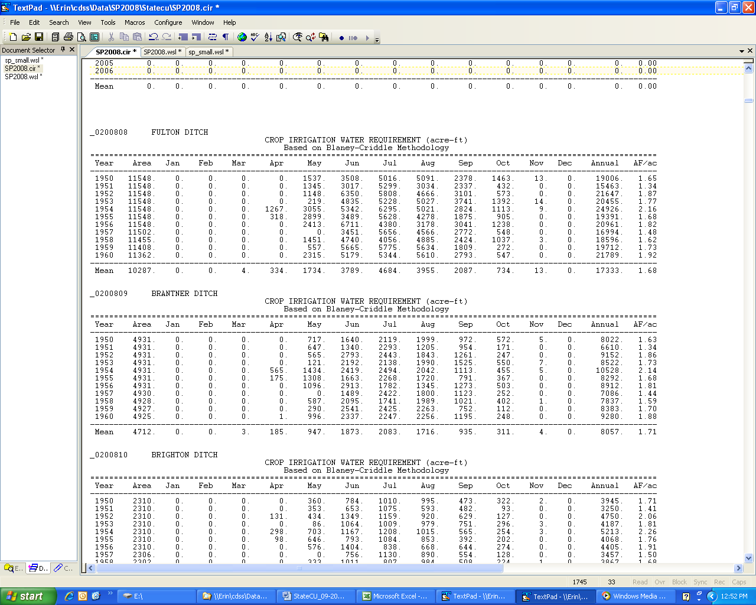

**# *.wsl – Supply-limited Consumptive Use Output File**

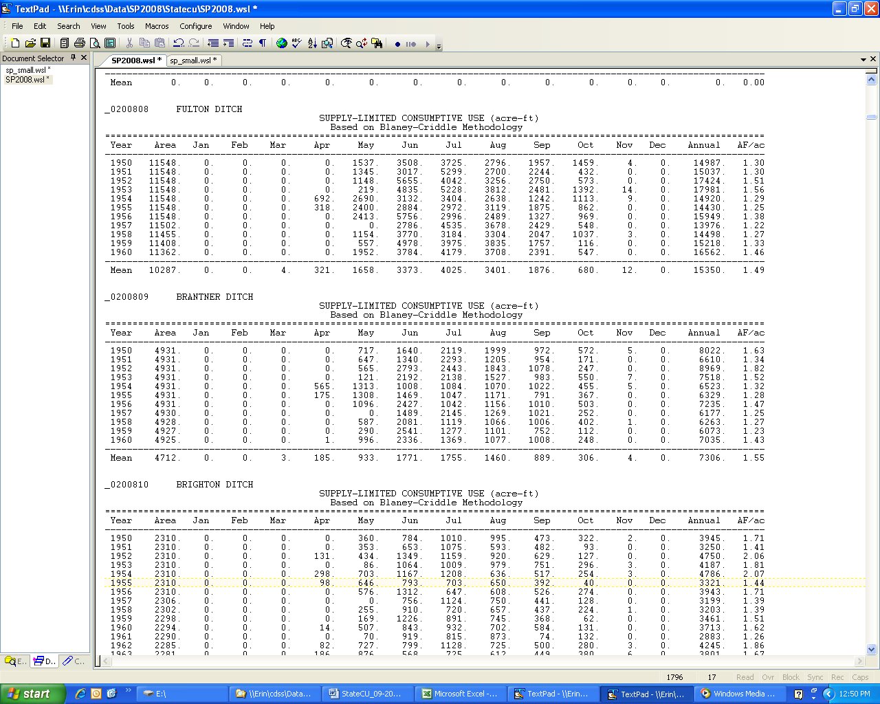

**#*.dwb –Detailed Water Budget Output File**

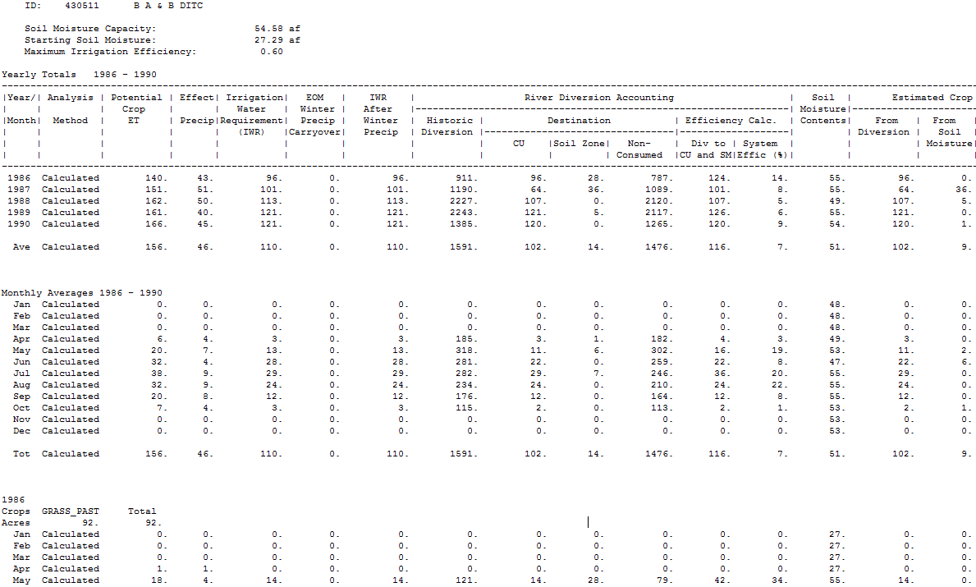

**#*.swb – Farm Water Budget (For Simulation) Output File**

Soil Moisture Capacity: 10245.21 af

Starting Soil Moisture: 2561.30 af

Yearly Totals for Scenario 1986 - 1990

-------------------------------------------------------------------------------------------------------------------------------------------------------------------------------------------

| % | Analysis |Year/| Potential | Effect| Irrigation| EOM | IWR | River Diversion Accounting | Soil | Estimated Crop CU |

|Project| | | Crop | | Water | Winter | After |-----------------------------------------------------------------| Moisture|------------------------------|

| Calcd | Method |Month| ET | Precip|Requirement| Precip | Winter | Historic | Destination | Efficiency Calc. | Contents| From | From | Total |

| | | | | | (IWR) |Carryover| Precip | Diversion |---------------------------------|-------------------| | Diversion | Soil | |

| | | | | | | | | | CU |Soil Zone| Unlagged | Div to | Calc. | | | Moisture| |

| | | | | | | | | | | | Consumed |CU and SM|Effic (%)| | | | |

-------------------------------------------------------------------------------------------------------------------------------------------------------------------------------------------

100.0% Prorated 1986 39704. 12400. 27304. 0. 27304. 212421. 24639. 6463. 181318. 31102. 15. 7069. 24639. 1956. 26595.

100.0% Prorated 1987 42360. 13290. 29069. 0. 29069. 257609. 23899. 1919. 231791. 25817. 10. 7058. 23899. 1930. 25829.

100.0% Prorated 1988 45336. 12772. 32564. 0. 32564. 275871. 25648. 1508. 248716. 27156. 10. 6667. 25648. 1899. 27547.

100.0% Prorated 1989 45195. 10763. 34432. 0. 34432. 267722. 32101. 2505. 233116. 34606. 13. 7571. 32101. 1600. 33702.

100.0% Prorated 1990 46192. 11662. 34531. 0. 34531. 254709. 29669. 1207. 223833. 30876. 12. 6338. 29669. 2440. 32109.

Prorated Ave. 43757. 12177. 31580. 0. 31580. 253666. 27191. 2720. 223755. 29912. 12. 6338. 27191. 1965. 29156.

Project Monthly Averages 1986 - 1990

Prorated Jan 0. 0. 0. 0. 0. 867. 0. 60. 807. 60. 7. 6245. 0. 0. 0.

Prorated Feb 0. 0. 0. 0. 0. 791. 0. 31. 760. 31. 4. 6275. 0. 0. 0.

Prorated Mar 14. 6. 7. 0. 7. 881. 1. 5. 875. 5. 1. 6274. 1. 6. 7.

Prorated Apr 1773. 933. 840. 0. 840. 14694. 494. 466. 13734. 960. 7. 6467. 494. 272. 767.

Prorated May 5537. 1926. 3611. 0. 3611. 38895. 3098. 1068. 34729. 4166. 11. 7170. 3098. 365. 3463.

Prorated Jun 9195. 1244. 7950. 0. 7950. 58239. 7264. 648. 50327. 7912. 14. 7444. 7264. 374. 7637.

Prorated Jul 10851. 2615. 8236. 0. 8236. 47621. 7388. 216. 40016. 7604. 16. 7485. 7388. 175. 7564.

Prorated Aug 9142. 2336. 6806. 0. 6806. 39372. 5689. 79. 33604. 5767. 15. 7154. 5689. 409. 6098.

Prorated Sep 5429. 2033. 3396. 0. 3396. 32197. 2745. 106. 29346. 2851. 9. 7012. 2745. 249. 2994.

Prorated Oct 1816. 1084. 733. 0. 733. 17948. 512. 41. 17395. 553. 3. 6938. 512. 115. 627.

Prorated Nov 0. 0. 0. 0. 0. 1333. 0. 2. 1331. 2. 0. 6940. 0. 0. 0.

Prorated Dec 0. 0. 0. 0. 0. 831. 0. 0. 830. 0. 0. 6940. 0. 0. 0.

Prorated Ave. 43757. 12177. 31580. 0. 31580. 253666. 27191. 2720. 223755. 29912. 12. 6338. 27191. 1965. 29156.

100.0% 1986

Crops ALFALFA GRASS_PAST SPRING_GRA CORN_GRAIN Total

Acres 2087. 22804. 68. 275. 25235.

Prorated Jan 0. 0. 0. 0. 0. 676. 0. 298. 378. 298. 44. 2859. 0. 0. 0.

Prorated Feb 0. 0. 0. 0. 0. 611. 0. 153. 458. 153. 25. 3012. 0. 0. 0.

Prorated Mar 40. 21. 19. 0. 19. 681. 2. 15. 664. 17. 2. 3009. 2. 17. 19.

**# *.4wb – Detailed 4 Land Category Water Budge Output File**

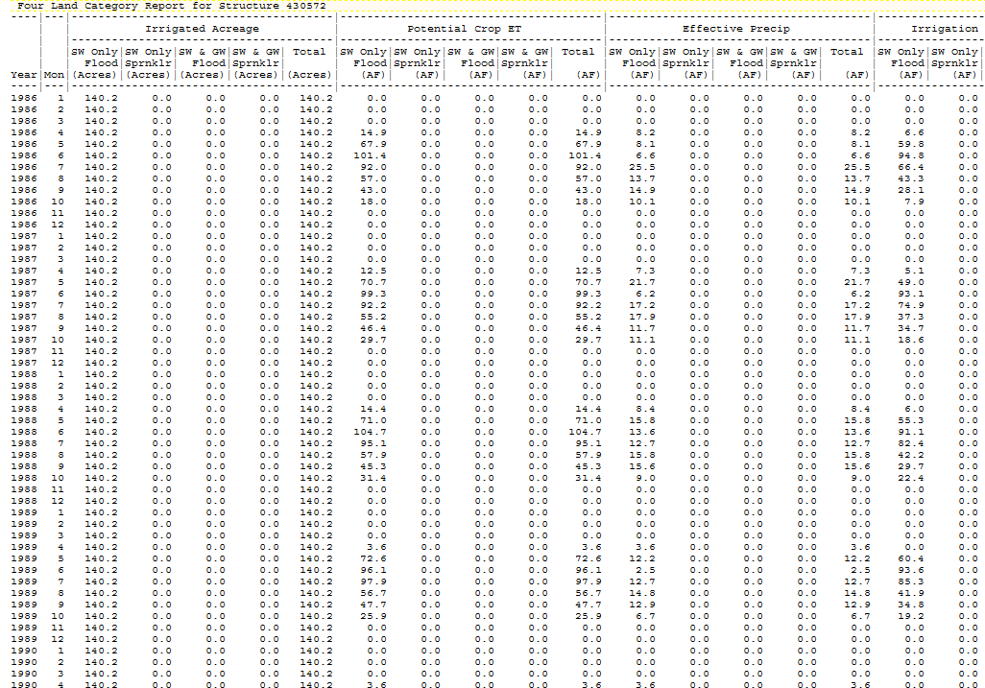

**# *.obc – Detailed Blaney-Criddle Output File**

Detailed Results of the Consumptive Use Calculation Blaney-Criddle Method

430511 B A & B DITCH NO 1

GRASS_PASTURE Soil = NO SOIL Year = 1986

========================================================

Month percent temp daylight f kt kc k ETp Re IWR

month (F) (%) (in) (in) (in)

----------------------------------------------------------------------------------------------

Apr28 10.0 45.28 0.94 0.43 0.47 0.88 0.41 0.18 0.13 0.05

May 100.0 49.22 10.01 4.93 0.54 0.90 0.48 2.38 0.57 1.81

Jun 100.0 61.44 10.09 6.20 0.75 0.92 0.69 4.27 0.44 3.83

Jul 100.0 63.16 10.22 6.46 0.78 0.93 0.72 4.65 1.83 2.82

Aug 100.0 63.12 9.55 6.03 0.78 0.90 0.70 4.24 1.13 3.11

Sep 100.0 51.02 8.39 4.28 0.57 0.87 0.49 2.12 1.17 0.95

Oct 8 25.8 46.18 2.06 0.95 0.48 0.83 0.40 0.38 0.36 0.02

----------------------------------------------------------------------------------------------

Season Total 18.23 5.63 12.60

GRASS_PASTURE Soil = NO SOIL Year = 1987

========================================================

Month percent temp daylight f kt kc k ETp Re IWR

month (F) (%) (in) (in) (in)

----------------------------------------------------------------------------------------------

Apr18 43.3 46.31 4.01 1.85 0.49 0.87 0.42 0.79 0.40 0.39

May 100.0 51.26 10.01 5.13 0.57 0.90 0.52 2.65 1.54 1.11

Jun 100.0 60.22 10.09 6.08 0.73 0.92 0.67 4.07 0.42 3.65

Jul 100.0 63.32 10.22 6.47 0.78 0.93 0.72 4.68 1.24 3.43

Aug 100.0 61.13 9.55 5.84 0.74 0.90 0.67 3.93 1.40 2.53

Sep 100.0 55.12 8.39 4.62 0.64 0.87 0.56 2.57 0.87 1.70

Oct22 71.0 49.02 5.57 2.73 0.53 0.81 0.43 1.18 0.73 0.44

---------------------------------------------------------------------------------------------

Season Total 19.86 6.60 13.26

#**penmon.opm – Detailed Penman-Monteith Output File**

Detailed Results of the Consumptive Use Calculation Penman-Montieth Method 13010003ALA ALFALFA Mean KC Alfalfa Based Year = 1994 ___________________________________________________________________

DOY Date Ref ET Ka Kcm Kc ET Re IWR

(in) (in) (in) (in)

____________________________________________________________________

128 May 8 0.395 1.00 0.57 0.57 0.225 0.000 0.225

129 May 9 0.116 1.00 0.59 0.59 0.069 0.497 0.000

130 May 10 0.135 1.00 0.61 0.61 0.082 0.000 0.082

131 May 11 0.251 1.00 0.63 0.63 0.158 0.014 0.144

132 May 12 0.241 1.00 0.65 0.65 0.156 0.000 0.156

133 May 13 0.204 1.00 0.67 0.67 0.136 0.035 0.101

134 May 14 0.282 1.00 0.69 0.69 0.194 0.000 0.194

135 May 15 0.298 1.00 0.71 0.71 0.211 0.000 0.211

136 May 16 0.311 1.00 0.72 0.72 0.225 0.000 0.225

137 May 17 0.479 1.00 0.74 0.74 0.354 0.000 0.354

138 May 18 0.443 1.00 0.76 0.76 0.335 0.000 0.335

139 May 19 0.382 1.00 0.77 0.77 0.295 0.021 0.274

140 May 20 0.366 1.00 0.79 0.79 0.289 0.000 0.289

141 May 21 0.398 1.00 0.80 0.80 0.320 0.000 0.320

142 May 22 0.330 1.00 0.82 0.82 0.271 0.000 0.271

143 May 23 0.242 1.00 0.83 0.83 0.201 0.007 0.194

144 May 24 0.251 1.00 0.84 0.84 0.211 0.000 0.211

145 May 25 0.094 1.00 0.86 0.86 0.081 0.392 0.000

146 May 26 0.183 1.00 0.87 0.87 0.159 0.000 0.159

147 May 27 0.210 1.00 0.88 0.88 0.185 0.217 0.000

148 May 28 0.278 1.00 0.89 0.89 0.248 0.042 0.206

149 May 29 0.273 1.00 0.90 0.90 0.247 0.000 0.247

150 May 30 0.412 1.00 0.91 0.91 0.376 0.000 0.376

151 May 31 0.359 1.00 0.92 0.92 0.331 0.000 0.331

____________________________________________________________________

Monthly Total 5.359 1.225 4.906

**# *.ddc – StateMod Formatted Crop Irrigation Water Requirement File**

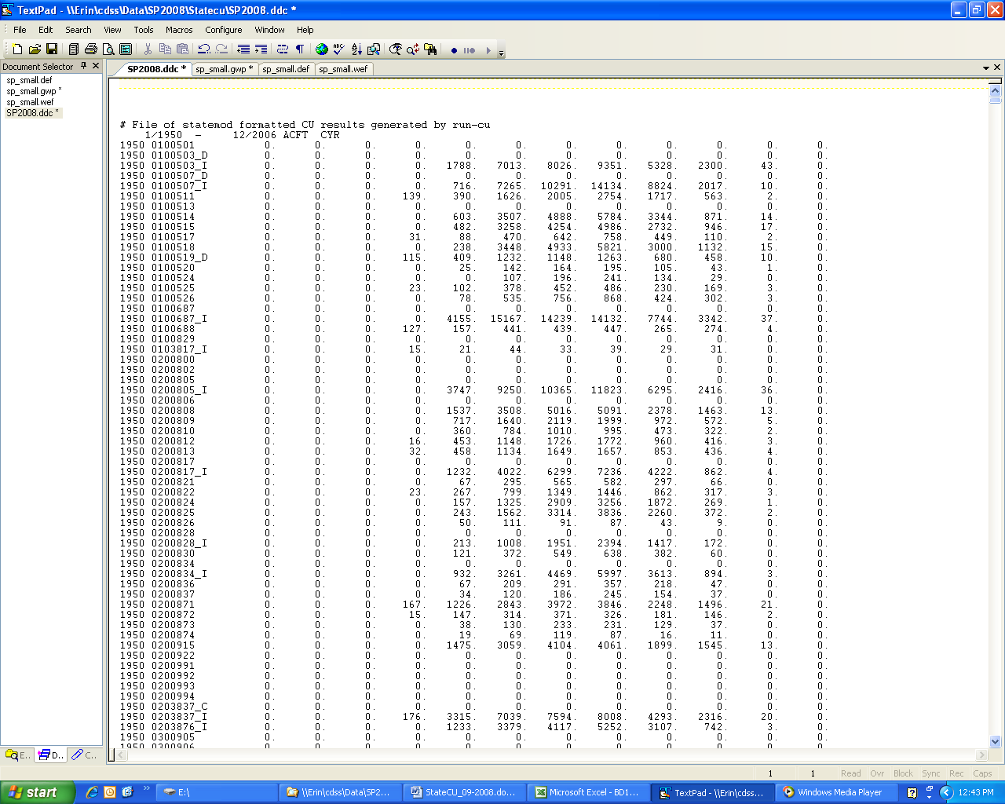**# *.gwp – StateMod Formatted Ground Water Pumping File**

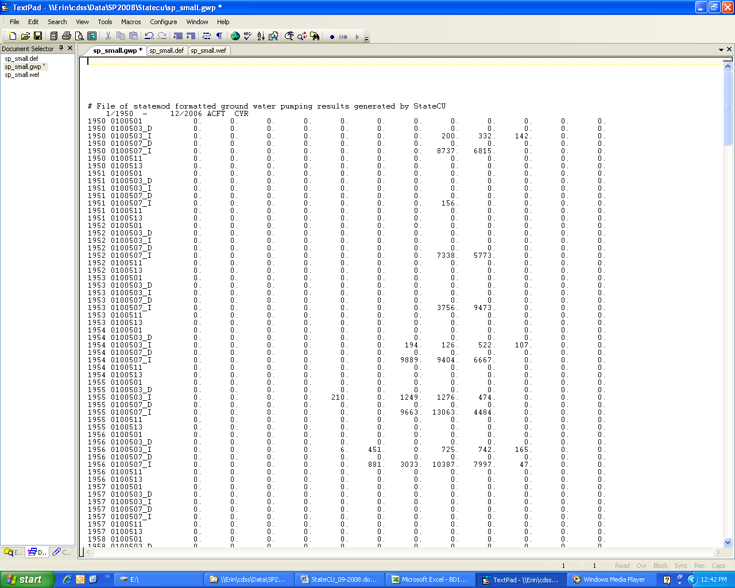**# *.def: Diversion Station Efficiency file for STATEMOD**

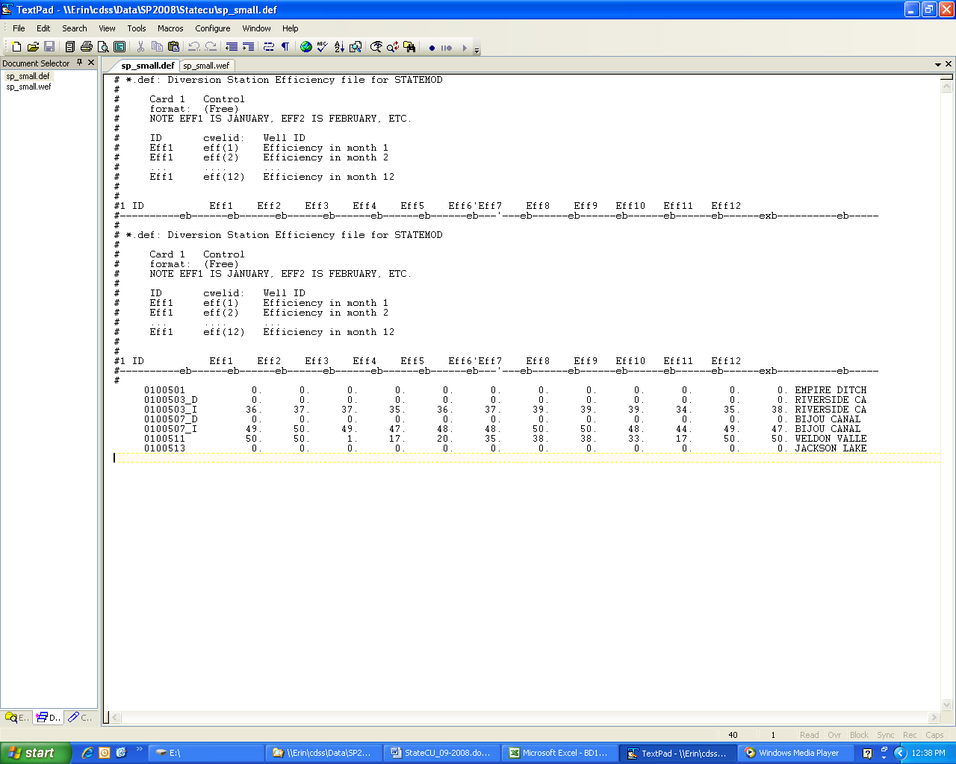

**# *.wef: Well Station Efficiency file for STATEMOD**

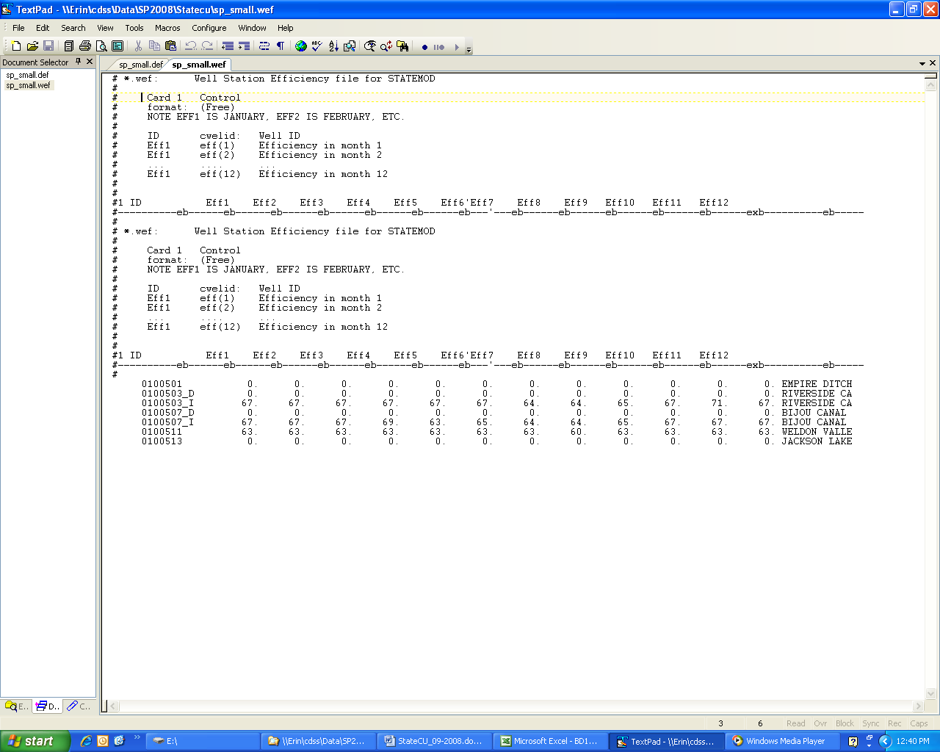

**# season.csv: Growing Season File**

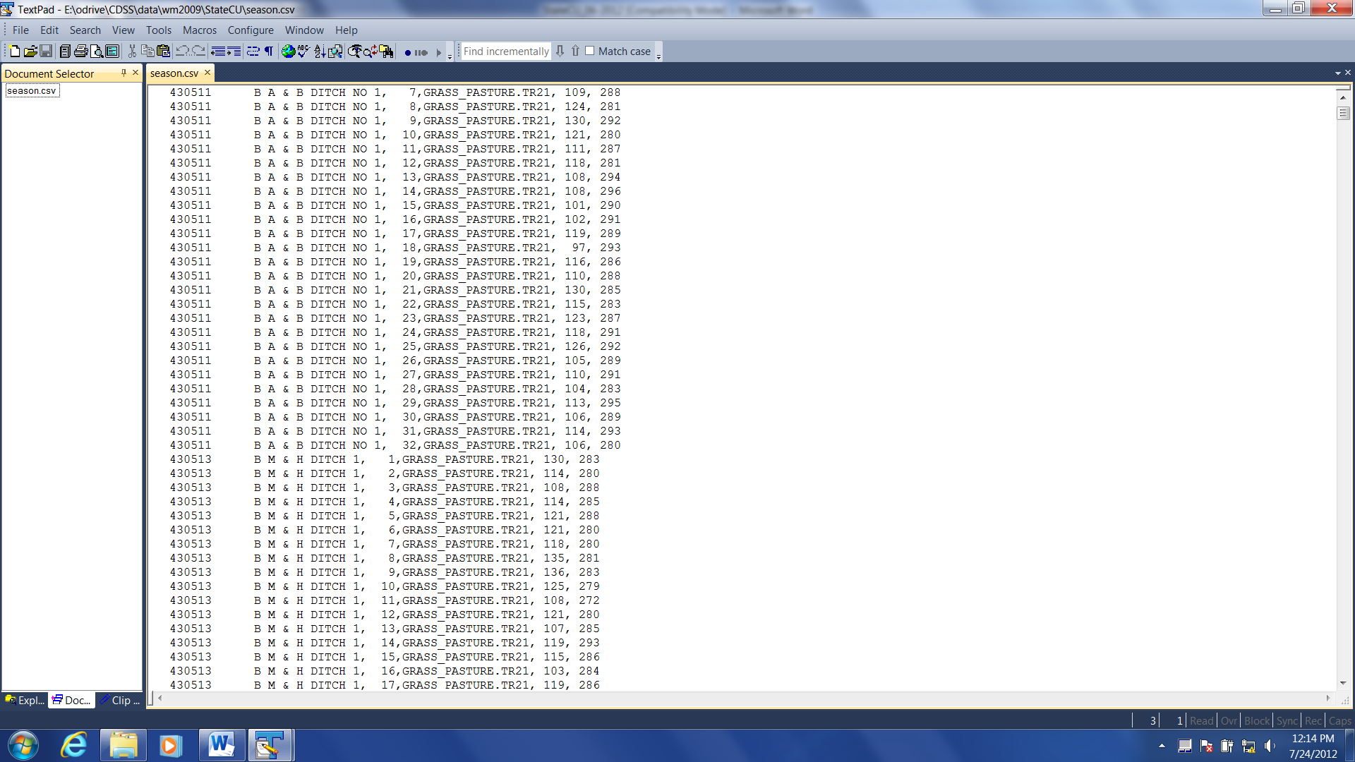

## Appendix B – StateCU Program Flow Charts and Subroutines

### Section B-1 Supporting Flow Charts

This section contains flowcharts showing the logical flow of the StateCU FORTRAN program. The flowcharts include the main body of the StateCU program; the Blaney-Criddle calculation; the Blaney-Criddle crop evapotranspiration calculation; the Penman-Monteith Calculation; the ASCE Standardized Penman-Monteith calculation; the Modified Hargreaves Calculation; the structure water balance; the structure water balance with ground water supplies; and other (non-irrigation) consumptive uses procedure. StateCU subroutines are indicated in italics.

**Read Response File, Control File,**

**and Climate Data**

***StateCU.for***

**Begin**

**Read Structure**

**and Assign Climate**

***StateCU.for***

**Daily ET  
Estimation Procedures  
*proto.for***

**Summaries of Crop**

**Consumptive Use**

***proj***

***.for***

**End**

**Structure Water**

**Balance**

***wsupsum***

***.for***

**Info**

**Blaney-Criddle ET  
Estimation Procedures  
*mainxc.for***

**Other Uses**

**Criddle**

**Blaney**

**-**

**Analysis Specified**

**Analysis Specified**

Figure B-1 – Main Body of StateCU Program

**Yes**

**No**

**Yes**

**No**

**Is IB = NB?**

**Is IY = NY?**

**IY =IY + 1**

**IB =IB + 1**

**IB = 0**

**IY = 0**

***calpcrop***

**Compute Crop ET**

**Compute Beg/End Growing Season**

***dayhrs***

**Compute Percent Daylight**

**End**

***.for***

***mainxc***

**Estimation Procedure**

**ET**

**Criddle**

**-**

**Blaney**

***readin***

**Begin**

**Read Crop Coefficients**

***.for***

***.for***

***frostall.for***

***.for***

Figure B-2 – Blaney-Criddle Calculation

###### Where NB = Total number of structures in scenario

NY = Total number of years in simulation

**Yes**

**No**

**Is IB = NB?**

**Is IY = NY?**

***frostall.for***

**Compute Beg/End Growing Season**

**Yes**

***calpcrop***

**Compute Crop ET**

**End**

***.for***

**IY =IY + 1**

**IY = 0**

**No**

**Compute ET for Ending Month of Growing Season**

**Compute ET for Full Months of Growing Season**

**Compute ET for Beginning Month of Growing Season**

**No**

**Compute Effective Rainfall**

**Yes**

**Is IP = NP?**

**IP =IP + 1**

**End**

**Begin**

***calpcrop.for***

**Compute Crop**

**Evapotranspiration**

**IP = 0**

**Annual**

**Perennial**

***annuacrp.for***

***perencrp.for***

**Perennial or Annual Crop?**

***intertd.for***

***intertd.for***

***xcrain.for***

Figure B-3 – Crop Evapotranspiration with Blaney-Criddle

Where NP = Total number of crop types for the current structure

***.for***

***.for,***

**Yes**

**No**

**No**

**Yes**

**IB = 0**

**IY = 0**

***etrref***

***etoref***

***.for,***

***etref***

**End**

***frost1.for***

***.for***

***proto***

**Begin**

***proto.for***

## Penman-Monteith Based

**ET Estimation Procedure**

**Read Crop Coefficients**

***kbasal.for***

**IY = IY + 1**

**Compute Reference ET**

**IB = IB + 1**

**Compute Weighted Average Reference ET**

**Compute Beginning and Ending Growing Season**

**Interpolate Daily Crop Coefficients**

***growth.for***

**Compute Crop Evapotranspiration**

***proto.for***

**Compute Effective Rainfall**

***rain.for***

**Is IB = NB?**

**Is IY = NY?**

Figure B-4 – Penman-Monteith and Standardized Penman-Monteith Calculation

###### Where NB = Total number of structures in scenario

NY = Total number of years in simulation

***.for***

***proto***

### Yes

**No**

**No**

**Yes**

**IB = 0**

**IY = 0**

***.for***

***etref***

**End**

***frost1.for***

***.for***

***proto***

***.for***

***kbasal***

**Begin**

**ET Estimation Procedure**

**Modified Hargreaves**

**Read Growth Rates and Crop Coefficients**

**IY = IY + 1**

**Compute Reference ET**

**IB = IB + 1**

**Compute Weighted Average Reference ET**

**Compute Beginning and Ending Growing Season**

## Compute Crop Evapotranspiration

***proto.for***

**Compute Effective Rainfall**

***rain.for***

**Is IB = NB?**

**Is IY = NY?**

Figure B-5 – Modified Hargreaves Calculation

###### Where NB = Total number of structures in scenario

NY = Total number of years in simulation

**Structure Water Balance**

***.for***

***slimit***

**No**

***.for***

***wsupsum***

**Begin**

**Yes**

**Read Water Supply Information**

***Slimit.for***

**Read Water Right Information**

**Consider Water Rights?**

**Adjust for Conveyance Efficiency =   
Farm Headgate Diversion**

**Determine Soil Moisture**

**Consider Soil Moisture?**

**Adjust for Max Application Efficiency**

**= Effective Surface Water Supply**

**No**

**Yes**

**Reservoir Capacity by Structure**

**Available Soil Moisture**

**Surface Water Supply**

**Water Supply Limited CU =**

**Remaining Water Supply Used**

**Irrigation Water Requirement**

**Water Supply Limited CU =**

**Determine Irrigation Efficiency**

**No**

**Yes**

**Yes**

**No**

**Reservoir Capacity?**

**Surface Water Supply > IWR?**

**Water Supply Limited CU = Surface**

**Water Supply + Soil Moisture Supply**

**End**

**Figure B-6 – Structure Water Balance Procedure Surface Water Only**

Procedure is performed for each structure in scenario for every simulation year. If presimulation for soil moisture initialization is selected then above logic is executed in a presimulation mode prior to simulation for results. If water rights are considered, diversions to CU and soil moisture reservoir and diversion from soil moisture reservoir are accounted for by water rights. Water supply read from the drain file is considered ‘other’ water, along with water diverted in excess of water rights under free river conditions. If water rights are considered and the ‘priority’ option for soil moisture is turned on, then senior priority water available for soil moisture is allowed to displace junior priority water in the soil reservoir and senior priority soil moisture is withdrawn and used prior to junior priority soil moisture.

**Read Surface Water Supply  
 Information  
*slimit.for***

**Adjust for Conveyance Efficiency =  
Farm Headgate Diversion**

**Apply Farm Diversion to Meet IWR on Sprinkler SW-only Acreage using Max Sprinkler efficiency**

**Apply Remaining Farm Diversion to Meet IWR on Flood SW-only Acreage using Max Sprinkler efficiency**

**Apply Remaining Farm Diversion to Meet IWR on   
Flood GW Acreage using Max Sprinkler efficiency**

**Pump to Meet IWR on Sprinkler GW Acreage up to Max Prorated Pump Rate**

**Structure Water Balance**

***Wsupsum.for***

**Pump to Meet Remaining IWR   
on Flood GW Acreage up to  
 Max Prorated Pump Rate**

**Flood GW**

**Sprinkler + WSL SW-only + WSL**

**Water Supply Limited CU = WSL**

**Yes**

**No**

**GW Acreage?**

**IWR Satisfied on Flood**

Figure B-7 – Structure Water Balance Procedure Ground Water Available  
gmode = 1 - Maximize Supply Approach

Acreage under each structure is divided into four categories, as shown in the flow chart. Sprinkler GW Acreage is sprinkler irrigated acreage identified as having a ground water source. Flood GW Acreage is flood irrigated acreage identified as having a ground water source. Sprinkler SW-only Acreage is sprinkler irrigated acreage without a ground water source. Flood SW-only Acreage is flood irrigated acreage without a ground water source. Soil moisture accounting is performed as shown in Figure B-6 for acreage receiving surface water. Maximum pumping rate is area-prorated between Sprinkler GW and Flood GW acreage. Procedure is performed for each structure in scenario for every simulation year.

**Adjust for Conveyance Efficiency =  
Farm Headgate Diversion**

**Distribute Farm Diversions to   
4 Land Types based on Acreage**

**Apply Sprinkler GW ‘Farm’ Share to meet IWR at Max Sprinkler Efficiency**

**Apply Flood GW ‘Farm’ Share to meet IWR at Max Flood Efficiency**

**Apply Sprinkler SW-only ‘Farm’ Share to meet IWR at Max Sprinkler Efficiency**

**Apply Flood SW-only ‘Farm’ Share to meet IWR at Max Flood Efficiency**

**No**

**GW Acreage?**

**IWR Satisfied on Flood**

**Flood GW**

**Sprinkler + WSL SW-only + WSL**

**Water Supply Limited CU = WSL**

**Yes**

**No**

**Sprinkler GW Acreage?**

**Pump to Meet Remaining IWR   
on Flood GW Acreage up to  
 Max Prorated Pump Rate**

**IWR Satisfied on**

**Yes**

**Read Surface Water Supply  
 Information  
*slimit.for***

***.for***

**Structure Water Balance**

***wsupsum***

**Pump to Meet Remaining IWR on  
 Sprinkler GW Acreage up to Max Prorated Pump Rate**

Figure B-8 – Structure Water Balance Procedure Ground Water Available  
gmode = 2 - Mutual Ditch Approach

Acreage under each structure is divided into three categories, as shown in the flow chart. Sprinkler GW Acreage is sprinkler irrigated acreage identified as having a ground water source. Flood GW Acreage is flood irrigated acreage identified as having a ground water source. Sprinkler SW-only Acreage is sprinkler irrigated acreage without a ground water source. Flood SW only Acreage is flood irrigated acreage without a ground water source. Soil moisture accounting is performed as shown in Figure B-6 for acreage receiving surface water. Maximum pumping rate is area-prorated between Sprinkler GW and Flood GW acreage. Procedure is performed for each structure in scenario for every simulation year.

**Adjust for Conveyance Efficiency =  
Farm Headgate Diversion**

**Read Surface Water Supply  
 Information  
*slimit.for***

**Distribute Farm Diversions to   
4 Land Types based on Acreage**

***.for***

***wsupsum***

**Structure Water Balance**

**Sprinkler GW Share of Farm Diversion is ‘Available for Recharge’**

**Apply Flood GW ‘Farm’ Share to meet IWR at Max Flood Efficiency**

**Apply Sprinkler SW-only ‘Farm’ Share to meet IWR at Max Sprinkler Efficiency**

**Apply Flood SW-only ‘Farm’ Share to meet IWR at Max Flood Efficiency**

**Pump to Meet IWR on   
Sprinkler GW Acreage up to Max Prorated Pump Rate**

**Pump to Meet Remaining IWR   
on Flood GW Acreage up to  
 Max Prorated Pump Rate**

**Flood GW**

**Sprinkler + WSL SW-only + WSL**

**Water Supply Limited CU = WSL**

**Yes**

**No**

**GW Acreage?**

**IWR Satisfied on Flood**

Figure B-9 – Structure Water Balance Procedure Ground Water Available  
gmode = 3 - Mutual Ditch Approach with Ground Water Pumped to   
 Meet Sprinkler Acreage Irrigation Water Requirements

Acreage under each structure is divided into three categories, as shown in the flow chart. Sprinkler GW Acreage is sprinkler irrigated acreage identified as having a ground water source. Flood GW Acreage is flood irrigated acreage identified as having a ground water source. Sprinkler SW-only Acreage is sprinkler irrigated acreage without a ground water source. Flood SW-only Acreage is flood irrigated acreage without a ground water source. Soil moisture accounting is performed as shown in Figure B-6 for acreage receiving surface water. Maximum pumping rate is area-prorated between Sprinkler GW and Flood GW acreage. Procedure is performed for each structure in scenario for every simulation year.

### Section B-2 Descriptions of Program Subroutines

This section describes the function of each subroutine contained in the StateCU FORTRAN Program.

**annuacrp.for**

This subroutine computes the crop coefficient, mean temperature and percent daylight hours of the month for annual crops for the Blaney-Criddle ET method. It includes the calculation required for part months (i.e., beginning and ending months) of the growing season. It is called by subroutine *calpcrop* for every structure in every year requiring arguments that indicate the beginning and ending of the growing season of the crop. It calls the subroutine *intertd* to calculate the monthly mean temperature and percent daylight hours during the part months. It calls the subroutine *interkc* to calculate the monthly crop coefficient. Error trapping capability is provided by calling the subroutine *myexit*. The main routines of subroutine *annuacrp* were taken from USBR XCONS2 program, which uses the SCS Modified Blaney-Criddle ET Estimation Method.

**calpcrop.for**

This subroutine calculates the crop consumptive use based on the SCS Modified Blaney-Criddle method. It is called by subroutine *mainxc*, which is the main subroutine for calculating crop consumptive use. It calls the subroutines *perencrp* and *annuacrp* to calculate monthly parameters and coefficients for perennial and annual crops, respectively. It calls the subroutine *xcrain* to calculate monthly effective rainfall. The subroutine *calpcrop* also generates an output file *\*.obc* that contains detailed results of the crop consumptive use calculation.

**clndr.for**

This subroutine calculated the equivalent of Julian day (or day of the year) to calendar month (1-12) and day (1-31). Leap years are also handled. It is called by the subroutines *annuacrp****,*** *perencrp*, and *calpcrop*.

**dayhrs.for**

This subroutine calculates the monthly percent daylight hours associated with a given latitude. A table of monthly values of percent daylight hours with respect to selected latitudes (0-64 degrees North) is used. This table is taken from the ASCE Manuals and Reports No. 70 on ET and Irrigation Water Requirements (Jensen et al. 1990), using the latitude assigned to the cropped area. It is called by subroutine *mainxc* to compute the percent daylight hours associated with the latitude of the cropped area associated with a structure. It is called by subroutine *summary* to compute the percent daylight hours associated with the latitude of the weather station for incorporation in the input summary file.

**dread.for**

This subroutine reads the daily climate data required for the Penman-Monteith, ASCE Standardized Penman-Monteith, and Daily Modified Hargreaves methods. It is called by the main program *statecu*.

**dsum.for**

This subroutine summarizes the input information and saves it to the *.sum output file when performing a daily ET analysis. Depending on a user-specified flag, the summary can either be basic or detailed. In addition, the weighted mean monthly temperature and precipitation value for each structure are calculated in this subroutine. *Summary* is called from the main program *statecu*. It calls subroutines *clndr* and *dayhrs*. Error trapping capability is provided by calling the subroutine *myexit.*

**dxcrain.for**

This subroutine computes the daily effective rainfall using three methods: 1) Maximum effective inches per day, 2) Fraction of daily precipitation is effective, and 3) SCS NEH4 method. The user can also specify to ignore the monthly effective rainfall. The subroutine *dxcrain* is called by the subroutine *proto*.

**etasce.for**

This subroutine computes the alfalfa-based reference ET during the given day. The equation formulations are based on ASCE Standardization of Reference Evapotranspiration Task Committee. The subroutine *etasce* is called by *etref*.

**etref.for**

This subroutine computes the daily reference ET using alfalfa-based formulas for the Penman-Monteith and ASCE Standardized Penman-Monteith methods for the given weather station for the current year of simulation. The daily climate datasets have units in English; however, the computations are performed in metric units. The results are then converted back to English units. The subroutine *etref* is called by the subroutine *proto*, which is the main subroutine for computing crop consumptive use by the Penman-Monteith and ASCE Standardized Penman-Monteith ET methods. This subroutine also computes the daily reference ET for the Modified Hargreaves ET method developed by Agro Engineering, Inc. *Etref* calls the subroutines *etoref* and *etrref* for grass-based and alfalfa-based Penman-Monteith and ASCE Standardized Penman-Monteith formulas.

**etrref.for**

This subroutine computes the alfalfa-based reference ET during the given day. The equation formulations are based on ASCE Manuals and Reports on Engineering Practice – No. 70. The subroutine *etrref* is called by *etref*.

**export.for**

This subroutine summarizes in tabular form the consumptive use from the export (transmountain diversions) category as read from the *\*.oth* file. It is called by subroutine *other*, which is the main subroutine for computing consumptive use from non-irrigation categories (other uses). It calls subroutine *otable*, which prepares the summary table for the given category.

**fall.for**

This subroutine computes the first day of frost in fall based on mean monthly temperature. It assumes that the fall frost temperature occurs only after July 15. If the weather data does not satisfy this assumption, the program may fail. The subroutine *fall* is called by subroutine *frost*,which is the main subroutine for determining the growing season of the given crop. These routines were taken from the USBR XCONS2 program, which uses the SCS Modified Blaney-Criddle ET Estimation Method.

**findsta.for**

This subroutine returns the structure match ‘index’ for routines that loop through structure information, such as time-series of acreage and diversions. It is called by multiple routines.

**foutput.for**

This subroutine generates a detailed daily tabular output of the consumptive use computation for Penman-Monteith, ASCE Standardized Penman-Monteith, and Modified Hargreaves methods for each structure. The detailed output for the selected structures are combined and saved in *.opm. The subroutine *fall* is called by *proto*, which is the main subroutine for both daily ET calculations.

**frost.for**

This subroutine determines the start and end of the growing season from the user specified dates, computed frost dates based on monthly mean temperature, and published 28 or 32 degree F frost dates. This subroutine calculates the growing season for a structure for a single year in the simulation. Each crop is assigned a separate set of flags (one each for the start and end of the growing season) indicating the type of frost date method to use. If the value is 0, the frost date is based on the monthly mean temperature. If the value is 1, the frost date is based on the published 28 degree F frost date. If the value is 2, the frost date is based on the published 32 degree F frost date. The final frost dates are compared to the user-specified dates, always choosing the date which shortens the growing season (less critical date). The subroutine *frost* is called by the subroutine *frostall*. It calls the subroutine *spring* and *fall* for determining frost dates based on monthly mean temperature for spring and fall, respectively. Error trapping capability is provided by calling the subroutine *myexit*.

**frostall.for**

This subroutine loops through years and calls the subroutine *frost* for each year. It is called by the subroutines *mainxc* and *proto*.

**growth.for**

This subroutine computes the daily crop coefficient for the Penman-Monteith and ASCE Standardized Penman-Monteith methods by straight line interpolation using the crop coefficient dataset provided for the Penman-Monteith and ASCE Standardized Penman-Monteith calculations. It is called by the subroutine *proto*.

**indcrop.for**

This subroutine assigns an internal crop indices to correspond with the crop name. It is called by the subroutine *readin*.

**init.for**

This subroutine initializes constants assigned to variables used in StateCU, such as days in each month. It is called by the main program *statecu*.

**interkc.for**

This subroutine computes the crop coefficient kc, climatic coefficient kt, and (t x d) /100 for the current month for the annual crops only. It is called by the subroutine *annuacrp*. The routines are based on USBR XCONS2 program, which uses the SCS Modified Blaney-Criddle ET Estimation Method.

**intertd.for**

This subroutine computes the monthly mean temperature percent daylight hours for part months (beginning month in the spring and ending month in the fall). It is called by the subroutines *annuacrp* and *perencrp*. The routines are based on USBR XCONS2 program, which uses the SCS Modified Blaney-Criddle ET Estimation Method.

**julian.for**

This subroutine computes the equivalent of calendar date to Julian day (day of the year). Leap years are handled. It is called by the subroutines *annuacrp*, *perencrp*, *fall*, *spring*, *frost*, and *intertd*.

**kbasal.for**

This subroutine reads the Penman-Monteith crop coefficient file. The subroutine *kbasal* is called by *proto*.

**kcpm.for**

This subroutine calculates the daily crop coefficients for the Penman-Monteith and ASCE Standardized Penman-Monteith equations by straight line interpolation using the crop coefficient data provided in the *.kpm file for all crops for the entire growing season, except for alfalfa and pasture for the period after effective cover. The subroutine is called by *growth*.

**kcpm2.for**

This subroutine calculates the daily crop coefficients for the Penman-Monteith and ASCE Standardized Penman-Montieth equations by straight line interpolation using the crop coefficient data provided in the *.kpm file for crops other than alfalfa and pasture for the period after effective cover. The subroutine is called by *growth*.

**mainxc.for**

This subroutine is the main calling subroutine for computing Blaney-Criddle crop consumptive use. It is called by the main program *statecu*. It calls the subroutines *dayhrs*, *readin*, *calpcrop*, and *frost*.

**myexit.for**

This subroutine implements the exit routines when the program is about to stop. The history of execution is saved in the *\*.log* file. The subroutine myexit is called by the subroutines *annuacrp*, *dayhrs*, *fall*, *frost*, *indcrop*, *julian*, *perencrp*, *readin*, *statecu*, and *summary*.

**perencrp.for**

This subroutine computes the crop coefficient, mean temperature, percent daylight hours, and parameter f of the month for perennial crops. It includes the computation required for part months (i.e., beginning and ending months) of the growing season. It is called by subroutine *calpcrop* for structure for every year requiring arguments that indicate the beginning and ending of the growing season of the crop. It calls the subroutine *intertd* to calculate the monthly mean temperature and percent daylight hours during the part months. Error trapping capability is provided by calling the subroutine *myexit*. The main routines of subroutine *perencrp* were taken from USBR XCONS2 program, which uses the SCS Modified Blaney-Criddle ET Estimation Method.

**pmclim.for**

This subroutine reads the daily climate files for the Penman-Monteith, ASCE Standardized Penman-Monteith, and Modified Hargreaves ET methods and writes them to the input summary file. The subroutine *pmclim* is called by *proto*.

**proj.for**

This subroutine generates the *\*.pcu* and *\*.wsl* files, which are tabular summaries of the monthly and yearly potential and water supply limited consumptive use, respectively. The consumptive use is expressed in acre-feet. The subroutine *proj* is called by the main program *statecu*. It calls the subroutine *table* that creates the summary table for each structure.

**proto.for**

This subroutine is the main calling subroutine for computing crop consumptive use by the Penman-Monteith, ASCE Standardized Penman-Monteith, and Modified Hargreaves methods. The subroutine *proto* is called by the main program *statecu*. It calls the subroutines *etref*, *frost2*, *kbasal*, *growth*, *clndr*, *rain*, and *foutput*.

**rain.for**

This subroutine computes the daily effective rainfall used with the Penman-Monteith, ASCE Standardized Penman-Monteith, and Modified Hargreaves ET methods. The daily effective rainfall can be computed using three methods: 1) all daily total rainfall below a user-specified amount is considered effective; 2) effective rainfall is equal to a user-specified fraction of the total rainfall; and 3) curve number method based on the NEH SEC 4 method. The subroutine *rain* is called by the subroutine *proto* each day of the computation.

**readfn.for**

This subroutine reads the file names and corresponding file type identifier in the *.rcu file. This subroutine is called by the main program *statecu*.

**readin.for**

This subroutine reads the Blaney-Criddle crop coefficients from the *.kbc file. This subroutine is called by *mainxc*.

**skipln.for**

This subroutine skips a fixed number of lines in an input file, to position the file for the program to read the appropriate input data. It is called by subroutines *lstock*, *reserv*, *munic*, *fswild*, *stockp*, *miner*a, *therma*, *export*, and *recrea*.

**skipn.for**

This subroutine skips CDSS header cards placed on input files, defined by a ‘#’ in the first column, to position the file for the program to read the appropriate input data. It is called by subroutines *other, readin*, *statecu*, *slimit*, s*ummary*, *kbasal*, and *proto*.

**slimit.for**

This subroutine reads the structure parameter file for all analyses. In addition, if a water supply limited consumptive use analysis is chosen, this subroutine reads the water supply information (usually a StateMod .ddh file) and converts the diversions from water year to calendar year. If water supply limited consumptive use by priority is chosen, water rights information for the structures in the scenario is also read. This subroutine is called by the main program *statecu*.

**spring.for**

This subroutine computes the last day of frost in spring based on mean monthly temperature. It assumes that the spring frost temperature occurs no later than July 15. If the weather data does not satisfy this assumption, the program may fail. The subroutine *spring* is called by subroutine *frost*, which is the main subroutine for determining the growing season of the given crop. These routines were taken from the USBR XCONS2 program, which uses the SCS Modified Blaney-Criddle ET Estimation Method.

**stable.for**

This subroutine prepares the summary tables (month and year) for water supply. It is called by the subroutine *wsupply* to incorporate water supply in the input summary file.

**statecu.for**

This is the main routine for the StateCU FORTRAN program. It reads the response file and control file and calls the appropriate subroutines based on the level of analysis chosen.

**summary.for**

This subroutine summarizes the input information and saves it to the *.sum output file when performing a monthly ET analysis. Depending on a user-specified flag, the summary can either be basic or detailed. In addition, the weighted mean monthly temperature and precipitation valued for each structure are calculated in this subroutine. *Summary* is called from the main program *statecu*. It calls subroutines *clndr* and *dayhrs*. Error trapping capability is provided by calling the subroutine *myexit.*

**table.for**

This subroutine creates the potential and water supply limited consumptive use summary tables (month and year) for each structure. The consumptive use values are provided in acre-feet. This subroutine is called by the subroutine *proj*.

**wsupply.for**

This subroutine writes the water supply information to the input summary file when a water supply analysis is chosen. This subroutine is called by the main program *statecu*.

**wsupsum.for**

This subroutine performs the structure water budget and prepares the *\*.swb,* *\*.dwb,* and binary output files when a water supply limited analysis is requested. Water supply from direct diversions, ground water, and the soil moisture reservoir is tracked for direct crop use and soil storage. If water rights are considered, the water is ‘colored’ to account for senior, junior, and other water use. If a river depletion analysis is requested, *wsupsum* accounts for return flow percentages and timing. This subroutine is called by the main program *statecu*.

**xcrain.for**

This subroutine computes the monthly effective rainfall using two methods: 1) SCS method with net application depth, and 2) USBR method. The user can also specify to ignore the monthly effective rainfall. The subroutine *xcrain* is called by the subroutine *calpcrop*. The routines are based on USBR XCONS2 program, which uses the SCS Modified Blaney-Criddle ET Estimation Method.