Command Reference: readAgStatsTSFromDateValue()

Read agricultural statistics data from a DateValue time series file

StateCU Command
Version 02.14.00, 2007-07-03, Color, Acrobat Distiller

This command was used with Río Grande Phase 4 work and is no longer used with standard procedures. It can be used for evaluating agricultural statistics data for data filling.

The readAgStatsTSFromDateValue() command reads agricultural statistics time series from a DateValue file. These time series can be generated, for example, using TSTool and the Colorado and national agricultural statistics in HydroBase. The yearly agricultural statistics, by county and crop, can be used to fill crop pattern time series using proration (see the fillCropPatternTSProrate() command). The location part of the time series must be the county (e.g., RIO GRANDE) and the data type should be the crop type (e.g., ALFALFA). The following dialog is used to edit the command and illustrates the syntax of the command.

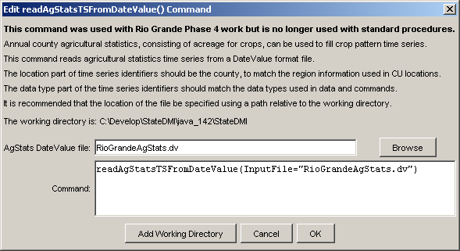
readAgStatsTSFromDateValue
readAgStatsTSFromDateValue() Command Editor

The command syntax is as follows:

readAgStatsTSFromDateValue(param=value,…)

Command Parameters

Parameter | Description | Default
InputFile | The name of the input file to read, surrounded by double quotes. | None – must be specified.

