Command Reference: readCropPatternTSFromDBF()

Read crop pattern time series data from a DBase database file

StateCU Command
Version 01.17.02, 2005-01-27, Color, Acrobat Distiller

This command was developed for evaluating preliminary data and should not be used in production.

The readCropPatternTSFromDBF() command reads crop pattern time series from a DBase (*.dbf) database file and defines crop pattern time series in memory. The crop pattern time series can then be manipulated and output with other commands. The DBase file is expected to include the attributes for an ESRI shapefile for irrigated lands assessment information. This file includes records for each parcel, including the surface and optionally well supply information. If a CU Location is a diversion, the crop pattern data are determined by accumulating irrigated acres for the ditch service area. If the CU Location is an aggregate of parcels, the area is determined from the parcel data. This command is useful if the irrigated lands spatial data have not yet been loaded into HydroBase or if a comparison between spatial data and HydroBase is desired (if data are available in HydroBase, the readCropPatternTSFromHydroBase() command can be used).

A single location or location that is part of an aggregate/system can have its data specified with a setCropPatternTS(…,ProcessWhen=WithParcels,…) command. In this case, it is expected that the acreage will not be found in the DBase file.

Multiple readCropPatternTSFromDBF() and readCropPatternTSFromHydroBase() commands can be used, with the final acreage being the combination of all data. It is assumed, however, that commands will supply data for separate years (e.g., HydroBase could supply data for earlier years and a DBase file for recent work). However, such combinations have not been extensively tested.
The following dialog is used to edit the command and illustrates the syntax of the command.

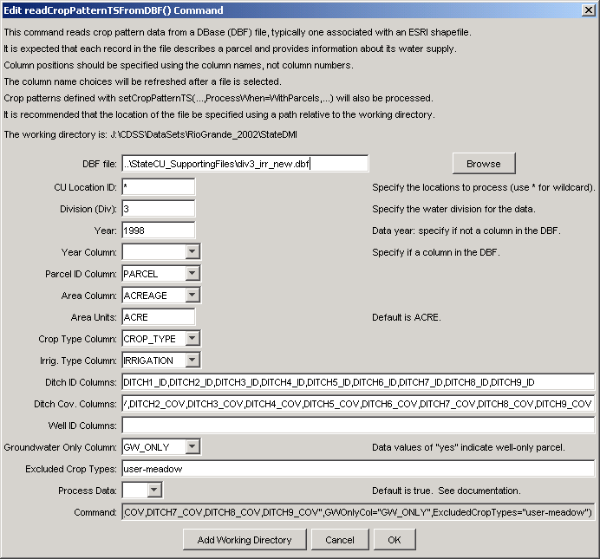
readCropPatternTSFromDBF
readCropPatternTSFromDBF() Command Editor

The command syntax is as follows:

readCropPatternTSFromDBF(param=value,param=value,…)

Command Parameters

Parameter | Description | Default
DBFFile | The name of the database file to read. | None – must be specified.
IDCol | The name of the column containing the CU Location identifiers. | None – must be specified.
Div | The water division | None – the water division is needed to uniquely identify parcels.
Year | The year for the irrigated lands data. | None - specify if the year is not available in the file.
YearCol | The name of the column containing the year for the irrigated lands assessment data. | None – if the year is included in the file, use it instead of specifying the year as a parameter.
ParcelIDCol | The name of the column containing the parcel identifier. | None – must be specified.
AreaCol | The name of the column containing the parcel area. | None – must be specified.
AreaUnits | The units for the area. | ACRE
CropTypeCol | The name of the column containing the crop type. | None – must be specified.
IrrigTypeCol | The name of the column containing the irrigation type. | None – must be specified.
DitchIDCols | The name of the columns containing the surface water supply ditch identifiers. | None – must be specified.
DitchCovCols | The name of the columns containing the surface water supply ditch coverage fractions. This is the fraction of a parcel that is served by a ditch. | None – must be specified.
WellIDCols | The name of the columns containing the well supply well identifiers. | Currently not used because well aggregates are typically used to group wells by parcel.
GWOnlyCol | The name of the column containing the groundwater only flag. | Blank - a value of yes in the data field allows software to know to not search the surface water part of the data record.
ExcludedCropTypes | A list of crop types to be excluded if found. This can be used to exclude non-irrigated crop types. | Blank – do not exclude any crops.
ProcessData | Indicates whether the data records should be processed into crop patterns. When processing irrigation practice time series, the DBF file may be needed to indicate ditch to parcel relationships, but the data do not need to be processed into output. | True – do process the crop pattern time series data.

This page is intentionally blank.

