Command Reference: setCULocationDelayTableAssignmentsFrom StateMod()

Set CU Location delay table assignments from data in a StateMod file

StateCU Command
Version 01.07.00, 2004-03-31, Color, Acrobat Distiller

The setCULocationDelayTableAssignmentsFromStateMod() command reads delay table assignment data from a StateMod diversion or well stations file and transfers the data to a CU Location. The following dialog is used to edit the command and illustrates the syntax of the command.

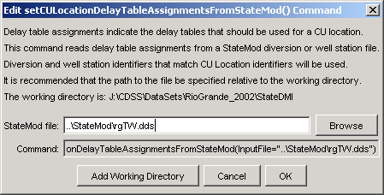
setCULocationDelayTableAssignmentsFromStateMod
setCULocationDelayTableAssignmentsFromStateMod() Command Editor

The command syntax is as follows:

setCULocationDelayTableAssignmentsFromStateMod(param=value,…)

Command Parameters

Parameter | Description | Default
InputFile | The name of the input file to read, surrounded by double quotes. | None – must be specified.

