Command Reference: synchronizeIrrigationPracticeAndCropPatternTS

Synchronize irrigation practice and crop pattern time series for each CU Location

StateCU Command
Version 02.14.00, 2007-07-03, Color, Acrobat Distiller

THIS COMMAND IS OBSOLETE – INSTEAD, MASS BALANCE IS ENFORCED BY NEWER DATA FILLING COMMANDS. This older command was used for Phase 4 Río Grande work. However, an entirely new procedure has now been implemented, which can be applied to all basins. The new procedure relies on processing water rights into a StateMod water rights file and then using this file as input when processing parcels for the irrigation practice time series. Other commands have also been implemented to allow more control over acreage processing.

The synchronizeIrrigationPracticeAndCropPatternTS() command synchronizes the acreage data in the irrigation practice time series (yearly) and crop pattern time series (yearly). This command should typically only be used when groundwater supply is available, and is necessary because the crop acreages are determined two different ways:

- The crop pattern acreage (CDS file) is determined from crops (e.g., by utilizing irrigated lands spatial data). Missing years of data are interpolated/prorated using historical agricultural crop statistics, simple interpolation, repeat, or other method.
- The acreage values in the irrigation practice (IPY) file are determined from water rights. Parcels are turned on over time based on the appropriation date of rights, resulting in a step-function of acreage:
  - The total acreage is determined based on parcel having surface or groundwater (well) supply.
  - The groundwater acreage is determined based on parcels having well supply.
  - The sprinkler acreage is determined based on whether the irrigation method for a parcel is sprinkler.

Each of the above approaches will result in different acreage values, which must be synchronized for consistent model results.

To use this command, the output period must be set. Irrigation practice and crop pattern time series must be available in memory from previous commands (see the readCropPatternTSFromStateCU() command). This command should be used after all time series are filled. Normally, the command is used near the end of the IPY commands file, before writing output.

The processing logic is as follows:

Loop through each matching CU location and get the corresponding irrigation practice and crop pattern time series.
- Loop through the output period.
  - Get the data values for the year and round to the precision used in the irrigation practice time series file (integers).
  - Compare the rounded values and make adjustments in the time series values:
If groundwater-only supply (aggregate/system using parcels):
    - Check the GWOnlyGWAcreage parameter and, if appropriate, adjust the data accordingly (adjust groundwater or total acreage) – see the parameter description below for available options.
    - Check the SprinklerAcreage parameter and, if appropriate, adjust the data accordingly (adjust the sprinkler acreage) – see the parameter description below for available options.
    - Set the irrigation practice total acreage to the crop pattern total.
Else if any other location (surface and/or groundwater supply):
- Check the DivAndWellGWAcreage parameter and, if appropriate, adjust the data accordingly (adjust groundwater acreage) – see the parameter description below for available options.
- Check the SprinklerAcreage parameter and, if appropriate, adjust the data accordingly (adjust the sprinkler acreage) – see the parameter description below for available options.
- Set the irrigation practice total acreage to the crop pattern total.

The sprinkler and groundwater acreage are not compared. Messages are printed to the log file for any values that are adjusted (values that do not need to be changed will not result in a message). To minimize messages and changes, comparisons are made to the precision of values written to the irrigation practice time series file.

The following dialog is used to edit the command and illustrates the syntax of the command.

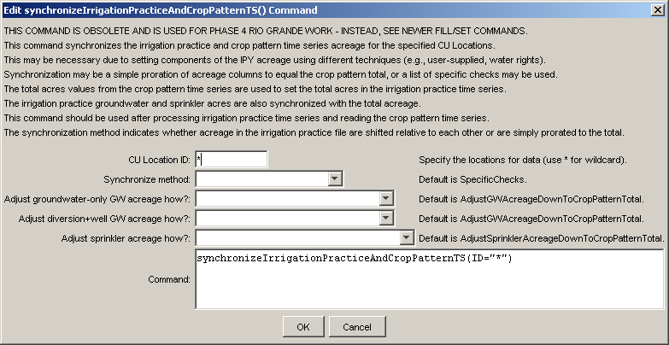
synchronizeIrrigationPracticeAndCropPatternTS
synchronizeIrrigationPracticeAndCropPatternTS() Command Editor

The command syntax is as follows:

synchronizeIrrigationPracticeAndCropPatternTS(param=value,…)

Command Parameters

Parameter | Description | Default
ID | A single CU Location identifier to match or a pattern using wildcards (e.g., 20*). | None – must be specified.
GWOnly  GWAcreage | Indicate how to adjust the groundwater acreage for locations that have groundwater-only supply, one of:  - AdjustGWAcreageToCropPatternTotal – adjust the irrigation practice groundwater acreage total up or down to match the crop pattern total acreage.  - AdjustGWAcreageDownToCropPatternTotal – adjust the irrigation practice groundwater acreage total down to match the crop pattern total acreage.  - AdjustCropPatternTotalToGWAcreage – adjust the crop pattern total acreage up or down to match the irrigation practice groundwater acreage.  - AdjustNone – do not adjust the groundwater acreage and total acreage relative to each other. | Adjust  GWAcreageDownTo  CropPattern  Total
DivAndWell  GWAcreage | Indicate how to adjust the groundwater acreage for locations that have surface and groundwater supply, one of:  - AdjustGWAcreageDownToCropPatternTotal – adjust the irrigation practice groundwater acreage total DOWN to match the crop pattern total acreage. Groundwater acreage less than the total will not be adjusted.  - AdjustNone – do not adjust the groundwater acreage. | Adjust  GWAcreage  DownTo  CropPattern  Total
Sprinkler  Acreage | Indicate how to adjust the sprinkler acreage, one of:  - AdjustSprinklerAcreageDownToCropPatternTotal – adjust the irrigation practice sprinkler acreage DOWN to match the crop pattern total acreage. Sprinkler acreage less than the total acreage will not be adjusted.  - AdjustNone – do not adjust the sprinkler acreage.  There is currently no adjustment to groundwater acreage. | Adjust  Sprinkler  Acreage  DownTo  CropPattern  Total

This page is intentionally blank.

