Command Reference: writeCULocationDelayTableAssignmentsToStateCU()

Write CU Location delay table assignment data to a StateCU file

StateCU Command
Version 01.17.00, 2005-01-20, Color, Acrobat Distiller

The writeCULocationDelayTableAssignmentsToStateCU() command writes CU Location delay table assignments that have been defined to a StateCU delay table assignment file. The following dialog is used to edit the command and illustrates the syntax of the command.

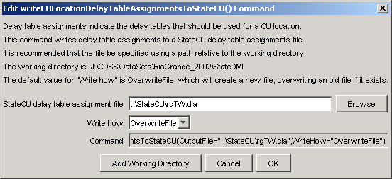
writeCULocationDelayTableAssignmentsToStateCU
writeCULocationDelayTableAssignmentsToStateCU() Command Editor

The command syntax is as follows:

writeCULocationDelayTableAssignmentsToStateCU(param=value,…)

Command Parameters

Parameter | Description | Default
OutputFile | The name of the output file to write, surrounded by double quotes. | None – must be specified.
WriteHow | OverwriteFile if the file should be overwritten or UpdateFile if the file should be updated, resulting in the previous header being carried forward. | OverwriteFile

