StateDMI

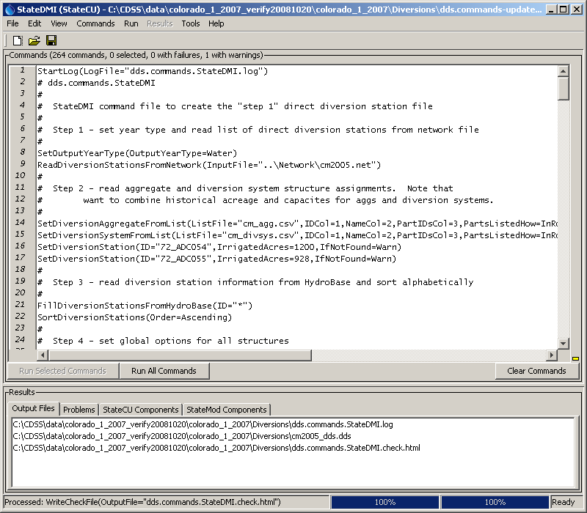

Colorado Department of Natural Resources
Colorado Water Conservation Board
Division of Water Resources

Developed by:

 | Riverside Technology, inc.

Version 03.12.02, 2013-04-17

This page is intentionally blank.

This document is formatted for double-sided printing.

Cover graphic is Main_cover.

