Command Reference: #
Comment line

General Command
Version 3.08.02, 2010-01-06

The # command indicates single-line comments. Commands can be converted to and from # comments. See also the /* and */ comment block commands, which are to comment multiple commands.

The following dialog is used to edit the command and illustrates the command syntax:

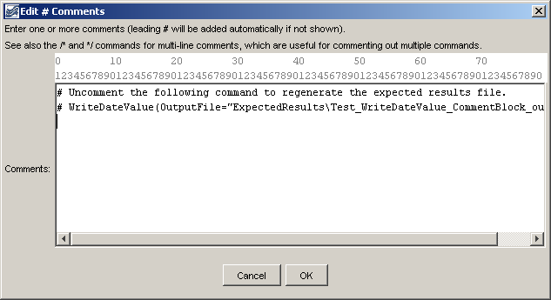
Comment
# Command Editor

The command syntax is as follows:

# Some text

A sample command file is as follows:

#
# Some comments…
#

This page is intentionally blank.

