Command Reference: /*
Comment block start

General Command
Version 3.08.02, 2010-01-06

The /* command starts a multi-line comment block and is useful for inserting long comments or temporarily commenting out blocks of commands. See also the */ and # commands. Commands between the /* and */ are not converted to comments but are skipped during processing.

The following dialog is used to edit the command and illustrates the command syntax:

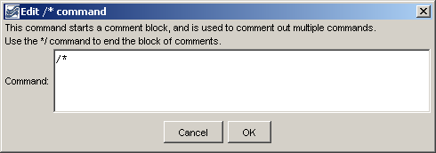
CommentBlockStart
/* Command Editor

The command syntax is as follows:

/*

A sample command file is as follows:

/*
SomeCommentedOutCommands()…
*/

This page is intentionally blank.

