Command Reference: CalculateDiversionDemandTSMonthlyAsMax()

Calculate diversion demand time series (monthly) as the maximum of the existing demands and the historical time series

StateMod Command
Version 3.09.01, 2010-02-01

The CalculateDiversionDemandTSMonthlyAsMax() command calculates diversion demand time series (monthly) as the maximum of the existing demands and the historical diversion time series. This command is typically used after the CalculateDiversionDemandTSMonthly() command.

If a diversion is defined as a MultiStruct, the primary diversion station will be checked using the sum of the historical time series and a sum of the demand time series. Secondary diversion stations will not be checked (the demand will likely have been set to zero in a previous CalculateDiversionDemandTSMonthly() command).

If necessary, use set commands after this command to force demand time series values (e.g., zeros).

The following dialog is used to edit the command and illustrates the syntax of the command.

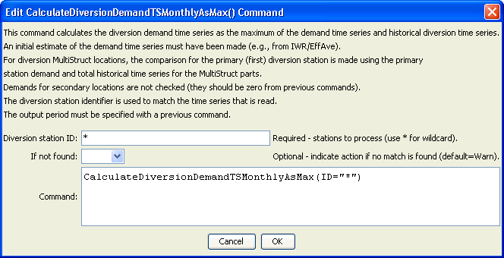
CalculateDiversionDemandTSMonthlyAsMax
CalculateDiversionDemandTSMonthlyAsMax() Command Editor

The command syntax is as follows:

CalculateDiversionDemandTSMonthlyAsMax(Parameter=value,…)

Command Parameters

Parameter | Description | Default
ID | A single diversion station identifier to match or a pattern using wildcards (e.g., 20*). | None – must be specified.
IfNot  Found | Used for error handling, one of the following:  - Add – add the time series if the ID is not matched and is not a wildcard  - Fail – generate a failure message if the ID is not matched  - Ignore – ignore (don’t add and don’t generate a message) if the ID is not matched  - Warn – generate a warning message if the ID is not matched | Warn

The following abbreviated command file illustrates how irrigation water requirement time series can be processed into average demand time series:

StartLog(LogFile="Cddm.commands.StateDMI.log")
# Cddm.commands.StateDMI
#
# StateDMI command file to create the Calculated demand file
#
# Step 1 - set the output period, used to compute averages...
#
SetOutputPeriod(OutputStart="10/1908",OutputEnd="09/2005")
SetOutputYearType(OutputYearType=Water)
#
# Step 2 - read historical diversion file -defines structures for *.ddm file
# plus read *.ddh file
#
ReadDiversionStationsFromStateMod(InputFile="..\StateMod\cm2005.dds")
ReadDiversionHistoricalTSMonthlyFromStateMod(InputFile="..\StateMod\cm2005.ddh")
#
# Step 3 - read StateCU *.iwr and *.def files (irrigation requirements and average efficiencies)
#
ReadIrrigationWaterRequirementTSMonthlyFromStateCU(InputFile="..\StateMod\cm2005.iwr")
# calculateDiversionStationEfficiencies(ID="*",EffMin=0,EffMax=60,
EffCalcStart=10/1974,EffCalcEnd=9/2004,LEZeroInAverage=False)
SetDiversionStationsFromList(ListFile="cm2005.def",IDCol="1",EffMonthlyCol="2",
Delim="Space",MergeDelim=True)
#
# Step 4 - determine calculated demand = iwr/efficiency
# - take max of calculated demand and historical diversion
#
CalculateDiversionDemandTSMonthly(ID="*")
CalculateDiversionDemandTSMonthlyAsMax(ID="*")
#
# Step 5 - set carriers nodes demand to 0, set full demand and summary demand nodes
#
# set carrier "transbasin" diversion to Divide Creek to "0", use operating rules to satisfy demand
SetDiversionDemandTSMonthlyConstant(ID="724721",Constant=0)
…similar commands omitted…
# Step 7 - write out calculated demand file
#
WriteDiversionDemandTSMonthlyToStateMod(OutputFile="..\StateMod\cm2005C.ddm")
#
# Check the results
CheckDiversionDemandTSMonthly(ID="*")
WriteCheckFile(OutputFile="Cddm.commands.StateDMI.check.html")

