Command Reference: CalculateDiversionStationEfficiencies()

Calculate diversion station average efficiencies using historical and irrigation water requirement time series

StateMod Command
Version 3.09.01, 2010-02-01

This command is generally not used with current modeling procedures. Instead, a variable efficiency approach is used where monthly average efficiencies are computed in StateCU and are set in diversion stations using a SetDiversionStationsFromList(…,EffMonthlyCol=…) command. This command is retained to duplicate previous work.

The CalculateDiversionStationEfficiencies() command calculates average monthly efficiencies for diversion stations and updates the diversion station information in memory. Efficiencies are calculated as irrigation water requirement divided by historical diversion time series. The detailed results of calculations can optionally be printed to a report file. The diversion historical time series (monthly) and irrigation water requirement time series (monthly) should be read or created with other commands, and should be filled before calculations, if appropriate. Only StateMod diversion stations with demand source for agricultural irrigation will be processed. The output year type must be specified correctly because efficiencies are stored in diversion stations according to the year type for the StateMod data set. Diversion MultiStruct stations are processed by using the total irrigation water requirement and historical diversions for all stations in the MultiStruct. A WriteDiversionStationsToStateMod() command must be executed to actually write the updated efficiency data.

The following dialog is used to edit the command and illustrates the syntax of the command.

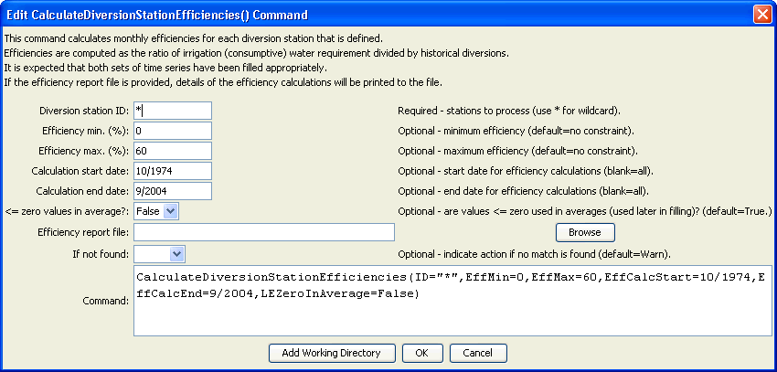
CalculateDiversionStationEfficiencies
CalculateDiversionStationEfficiencies() Command Editor

The command syntax is as follows:

CalculateDiversionStationEfficiencies(Parameter=Value,…)

Command Parameters

Parameter | Description | Default
ID | A single diversion station identifier to match or a pattern using wildcards (e.g., 20*). | None – must be specified.
EffMin | Minimum efficiency to allow, percent. Calculated efficiencies less than this value will be set to the minimum. | Do not constrain the efficiency.
EffMax | Maximum efficiency to allow, percent. Calculated efficiencies greater than this value will be set to the maximum. | Do not constrain the efficiency.
EffCalcStart | The start date (e.g., YYYY-MM) for efficiency calculations. Use this to limit the period for data considered in calculations. | Use the full period.
EffCalcEnd | The end date (e.g., YYYY-MM) for efficiency calculations. Use this to limit the period for data considered in calculations. | Use the full period.
LEZeroInAverage | If true, values less than or equal to zero will be considered when computing monthly time series averages. If false, values less than or equal to zero will be excluded from the averages. | True
EffReportFile | If specified, a high-detail report will be created, listing for each diversion station the irrigation water requirement, historical diversion, and resulting efficiency values. Creating the report slows processing slightly. | If blank, no report is generated.
IfNotFound | Used for error handling, one of the following:  - Fail – generate a failure message if the ID is not matched  - Ignore – ignore (don’t add and don’t generate a message) if the ID is not matched  - Warn – generate a warning message if the ID is not matched | Warn

