Command Reference: CalculateStreamEstimateCoefficients()

Calculate stream estimate coefficients data

StateMod Command
Version 3.09.01, 2010-02-01

The CalculateStreamEstimateCoefficients() command calculates stream estimate coefficients for each stream estimate station that is in memory – the previous values will be overwritten. If SetStreamEstimateCoefficientsPFGage() commands are used, they should be specified before this command. Conversely, SetStreamEstimateCoefficients() commands, if used, should be provided after this command. The following dialog is used to edit the command and illustrates the syntax of the command.

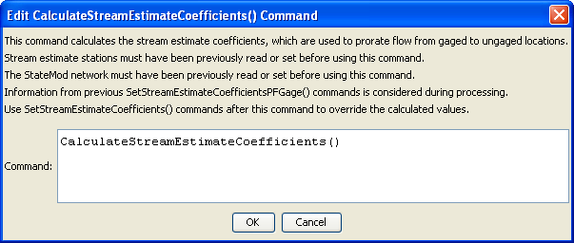
CalculateStreamEstimateCoefficients
CalculateStreamEstimateCoefficients() Command Editor

The command syntax is as follows:

CalculateStreamEstimateCoefficients(Parameter=Value,,…)

Command Parameters

Parameter | Description | Default
 | Currently, this command has no parameters.

The following command file illustrates how a StateMod stream estimate coefficients file can be created:

StartLog(LogFile="rib.commands.StateDMI.log")
# rib.commands.StateDMI
#
# Creates the Stream Estimate Station Coefficient Data file
#
# Step 1 - read river nodes from the network file and create file framework
#
ReadStreamEstimateStationsFromNetwork(InputFile="..\Network\cm2005.net")
#
# Step 2 - set preferred gages for "neighboring" gage approach
# this baseflow nodes are generally on smaller non-gaged tribs and have
# different flow characteristics than next downstream gages
#
SetStreamEstimateCoefficientsPFGage(ID="360645",GageID="09055300")
SetStreamEstimateCoefficientsPFGage(ID="360801",GageID="09055300")
SetStreamEstimateCoefficientsPFGage(ID="362002",GageID="09054000")
SetStreamEstimateCoefficientsPFGage(ID="360829",GageID="09047500")
..similar commands omitted…
#
# Step 3 - calculate stream coefficients
CalculateStreamEstimateCoefficients()
#
# Step 4 - set proration factors directly
#
SetStreamEstimateCoefficients(ID="364512",ProrationFactor=1.000,IfNotFound=Warn)
SetStreamEstimateCoefficients(ID="374641",ProrationFactor=0.200,IfNotFound=Warn)
SetStreamEstimateCoefficients(ID="374648",ProrationFactor=0.350,IfNotFound=Warn)
SetStreamEstimateCoefficients(ID="380880",ProrationFactor=1.000,IfNotFound=Warn)
SetStreamEstimateCoefficients(ID="381594",ProrationFactor=0.800,IfNotFound=Warn)
SetStreamEstimateCoefficients(ID="384617",ProrationFactor=0.700,IfNotFound=Warn)
SetStreamEstimateCoefficients(ID="510639",ProrationFactor=1.000,IfNotFound=Warn)
SetStreamEstimateCoefficients(ID="514603",ProrationFactor=0.800,IfNotFound=Warn)
SetStreamEstimateCoefficients(ID="514620",ProrationFactor=1.000,IfNotFound=Warn)
SetStreamEstimateCoefficients(ID="510728",ProrationFactor=1.000,IfNotFound=Warn)
SetStreamEstimateCoefficients(ID="530555",ProrationFactor=0.180,IfNotFound=Warn)
SetStreamEstimateCoefficients(ID="530678",ProrationFactor=0.230,IfNotFound=Warn)
SetStreamEstimateCoefficients(ID="531082",ProrationFactor=1.000,IfNotFound=Warn)
SetStreamEstimateCoefficients(ID="954683",ProrationFactor=0.400,IfNotFound=Warn)
#
# Step 5 - create streamflow estimate coefficient file
#
WriteStreamEstimateCoefficientsToStateMod(OutputFile="..\StateMOD\cm2005.rib")
#
# Check the results
CheckStreamEstimateCoefficients(ID="*")
WriteCheckFile(OutputFile="rib.commands.StateDMI.check.html")

