Command Reference: CalculateWellDemandTSMonthly()

Calculate well demand time series (monthly) using irrigation water requirement and average monthly efficiencies

StateMod Command
Version 3.09.01, 2010-02-01

The CalculateWellDemandTSMonthly() command calculates well demand time series (monthly) by dividing the irrigation water requirement (IWR) time series (monthly) by average monthly efficiencies. The IWR time series should have been read by a previous command. The well station efficiencies should also have been calculated, set, or read using previous commands. The output year type must be specified correctly because efficiencies are stored in well stations according to the year type for the StateMod data set. If time series data are not available, a demand time series with zero values is created – this time series can be replaced with SetWellDemandTSMonthly() commands, if necessary. Only well stations that have a demand type (StateMod well station idvcomw) equal to one are processed. For “diversion + well” well stations, the demand is typically calculated using only the diversion station IWR and historical diversion time series and is written to the diversion demand time series file.

The following dialog is used to edit the command and illustrates the syntax of the command.

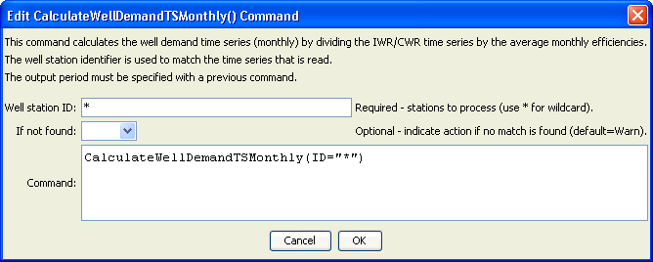
CalculateWellDemandTSMonthly
CalculateWellDemandTSMonthly() Command Editor

The command syntax is as follows:

CalculateWellDemandTSMonthly(Parameter=Value,…)

Command Parameters

Parameter | Description | Default
ID | A single well station identifier to match or a pattern using wildcards (e.g., 20*). | None – must be specified.
IfNotFound | Used for error handling, one of the following:  - Fail – generate a failure message if the ID is not matched  - Ignore – ignore (don’t add and don’t generate a message) if the ID is not matched  - Warn – generate a warning message if the ID is not matched | Warn

