Command Reference: CalculateWellDemandTSMonthlyAsMax()

Calculate well demand time series (monthly) as the maximum of the existing demands and the historical pumping time series

StateMod Command
Version 3.09.01, 2010-02-01

The CalculateWellDemandTSMonthlyAsMax() command calculates well demand time series (monthly) as the maximum of the existing demands and the historical pumping time series.

The following dialog is used to edit the command and illustrates the syntax of the command.

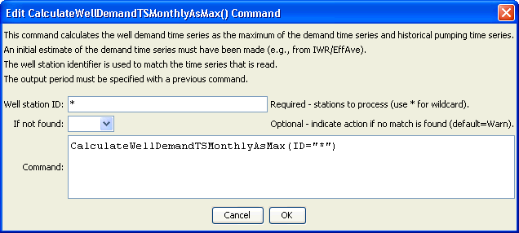
CalculateWellDemandTSMonthlyAsMax
CalculateWellDemandTSMonthlyAsMax() Command Editor

The command syntax is as follows:

CalculateWellDemandTSMonthlyAsMax(Parameter=Value,…)

Command Parameters

Parameter | Description | Default
ID | A single well station identifier to match or a pattern using wildcards (e.g., 20*). | None – must be specified.
IfNot  Found | Used for error handling, one of the following:  - Add – add the time series if the ID is not matched and is not a wildcard  - Fail – generate a failure message if the ID is not matched  - Ignore – ignore (don’t add and don’t generate a message) if the ID is not matched  - Warn – generate a warning message if the ID is not matched | Warn

