Command Reference: CheckBlaneyCriddle()

Check Blaney-Criddle data for problems

StateCU Command
Version 3.08.02, 2010-01-05

The CheckBlaneyCriddle() command checks the Blaney-Criddle crop coefficient data for problems. The command should usually be used with a WriteCheckFile() command at the end of a command file.

The following dialog is used to edit the command and illustrates the syntax of the command.

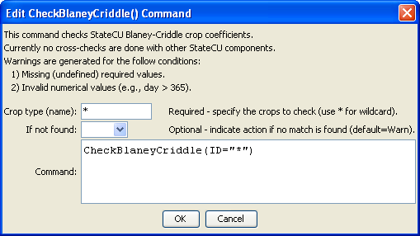
CheckBlaneyCriddle
CheckBlaneyCriddle() Command Editor

The command syntax is as follows:

CheckBlaneyCriddle(Parameter=Value,…)

Command Parameters

Parameter | Description | Default
ID | The name of the crop(s) to check. Use * to match a pattern. | None – must be specified.
IfNotFound | One of the following:  - Fail – generate a failure message if the identifier is not matched  - Ignore – ignore (don’t generate a message) if the identifier is not matched  - Warn – generate a warning message if the identifier is not matched | Warn

The following example command file illustrates how Blaney-Criddle coefficients can be defined, checked, and written to a StateCU file:

StartLog(LogFile="Crops_KBC.StateDMI.log")
#
# StateDMI commands to create the Rio Grande Blaney-Criddle coefficients File
#
# History:
#
# 2004-03-16 Steven A. Malers, RTi Initial version using StateDMI.
# 2007-04-23 SAM, RTi Update for Rio Grande Phase 5.
#
# Step 1 - read data from HydroBase
#
# Read the general Blaney-Criddle coefficients first and then override with Rio Grande
# data.
ReadBlaneyCriddleFromHydroBase(BlaneyCriddleMethod="BLANEY-CRIDDLE_TR-21")
ReadBlaneyCriddleFromHydroBase(BlaneyCriddleMethod="BLANEY-CRIDDLE_RIO_GRANDE")
#
# Step 3 - write the file
#
SortBlaneyCriddle(Order=Ascending)
WriteBlaneyCriddleToStateCU(OutputFile="rg2007.kbc")
#
# Check the results
#
CheckBlaneyCriddle(ID="*")
WriteCheckFile(OutputFile="rg2007.kbc.check.html")

