Command Reference: CheckClimateStations()

Check climate station data for problems

StateCU Command
Version 3.08.02, 2010-01-05

The CheckClimateStations() command checks the climate stations for problems. The command should usually be used with a WriteCheckFile() command at the end of a command file.

The following dialog is used to edit the command and illustrates the syntax of the command.

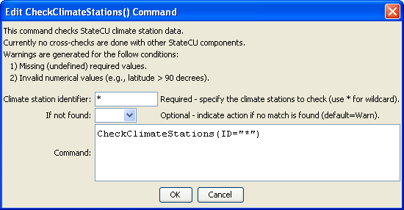
CheckClimateStations
CheckClimateStations() Command Editor

The command syntax is as follows:

CheckClimateStations(Parameter=Value,…)

Command Parameters

Parameter | Description | Default
ID | The identifier for the station(s) to check. Use * to match a pattern. | None – must be specified.
IfNotFound | One of the following:  - Fail – generate a failure message if the climate station identifier is not matched  - Ignore – ignore (don’t generate a message) if the climate station identifier is not matched  - Warn – generate a warning message if the climate station identifier is not matched | Warn

The following example command file illustrates how climate stations can be defined, sorted, checked, and written to a StateCU file:

ReadClimateStationsFromList(ListFile="climsta.lst",IDCol=1)
FillClimateStationsFromHydroBase(ID="*")
SetClimateStation(ID="3016",Region2="14080106",IfNotFound=Warn)
SetClimateStation(ID="1018",Region2="14040106",IfNotFound=Warn)
SetClimateStation(ID="1928",Elevation=6440,IfNotFound=Warn)
SetClimateStation(ID="0484",Region1="MOFFAT",IfNotFound=Add)
SortClimateStations()
WriteClimateStationsToStateCU(OutputFile="COclim2006.cli")
#
# Check the results
#
CheckClimateStations(ID="*")
WriteCheckFile(OutputFile="COclim2006.cli.check.html")

