Command Reference: CheckInstreamFlowDemandTSAverageMonthly()

Check instream flow demand time series (average monthly) data for problems

StateMod Command
Version 3.09.01, 2010-02-01

The CheckInstreamFlowDemandTSAverageMonthly() command checks instream flow demand time series (average monthly) data for problems. The command should usually be used with a WriteCheckFile() command at the end of a command file.

The following dialog is used to edit the command and illustrates the syntax of the command.

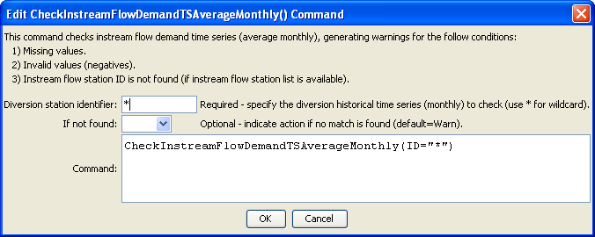
CheckInstreamFlowDemandTSAverageMonthly
CheckInstreamFlowDemandTSAverageMonthly() Command Editor

The command syntax is as follows:

CheckInstreamFlowDemandTSAverageMonthly(Parameter=Value,…)

Command Parameters

Parameter | Description | Default
ID | The identifier for the location(s) to check. Use * to match a pattern. | None – must be specified.
IfNotFound | One of the following:  - Fail – generate a failure message if the location identifier is not matched  - Ignore – ignore (don’t generate a message) if the location identifier is not matched  - Warn – generate a warning message if the location identifier is not matched | Warn

The following excerpt from a command file illustrates how instream flow demand time series can be checked and written to a StateMod file:

#
# Create instream demand time series file
#
WriteInstreamFlowDemandTSAverageMonthlyToStateMod(OutputFile="..\STATEMOD\cm2005.ifa")
#
# Check the results
CheckInstreamFlowDemandTSAverageMonthly(ID="*")
WriteCheckFile(OutputFile="ifa.commands.StateDMI.check.html")

