Command Reference: CheckIrrigationPracticeTS()

Check irrigation practice time series data for problems

StateCU Command
Version 3.08.02, 2010-01-05

The CheckIrrigationPracticeTS() command checks the irrigation practice time series data for problems. The command should usually be used with a WriteCheckFile() command at the end of a command file.

The following dialog is used to edit the command and illustrates the syntax of the command.

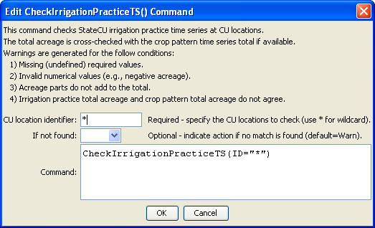
CheckIrrigationPracticeTS
CheckIrrigationPracticeTS() Command Editor

The command syntax is as follows:

CheckIrrigationPracticeTS(Parameter=Value,…)

Command Parameters

Parameter | Description | Default
ID | The location identifiers for the time series to check. Use * to match a pattern. | None – must be specified.
IfNotFound | One of the following:  - Fail – generate a failure message if the identifier is not matched  - Ignore – ignore (don’t generate a message) if the identifier is not matched  - Warn – generate a warning message if the identifier is not matched | Warn

The following excerpt from a command file illustrates how irrigation practice time series can be checked and written to a StateCU file:

#
# Create irrigation practice file
#
WriteIrrigationPracticeTSToStateCU(OutputFile="cm2006.ipy")
#
# Check the results
CheckIrrigationPracticeTS(ID="*")
WriteCheckFile(OutputFile="ipy.commands.StateDMI.check.html")

