Command Reference: CheckPenmanMonteith()

Check Penman-Monteith data for problems

StateCU Command
Version 3.10.00, 2010-04-02

The CheckPenmanMonteith() command checks the Penman-Monteith crop coefficient data for problems. The command should usually be used with a WriteCheckFile() command at the end of a command file.

The following dialog is used to edit the command and illustrates the syntax of the command.

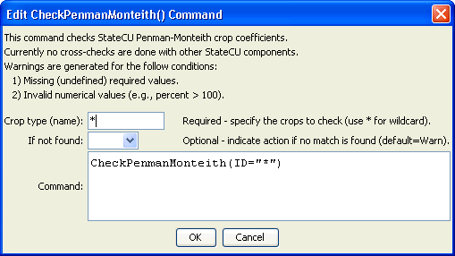
CheckPenmanMonteith
CheckPenmanMonteith() Command Editor

The command syntax is as follows:

CheckPenmanMonteith(Parameter=Value,…)

Command Parameters

Parameter | Description | Default
ID | The name of the crop(s) to check. Use * to match a pattern. | None – must be specified.
IfNotFound | One of the following:  - Fail – generate a failure message if the identifier is not matched  - Ignore – ignore (don’t generate a message) if the identifier is not matched  - Warn – generate a warning message if the identifier is not matched | Warn

The following example command file illustrates how Penman-Monteith coefficients can be defined, checked, and written to a StateCU file:

StartLog(LogFile="Crops_KPM.StateDMI.log")
#
# StateDMI commands to create the Penman-Monteith crop coefficients file
#
# Step 1 - read data from HydroBase
#
# Read the general ASCE standardized coefficients
ReadPenmanMonteithFromHydroBase(PenmanMonteithMethod="PENMAN-MONTEITH_ALFALFA")
#
# Step 3 - write the file
#
SortPenmanMonteith()
WritePenmanMonteithToStateCU(OutputFile="rg2007.kpm")
#
# Check the results
#
CheckPenmanMonteith(ID="*")
WriteCheckFile(OutputFile="Crops_KPM.StateDMI.check.html")

