Command Reference: CheckRiverNetwork()

Check river network data for problems

StateMod Command
Version 3.09.01, 2010-02-03

The CheckRiverNetwork() command checks river network data for problems. The command should usually be used with a WriteCheckFile() command at the end of a command file.

The following dialog is used to edit the command and illustrates the syntax of the command.

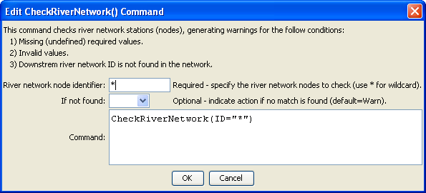
CheckRiverNetwork
CheckRiverNetwork() Command Editor

The command syntax is as follows:

CheckRiverNetwork(Parameter=Value,…)

Command Parameters

Parameter | Description | Default
ID | The identifier for the location(s) to check. Use * to match a pattern. | None – must be specified.
IfNotFound | One of the following:  - Fail – generate a failure message if the location identifier is not matched  - Ignore – ignore (don’t generate a message) if the location identifier is not matched  - Warn – generate a warning message if the location identifier is not matched | Warn

The following command file illustrates how a StateMod river network file can be created from the generalized network file:

StartLog(LogFile="rin.commands.StateDMI.log")
# rin.commands.StateDMI
#
# creates the river network file for the Colorado River monthly/daily models
#
# Step 1 - read river nodes from the network file and create file framework
#
ReadNetworkFromStateMod(InputFile="cm2005.net")
CreateRiverNetworkFromNetwork()
#
# Step 2 - get node (diversion, stream stations, reservoirs, instream flows)
# names from HydroBase
#
FillRiverNetworkFromHydroBase(ID="*",NameFormat=StationName_NodeType)
#
# Step 3 - read missing node names from network file
#
FillRiverNetworkFromNetwork(ID="*",NameFormat="StationName_NodeType",
CommentFormat="StationID")
#
# Step 4 - create StateMod river network file
#
WriteRiverNetworkToStateMod(OutputFile="..\StateMod\cm2005.rin")
#
# Check the results
CheckRiverNetwork(ID="*")
WriteCheckFile(OutputFile="rin.commands.StateDMI.check.html")

