Command Reference: CheckStreamEstimateCoefficients()

Check stream estimate coefficients data for problems

StateMod Command
Version 3.09.01, 2010-02-01

The CheckStreamEstimateCoefficients() command checks stream estimate coefficients data for problems. The command should usually be used with a WriteCheckFile() command at the end of a command file.

The following dialog is used to edit the command and illustrates the syntax of the command.

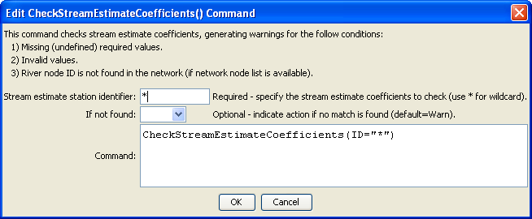
CheckStreamEstimateCoefficients
CheckStreamEstimateCoefficients() Command Editor

The command syntax is as follows:

CheckStreamEstimateCoefficients(Parameter=Value,…)

Command Parameters

Parameter | Description | Default
ID | The identifier for the location(s) to check. Use * to match a pattern. | None – must be specified.
IfNotFound | One of the following:  - Fail – generate a failure message if the location identifier is not matched  - Ignore – ignore (don’t generate a message) if the location identifier is not matched  - Warn – generate a warning message if the location identifier is not matched | Warn

The following command file illustrates how a StateMod stream estimate coefficients file can be created:

StartLog(LogFile="rib.commands.StateDMI.log")
# rib.commands.StateDMI
#
# Creates the Stream Estimate Station Coefficient Data file
#
# Step 1 - read river nodes from the network file and create file framework
#
ReadStreamEstimateStationsFromNetwork(InputFile="..\Network\cm2005.net")
#
# Step 2 - set preferred gages for "neighboring" gage approach
# this baseflow nodes are generally on smaller non-gaged tribs and have
# different flow characteristics than next downstream gages
#
SetStreamEstimateCoefficientsPFGage(ID="360645",GageID="09055300")
SetStreamEstimateCoefficientsPFGage(ID="360801",GageID="09055300")
SetStreamEstimateCoefficientsPFGage(ID="362002",GageID="09054000")
SetStreamEstimateCoefficientsPFGage(ID="360829",GageID="09047500")
..similar commands omitted…
#
# Step 3 - calculate stream coefficients
CalculateStreamEstimateCoefficients()
#
# Step 4 - set proration factors directly
#
SetStreamEstimateCoefficients(ID="364512",ProrationFactor=1.000,IfNotFound=Warn)
SetStreamEstimateCoefficients(ID="374641",ProrationFactor=0.200,IfNotFound=Warn)
SetStreamEstimateCoefficients(ID="374648",ProrationFactor=0.350,IfNotFound=Warn)
SetStreamEstimateCoefficients(ID="380880",ProrationFactor=1.000,IfNotFound=Warn)
SetStreamEstimateCoefficients(ID="381594",ProrationFactor=0.800,IfNotFound=Warn)
SetStreamEstimateCoefficients(ID="384617",ProrationFactor=0.700,IfNotFound=Warn)
SetStreamEstimateCoefficients(ID="510639",ProrationFactor=1.000,IfNotFound=Warn)
SetStreamEstimateCoefficients(ID="514603",ProrationFactor=0.800,IfNotFound=Warn)
SetStreamEstimateCoefficients(ID="514620",ProrationFactor=1.000,IfNotFound=Warn)
SetStreamEstimateCoefficients(ID="510728",ProrationFactor=1.000,IfNotFound=Warn)
SetStreamEstimateCoefficients(ID="530555",ProrationFactor=0.180,IfNotFound=Warn)
SetStreamEstimateCoefficients(ID="530678",ProrationFactor=0.230,IfNotFound=Warn)
SetStreamEstimateCoefficients(ID="531082",ProrationFactor=1.000,IfNotFound=Warn)
SetStreamEstimateCoefficients(ID="954683",ProrationFactor=0.400,IfNotFound=Warn)
#
# Step 5 - create streamflow estimate coefficient file
#
WriteStreamEstimateCoefficientsToStateMod(OutputFile="..\StateMOD\cm2005.rib")
#
# Check the results
CheckStreamEstimateCoefficients(ID="*")
WriteCheckFile(OutputFile="rib.commands.StateDMI.check.html")

