Command Reference: CheckTimeSeries()
Check time series data values against criteria
Version 09.04.02, 2009-07-31

The CheckTimeSeries() command checks time series data values against criteria, for example to identify missing, bad, or extreme data values. A warning is generated for each match. The WriteCheckFile() command can then be used to write a summary of the warnings.

The following dialog is used to edit the command and illustrates the command syntax.

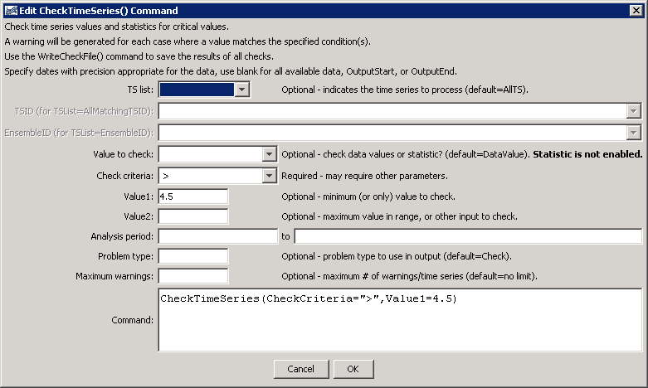
CheckTimeSeries
CheckTimeSeries() Command Editor

The command syntax is as follows:

CheckTimeSeries(Parameter=Value,…)

Command Parameters

Parameter | Description | Default
TSList | Indicates the list of time series to be processed, one of:  - AllMatchingTSID – all time series that match the TSID (single TSID or TSID with wildcards) will be processed.  - AllTS – all time series before the command will be processed.  - EnsembleID – all time series in the ensemble will be processed.  - LastMatchingTSID – the last time series that matches the TSID (single TSID or TSID with wildcards) will be processed.  - SelectedTS – the time series selected with the SelectTimeSeries() command will be processed. | AllTS
TSID | The time series identifier or alias for the time series to be modified, using the * wildcard character to match multiple time series. | Required if TSList=*TSID.
EnsembleID | The ensemble to be modified, if processing an ensemble. | Required if TSList=EnsembleID.
ValueToCheck | One of the following:  - DataValue to indicate that raw data values should be checked.  - Statistic to indicate that a statistic computed from data values should be checked (currently not enabled). | DataValue.
CheckCriteria | The criteria that is checked, one of:  - AbsChange> – check for absolute change from one value to the next value > Value1  - AbsChangePercent> – check for absolute change in percent from one value to the next value > Value1.  - InRange – check for value in range >= Value1 and <= Value2.  - OutOfRange – check for value < Value1 or > Value2.  - Missing – check for missing values.  - Repeat – check for values that are the same as the previous value.  - < – check for values < Value1.  - <= – check for values <= Value1.  - > – check for values > Value1.  - >= – check for values >= Value1.  - == – check for values equal to Value1. | None – must be specified.
AnalysisStart | The date/time to start analyzing data. | Full period is analyzed.
AnalysisEnd | The date/time to end analyzing data. | Full period is analyzed.
ProblemType | The problem type that will be shown in warning messages (currently not enabled). | Check
MaxWarnings | The maximum number of warnings to list for each time series, useful if output is very large. | List all warnings.

