Command Reference: CompareFiles()
Compare text files to determine whether they are different

General Command
Version 03.08.02, 2010-01-06

The CompareFiles() command compares text files to determine data differences. For example, the command can be used to compare old and new files produced by a software process.

Each line in the file is compared. By default, lines beginning with # are treated as comment lines and are ignored (see CommentLineChar to specify the comment indicator). Therefore, only non-comment lines are compared. Differences and simple statistics are printed to the log file. A warning can be generated if a difference is detected or if no differences are detected.

The following dialog is used to edit the command and illustrates the syntax for the command.

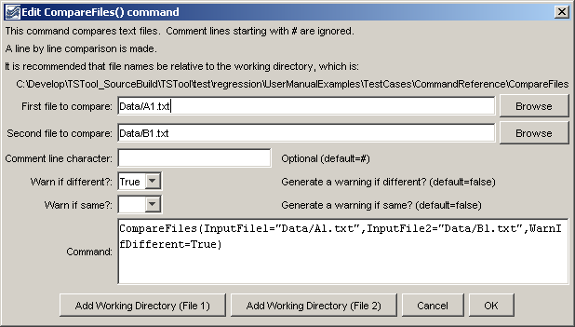
CompareFiles
CompareFiles() Command Editor

The command syntax is as follows:

CompareFiles(Parameter=Value,…)

Command Parameters

Parameter | Description | Default
InputFile1 | The name of the first file to read. Enclose the name in double quotes to protect whitespace and special characters. | None – the file name is required.
InputFile2 | The name of the second file to read. Enclose the name in double quotes to protect whitespace and special characters. | None – the file name is required.
CommentLineChar | The character(s) that if found at the start of a line indicate comment lines. Comment lines are ignored in the comparison because they typically may include information such as date/time that changes even if the remainder of the file contents are the same. | #
WarnIfDifferent | If True and at least one difference is detected, a warning will be generated by the command, which will result in software like TSTool displaying a warning. If False, only status messages are written to the log file. The warning is useful if it is critical to detect any difference in the files. | Do not generate a warning if the files are different. Differences are printed to the log file.
WarnIfSame | If True and no differences are detected, a warning will be generated by the command, which will result in software like TSTool displaying a warning. If False, only status messages are written to the log file. The warning is useful if it is critical to detect files that are the same. | Do not generate a warning if the files are the same.

The following example illustrates how two files can be compared. For example, use similar commands to compare results from two model runs, two database queries, or when testing software:

CompareFiles(InputFile1="Data/A1.txt",InputFile2="Data/B1.txt",
WarnIfDifferent=True)

