Command Reference: CreateIrrigationPracticeTSForCULocations()

Create empty irrigation practice time series for each CU Location

StateCU Command
Version 3.09.01, 2010-02-01

The CreateIrrigationPracticeTSForCULocations() command creates empty irrigation practice time series for each CU Location. This ensures that the irrigation practice time series will be in the same order as the CU locations initializes the time series with missing data values that can be filled with other commands.

The following dialog is used to edit the command and illustrates the syntax of the command.

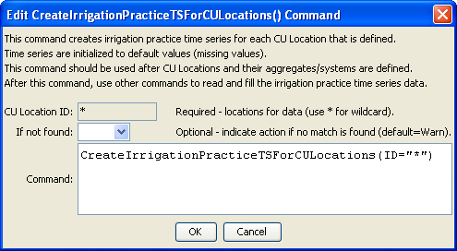
CreateIrrigationPracticeTSForCULocations
CreateIrrigationPracticeTSForCULocations() Command Editor

The command syntax is as follows:

CreateIrrigationPracticeTSForCULocations(Parameter=Value,…)

Command Parameters

Parameter | Description | Default
ID | A single CU Location identifier to match or a pattern using wildcards (e.g., 20*). | None – must be specified as *
IfNotFound | Used for error handling, one of the following:  - Fail – generate a failure message if the ID is not matched  - Ignore – ignore (don’t add and don’t generate a message) if the ID is not matched  - Warn – generate a warning message if the ID is not matched | Warn

