Command Reference: CreateNetworkFromRiverNetwork()

Create a generalized network from a StateMod river network

StateCU Command
Version 3.09.01, 2010-02-01

The CreateNetworkFromRiverNetwork() command creates a generalized network from a StateMod river network. This is used, for example, when a StateMod data set has been developed without StateDMI and a generalized network file is now needed for full StateDMI use. The generalized network file can be edited using the interactive model schematic editor. The following dialog is used to edit the command and illustrates the syntax of the command.

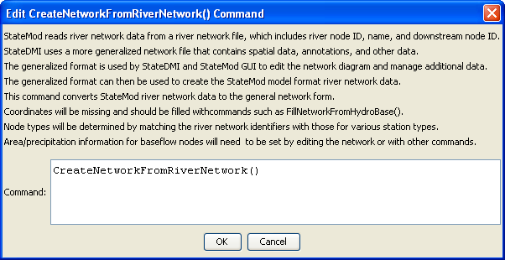
CreateNetworkFromRiverNetwork
CreateNetworkFromRiverNetwork() Command Editor

The command syntax is as follows:

CreateNetworkFromRiverNetwork()

Command Parameters

Parameter | Description | Default
 | There are no parameters for this command.

The following example command file illustrates how the command might be used:

# Create a generalized XML network from individual StateMod files
# Read the network, which contains upstream to downstream connectivity but does
# not indicate node types
ReadRiverNetworkFromStateMod(InputFile=cm2005.rin)
# Read the stations, which imply the node types
ReadRiverStreamGageStationsFromStateMod(InputFile=cm2005.ris)
ReadRiverDiversionStationsFromStateMod(InputFile=cm2005.dds)
ReadRiverReservoirStationsFromStateMod(InputFile=cm2005.res)
ReadRiverInstreamFlowStationsFromStateMod(InputFile=cm2005.ifs)
ReadRiverWellStationsFromStateMod(InputFile=cm2005.wes)
# To be developed...
#ReadRiverPlanStationsFromStateMod()
ReadRiverStreamEstimateStationsFromStateMod(InputFile=cm2005.ris)
# Now create the generalized network, using the connectivity and node types
CreateNetworkFromRiverNetwork()
# Fill in node names and locations from HydroBase, if any is still missing
FillNetworkFromHydroBase()
# Write the generalized network
WriteNetworkToStateMod(OutputFile="cm2005.net")
# Check for errors (the following is not yet implemented)
#CheckNetwork()
WriteCheckFile(OutputFile="cm2005.net.check.html")

