Command Reference: CreateRiverNetworkFromNetwork()

Create a StateMod river network from a generalized network

StateMod Command
Version 3.09.01, 2010-02-03

The CreateRiverNetworkFromNetwork() command creates a StateMod river network from a generalized network. This is used, for example, when a change has been made to the generalized network (e.g., by editing interactively in StateDMI) and a consistent StateMod river network file must be created.

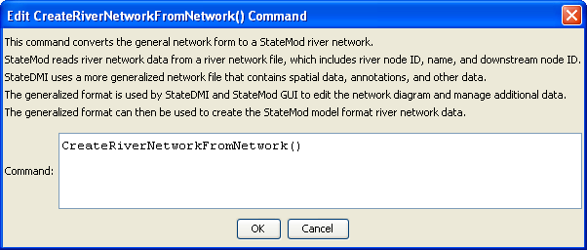
CreateRiverNetworkFromRiverNetwork
CreateRiverNetworkFromRiverNetwork() Command Editor
The command syntax is as follows:

CreateRiverNetworkFromRiverNetwork()

Command Parameters

Parameter | Description | Default
 | There are no parameters for this command.

The following command file illustrates how a StateMod river network file can be created from the generalized network file:

StartLog(LogFile="rin.commands.StateDMI.log")
# rin.commands.StateDMI
#
# creates the river network file for the Colorado River monthly/daily models
#
# Step 1 - read river nodes from the network file and create file framework
#
ReadNetworkFromStateMod(InputFile="cm2005.net")
CreateRiverNetworkFromNetwork()
#
# Step 2 - get node (diversion, stream stations, reservoirs, instream flows)
# names from HydroBase
#
FillRiverNetworkFromHydroBase(ID="*",NameFormat=StationName_NodeType)
#
# Step 3 - read missing node names from network file
#
FillRiverNetworkFromNetwork(ID="*",NameFormat="StationName_NodeType",
CommentFormat="StationID")
#
# Step 4 - create StateMod river network file
#
WriteRiverNetworkToStateMod(OutputFile="..\StateMod\cm2005.rin")
#
# Check the results
CheckRiverNetwork(ID="*")
WriteCheckFile(OutputFile="rin.commands.StateDMI.check.html")

