Command Reference: FillCULocation()

Fill CU Location data

StateCU Command
Version 3.09.00, 2010-01-24

The FillCULocation() command fills missing data in existing CU Locations. The following dialog is used to edit the command and illustrates the syntax of the command.

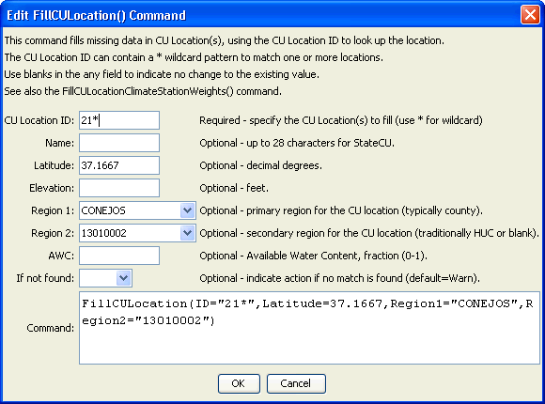
FillCULocation
FillCULocation() Command Editor

The command syntax is as follows:

FillCULocation(Parameter=Value,…)

Command Parameters

Parameter | Description | Default
ID | A single CU Location identifier to match or a pattern using wildcards (e.g., 20*). | None – must be specified.
Name | The name to be assigned for matching locations. | If not specified, the original value will remain.
Latitude | The latitude to be assigned for all matching CU Locations with missing latitude. | If not specified, the original value will remain.
Elevation | The elevation to be assigned for matching locations. | If not specified, the original value will remain.
Region1 | The Region1 to be assigned for all matching CU Locations with missing Region1. | If not specified, the original value will remain.
Region2 | The Region2 to be assigned for all matching CU Locations with missing Region2. | If not specified, the original value will remain.
AWC | The available water content (AWC) to be assigned for all matching CU Locations with missing AWC. | If not specified, the original value will remain.
IfNotFound | Used for error handling, one of the following:  - Fail – generate a failure message if the ID pattern is not matched  - Ignore – ignore (don’t generate a message) if the ID pattern is not matched  - Warn – generate a warning message if the ID pattern is not matched | Warn

