Command Reference: FillCULocationClimateStationWeights ()

Fill CU Location climate station weights data

StateCU Command
Version 3.09.00, 2010-01-24

The FillCULocationClimateStationWeights() command fills climate station weights data in existing CU Locations. Only locations that have no climate stations assigned will be modified. The following dialog is used to edit the command and illustrates the syntax of the command.

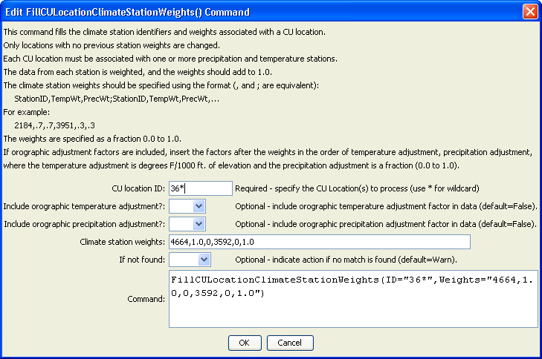
FillCULocationClimateStationWeights
FillCULocationClimateStationWeights () Command Editor
The command syntax is as follows:

FillCULocationClimateStationWeights(Parameter=Value,…)

Command Parameters

Parameter | Description | Default
ID | A single CU Location identifier to match or a pattern using wildcards (e.g., 20*). | None – must be specified.
Include  Orographic  TempAdj | If True, include the orographic temperature adjustment factor, after the Weights described below, specified as degrees/1000 feet. | False
Include  Orographic  PrecAdj | If True, include the orographic precipitation adjustment factor, after the Weights described below, specified as a fraction 0.0 to 1.0. Place after the orographic temperature adjustment factor if it is specified. | False
Weights | A repeating pattern of StationID, TempWt, PrecWt, where the station identifiers match climate station identifiers and the weights are specified as fractions in the range 0.0 to 1.0. Also include the orographic temperature and/or orographic precipitation adjustment factors if the above parameters are True. | None – must be specified.
IfNotFound | Used for error handling, one of the following:  - Fail – generate a failure message if the ID pattern is not matched  - Ignore – ignore (don’t generate a message) if the ID pattern is not matched  - Warn – generate a warning message if the ID pattern is not matched | Warn

An example command file is shown below:

ReadCULocationsFromList(ListFile="cmstrlist.csv",IDCol=1,NameCol=6)
FillCULocationsFromHydroBase(ID="*",CULocType=Structure,Region1Type=County,Region2Type=HUC)
SetCULocationsFromList(ListFile="cmstrlist.csv",IDCol=1,LatitudeCol=2,AWCCol=11)
SetCULocationsFromList(ListFile="plateau.csv",IDCol=1,Region1Col=2)
SetCULocationClimateStationWeightsFromList(ListFile="cowts.csv",StationIDCol=1,
Region1Col=2,Region2Col=3,TempWtCol=4,PrecWtCol=5)
FillCULocationClimateStationWeights(ID="72_ADC065",Weights="3146,0.68,0.68,3489,0.32,0.32")
FillCULocationClimateStationWeights(ID="36*",Weights="4664,1.0,0,3592,0,1.0")
FillCULocationClimateStationWeights(ID="37*",Weights="2454,1.0,1.0")
FillCULocationClimateStationWeights(ID="38*",Weights="3359,1.0,1.0")
FillCULocationClimateStationWeights(ID="39*",Weights="7031,1.0,1.0")
FillCULocationClimateStationWeights(ID="45*",Weights="7031,1.0,1.0")
FillCULocationClimateStationWeights(ID="50*",Weights="3500,0.5,0.5,4664,0.5,0.5")
FillCULocationClimateStationWeights(ID="51*",Weights="3500,0.5,0.5,4664,0.5,0.5")
FillCULocationClimateStationWeights(ID="52*",Weights="9265,1.0,1.0")
FillCULocationClimateStationWeights(ID="53*",Weights="9265,1.0,1.0")
FillCULocationClimateStationWeights(ID="70*",Weights="0214,1.0,1.0")
FillCULocationClimateStationWeights(ID="72*",Weights="1741,1.0,1.0")
FillCULocationClimateStationWeights(ID="950001",Weights="3146,0.68,0.68,3489,0.32,0.32")
FillCULocationClimateStationWeights(ID="950010",Weights="7031,1.0,1.0")
FillCULocationClimateStationWeights(ID="950011",Weights="7031,1.0,1.0")
FillCULocationClimateStationWeights(ID="950050",Weights="3146,0.68,0.68,3489,0.32,0.32")
WriteCULocationsToStateCU(OutputFile="cm2006.str",WriteHow=OverwriteFile)
# Check the results
CheckCULocations(ID="*")
WriteCheckFile(OutputFile="cm2006.str.check.html")

