Command Reference: FillCULocationsFromHydroBase()

Fill CU Location data from HydroBase

StateCU Command
Version 3.09.00, 2010-01-24

The FillCULocationsFromHydroBase() command fills missing data in existing CU Locations, using HydroBase for data. The following dialog is used to edit the command and illustrates the syntax of the command.

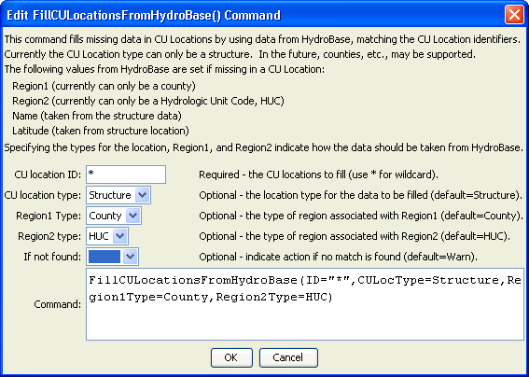
FillCULocationssFromHydroBase
FillCULocationsFromHydroBase() Command Editor

The command syntax is as follows:

FillCULocationsFromHydroBase(Parameter=Value,…)

Command Parameters

Parameter | Description | Default
ID | A single CU Location identifier to match or a pattern using wildcards (e.g., 20*). | None – must be specified.
CULocType | Indicates whether CU Locations are structures or climate stations, to indicate which HydroBase data to query. | Structure
Region1Type | The meaning of Region1 in the data set, to indicate which HydroBase data to query. | County
Region2Type | The meaning of Region2 in the data set, to indicate which HydroBase data to query. | HUC
IfNotFound | Used for error handling, one of the following:  - Fail – generate a failure message if the ID pattern is not matched  - Ignore – ignore (don’t generate a message) if the ID pattern is not matched  - Warn – generate a warning message if the ID pattern is not matched | Warn

