Command Reference: FillClimateStation()

Fill climate station data

StateCU Command
Version 3.12.00, 2011-01-17

The FillClimateStation() command fills missing data in existing climate stations. The following dialog is used to edit the command and illustrates the syntax of the command.

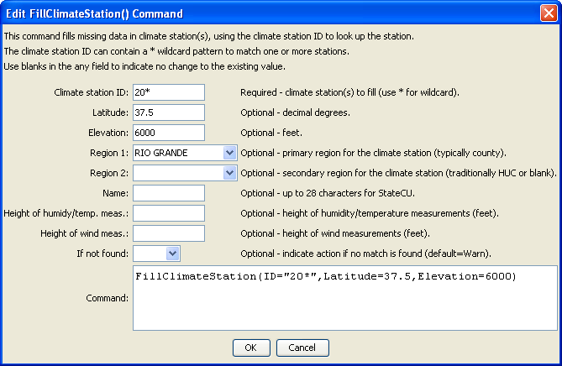
FillClimateStation
FillClimateStation() Command Editor

The command syntax is as follows:

FillClimateStation(Parameter=Value,…)

Command Parameters

Parameter | Description | Default
ID | A single climate station identifier to match or a pattern using wildcards (e.g., 20*). | None – must be specified.
Latitude | The climate station latitude to be assigned for all matching climate stations with missing latitude. | If not specified, the original value will remain.
Elevation | The climate station elevation to be assigned for all matching climate stations with missing elevation. | If not specified, the original value will remain.
Region1 | The climate station Region1 (typically county) to be assigned for all matching climate stations with missing Region1. | If not specified, the original value will remain.
Region2 | The climate station Region2 (traditionally HUC but can be blank) to be assigned for all matching climate stations with missing Region2. | If not specified, the original value will remain.
Name | The climate station name to be assigned for all matching climate stations with missing name. | If not specified, the original value will remain.
HeightHumidityMeas | The height of humidity and temperature measurements (feet), only used with daily analysis. | If not specified, the original value will remain.
HeightWindMeas | The height of wind measurements (feet), only used with daily analysis. | If not specified, the original value will remain.
IfNotFound | Used for error handling, one of the following:  - Fail – generate a failure message if the ID pattern is not matched  - Ignore – ignore (don’t generate a message) if the ID pattern is not matched  - Warn – generate a warning message if the ID pattern is not matched | Warn

