Command Reference: FillClimateStationsFromHydroBase()

Fill climate station data from HydroBase

StateCU Command
Version 3.08.02, 2010-01-05

The FillClimateStationsFromHydroBase() command fills missing data in existing climate stations, using HydroBase for data. The following dialog is used to edit the command and illustrates the syntax of the command.

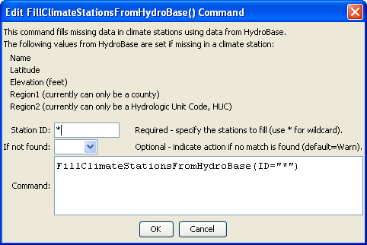
FillClimateStationsFromHydroBase
FillClimateStationsFromHydroBase() Command Editor

The command syntax is as follows:

FillClimateStationsFromHydroBase(Parameter=Value,…)

Command Parameters

Parameter | Description | Default
ID | A single climate station identifier to match or a pattern using wildcards (e.g., 20*). | None – must be specified.
IfNotFound | Used for error handling, one of the following:  - Fail – generate a failure message if the climate station is not found  - Ignore – ignore (don’t generate a message) if the climate station is not found  - Warn – generate a warning message if the climate station is not found | Warn

The following example command file illustrates how climate stations can be defined, filled from HydroBase, and written to a StateCU file:

ReadClimateStationsFromList(ListFile="climsta.lst",IDCol=1)
FillClimateStationsFromHydroBase(ID="*")
SetClimateStation(ID="3016",Region2="14080106",IfNotFound=Warn)
SetClimateStation(ID="1018",Region2="14040106",IfNotFound=Warn)
SetClimateStation(ID="1928",Elevation=6440,IfNotFound=Warn)
SetClimateStation(ID="0484",Region1="MOFFAT",IfNotFound=Add)
WriteClimateStationsToStateCU(OutputFile="COclim2006.cli")

