Command Reference: FillCropPatternTSInterpolate()

Fill crop pattern time series values using interpolation

StateCU Command
Version 3.09.01, 2010-02-01

The FillCropPatternTSInterpolate() command fills crop pattern time series data for a CU Location, using interpolation. Data will not be extrapolated past the end-points and therefore another fill method (e.g., FillCropPatternTSRepeat()) may be required after the interpolation command. Filling is currently always in a forward direction. If the data set contains groundwater, it is typical to fill groundwater-only crop pattern time series prior to the first year of HydroBase data using FillCropPatternTSUsingWellRights() and use FillCropPatternTSRepeat() and/or FillCropPatternTSInterpolate() for all other time series and parts of the period.

The following dialog is used to edit the command and illustrates the syntax of the command.

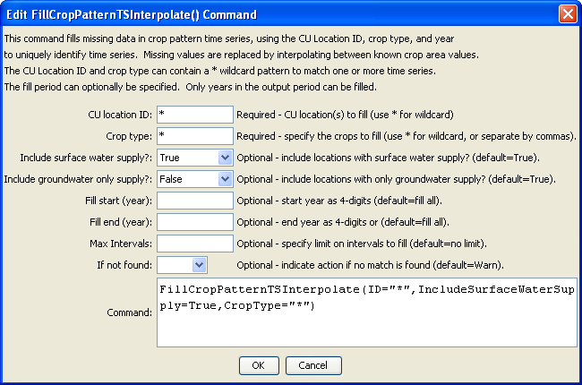
FilltCropPatternTSInterpolate
FillCropPatternTSInterpolate() Command Editor

The command syntax is as follows:

FillCropPatternTSInterpolate(Parameter=Value,…)

Command Parameters

Parameter | Description | Default
ID | A single CU Location identifier to match or a pattern using wildcards (e.g., 20*). | None – must be specified.
CropType | A single crop type to match or a pattern using wildcards (e.g., *). | None – must be specified.
IncludeSurfaceWaterSupply | Indicate whether locations with surface water supply should be processed (those other than groundwater-only locations). | True
IncludeGroundwaterOnlySupply | Indicate whether locations with only groundwater supply (collections where PartType=Parcel) should be processed. Typically this is specified as true unless FillCropPatternTS UsingWellRights() has been applied for the fill period. | True
FillStart | The first year to fill. This should be a year with observations to allow interpolation. | If not specified, fill the full period.
FillEnd | The last year to fill. This should be a year with observations to allow interpolation. | If not specified, fill the full period.
MaxIntervals | The maximum number of intervals to fill in any gap. | If not specified, fill the entire gap.
IfNotFound | Used for error handling, one of the following:  - Fail – generate a failure message if the ID is not matched  - Ignore – ignore (don’t add and don’t generate a message) if the ID is not matched  - Warn – generate a warning message if the ID is not matched | Warn

