Command Reference: FillCropPatternTSRepeat()

Fill crop pattern time series values by repeating values

StateCU Command
Version 3.12.00, 2010-12-09

The FillCropPatternTSRepeat() command fills crop pattern time series data for a CU Location by repeating known values. Filling can occur forward or backward in time, but not both. Therefore, it may be necessary to use two similar commands, one filling forward, and one filling backward, in order to completely fill the ends of time series.

The following dialog is used to edit the command and illustrates the syntax of the command.

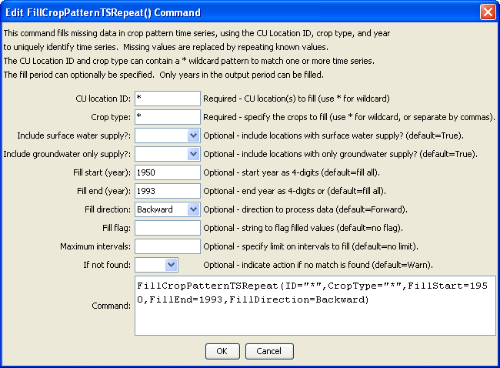
FilltCropPatternTSRepeat
FillCropPatternTSRepeat() Command Editor

The command syntax is as follows:

FillCropPatternTSRepeat(Parameter=Value,…)

Command Parameters

Parameter | Description | Default
ID | A single CU Location identifier to match or a pattern using wildcards (e.g., 20*). | None – must be specified.
CropType | A single crop type to match or a pattern using wildcards (e.g., *). | None – must be specified.
IncludeSurfaceWaterSupply | Indicate whether locations with surface water supply should be processed (those other than groundwater-only locations). | True
IncludeGroundwaterOnlySupply | Indicate whether locations with only groundwater supply (collections where PartType=Parcel) should be processed. Typically this is specified as true. | True
FillStart | The first year to fill, typically a year with observations if filling forward. | If not specified, fill the full period.
FillEnd | The last year to fill, typically a year with observations if filling backward. | If not specified, fill the full period.
FillDirection | The direction to fill, either Forward or Backward. | Forward
FillFlag | A string to flag values that are filled, supported by some output formats. | No flag is used
MaxIntervals | The maximum number of intervals to fill in any gap. | If not specified, fill the entire gap.
IfNotFound | Used for error handling, one of the following:  - Fail – generate a failure message if the ID is not matched  - Ignore – ignore (don’t add and don’t generate a message) if the ID is not matched  - Warn – generate a warning message if the ID is not matched | Warn

