Command Reference: FillDiversionDemandTSMonthlyConstant()

Fill diversion demand time series (monthly) values using a constant value

StateMod Command
Version 3.09.01, 2010-02-01

The FillDiversionDemandTSMonthlyConstant() command fills missing diversion demand time series (monthly) data, using a constant value. This command is useful, for example, to set demand values to zero if other fill commands are unable to provide data estimates for missing data.

The following dialog is used to edit the command and illustrates the syntax of the command.

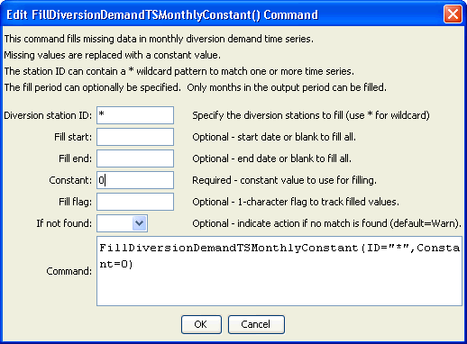
FillDiversionDemandTSMonthlyConstant
FillDiversionDemandTSMonthlyConstant() Command Editor

The command syntax is as follows:

FillDiversionDemandTSMonthlyConstant(Parameter=Value,…)

Command Parameters

Parameter | Description | Default
ID | A single diversion station identifier to match or a pattern using wildcards (e.g., 20*). | None – must be specified.
FillStart | The first year to fill. | If not specified, fill the full period.
FillEnd | The last year to fill. | If not specified, fill the full period.
Constant | The constant value to be used to fill missing data. | None – must be specified.
FillFlag | If specified as a single character, data flags will be enabled for the time series and each filled value will be tagged with the specified character. The flag can then be used later to label graphs, etc. The flag will be appended to existing flags if necessary. | No flag is assigned.
IfNotFound | Used for error handling, one of the following:  - Fail – generate a failure message if the ID is not matched  - Ignore – ignore (don’t add and don’t generate a message) if the ID is not matched  - Warn – generate a warning message if the ID is not matched | Warn

