Command Reference: FillDiversionRight()

Fill diversion right data

StateCU and StateMod Command
Version 3.09.00, 2010-01-26

The FillDiversionRight() command fills missing data in existing diversion rights. The following dialog is used to edit the command and illustrates the syntax of the command.

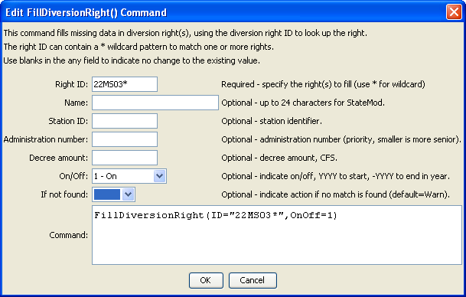
FillDiversionRight
FillDiversionRight() Command Editor

The command syntax is as follows:

FillDiversionRight(Parameter=Value,…)

Command Parameters

Parameter | Description | Default
ID | A single diversion right identifier to match or a pattern using wildcards (e.g., 20*). | None – must be specified.
Name | The name to be assigned for all matching diversion right identifiers with missing name. | If not specified, the original value will remain.
StationID | The diversion station identifier to be assigned for all matching diversion right identifiers with missing diversion station identifier. | If not specified, the original value will remain.
AdministrationNumber | The administration number to be assigned for all matching diversion right identifiers with missing administration number. | If not specified, the original value will remain.
Decree | The water right decree to be assigned for all matching diversion right identifiers with missing administration decree. | If not specified, the original value will remain.
OnOff | The on/off switch to be assigned for all matching diversion right identifiers with missing on/off switch, either 1 for on or 0 for off, a positive 4-digit year to turn the right on starting in the year, or a negative 4-digit year to turn the right off starting in the year. | If not specified, the original value will remain.
IfNotFound | Used for error handling, one of the following:  - Fail – generate a failure message if the ID is not matched  - Ignore – ignore (don’t generate a message) if the ID is not matched  - Warn – generate a warning message if the ID is not matched | Warn

