Command Reference: FillDiversionStationsFromHydroBase()

Fill diversion station data from HydroBase

StateMod Command
Version 3.09.01, 2010-02-01

The FillDiversionStationsFromHydroBase() command fills missing data in existing diversion stations, using HydroBase for data.

The following dialog is used to edit the command and illustrates the syntax of the command.

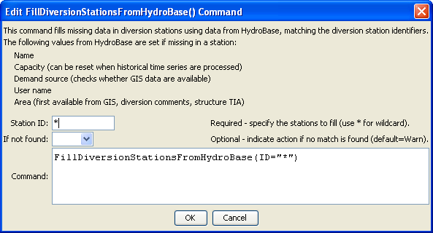
FillDiversionStationsFromHydroBase
FillDiversionStationsFromHydroBase() Command Editor

The command syntax is as follows:

FillDiversionStationsFromHydroBase(Parameter=Value,…)

Command Parameters

Parameter | Description | Default
ID | A single diversion station identifier to match or a pattern using wildcards (e.g., 20*). | None – must be specified.
IfNotFound | Used for error handling, one of the following:  - Fail – generate a failure message if the ID is not matched  - Ignore – ignore (don’t add and don’t generate a message) if the ID is not matched  - Warn – generate a warning message if the ID is not matched | Warn

