Command Reference: FillDiversionStationsFromNetwork()

Fill diversion station data from a StateMod network

StateMod Command
Version 3.09.01, 2010-02-01

The FillDiversionStationsFromNetwork() command fills missing data in diversion stations, using a StateMod network for data. This command is usually used after filling from other sources (e.g., HydroBase), because the information in the network file may have been specified mainly for the diagram and therefore does not necessarily match official data sources. It is assumed that the network has been read in a previous command (e.g., when the list of diversion stations was originally read).

The following dialog is used to edit the command and illustrates the syntax of the command.

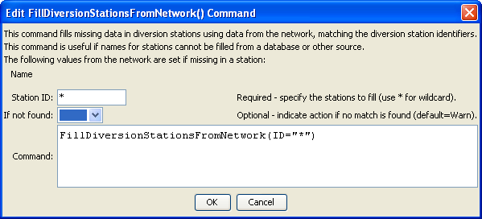
FillDiversionStationsFromNetwork
FillDiversionStationsFromNetwork() Command Editor

The command syntax is as follows:

FillDiversionStationsFromNetwork(Parameter=Value,…)

Command Parameters

Parameter | Description | Default
ID | A single diversion station identifier to match or a pattern using wildcards (e.g., 20*). | None – must be specified.
IfNotFound | Used for error handling, one of the following:  - Fail – generate a failure message if the ID is not matched  - Ignore – ignore (don’t add and don’t generate a message) if the ID is not matched  - Warn – generate a warning message if the ID is not matched | Warn

The following example illustrates how to fill diversion station names from the network. A command to fill from HydroBase or another source will often be run before the second command below.

ReadDiversionStationsFromNetwork(InputFile="sp2005.net")
FillDiversionStationsFromNetwork(ID="*")

