Command Reference: FillInstreamFlowStation()

Fill instream flow station data

StateMod Command
Version 3.09.01, 2010-02-01

The FillInstreamFlowStation() command fills missing data in existing instream flow stations. The following dialog is used to edit the command and illustrates the syntax of the command.

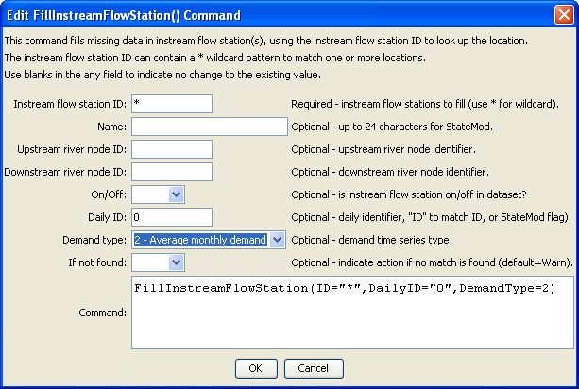
FillInstreamFlowStation
FillInstreamFlowStation() Command Editor

The command syntax is as follows:

FillInstreamFlowStation(Parameter=Value,…)

Command Parameters

Parameter | Description | Default
ID | A single instream flow station identifier to match or a pattern using wildcards (e.g., 20*). | None – must be specified.
Name | The name to be assigned for all matching instream flow station identifiers with missing name. | If not specified, the original value will remain.
UpstreamRiverNodeID | The upstream river node identifier to be assigned for all matching instream flow station identifiers with missing river node identifier. | If not specified, the original value will remain.
DownstreamRiverNodeID | The downstream river node identifier to be assigned for all matching instream flow station identifiers with missing river node identifier. | If not specified, the original value will remain.
OnOff | The on/off switch to be assigned for all matching instream flow station identifiers with missing river node identifier, either 1 for on or 0 for off. | If not specified, the original value will remain.
DailyID | The daily identifier to be assigned for all matching stream gage identifiers with missing river node identifier | If not specified, the original value will remain.
DemandType | The demand type to be assigned for all matching instream flow stations with missing demand type, one of:  1 – Monthly demand  2 – Average monthly demand | If not specified, the original value will remain.
IfNotFound | Used for error handling, one of the following:  - Fail – generate a failure message if the ID is not matched  - Ignore – ignore (don’t generate a message) if the ID is not matched  - Warn – generate a warning message if the ID is not matched | Warn

