Command Reference: FillInstreamFlowStationsFromHydroBase()

Fill instream flow station data from HydroBase

StateMod Command
Version 3.09.01, 2010-02-01

The FillInstreamFlowStationsFromHydroBase() command fills missing data in existing instream flow stations, using HydroBase for data. The following dialog is used to edit the command and illustrates the syntax of the command.

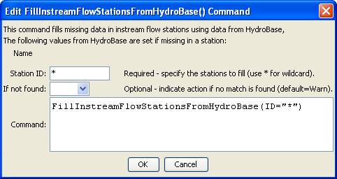
FillInstreamFlowStationsFromHydroBase
FillInstreamFlowStationsFromHydroBase() Command Editor

The command syntax is as follows:

FillInstreamFlowStationsFromHydroBase(Parameter=Value,…)

Command Parameters

Parameter | Description | Default
ID | A single instream flow station identifier to match or a pattern using wildcards (e.g., 20*). | None – must be specified.
IfNotFound | Used for error handling, one of the following:  - Fail – generate a failure message if the ID is not matched  - Ignore – ignore (don’t generate a message) if the ID is not matched  - Warn – generate a warning message if the ID is not matched | Warn

