Command Reference: FillInstreamFlowStationsFromNetwork()

Fill instream flow station data from a StateMod network

StateMod Command
Version 3.09.01, 2010-02-01

The FillInstreamFlowStationsFromNetwork() command fills missing data in instream flow stations, using a StateMod network for data. This command is usually used after filling from other sources (e.g., HydroBase), because the information in the network file may have been specified mainly for the diagram and therefore does not necessarily match official data sources. It is assumed that the network has been read in a previous command (e.g., when the list of instream flow stations was originally read).

The following dialog is used to edit the command and illustrates the syntax of the command.

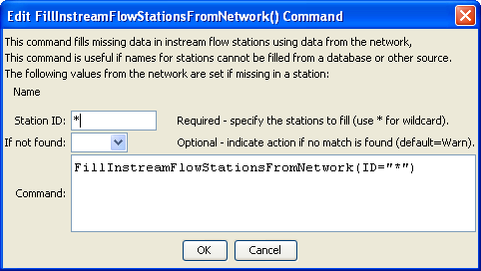
FillInstreamFlowStationsFromNetwork
FillInstreamFlowStationsFromNetwork() Command Editor

The command syntax is as follows:

FillInstreamFlowStationsFromNetwork(Parameter=Value,…)

Command Parameters

Parameter | Description | Default
ID | A single instream flow station identifier to match or a pattern using wildcards (e.g., 20*). | None – must be specified.

The following example illustrates how to fill instream flow station names from the network. A command to fill from HydroBase or another source will often be run before the second command below.

ReadInstreamFlowStationsFromNetwork(InputFile="sp2005.net")
FillInstreamFlowStationsFromNetwork(ID="*")

