Command Reference: FillReservoirRight()

Fill reservoir right data

StateMod Command
Version 3.09.01, 2010-02-01

The FillReservoirRight() command fills missing data in existing reservoir rights. The following dialog is used to edit the command and illustrates the syntax of the command.

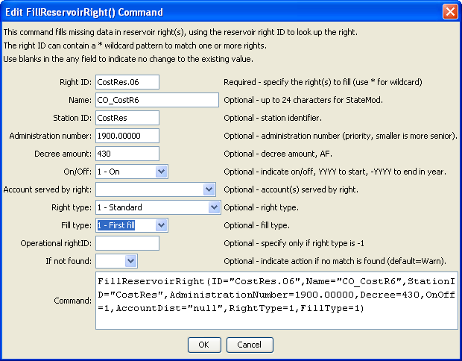
FillReservoirRight
FillReservoirRight() Command Editor

The command syntax is as follows:

FillReservoirRight(Parameter=Value,…)

Command Parameters

Parameter | Description | Default
ID | A single reservoir right identifier to match or a pattern using wildcards (e.g., 20*). | None – must be specified.
Name | The name to be assigned for all matching reservoir right identifiers with missing name. | If not specified, the original value will remain.
StationID | The reservoir station identifier to be assigned for all matching reservoir right identifiers with missing reservoir station identifier. | If not specified, the original value will remain.
Administration  Number | The administration number to be assigned for all matching reservoir right identifiers with missing administration number. | If not specified, the original value will remain.
Decree | The water right decree to be assigned for all matching reservoir right identifiers with missing administration decree. | If not specified, the original value will remain.
OnOff | The on/off switch to be assigned for all matching reservoir right identifiers with missing on/off switch, either 1 for on or 0 for off, a positive 4-digit year to turn the right on starting in the year, or a negative 4-digit year to turn the right off starting in the year. | If not specified, the original value will remain.
AccountDist | The account distribution option to be assigned for all matching reservoir rights (see StateMod documentation). | If not specified, the original value will remain.
RightType | The reservoir right type to be assigned for all matching reservoir rights (see StateMod documentation). | If not specified, the original value will remain.
FillType | The reservoir right fill type to be assigned for all matching reservoir rights (see StateMod documentation). | If not specified, the original value will remain.
OpRightID | The out-of-priority associated operational right (see StateMod documentation). | If not specified, the original value will remain.
IfNotFound | Used for error handling, one of the following:  - Fail – generate a failure message if the ID is not matched  - Ignore – ignore (don’t generate a message) if the ID is not matched  - Warn – generate a warning message if the ID is not matched | Warn

