Command Reference: FillReservoirStationsFromHydroBase()

Fill reservoir station data from HydroBase

StateMod Command
Version 3.14.00, 2004-09-14, Color, Acrobat Distiller

The FillReservoirStationsFromHydroBase() command fills missing data in existing reservoir stations, using HydroBase for data.

If not in HydroBase, a bounding zero value point is inserted as the first record in the curve. A maximum bound of content 9999999 is also added, using the area and seepage of the last record from HydroBase.

The following dialog is used to edit the command and illustrates the syntax of the command.

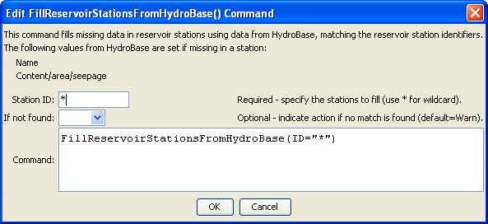
FillReservoirStationsFromHydroBase
FillReservoirStationsFromHydroBase() Command Editor

The command syntax is as follows:

FillReservoirStationsFromHydroBase(Parameter=Value,…)

Command Parameters

Parameter | Description | Default
ID | A single reservoir station identifier to match or a pattern using wildcards (e.g., 20*). | None – must be specified.
IfNotFound | Used for error handling, one of the following:  - Fail – generate a failure message if the ID is not matched  - Ignore – ignore (don’t add and don’t generate a message) if the ID is not matched  - Warn – generate a warning message if the ID is not matched | Warn

